Part 4
About tagger3.py

tagger3 is like tagger2+tagger1 combined (word embeddings + loading pretrained model).
In addition, it add 3-letter prefix & suffix embeddings for each word. To be able to infer something from unknown words.
So each word is assigned 3 embeddings (word, prefix, suffix), they are summed, then the word window is concatenated, and passed through a fully connected layer, with tanh activation. Then a final layer with activation softmax.

Flow:
Input tensor shape is: [batch_size, 5, 3]
Reshape: [batch_size, 15]
Mult by embeddings: [batch_size, 15, 50]
Reshape: [batch, 5, 3, 50]
Sum dim 2 (feature embeddings for each word): [batch_size, 5, 50]
Reshape: [batch_size, 250]
Hidden layer (activation: tanh): [batch_size, num_labels*4]
Output layer (activation: softmax): [batch_size, num_labels]

Notes:
1) loading pretrained model is optional, and as we will see only damaged performance here.
2) Same Model class is used for tagger1&tagger 2, except the input dimension is: [batch_size, 5, 1]. Making it possible to reuse Model class for all assignments.
3) Prefix and suffix used the same ids (i.e ‘ial’ suffix and ‘ial’ prefix got the id for embedding layer. It is wrong to do so, but I lacked the time to fix it).

POS dataset:

- Dev accuracy: 96.5% (not pretrained), 95.5% (pretrained)
- Parameters:
  - window_size: 2
  - learning rate (start): 0.001
  - batch size: 500
  - epoches: 7 (not pretrained), 6 (pretrained)
- Hard coded tricks:
  - Adam optimizer
  - Replace digits with # (not pretrained)
  - Keep upper case (not pretrained), lower case (pretrained)
  - Filter rare words
  - Filter rare prefixes/suffixes
  - Any unknown word, prefix or suffix is replaced with UNK

Notes & Impressions:
- Using pretrained model with tagger3 damaged performance by a little bit. I believe it is because I was forced to give up the replace digit trick, and keeping the upper case trick. (The vocab.txt is lower case, and includes numbers)
- Converged quickly.
- Better then tagger1.py, but not by much (95.1% → 96.5%)

Graph(not pretrained):
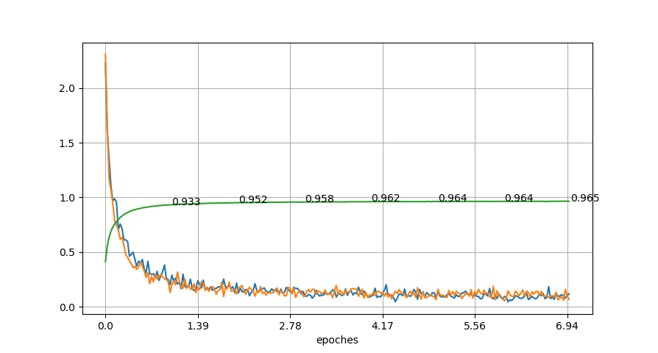

- Dev accuracy
- Dev loss
- Train loss

Final accuracy: 96.5%

Graph (pretrained):
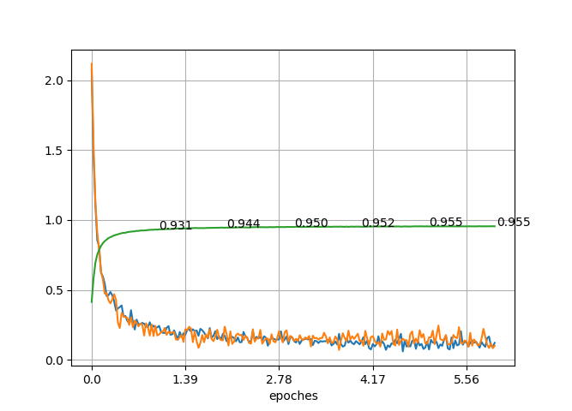

NER dataset:

- Dev accuracy: 81.7% (not pretrained), 76.7% (pretrained)
- Parameters:
  - window_size: 2
  - learning rate (start): 0.001
  - batch size: 500
  - epoches: 25 (not pretrained), 20 (pretrained)
- Hard coded tricks:
  - Same as POS

Notes & Impressions:

- Pretrained model really damaged performance here, it is also because I was forced to give up upper case letters, and replacing digits. Those two tricks really made a difference in the NER.
- Using pretrained model got 76.7%, which is roughly the same as tagger1 76.9%. I believe it is because tagger1 was better with keeping upper case & replacing digits, but tagger3 was better by using prefix&suffix embeddings. Turns out it balanced each other.

Graph (not pretrained):

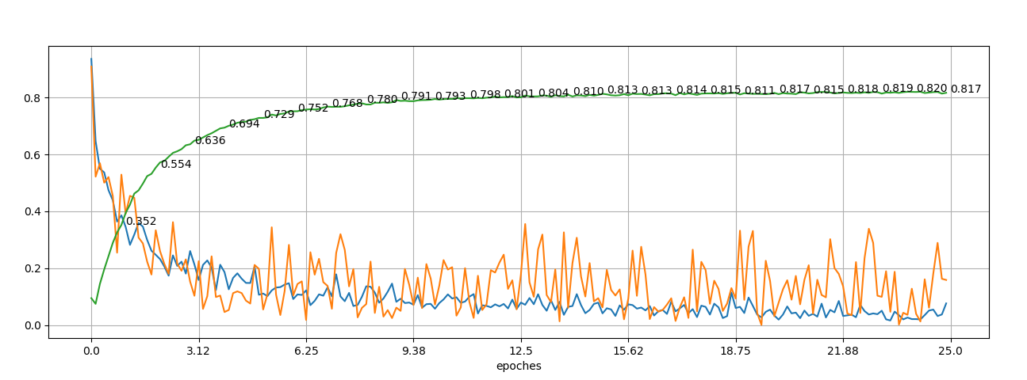

- Dev accuracy
- Dev loss
- Train loss

Final accuracy: 81.7% (>76.9% of tagger1)

Graph (pretrained):
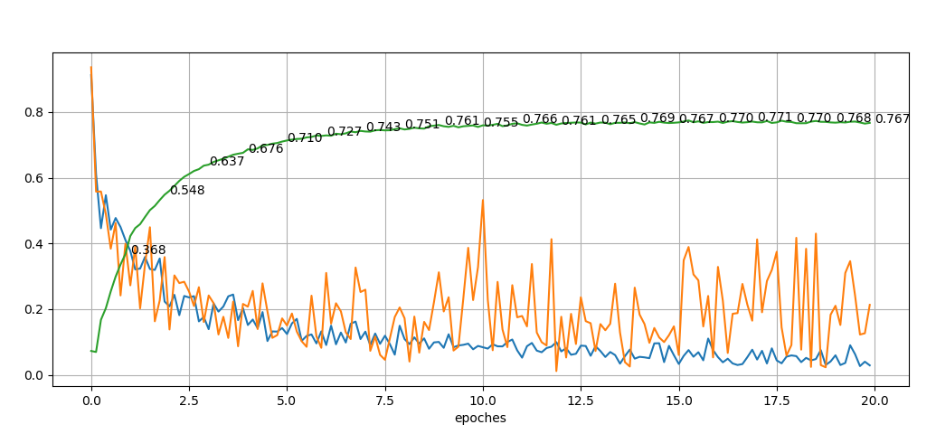

Final result: 76.7% (same as tagger1 76.9%)

