**Results – Posts until 21/07/2016**

**Author type:**



1. Run on the top 10 features:
2. Number of posts – 0.2327
3. Number of followers – 0.2115
4. Average posts per day total – 0.1957
5. Average post length – 0.1952
6. Listed count – 0.1941
7. Friends followers ratio – 0.1934
8. Account age – 0.1715
9. Average links – 0.168
10. Average user mentions – 0.1607
11. Number of friends – 0.1262

We ran J48 with Cross validation 10 folds on 3,371 instances.

Including author_type

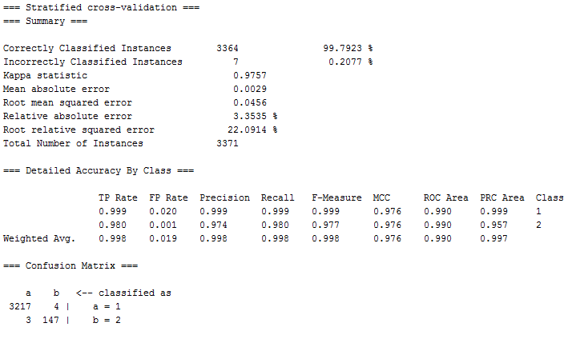

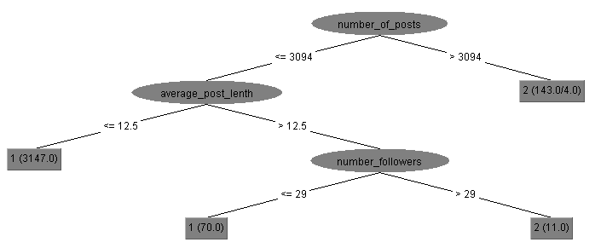

1. Run on the 9 features. Remove the top:
2. Number of followers – 0.2115
3. Average posts per day total – 0.1957
4. Average post length – 0.1952
5. Listed count – 0.1941
6. Friends followers ratio – 0.1934
7. Account age – 0.1715
8. Average links – 0.168
9. Average user mentions – 0.1607
10. Number of friends – 0.1262

We ran J48 with Cross validation 10 folds on 3,371 instances.

Including author_type

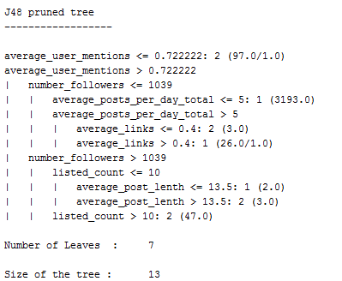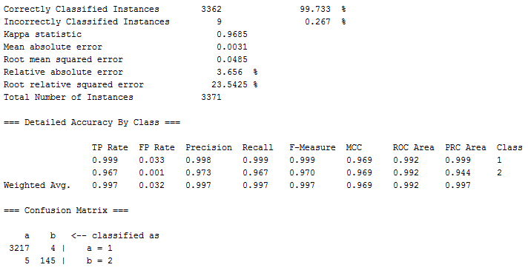

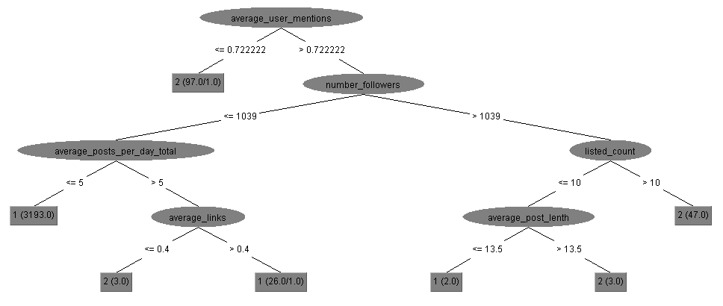

1. Run on the 8 features. Remove the top 2:
2. Average posts per day total – 0.1957
3. Average post length – 0.1952
4. Listed count – 0.1941
5. Friends followers ratio – 0.1934
6. Account age – 0.1715
7. Average links – 0.168
8. Average user mentions – 0.1607
9. Number of friends – 0.1262

We ran J48 with Cross validation 10 folds on 3,371 instances.

Including author_type

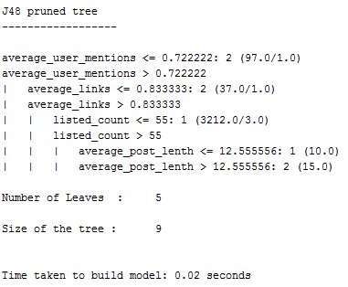

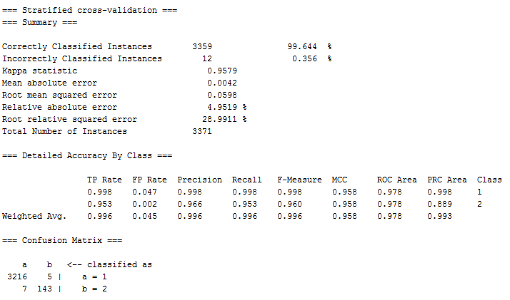

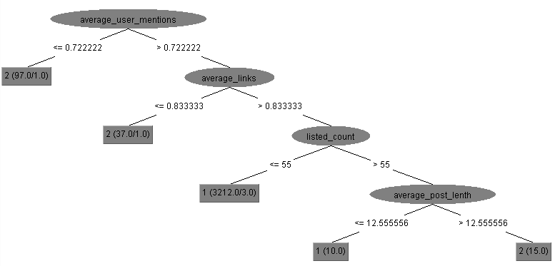

1. Run on the 7 features. Remove the top 3:
2. Average post length – 0.1952
3. Listed count – 0.1941
4. Friends followers ratio – 0.1934
5. Account age – 0.1715
6. Average links – 0.168
7. Average user mentions – 0.1607
8. Number of friends – 0.1262

We ran J48 with Cross validation 10 folds on 3,371 instances.

Including author_type

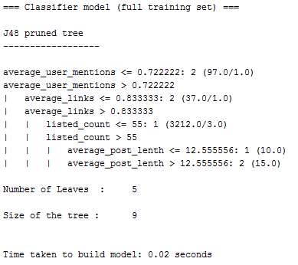

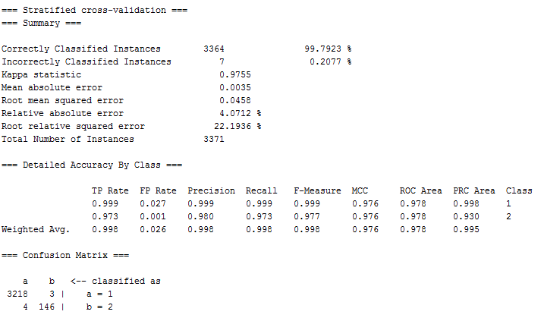

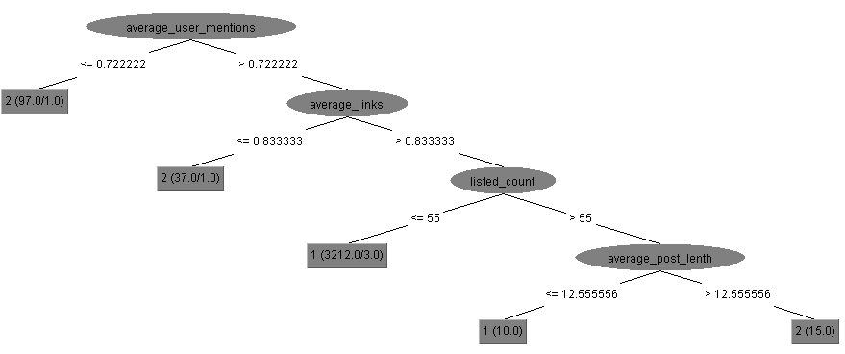

1. Run on the 6 features. Remove the top 4:
2. Listed count – 0.1941
3. Friends followers ratio – 0.1934
4. Account age – 0.1715
5. Average links – 0.168
6. Average user mentions – 0.1607
7. Number of friends – 0.1262

We ran J48 with Cross validation 10 folds on 3,371 instances.

Including author_type

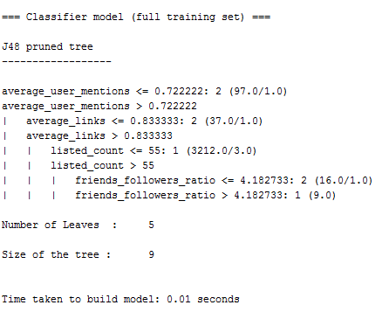

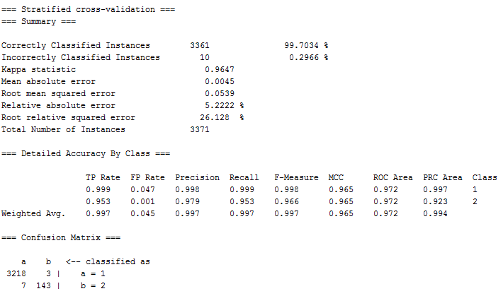

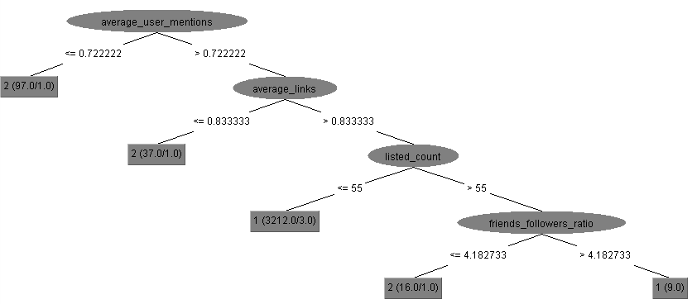

1. Run on the 5 features. Remove the top 5:
2. Friends followers ratio – 0.1934
3. Account age – 0.1715
4. Average links – 0.168
5. Average user mentions – 0.1607
6. Number of friends – 0.1262

We ran J48 with Cross validation 10 folds on 3,371 instances.

Including author_type

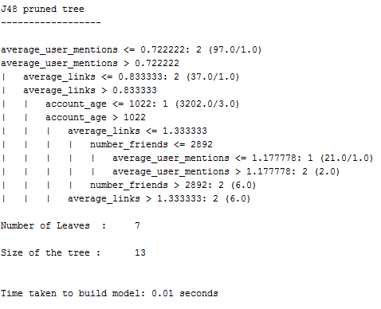

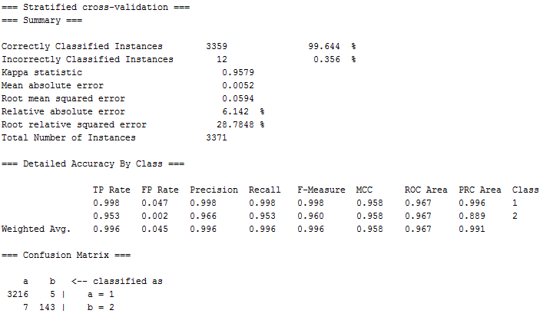

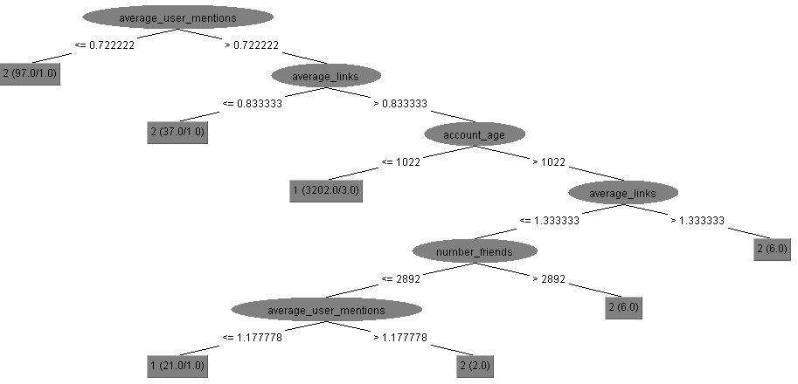

1. Run on the 4 features. Remove the top 6:
2. Account age – 0.1715
3. Average links – 0.168
4. Average user mentions – 0.1607
5. Number of friends – 0.1262

We ran J48 with Cross validation 10 folds on 3,371 instances.

Including author_type

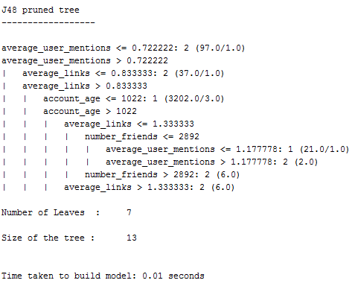

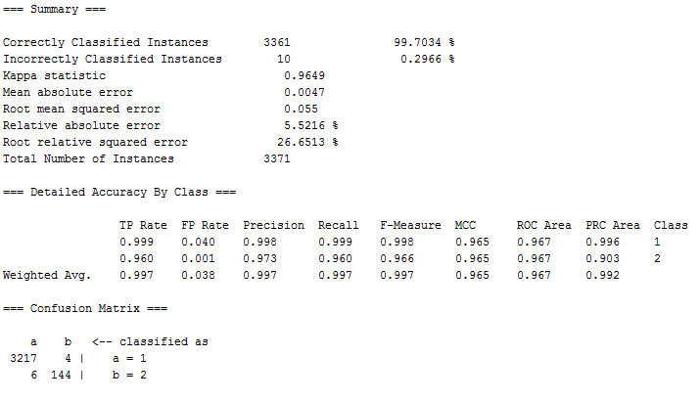

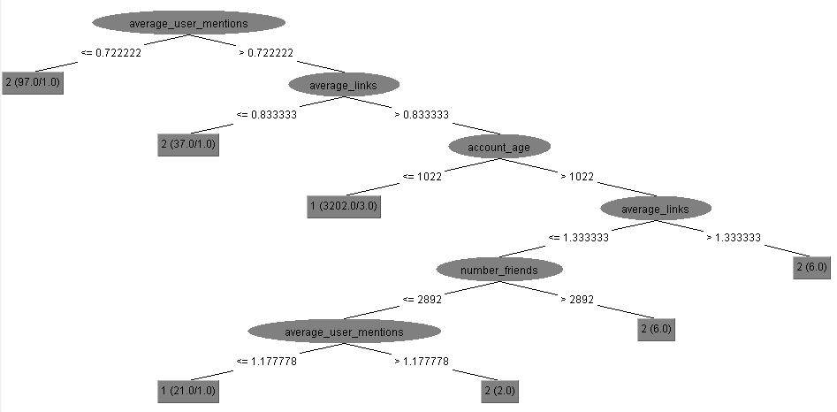

1. Run on the 3 features. Remove the top 7:
2. Average links – 0.168
3. Average user mentions – 0.1607
4. Number of friends – 0.1262

We ran J48 with Cross validation 10 folds on 3,371 instances.

Including author_type

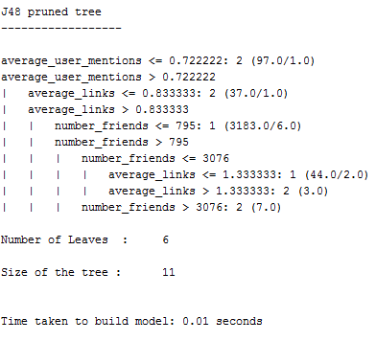

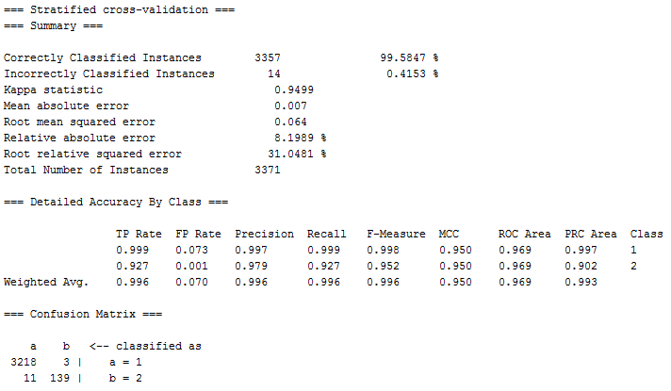

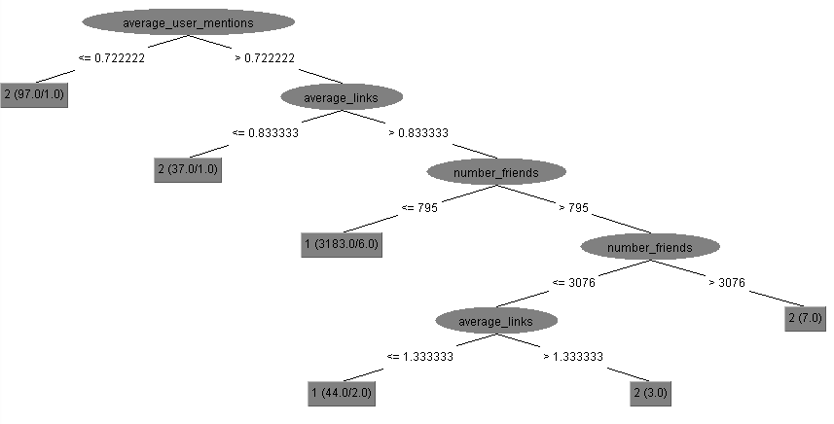

1. Run on the 2 features. Remove the top 8:
2. Average user mentions – 0.1607
3. Number of friends – 0.1262

We ran J48 with Cross validation 10 folds on 3,371 instances.

Including author_type

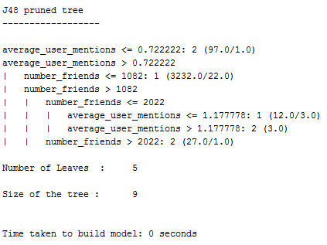

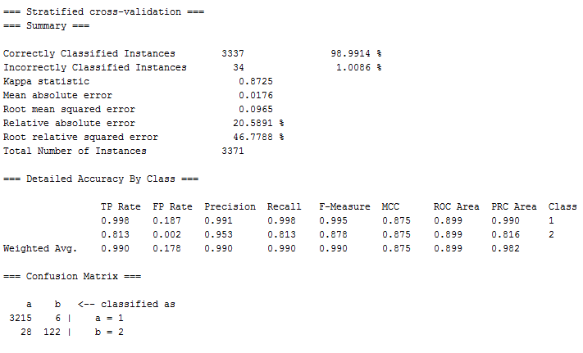

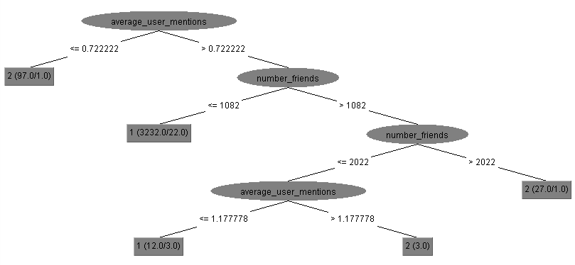

1. Run on the 8 features. Remove the top 9:
2. Number of friends – 0.1262

We ran J48 with Cross validation 10 folds on 3,371 instances.

Including author_type

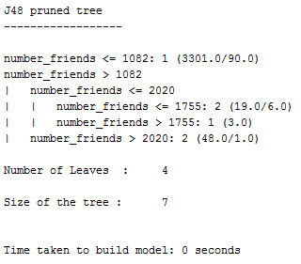

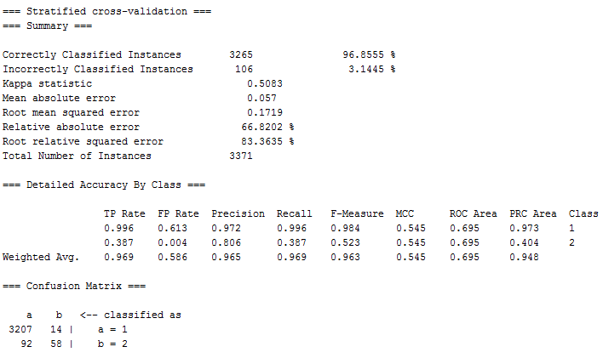

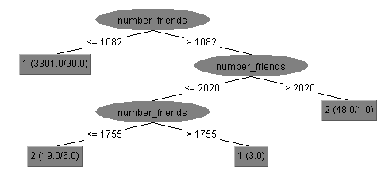

1. Run on the top 10 features:
2. Boost score avg – 0.0996
3. Boost score sum – 0.0696
4. Default profile – 0.057
5. Average minutes between posts – 0.0446
6. Co-citation net closeness centrality -0.0213
7. Co-citation net betweeness centrality aggregation function mean neighb size 1 - 0.0213
8. Co-citation net degree centrality – 0.0213
9. Co-citation net clustering aggregation function mean neigb size 1 - 0.0213
10. Co-citation net degree centrality aggregation function mean neighb size 1 – 0.0213
11. Co-citation net closeness centrality aggregation function mean neighb size 1 – 0.0213

Random Forest:

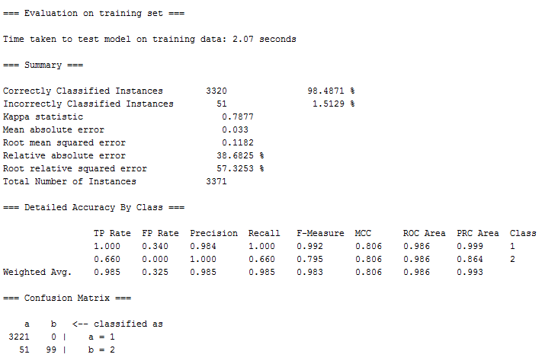

**AdaBoost**

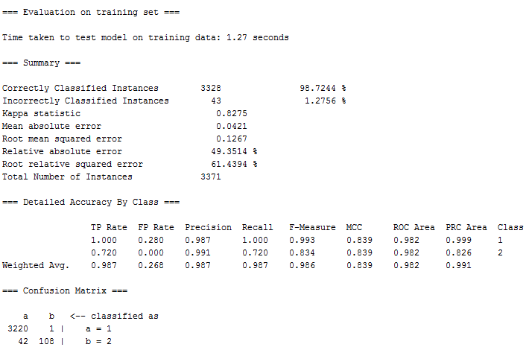

**Most effective attributes**:

Dataset contains 18,022 users among them 3,221 bad actors and 150 good actors. All the others are unlabeled.

The most efficient for distinguishing:

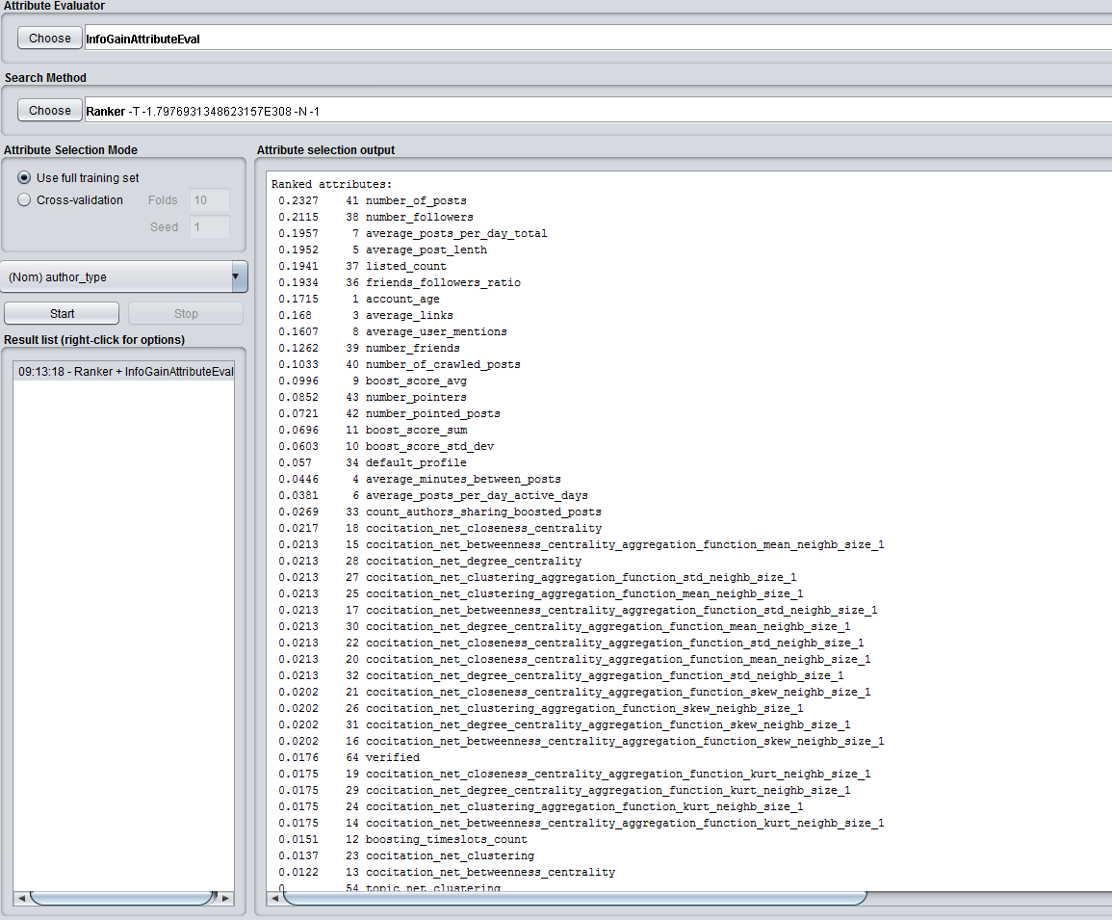

1. Run on the top 10 features:
2. Number of posts – 0.2327
3. Number of followers – 0.2115
4. Average posts per day total – 0.1957
5. Average post length – 0.1952
6. Listed count – 0.1941
7. Friends followers ratio – 0.1934
8. Account age – 0.1715
9. Average links – 0.168
10. Average user mentions – 0.1607
11. Number of friends – 0.1262

We ran Adaboost with Cross validation 10 folds on 3,371 instances.

Including author_type

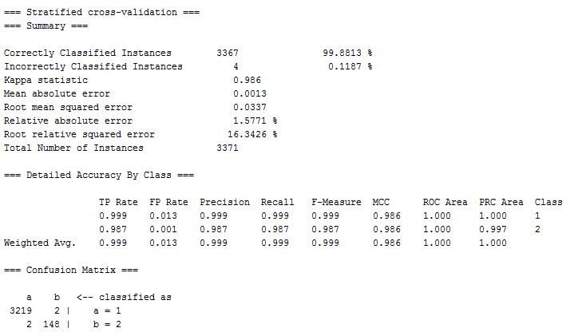

1. Run on the top 9 features:
2. Number of followers – 0.2115
3. Average posts per day total – 0.1957
4. Average post length – 0.1952
5. Listed count – 0.1941
6. Friends followers ratio – 0.1934
7. Account age – 0.1715
8. Average links – 0.168
9. Average user mentions – 0.1607
10. Number of friends – 0.1262

We ran Adaboost with Cross validation 10 folds on 3,371 instances.

Including author_type

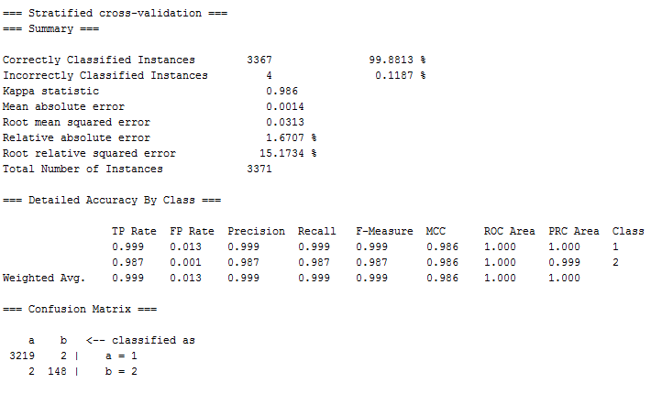

1. Run on the top 8 features:
2. Average posts per day total – 0.1957
3. Average post length – 0.1952
4. Listed count – 0.1941
5. Friends followers ratio – 0.1934
6. Account age – 0.1715
7. Average links – 0.168
8. Average user mentions – 0.1607
9. Number of friends – 0.1262

We ran Adaboost with Cross validation 10 folds on 3,371 instances.

Including author_type

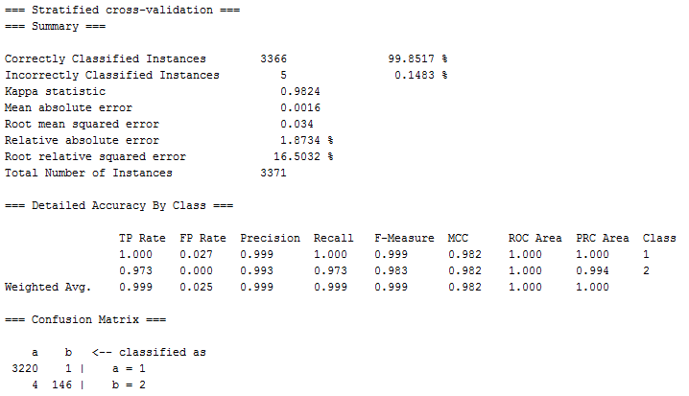

1. Run on the top 7 features:
2. Average post length – 0.1952
3. Listed count – 0.1941
4. Friends followers ratio – 0.1934
5. Account age – 0.1715
6. Average links – 0.168
7. Average user mentions – 0.1607
8. Number of friends – 0.1262

We ran Adaboost with Cross validation 10 folds on 3,371 instances.

Including author_type

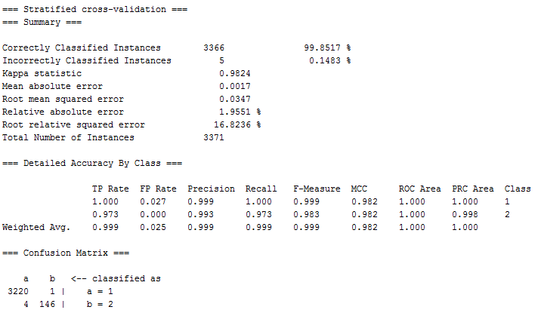

1. Run on the top 6 features:
2. Listed count – 0.1941
3. Friends followers ratio – 0.1934
4. Account age – 0.1715
5. Average links – 0.168
6. Average user mentions – 0.1607
7. Number of friends – 0.1262

We ran Adaboost with Cross validation 10 folds on 3,371 instances.

Including author_type

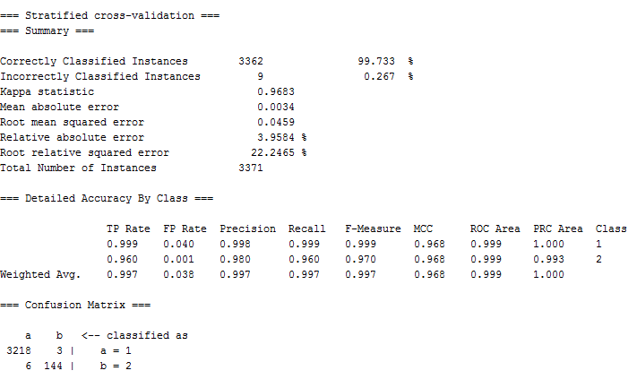

1. Run on the top 5 features:
2. Friends followers ratio – 0.1934
3. Account age – 0.1715
4. Average links – 0.168
5. Average user mentions – 0.1607
6. Number of friends – 0.1262

We ran Adaboost with Cross validation 10 folds on 3,371 instances.

Including author_type

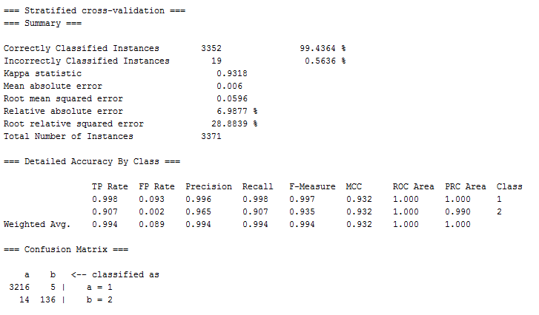

1. Run on the top 4 features:
2. Account age – 0.1715
3. Average links – 0.168
4. Average user mentions – 0.1607
5. Number of friends – 0.1262

We ran Adaboost with Cross validation 10 folds on 18,022 instances.

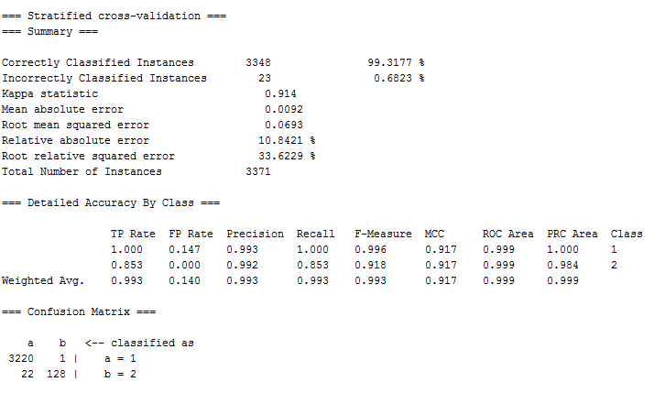

1. Run on the top 3 features:
2. Average links – 0.168
3. Average user mentions – 0.1607
4. Number of friends – 0.1262

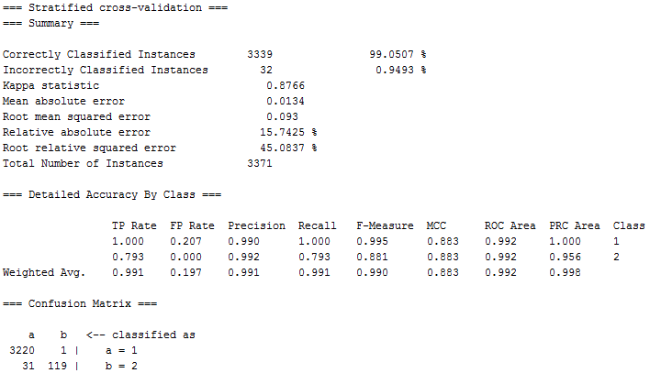

1. Run on the top 2 features:
2. Average user mentions – 0.1607
3. Number of friends – 0.1262

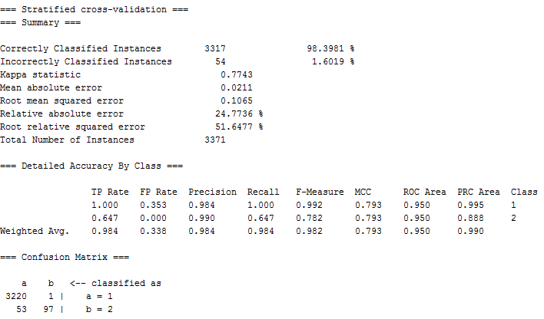

**Random Forest**

On 10 features:

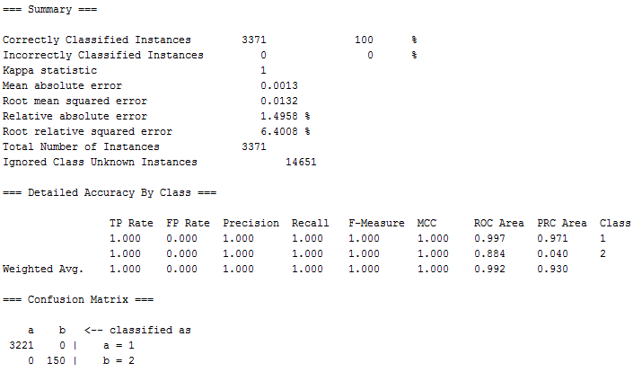

On 9 features:

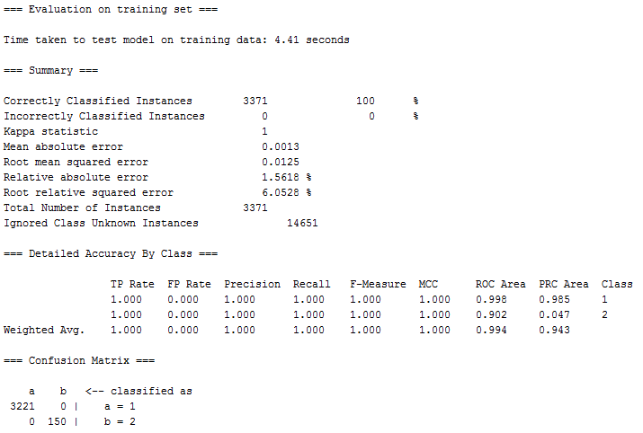

On 8 features:

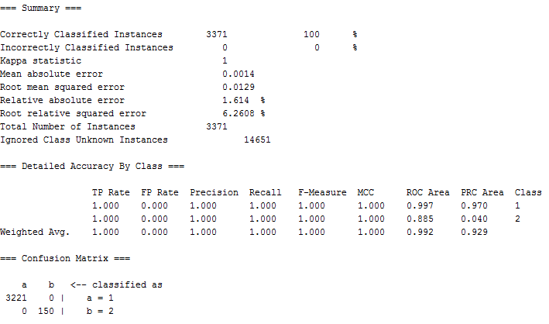

On 7 features:

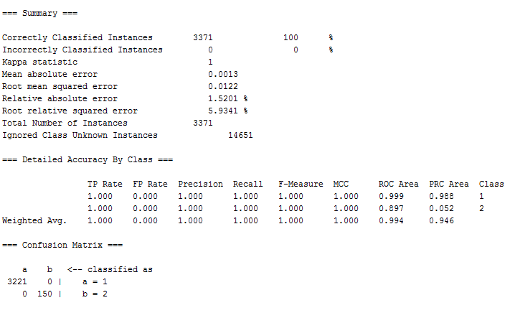

On 6 features:

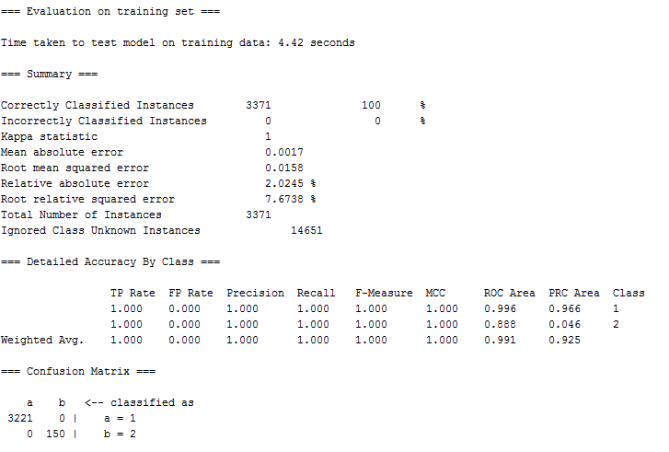

On 5 features:

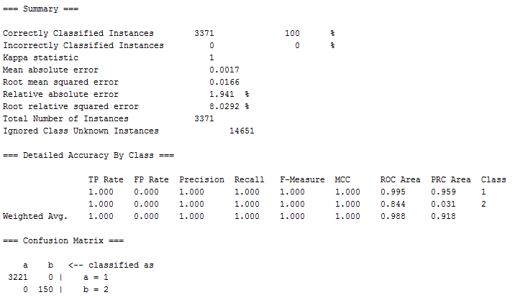

On 4 features:

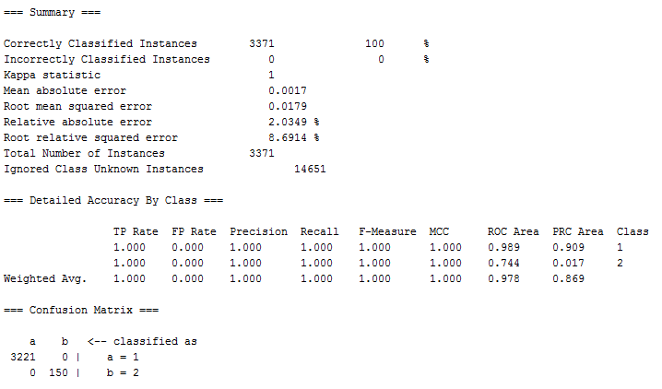

On 3 features:

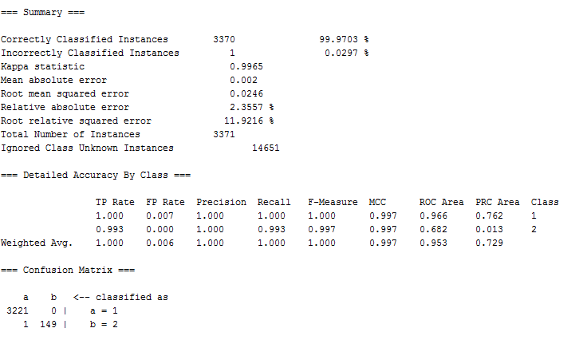

On 2 features:

