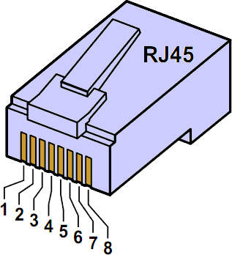

|  |  |  |  |
| --- | --- | --- | --- |
| Rem | Circuit | Wire Color | Pin# |
|  | +24V | Orange/White | 1 |
|  | NC? | Orange | 2 |
|  | -24V | Green/White | 3 |
|  | -24V | Blue | 4 |
|  | Data+ | Blue /White | 5 |
|  | Data- | Green | 6 |
|  | NC? | Brown/White | 7 |
|  | NC? | Brown | 8 |