Computer Vision HW3

Name: 毛弘仁 Department: 電機四 Student ID: B04901117

Part 1

I used Solution 2 (confining h11 2 + … + h33 2 = 1 through the use of SVD).

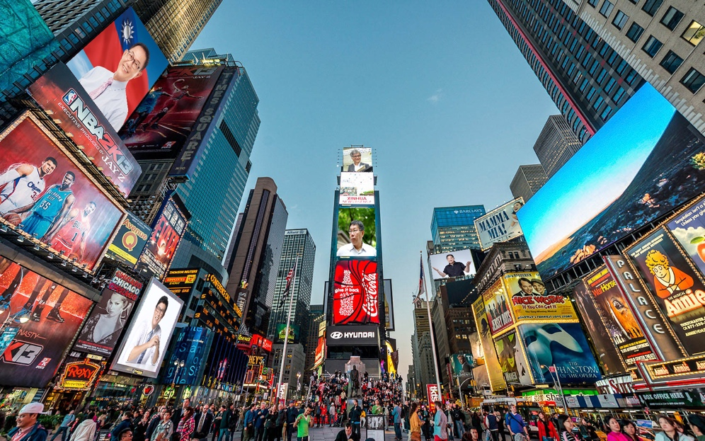



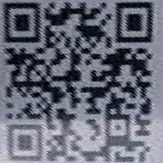Part 2

Decoded link: <http://media.ee.ntu.edu.tw/courses/cv/18F/>

Part 3

TODO.