Computer Vision HW4

Name: 毛弘仁 Department: 電機四 Student ID: B04901117

Part 1

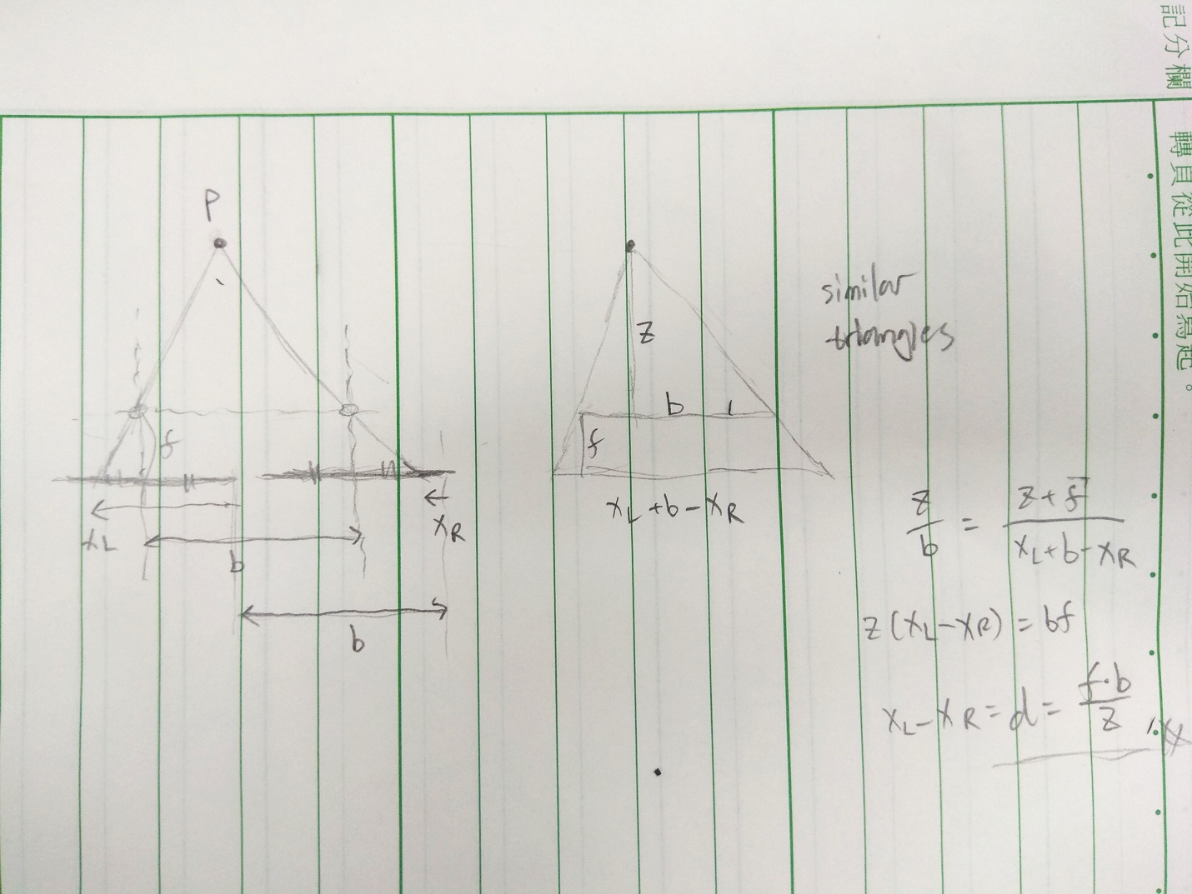

Part 2

Cost computation: Birchfield-Tomasi sub-pixel metric

Cost aggregation: minimize 1D energy (1 data term + 2 smoothness terms) in eight directions

Disparity optimization: winner takes all

Disparity refinement: uniqueness check, speckle filtering, left-right consistency check, hole-filling, median filtering

 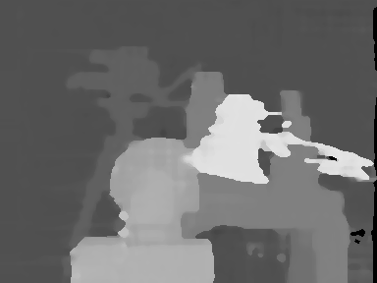

Tsukuba bad pixel ratio: 4.98%

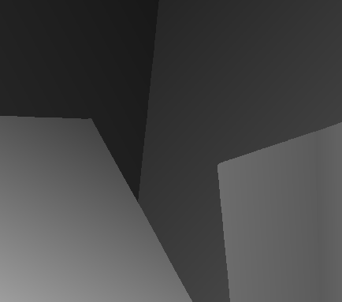 

Venus bad pixel ratio: 2.57%

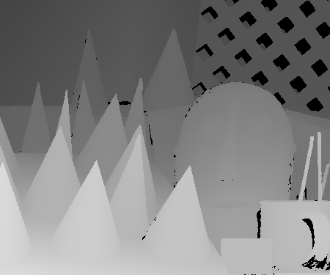 

Cones bad pixel ratio: 13.04%

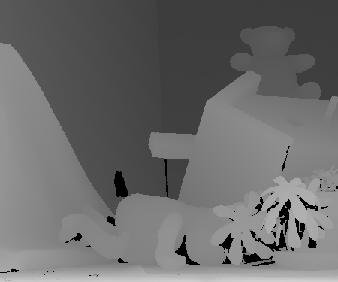 

Teddy bad pixel ratio: 17.77%

References:

1. <http://www.openrs.org/photogrammetry/2015/SGM%202008%20PAMI%20-%20Stereo%20Processing%20by%20Semiglobal%20Matching%20and%20Mutual%20Informtion.pdf>
2. <http://robotics.stanford.edu/~birch/publications/dissimilarity_pami1998.pdf>
3. <http://timosam.com/python_opencv_depthimage>