**Ping&watchdog - programming in C**

Authors:

Maor Saadon 318532421

Dovi Amiram 305677494

**Contents**

**1 System Characterization 2**

1.1 System Overview

1.1.1 About the System………………………………………………………..…………..3  
1.1.2 How to Install and Run the Program………………………….……..……..7

1.2 System Functionality

1.2.1 Code Description……………………………………………………..…………8-19  
1.2.2 Output…………………………………………………………………………………..21  
1.2.3 Functions………………………………………………………………………….22-31

**2 Research findings 34**

2.1 Wireshark

Part A…………………………………………………………….……………….34-36  
Part B……………………………………………………………………………37-39

2.2 Bibliography………………………………………………………………………..……………..48

**1 System Characterization**

**1.1 System Overview**

**1.1.1 About the System**

Part A:

The ping command is used to check the connection between 2 machines. In part A, we will implement the “ping” command.

we will write a program called “ping.c” which will get an argument indicating which host to ping.

The Internet Control Message Protocol (ICMP) is a supporting protocol in the Internet protocol suite. It is used by network devices, including routers, to send error messages and operational information indicating success or failure when communicating with another IP address, for example, an error is indicated when a requested service is not available or that a host or router could not be reached. ICMP differs from transport protocols such as TCP and UDP in that it is not typically used to exchange data between systems, nor is it regularly employed by end-user network applications (with the exception of some diagnostic tools like ping and traceroute).

ICMP ECHO REQUEST AND ICMP-ECHOREPLY - The ICMP echo request and the ICMP echo reply messages are commonly known as ping messages. Ping is a troubleshooting tool used by system administrators to manually test for connectivity between network devices, and also to test for network delay and packet loss.

The program will send an ICMP ECHO REQUEST to the host, and when receiving ICMP-ECHOREPLY, the program will send the next ICMP ECHO REQUEST (no need to stop).

Part B:

Watchdog is a timer to detect and recover your computer dis-functions or hardware fails. It’s a chip whose sole purpose is to receive a signal every millisecond from the CPU.

It will reboot the system if it hasn’t received any signal for 10 seconds (mostly when hardware fails).

We will modify the ping program and write a watchdog that will hold a timer (TCP connection on port 3000) to ensure that if we don’t receive an ICMP-ECHO-REPLY after sending an ICMP-REQUEST for 10 seconds, it will exit.

We will modify the ping.c program so that it will execute the watchdog.c program as well using fork + exec.

Every time better_ping.c sends a packet, we will update watchdog.c timer.

**1.1.2 How to Install and Run the Program**

To test the system for yourself, you would need a Linux based operating system.

Instructions:

1. Download the following files:
   1. ping.c
   2. better_ping.c
   3. watchdog
   4. Makefile
2. Put all of the above files in a single directory.
3. Open said directory in your Linux terminal.
4. Run the following commands:
   1. sudo apt install build-essential
   2. Make
   3. sudo ./parta <IP> - for part A
   4. sudo ./partb <IP> - for part B
5. When you want to close Part A you need to press on Ctrl+c

**1.2 System Functionality  
1.2.1 Code Description**

**watchdog.c:**

1. WATCHDOG_PORT is defined as 3000:



This is the port number that the watchdog program will listen on.

1. The main() function is then defined, which is the entry point of the program:

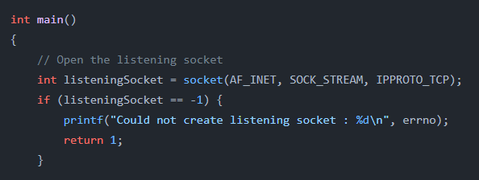

The socket() function is called to create a new socket.

1. The following code enables the reuse of the port on the listening socket:

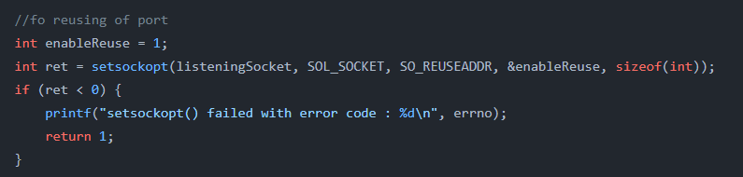

The setsockopt() function is called with the SO_REUSEADDR option to allow the reuse of the port on the listening socket. This is useful if the program needs to bind to a port that is still in the process of being released by the operating system after the program previously exited. The enableReuse variable is set to 1 to enable the reuse of the port, and the size of this variable is passed as the fifth argument. If the setsockopt() function fails, it returns -1, and an error message is printed to the console indicating the error code (stored in the errno global variable).

1. The following code creates a sockaddr_in structure to hold the server address and port, and binds the listening socket to this address:

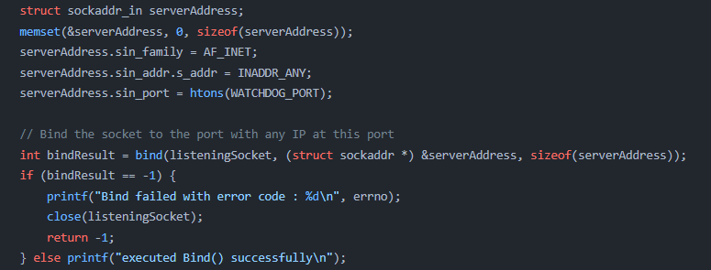

The memset() function is called to clear the serverAddress structure with zeros. The sin_family field is set to AF_INET to specify that the address is an IPv4 address, the sin_addr field is set to INADDR_ANY to specify that the socket should listen on any available IP address, and the sin_port field is set to the WATCHDOG_PORT macro value, converted to network byte order with the htons() function.  
The bind() function is then called to bind the listening socket to the serverAddress structure. If the bind() function fails, it returns -1, and an error message is printed to the console indicating the error code (stored in the errno global variable).

1. The following code starts listening for incoming connections on the listening socket:

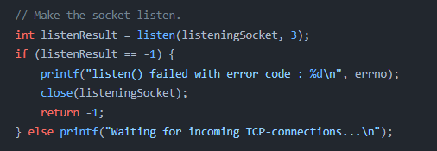

The listen() function is called with a backlog of 3 to specify the maximum number of pending connections that the operating system should allow. If the listen() function fails, it returns -1, and an error message is printed to the console indicating the error code (stored in the errno global variable).

1. The following code accepts an incoming connection and creates a new client socket:

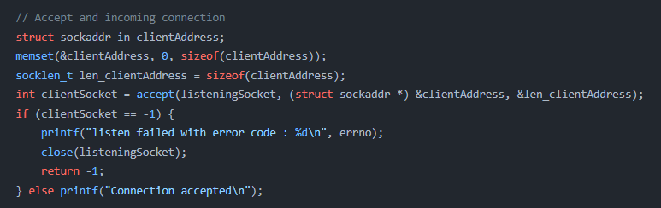

The accept() function is called to accept an incoming connection and create a new client socket. The clientAddress structure is used to hold the client's address and port, and the len_clientAddress variable is used to store the size of this structure. If the accept() function fails, it returns -1, and an error message is printed to the console indicating the error code (stored in the errno global variable).

1. The following code sets both the listening socket and the client socket to non-blocking mode:

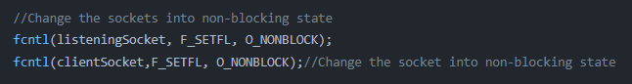

The fcntl() function is called with the F_SETFL command to set the file descriptor flags for both the listening socket and the client socket. The O_NONBLOCK flag is passed to set the sockets to non-blocking mode. This means that the sockets will not block when the recv() function is called later in the program, allowing the program to continue execution if there is no data available to be received.

1. The following code initializes the start and end timeval structures, and declares the seconds variable:

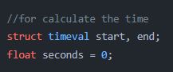

The start and end structures will be used to store the start and end times of the program, and the seconds variable will be used to hold the elapsed time between the start and end times.

1. The following code enters a loop where it waits for a message from the client:

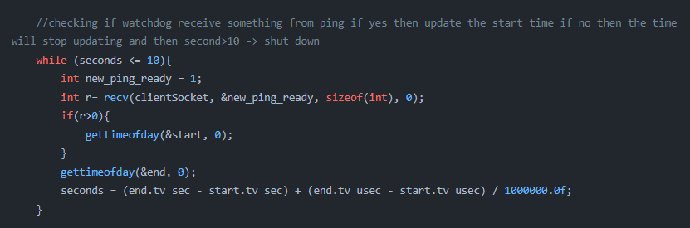

The recv() function is called to receive a message from the client. If the recv() function returns a value greater than zero, it means that a message was received, and the start time is reset using the gettimeofday() function. The end time is then also retrieved using gettimeofday(), and the elapsed time between the start and end times is calculated and stored in the seconds variable. If the elapsed time is greater than 10 seconds, the loop breaks.

1. The following code closes the client socket and the listening socket:

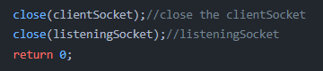

The close() function is called to close both the client socket and the listening socket. This releases the file descriptors associated with the sockets and allows them to be reused.

1. The following code shut down the sistem:

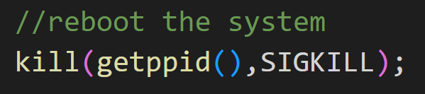

In order to finish the program when the timer greater than 10 seconds we use the kill() function sends a signal to a process or process group specified by pid.

**1.2.2 Output**

Part a:

Sending a ping five times to DNS server at ip: 1.1.1.1 and then aborting manually:

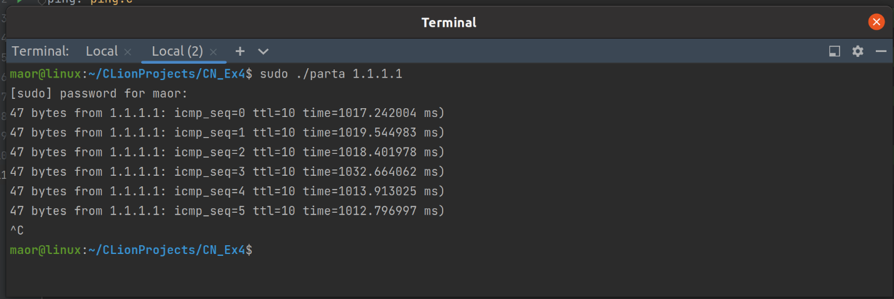

Part b:

Timing the time between each ICMP request and response, and announcing when the server is unreachable (over 10 secs to respond)

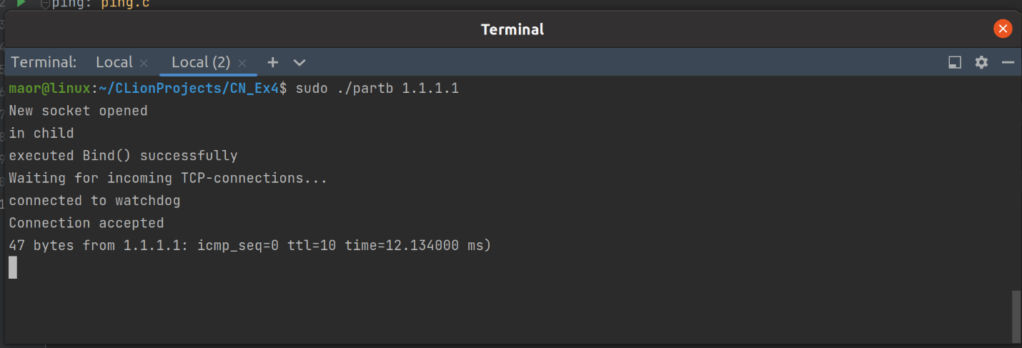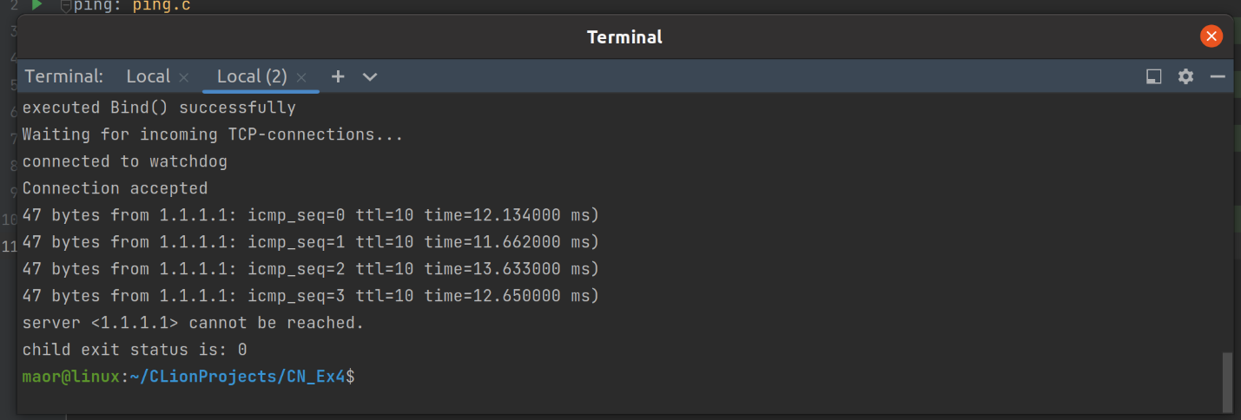

**1.2.3 Functions**

ping.c:

**socket():**

creates a new socket. Takes three arguments: the domain of the socket (e.g., AF_INET for IPv4, AF_INET6 for IPv6), the type of the socket (e.g., SOCK_STREAM for a stream socket, SOCK_DGRAM for a datagram socket), and the protocol to be used (e.g., 0 for the default protocol). It returns a socket descriptor that can be used to identify the socket in subsequent function calls, or -1 if the socket cannot be created.

**strcpy() :**

Copies the contents of a null-terminated string pointed to by src to the memory location pointed to by dest. It returns a pointer to dest.

**memset():**

Fills a block of memory with a specified value. It takes three arguments: a pointer to the memory location to be filled, the value to be written, and the number of bytes to be written. It returns a pointer to the memory location.

**inet_addr():**

Converts a string representation of an IPv4 address in dot-decimal notation to a 32-bit binary number in network byte order. It returns the binary representation of the address if the conversion is successful, and INADDR_NONE if the conversion fails.

**memcpy():**

Copies a block of memory from one location to another. It takes three arguments: a pointer to the destination memory location, a pointer to the source memory location, and the number of bytes to be copied. It returns a pointer to the destination memory location.

**gettimeofday():**

Gets the current time of day. It takes two arguments: a pointer to a struct timeval, which will be filled with the current time, and a pointer to a struct timezone, which will be filled with the current timezone. It returns 0 on success and -1 on failure.

**sendto():**

Sends a message to a socket. It takes six arguments: a socket descriptor, a pointer to the message to be sent, the length of the message, a set of flags, a pointer to a struct sockaddr, and the length of the struct sockaddr. It returns the number of bytes sent on success and -1 on failure.

**bzero():**

Sets all the bytes in a block of memory to zero. It takes two arguments: a pointer to the memory location to be filled with zeros, and the number of bytes to be set to zero. It returns no value.

**calculate_checksum(unsigned short *paddress, int len):**

This function calculates the checksum of a given input buffer: paddress, of length: len. It does this by performing a series of bitwise operations on the data in the buffer.

**validateNumber(char *str):**

This function checks if the input string: str, consists of only digits. If it does, it returns 1, otherwise it returns 0.

**validateIp(char *ip):**

This function checks if the input string: ip, is a valid IP address. It does this by splitting the string by the '.' delimiter and checking if each part consists of only digits and is between 0 and 255. If all these conditions are met, it returns 1, otherwise it returns 0.

better_ping.c:

1. All the functions in ping.c (see above)
2. additional functions:

**fork():**

creates a new process by duplicating the calling process. The new process is called the child process, and the calling process is called the parent process. The child process is an exact copy of the parent process, except for the return value of the fork function. The fork function returns the process ID of the child process to the parent process, and 0 to the child process.

**execvp():**

replaces the current process image with a new process image. It takes two arguments: the name of the file to be executed and an array of pointers to null-terminated strings that represent the arguments to the new process. The last element of the array must be a null pointer. It returns no value, but if the execution of the new process image is successful, the calling process is replaced by the new process and does not return. If the execution fails, execvp returns -1 and sets the global variable errno to indicate the error.

**sleep():**

causes the calling process to suspend execution for a specified number of seconds. It takes a single argument: the number of seconds to sleep.

**fcntl():**

Performs file control operations on a file descriptor. It takes three arguments: the file descriptor on which to perform the operation, the command to be executed, and an optional argument that depends on the command. It returns a result that depends on the command, or -1 if the command fails and sets the global variable errno to indicate the error.

**wait():**

waits for a child process to change its state. It takes two arguments: a pointer to a pid_t variable that will be filled with the process ID of the terminated child process, and an optional pointer to a status variable that will be filled with the exit status of the terminated child process. It returns the process ID of the terminated child process, or -1 if there are no child processes or if an error occurs and sets the global variable errno to indicate the error.

watchdog.c:

1. Some of the functions mentioned above.
2. Additional functions:

**setsockopt():**

Used to set options on a socket. It takes three arguments: the socket descriptor, the level at which the option is defined, and the option name. It can be used to modify a variety of options, including socket timeouts, buffer sizes, and the type of service provided.

**kill():**

The kill() function sends a signal to a process or process group specified by pid. The signal to be sent is specified by sig and is either 0 or one of the signals from the list in the <sys/signal. h> header file. The process sending the signal must have appropriate authority to the receiving process or processes.

**2 Research findings**

**2.1 Wireshark**

When we put <IP> = 1.1.1.1 on part A



When we put other <IP> = 1.1.1.2 on part B

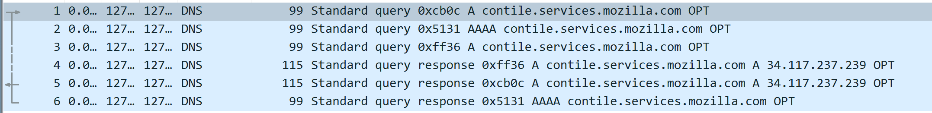

When we put <IP> = 1.1.1.1 on part B

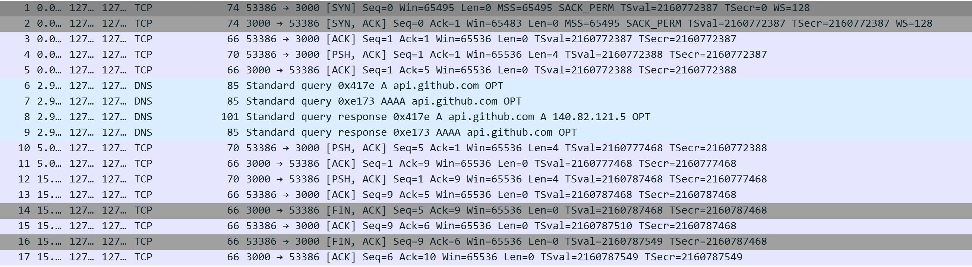

**2.5 Bibliography**

Ping

<https://www.geeksforgeeks.org/ping-in-c/>

For checking the IP

<https://www.tutorialspoint.com/c-program-to-validate-an-ip-address>

Watchdog

https://www.youtube.com/watch?v=xJb-btYIYYA&ab_channel=udemyjobzzsolutions

Fork

https://www.geeksforgeeks.org/fork-system-call/

About the functions  
‘man’ command on vs terminal

For many things

[ChatGPT: Optimizing Language Models for Dialogue (openai.com)](https://openai.com/blog/chatgpt/)

<https://www.google.com/search?gs_ssp=eJzj4tTP1TcwMU02T1JgNGB0YPBiS8_PT89JBQBASQXT&q=google&oq=googlr&aqs=chrome.1.69i57j46i10i131i199i433i465i512j0i10i131i433i512l4j69i60j69i65.3825j0j4&sourceid=chrome&ie=UTF-8>