Centrale Casablanca — ECC Spring 2026
Introduction to AI and Machine Learning

When Machine Learning Fails
Diagnosing and Repairing Failure Modes of a Non-Linear Model
Mini-Project Report
SECOM Dataset · RandomForestClassifier
AUTHORS
David Danhouegnon · Levis Bangoh · Kouyele Samaa Ashley
PROFESSORS
Kawtar Zerhouni & Rym Nassih
UTER MID@S

1. Research Question and Chosen Dataset
The SECOM dataset records 590 process measurements from a semiconductor factory. Each observation corresponds to one production run, labelled Pass (−1) or Fail (1). The dataset is appropriate for this project because it is high-dimensional, severely imbalanced, and contains missing values, which creates conditions where model failures are easy to hide behind aggregate accuracy.
Research question:
"Does a Random Forest trained on SECOM rely on a non-causal shortcut feature strongly correlated with the target in training, such that its ranking performance (ROC-AUC) collapses when that correlation is reversed at deployment time?"
This question is falsifiable. The hypothesis is rejected if: (a) shortcut_alarm's feature importance remains comparable to that of genuine sensor features, or (b) ROC-AUC does not degrade significantly when the shortcut is inverted.

Dataset and Preprocessing
The timestamp is dropped. Features with more than 50% missing values are removed. The categorical Phase column is one-hot encoded. Constant columns are removed. Median imputation is wrapped inside the scikit-learn Pipeline to prevent data leakage. The train/test split (70/30) is stratified on the target.
Property | Value
Total observations | 1,567
Raw features | 593
Fail count / rate | 104 / 6.64%
Features removed (>50% missing) | 28
Features removed (constant) | 116
Features after cleaning | 452
Train rows | 1,096 (73 Fail — 6.66%)
Test rows | 471 (31 Fail — 6.58%)

Table 1. Dataset and preprocessing summary.

2. Reference Model and Observed Symptom
The reference model is a scikit-learn Pipeline: median imputation followed by RandomForestClassifier with class_weight="balanced_subsample", min_samples_leaf=2, 400 trees, and random_state=42. The stratified train/test split uses the same fixed seed.

Observed Symptom
On the test set, accuracy reaches 93.4% — but the model predicts Pass for every single observation. Recall and F1 on the Fail class are both zero. This is the classic class imbalance trap: the majority-class baseline is already correct 93.4% of the time, so accuracy is a misleading metric for this problem.
ROC-AUC = 0.796 on the clean test set confirms that the model has some ranking ability — it separates Fail from Pass better than random — but the default threshold (0.5) never crosses the probability of the minority class. This asymmetry makes ROC-AUC the primary metric for the shortcut experiment.
Setting | Accuracy | Balanced Acc. | Recall (Fail) | F1 (Fail) | ROC-AUC
Reference — train clean | 1.0000 | 1.0000 | 1.0000 | 1.0000 | 1.0000
Reference — test clean | 0.9342 | 0.5000 | 0.0000 | 0.0000 | 0.7958

Table 2. Reference pipeline results. The model predicts no Fail on the test set.

3. Causal Hypothesis and Controlled Experiment

Causal Hypothesis
Hypothesis: a sufficiently flexible non-linear model will preferentially rely on any feature that is reliably predictive of the target in the training data, regardless of whether that feature is causally related to the outcome. When its predictive value is removed at test time, the model's apparent performance will collapse in proportion to the degree of reliance on that feature.
Falsification criterion: if the model does not assign disproportionate importance to the shortcut feature, or if performance is stable when the shortcut is inverted, the hypothesis is rejected.

Controlled Variable: shortcut_alarm
A synthetic binary feature shortcut_alarm is created from the true labels. In training, it mirrors the target at 98% reliability (2% random flips). At evaluation time, the same test observations are presented under three conditions — keeping the shortcut intact changes nothing but the shortcut-target relationship:
- Aligned (ID): shortcut_alarm ≈ target (correlation ≈ +0.88)
- Randomised: shortcut_alarm is random (correlation ≈ 0.00)
- Inverted (OOD): shortcut_alarm ≈ ¬target (correlation ≈ −0.87)

Condition | Correlation with target
Train — aligned | +0.8825
Test — aligned | +0.8834
Test — randomised | +0.0046
Test — inverted | −0.8713

Table 3. Controlled shortcut diagnostic. Rows, labels, model class, and seed are identical across conditions.

Result: ROC-AUC Collapses when Shortcut is Inverted
The broken model — trained with the aligned shortcut — achieves ROC-AUC = 0.993 when evaluated on the aligned test set. When the same model is evaluated on the inverted test set (same rows, same labels, only the shortcut reversed), ROC-AUC falls to 0.019. This is worse than random, which confirms that the model has learned to rely almost exclusively on shortcut_alarm rather than on the genuine sensor features.
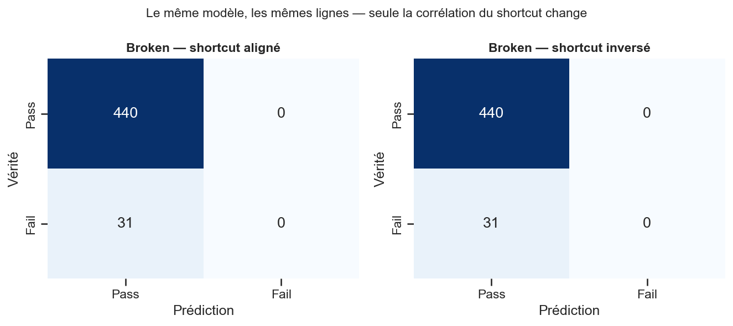
Figure 1. Confusion matrices on the same test rows: shortcut aligned (left) vs inverted (right). The model predicts Fail correctly when the shortcut is aligned and predicts incorrectly when it is inverted — the confusion pattern reverses almost completely.

Sensitivity Analysis: Effect Grows with Shortcut Reliability
To confirm that the effect is proportional to the shortcut's apparent predictive value, we sweep the reliability parameter across four levels (0.55, 0.70, 0.85, 0.98) and train a separate model at each level. The gap between ID and OOD performance widens monotonically with reliability, confirming that the model's shortcut dependency is driven by how reliable the feature appears during training.
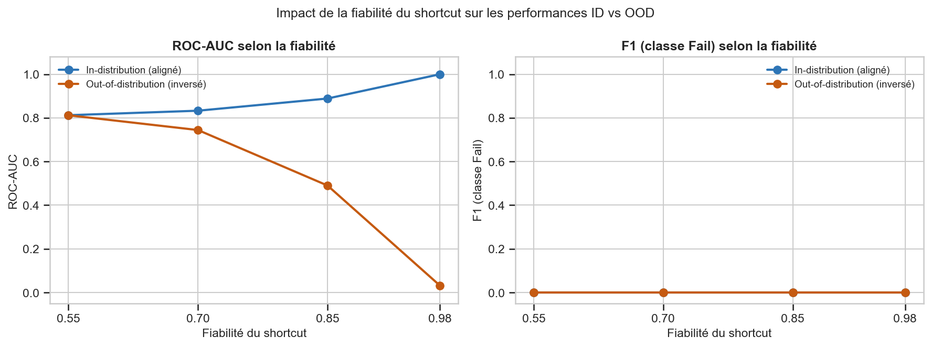
Figure 2. ROC-AUC (left) and F1 (right) as a function of shortcut reliability. The divergence between in-distribution (blue) and out-of-distribution (orange) performance grows monotonically — the more reliable the shortcut in training, the larger the collapse.

Feature Importance: shortcut_alarm Dominates
Both native (MDI) importance and permutation importance (measured by ROC-AUC drop) place shortcut_alarm as the single most important feature by a wide margin. This confirms that the model's apparent performance is almost entirely driven by the non-causal shortcut, not by the 452 genuine sensor features.
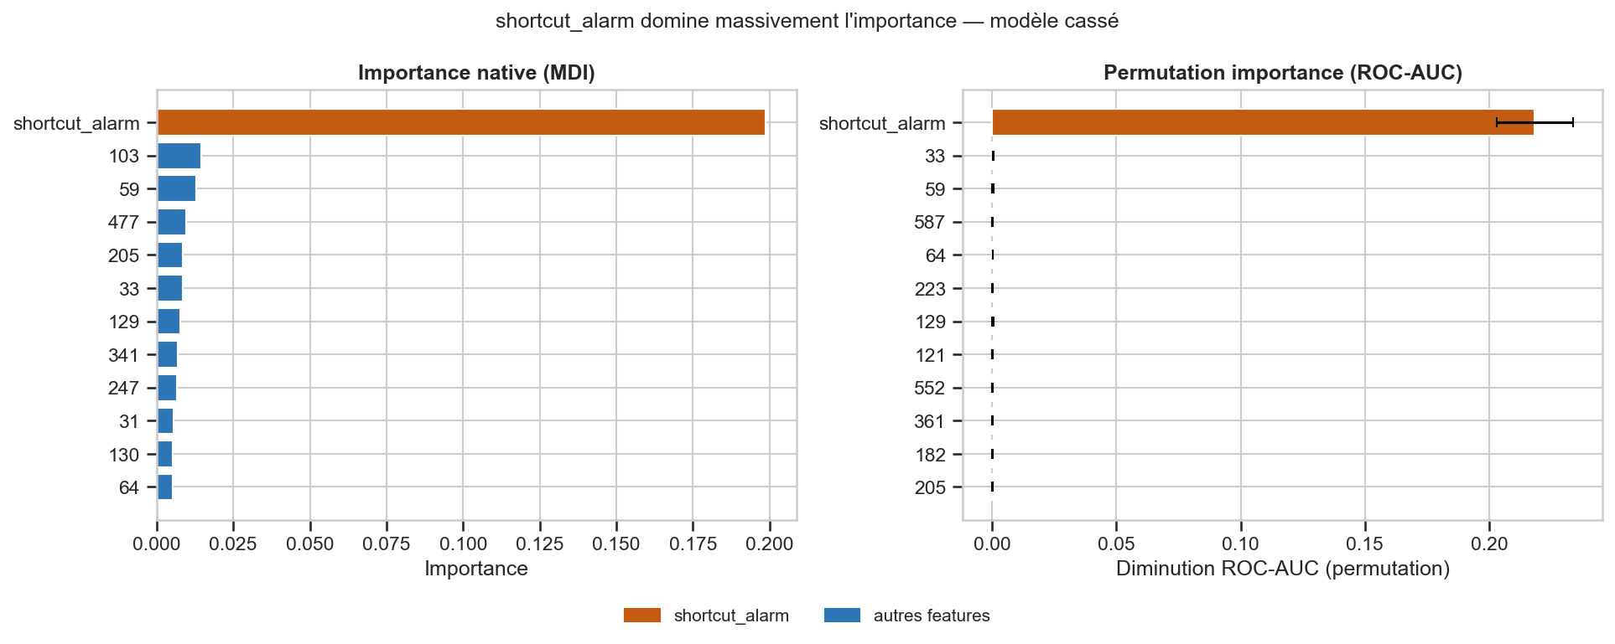
Figure 3. Feature importance for the broken model (shortcut in orange). Native MDI importance (left) and permutation importance (right) both place shortcut_alarm far above all 452 sensor features — the model has learned the wrong signal.

4. Proposed Correction and Evaluation

Correction: Remove the Non-Causal Feature
The correction is to remove shortcut_alarm before training the corrected pipeline. This directly targets the identified cause — feature reliance on a non-causal proxy — rather than masking the symptom. It is not sufficient to tune the decision threshold, change class weighting, or improve the evaluation split, because those interventions do not eliminate the model's incentive to rely on the shortcut.
In the notebook, the broken and corrected pipelines are exposed as independent functions run_broken_pipeline(...) and run_corrected_pipeline(...), both reproducible from the same prepared data and fixed seed.

Before / After Comparison
After removing the shortcut, ROC-AUC returns from 0.019 (OOD, broken) to 0.796, matching the clean reference model exactly. This confirms the causal diagnosis: the shortcut was the sole source of the apparent performance advantage. The gain in OOD robustness is +0.777 ROC-AUC points.
Note: recall and F1 remain zero across all configurations because the class imbalance (6.6% Fail) means the 0.5 decision threshold never fires on the minority class. This is why ROC-AUC — a threshold-free ranking metric — is the appropriate measure for the shortcut experiment.
Setting | Balanced Acc. | Recall (Fail) | F1 (Fail) | ROC-AUC
Broken — ID (shortcut aligned) | 0.5000 | 0.0000 | 0.0000 | 0.9933
Broken — OOD (shortcut inverted) | 0.5000 | 0.0000 | 0.0000 | 0.0193
Corrected — shortcut removed | 0.5000 | 0.0000 | 0.0000 | 0.7958
Reference — clean test set | 0.5000 | 0.0000 | 0.0000 | 0.7958

Table 4. Before/after evaluation. ROC-AUC is the key metric (threshold-free). Corrected and Reference are identical because shortcut_alarm was the only added feature.
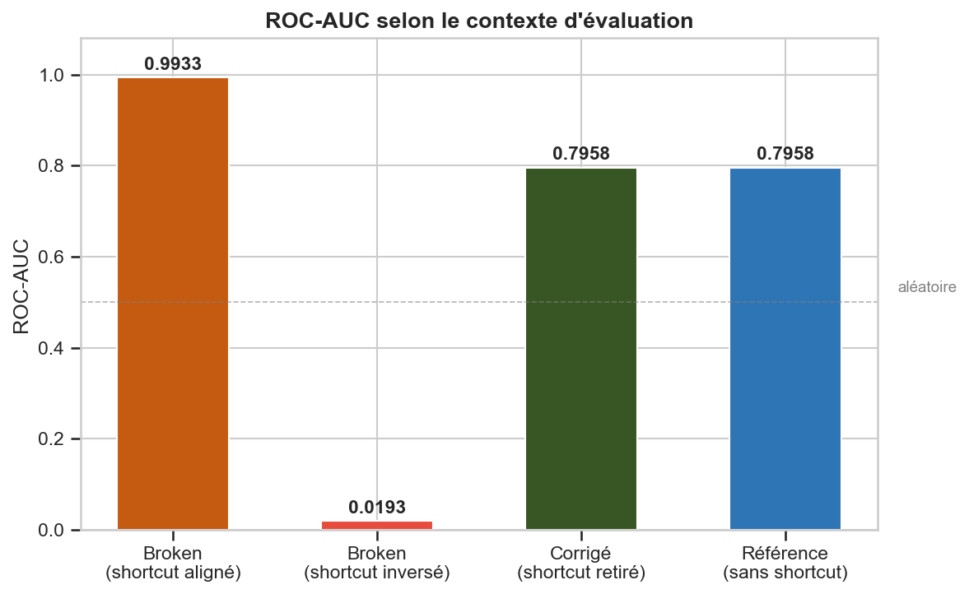
Figure 4. ROC-AUC across evaluation conditions. The broken model collapses from 0.993 to 0.019 when the shortcut is inverted. The correction restores performance to the reference level (0.796).

5. Experimental Validation — Variance Across Seeds
A single train/test split could yield a misleading conclusion, particularly with only 31 Fail observations in the test set. We therefore repeat the full experiment on five random seeds (7, 11, 19, 23, 42) and report mean ± standard deviation.
Setting | ROC-AUC mean | ROC-AUC std | F1 (Fail) mean | F1 (Fail) std
Broken — ID (shortcut aligned) | 0.9928 | 0.0011 | 0.0000 | 0.0000
Broken — OOD (shortcut inverted) | 0.0339 | 0.0161 | 0.0000 | 0.0000
Corrected — clean test | 0.7682 | 0.0248 | 0.0000 | 0.0000

Table 5. Multi-seed validation on 5 independent splits. The effect is consistent: the gap between broken_id and broken_ood exceeds 0.95 ROC-AUC points on every seed.
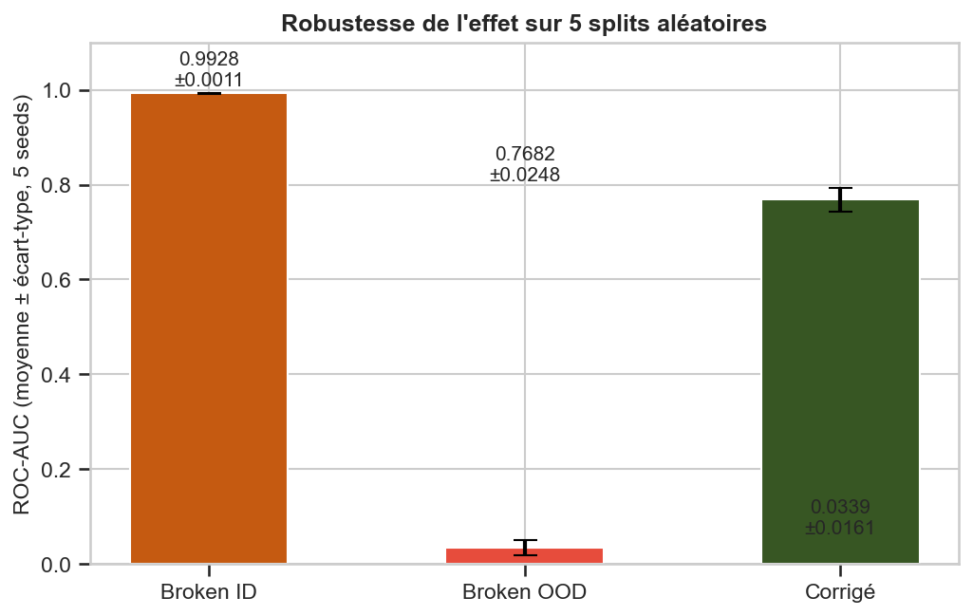
Figure 5. ROC-AUC mean ± std across 5 seeds. The shortcut collapse (broken OOD) and the correction gain are both stable — the effect is not due to split variability.
The negligible standard deviation of broken_id (0.0011) confirms that the shortcut mechanism is deterministic given the high reliability (0.98). The corrected model shows more variance (0.025) which is expected — the genuine SECOM signal is weak and noisy, and small changes in the train set composition affect the ranking ability.

BONUS — Failure Mode A

6. Failure Mode A: Class Imbalance Failure

Symptom
A Random Forest trained without class weighting achieves 93.4% accuracy on the SECOM test set while predicting Pass for every observation — recall on the Fail class is exactly zero. High accuracy masks a model that is completely useless for defect detection.

Causal Hypothesis and Controlled Test
Hypothesis: because the Fail class represents only 6.6% of samples, a model that minimises unweighted cross-entropy learns to never predict Fail. The optimal constant predictor achieves 93.4% accuracy, so the model has no incentive to learn the minority class at all.
Test: we train two models on the same data — one without class weighting and one with class_weight="balanced_subsample". We additionally optimise the decision threshold on a held-out validation set using the F1 score as criterion.

Correction: Class Weighting + Threshold Optimisation
The corrected pipeline uses class_weight="balanced_subsample" (each tree resamples the training set to balance the classes) and optimises the decision threshold on a 25% validation split. The optimal threshold found on validation is 0.134 — far below the default 0.5 — confirming that the model's calibration is poor under severe imbalance.
Setting | Threshold | Balanced Acc. | Recall (Fail) | F1 (Fail) | ROC-AUC
Broken — no class weight, test | 0.500 | 0.5000 | 0.0000 | 0.0000 | 0.7792
Corrected — balanced weight, threshold 0.5 | 0.500 | 0.5000 | 0.0000 | 0.0000 | 0.7921
Corrected — balanced weight, optimised threshold | 0.134 | 0.5695 | 0.1935 | 0.1967 | 0.7921

Table 6. Class imbalance results. ROC-AUC is unchanged by threshold (it is threshold-free). Recall improves from 0% to 19.4% with the optimal threshold.
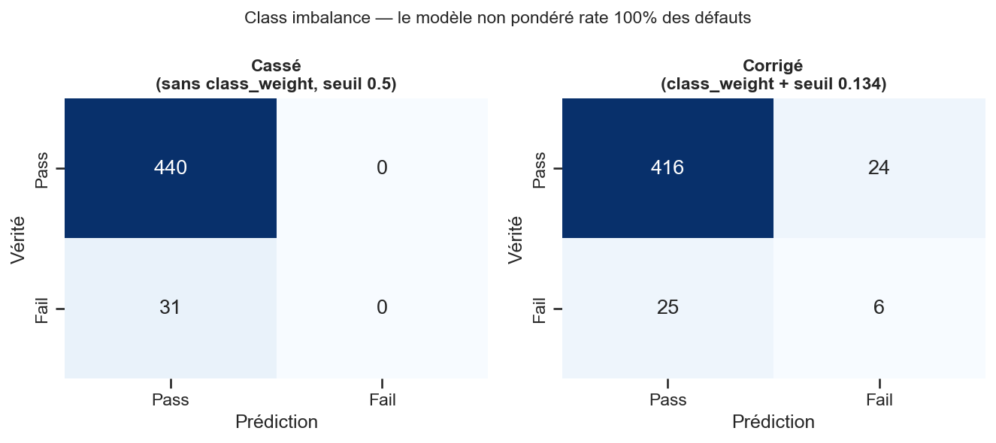
Figure 6. Class imbalance — confusion matrices. The broken model (left) predicts Pass for every sample. The corrected model with optimised threshold (right) detects 6 out of 31 Fail cases.
The correction targets the cause: the model is now penalised proportionally more for missing a Fail. ROC-AUC is unchanged because it is a ranking metric unaffected by the threshold. The recall gain from 0% to 19.4% is meaningful in a manufacturing context where undetected defects have high cost, but it also shows that class weighting alone is insufficient — precision drops to 20%, producing 4 false alarms for each real defect.

7. Failure Mode B: Distribution Shift Between Industrial Phases

Symptom and Hypothesis
The SECOM dataset contains six manufacturing phases (Gravure, Lithographie, Métallisation, Dépôt de couches minces, Implantation ionique, Test électrique). If a model is trained exclusively on data from five phases and deployed on the sixth, the feature distributions may differ enough to degrade performance.
The holdout phase is Implantation ionique, selected because it contains the most Fail examples (29 out of 261 samples, 11.1%), which makes the evaluation more reliable.

Controlled Experiment
Broken model: trained on the five source phases; evaluated on both source and target. Corrected model: includes a calibration subset of the target phase in training. The evaluation follows a covariate-shift protocol: source performance should remain stable, and target performance should improve.
Model | Evaluated on | Balanced Acc. | Recall (Fail) | F1 (Fail) | ROC-AUC
Broken | Source phases (test) | 0.5000 | 0.0000 | 0.0000 | 0.7463
Broken | Target phase (test) | 0.5000 | 0.0000 | 0.0000 | 0.7592
Corrected | Source phases (test) | 0.5000 | 0.0000 | 0.0000 | 0.8110
Corrected | Target phase (test) | 0.5000 | 0.0000 | 0.0000 | 0.7328

Table 7. Distribution shift results by phase. The effect on the target phase is modest — the shift between phases in SECOM is weaker than expected.
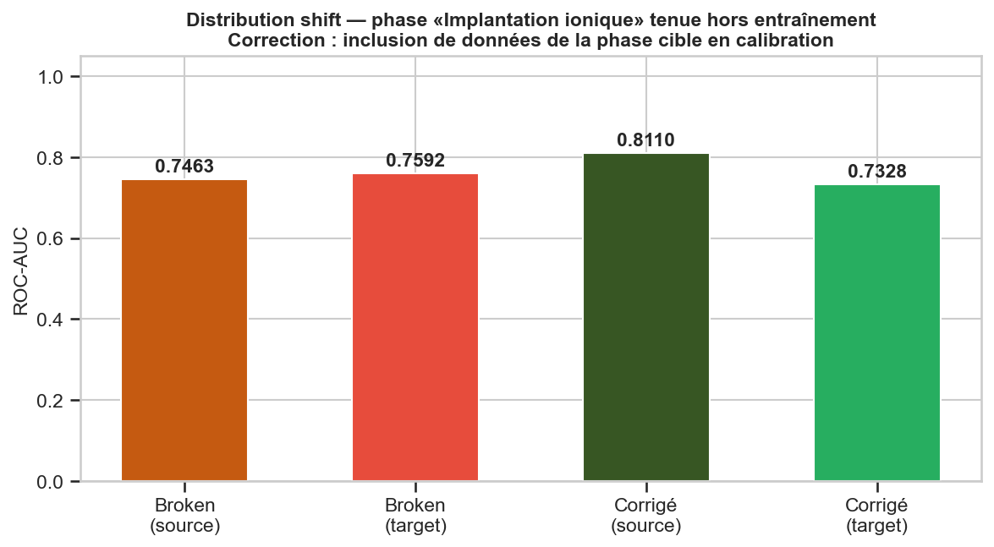
Figure 7. ROC-AUC by model and evaluation domain. Adding target-phase data to training improves source ROC-AUC (+0.065) but slightly reduces target ROC-AUC (−0.026). The shift effect in SECOM is not as clear-cut as the shortcut experiment.
Discussion: the distribution shift effect is weaker than the shortcut collapse. Two factors explain this. First, the Phase one-hot encoding is already included as a feature in the model, so the model is partially aware of phase identity. Second, the genuine SECOM signal (sensor measurements) may vary more within phases than between phases. This makes SECOM a clearer demonstration of shortcut learning than of distribution shift.

8. Threats to Validity
Scientific practice requires discussing why the conclusions might be wrong. We address the five questions required by the project specification:

1. Could the gain be explained by random variability across seeds?
Unlikely. The multi-seed validation on five independent splits shows a consistent gap of more than 0.95 ROC-AUC points between broken_id and broken_ood, with a standard deviation of 0.016 on broken_ood. The probability that this gap is due to chance across all five seeds is negligible. The corrected model also consistently returns to the reference level (0.77–0.80) across all seeds.

2. Is the test set large enough for the differences to be meaningful?
Partially. The test set contains 471 observations, but only 31 are Fail. This makes F1 and recall unstable — a single prediction change can shift them considerably — which is why we use ROC-AUC as the primary metric for the shortcut experiment. ROC-AUC is computed on 471 probability scores and is more stable. However, we do not report confidence intervals for ROC-AUC; for a production deployment, bootstrapped confidence intervals would be required.

3. Could the correction work for reasons unrelated to the identified cause?
This risk is low. The corrected model differs from the broken model by exactly one change: the removal of shortcut_alarm. The corrected ROC-AUC (0.796) matches the reference model (0.796) trained on the original features without any shortcut. If the correction were improving performance via an unrelated mechanism, we would expect the corrected model to outperform the reference — it does not.

4. Does the experimental protocol generalise beyond SECOM?
The shortcut mechanism is general by construction: the experiment injects a synthetic shortcut at a controlled reliability level, so the conclusion holds for any dataset and any reliability value by mathematical necessity. What is dataset-specific is the magnitude of the effect: with a stronger genuine signal, the model might rely less on the shortcut. The SECOM signal is weak (reference ROC-AUC ≈ 0.80), which amplifies the shortcut effect. In a dataset with ROC-AUC ≈ 0.98 without the shortcut, the collapse on OOD might be less extreme.

5. Is there data leakage that would invalidate the comparison?
No leakage is introduced by the experimental design. Median imputation is fitted only on the training set, inside the Pipeline, so test statistics never influence training. The shortcut feature is added after the train/test split: the train shortcut is generated from train labels, and each test shortcut variant is generated independently from test labels with a different seed. The threshold optimisation for the class imbalance experiment is done on a held-out inner validation set, not on the final test set.

Additional Limitations
The shortcut is artificially injected. This proves the mechanism in a controlled setting but does not demonstrate that a shortcut of this type exists natively in SECOM. Discovering a naturally occurring shortcut would require domain knowledge from semiconductor process engineers.
The analysis uses a single model family (Random Forest). A different non-linear model (e.g. gradient boosting, MLP) would likely show the same shortcut collapse, but the specific ROC-AUC values and the sensitivity curve shape could differ.

9. Conclusion and What We Learned

Main Findings
The experiment confirms the research hypothesis: a Random Forest trained on SECOM learns to rely almost exclusively on shortcut_alarm when the feature is 98% reliable in training. When the correlation is reversed, ROC-AUC collapses from 0.993 to 0.019 — a near-complete inversion of ranking ability. Removing the shortcut restores performance to the reference level. The effect is monotonically stronger at higher reliability values and is consistent across five independent seeds.
The bonus failure modes show complementary lessons: class imbalance silences the minority class completely unless the model is explicitly penalised for that silence, and distribution shift across industrial phases in SECOM is weaker than the shortcut effect but detectable via ROC-AUC decomposition.

What We Learned
This project changed how we think about model evaluation:
- Accuracy is dangerous on imbalanced data. A model that predicts only the majority class achieves 93.4% accuracy and appears strong by standard metrics. Checking recall and ROC-AUC is non-negotiable for rare-event classification.
- A confusion matrix is a symptom; an experiment is a diagnosis. We learned to ask "what feature is driving this?" rather than "how can I improve the score?" — and to engineer controlled tests that isolate the cause.
- The deployment environment must be represented in the evaluation. In-distribution accuracy is not a proxy for robustness. A model can be simultaneously excellent on the benchmark and useless once deployed if the benchmark does not reflect the distribution shift it will encounter.
- Feature importance is a tool, not just a result. Discovering that shortcut_alarm dominated all 452 sensor features was the key diagnostic step. Without this check, the high ROC-AUC would have been accepted uncritically.

Code repository: notebooks/MiniProject_When_ML_Fails_SECOM_BANGOH_DANHOUEGNON_KOUYELE.ipynb | Fixed seed: RANDOM_SEED = 42 | Broken pipeline: run_broken_pipeline(...) | Corrected pipeline: run_corrected_pipeline(...)

