Automate PC

|  |  |
| --- | --- |
| Author | Lori Zhang |
| Status | Draft |
| Revision | 1 |
| Last Saved | 5/20/2013 4:26:00 PM |

Revision History

|  |  |  |  |
| --- | --- | --- | --- |
| Rev | Author | Date | Comments |
| 1 | Lori Zhang |  |  |
|  |  |  |  |

# Idea

**Purpose:**

1. Let PC shutdown and startup automatically everyday
2. Let PC sync to latest codes and rebuild them automatically
3. Save power – shutdown PC when don’t need it
4. Build codes takes a hour sometimes, so let PC do it automatically in the morning before user arrive

# Auto start computer – change BIOS

**FOR HP computer:**

1. START computer, Press F10 to enter BIOS
2. In file menu “**Advanced 🡪 BIOS Power-On** ”, config to start computer every workday

# Auto shutdown PC and sync build codes when PC start

1. Copy files from folder “xutil\automatepc” (\\eptserver\DropBox\lori\S\automatepc)
2. Open file “readme.txt” as below.

**automatepc**

**Summary:**

1. Some scripts to auto shutdown pc, run tasks (sync and build codes) when pc startup, etc.

2. It gets settings in config.json, and create/delete tasks in windows task scheduler.

**Usages:**

**1. update config.json**

set code path in perforce, commands to run, etc.

**2. run "main.bat", which enables tasks (autoShutdown&syncBuildCodes in config.json)**

If access denied, try right click "run as admin"

**3. run the bat files when needed to enable/disable scheduled tasks**

Enable_autoShutdown.bat

Disable_autoShutdown.bat

Enable_autoShutdownAndSyncBuild.bat

Disable_autoShutdownAndSyncBuild.bat

# (Deprecated) Auto shutdown PC and sync build codes when PC start

## Create task – auto sync and rebuild codes when pc startup

1. **Open Task Schedule (or run “taskschd.msc”)**
2. **Create task, set run no matter log on or not (also store password)**

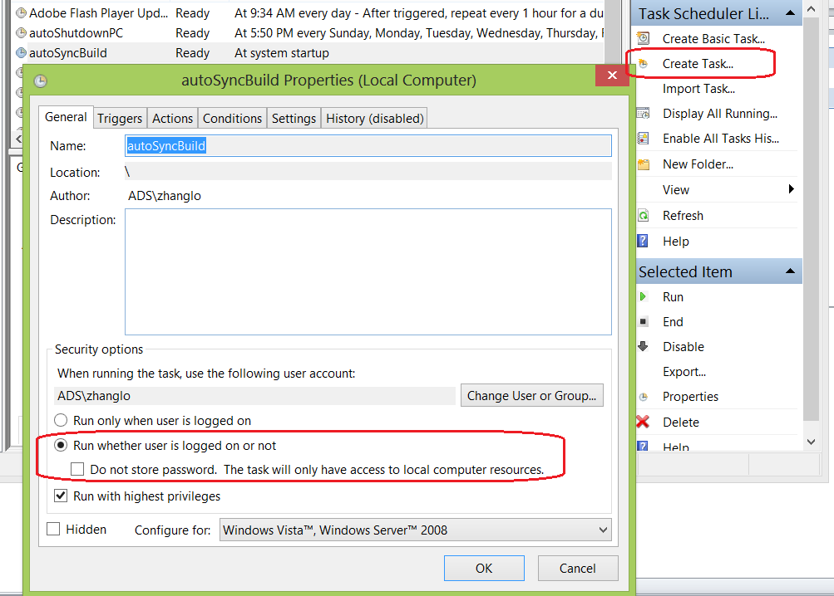

1. **Set task trigger, start task when computer start**

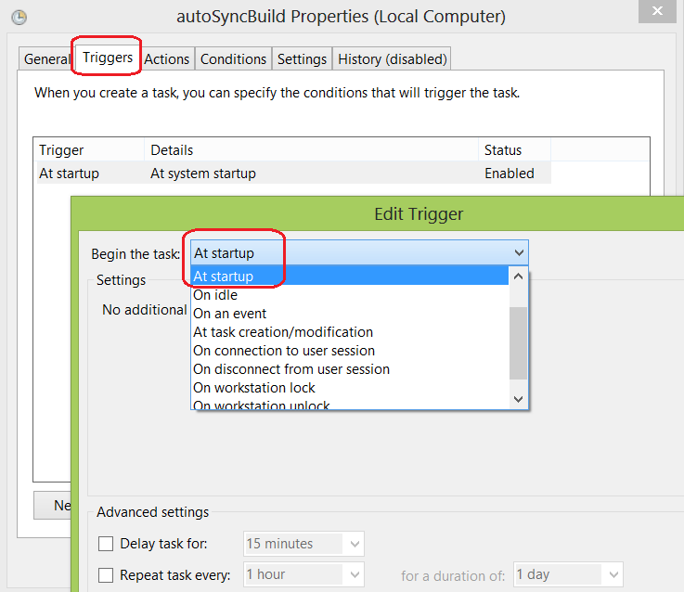

1. **Set the script to run, other tabs use default settings**
   1. \\eptserver\DropBox\lori\S\autoSyncBuild\autoSyncBuild_V1.py(copy this file and modify the configuration in it)

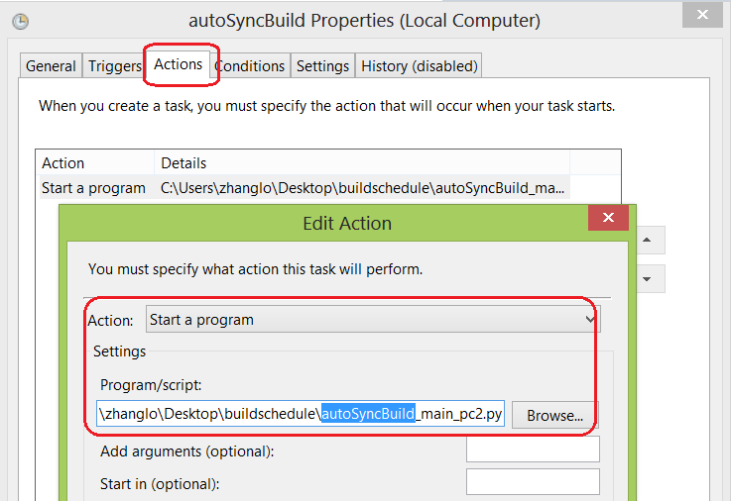

\\eptserver\DropBox\lori\S\autoSyncBuild\autoSyncBuild_V1.py

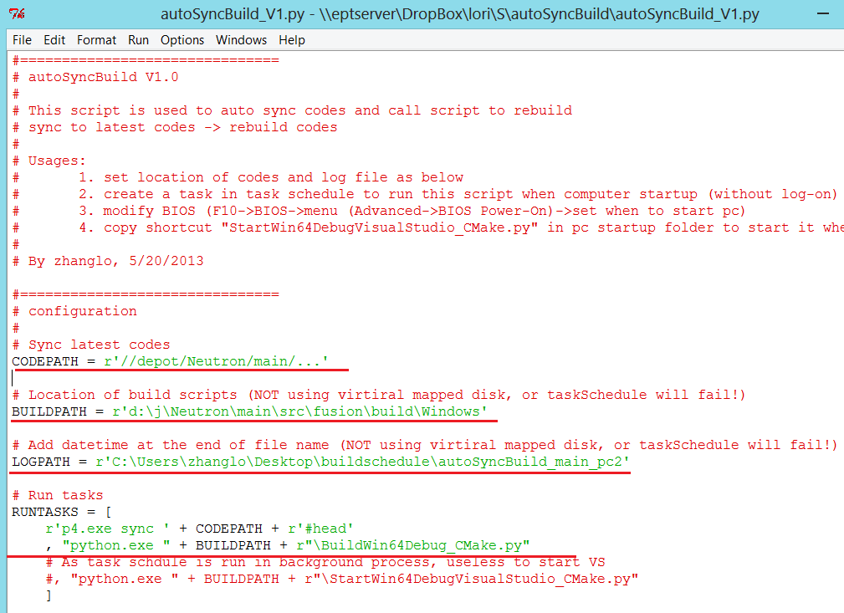

## Add programs to start automatically

1. **Open “startup” folder (or type: shell:startup)**
2. **Add shortcuts of programs** (that has UI) to this folder, so they’ll be started when PC log on
   1. Visual studio: main\src\Fusion\Build\Windows\StartWin64DebugVisualStudio_CMake.py
   2. Outlook
   3. Lync

## Create task – auto shutdown computer

Similar as 1.1, differences as below.

1. **Open Task Schedule (or run “taskschd.msc”)**
2. **Set task trigger**

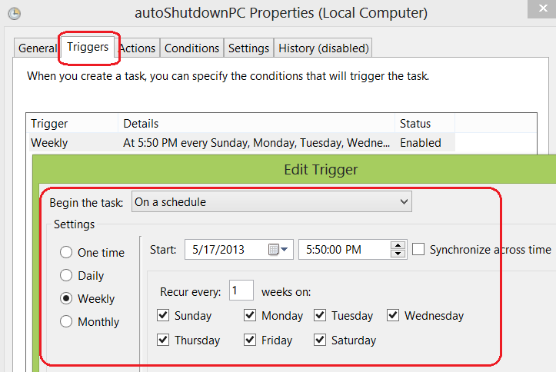

1. **Set task action: the program to shutdown computer**
   1. **c:\Windows\System32\shutdown.exe /s /t 0 /f**

