Breakfastclub - Agent-based

model simulation of a virtual classroom

Pasieka Manuel

Universidad Internacional de la Rioja, Logroño (España)

28. Augost 2019

Abstract

Agent-based models have proven to be a useful tool to study complex social phenomena. In this work we have developed a simulation using an agent-based model of a virtual class- room, simulating the behavior of children and adolescents in an autonomous study group. The agent cognition is based on the widely used Big-Five personality trait model, and agent behavior has been aligned with empirical studies showing how specific personality traits correlate with academic success. The simulation software was used to compare how different classroom compositions with an increasing ratio of children with Attention-deficit hyperactivity disorder (ADHD) typical personality traits affect the classroom dynamics.

Keywords

Agent-based model,

Big-Five,

ADHD

# Introduction

Agent based models have proven to be a useful tool to study complex social systems and social phenomena [1]. We have developed an agent-based model that is simulating a virtual classroom, in which students engage in autonomous study. Based on psychological literature we defined an Agent Logic that is defined by the Big-Five Personality Trait model [2].

# State of the Art

Although multi-agent models have been first applied in social sciences already in the 1960s in works like [3], they only really got popular in the last decade, as way to understand and discovery theoretical models of social phenomena [4].

There exist several simulators for a classroom setting ([5], [6]), that are used to study specific effects, or to train teachers.

Those systems have several deficiencies, including that they are not distributed as open source and free of charge, or that the agent model driving student behavior in the virtual classroom is following simple rules and is not making use of the advances in artificial intelligence.

# Objectives and Methodology

We have decided to build a new agent-based model that is capable of simulating a virtual classroom, basing agent behavior on empirical psychological personality model. It was validated that the simulated agent behavior follows empirical results, and we used the simulation to compare different classrooms differing in the personality profiles of the students.

# Contribution

We have developed the simulation using the Unity3D Game development environment. The source code of the simulation, including the data analysis pipeline is available under the MIT License  
from <https://github.com/mapa17/breakfastclub>.

Figure 1 shows the simulation presented to the user in an interactive session.

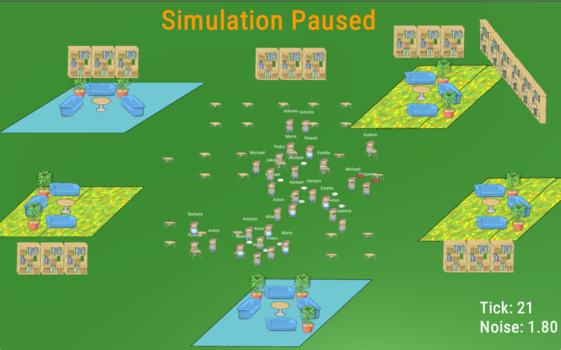

Figure 1. Visualization the simulation in an interactive session

The heart of the simulation is the Agent Logic that governs agent behavior, and was designed to simulate a student’s *Happiness*, *Motivation* to study, and *Attention* during studying. The agent behavior was selected to be *Chatting*, taking a *Break*, *Quarreling*/Arguing, *Studying Alone* or to *Study in small groups*.

The simulation does not try to model any physical aspects of the students or the environment, except the noise generated in the classroom, but instead students are defined by their personality profile.

We used the established and widely applied Big-Five Model for personality traits as the bases of agent behavior and defined the model in correspondence with empirical findings on how personality traits affect student’s behavior [7] and academic success [8].

The simulation is intended to be run in an interactive as well as in a batch-mode like manor. Specially the latter is important in order to use the simulation as a tool to study and form new theories of social phenomena in a classroom. The simulation is deterministic given a seed value, which makes it possible to run multiple instances of the simulation and evaluate the effect of randomness on a specific simulation scenario.

A simulation is defined by a classroom profile that contains the personality profiles based on the Big-Five of different Student Types and how many students of each type shall be simulated in the classroom.

Special focus has been laid on the data analysis of the results generated during the execution of the simulation. We provide python scripts that generate detail information about the behavior of each single student, as well as aggregated information concerning the classroom as a whole (see figure 2).

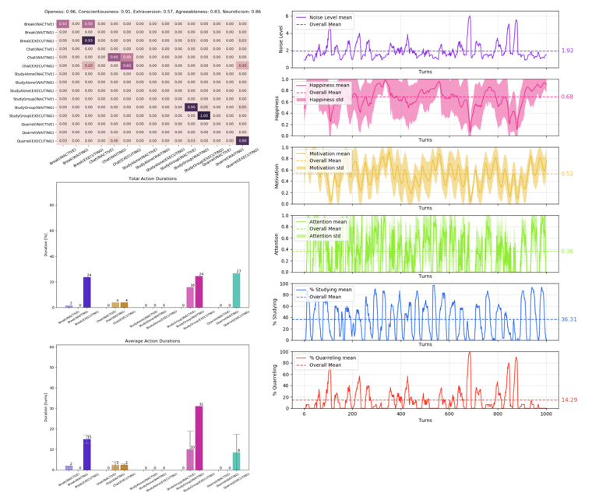

Figure 2. Agent information and classroom aggregates

# Results

Anxiety disorders affect many students word wide with an estimated prevalence between children and adolescents of 5-10% [9].

Attention-deficit hyperactivity disorder (ADHD) has a particular high prevalence, and we decided to study how students with ADHD prototypical personality profiles affect the social dynamics in the classroom.

Based on the literature [10] we defined four type of students, representing prototypical personality types on the five continuous Big-Five scale. Those types are *Normal*, *ADHD*, *Ambitious* and *Random.* Ambitious students have personality traits correlated with high academic success, and Random students have personality traits that are randomly defined.

Using those student types, we defined a series of classroom profiles, varying the ratio of students of each type. We included classes with only Normal students and no ADHD students (i.e. *ADHD-None*) to classes with a very high ratio of ADHD students (i.e. ADHD-VeryHigh). In order to compare how ambitious students, affect he classroom, we defined mixed class profiles with ADHD, Normal and Ambitious students. (i.e. ADHD-Low-Ambitious having a few ADHD students, half ambitious and the rest normal students).

Figure 3 shows how the different classroom profiles compare to each other based on average happiness and attention during learning, running five simulations for each profile.

A MANOVA and follow up Post-hoc tests are used to calculate the statistical significance between the distributions means.

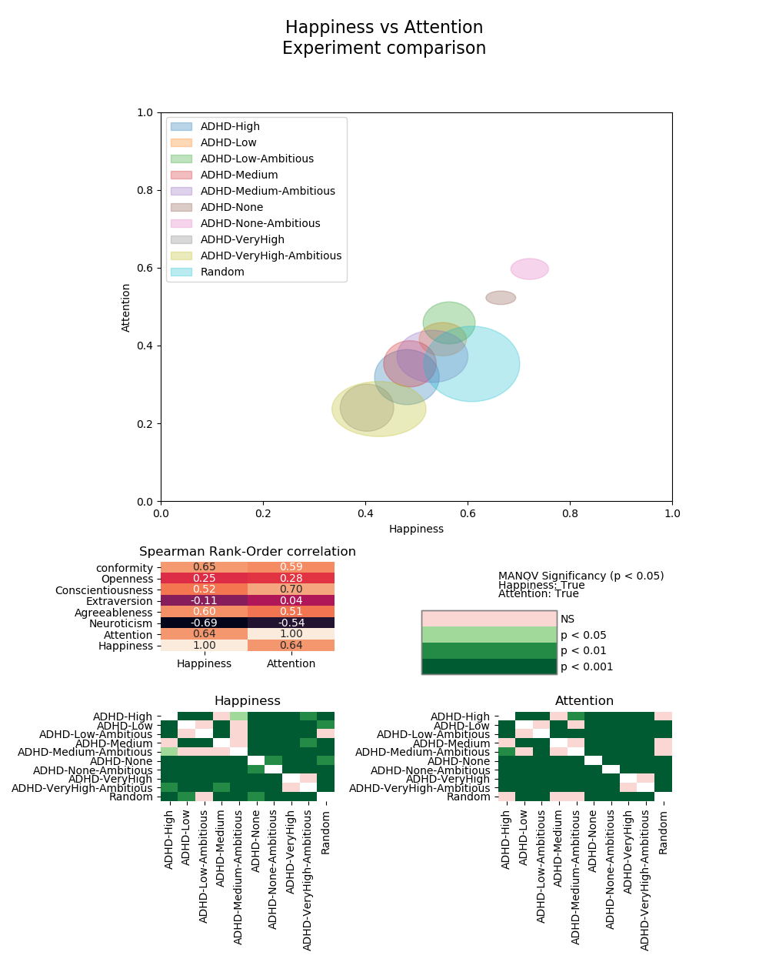

Figure 3. Comparing mean happiness and attention of different classroom profiels

# Discussion or Results Analysis

We found a strong negative correlation between happiness, attention and the ratio of ADHD students. Ambitious students although having the reverse effect, cannot counterbalance the of every very few ADHD students. It appears that only a few ADHD students in a classroom are sufficient to alter the behavior of the None-ADHD students, without changing their own average happiness or attention.

In addition, studying the classroom aggregates of different groups, we found that classrooms with ADHD students experience more frequently classroom wide quarrels (i.e. classroom riots). Specially classrooms with ambitious students that have a tendency to alternate between states of no quarrel to classroom riots, experience an increase in those riots with the inclusion of ADHD students.

# Conclusion

We have developed a multi-agent based model that is based on the Big-Five Personality trait model and generates behavior in concordance with the literature. We used the simulation to study how students with an ADHD prototypical personality profile effect mean classroom happiness and attention. We found a very strong effect of ADHD students on the behavior of None-ADHD students, reducing their mean happiness and attention, as well as increasing the frequency of class wide quarrels.

The simulation software in addition with the data analysis pipeline is available open source and under the MIT license from <https://github.com/mapa17/breakfastclub>.

References

1. Jackson, J. C., Rand, D., Lewis, K., Norton, M. I., & Gray, K. (2017). Agent-Based Modeling : A Guide for Social Psychologists. https://doi.org/10.1177/1948550617691100
2. Norman, W. T. (1963). Toward an adequate taxonomy of personality attributes: Replicated factor structure in peer nomination personality ratings. *The Journal of Abnormal and Social Psychology*, *66*(6), 574–583. https://doi.org/10.1037/h0040291
3. Schelling, T. C. (1971). Dynamic models of segregation†. The Journal of Mathematical Sociology, 1(2), 143–186. https://doi.org/10.1080/0022250X.1971.9989794
4. Gilbert, N., & Troitzsch, K. (2005). *Simulation For The Social Scientist*. McGraw-Hill Education. Retrieved from https://books.google.es/books?id=fBlaulpmNowC
5. Dieker, L. A., Hynes, M. C., Hughes, C. E., Hardin, S., & Becht, K. (2015). TLE TeachLivETM: Using Technology to Provide Quality Professional Development in Rural Schools. Rural Special Education Quarterly, 34(3), 11–16. https://doi.org/10.1177/875687051503400303
6. Badiee, F., & Kaufman, D. (2015). Design Evaluation of a Simulation for Teacher Education. *SAGE Open*, *5*(2), 215824401559245. https://doi.org/10.1177/2158244015592454
7. Ehrler, D. J., Evans, J. G., & McGhee, R. L. (1999). Extending Big-Five theory into childhood: A preliminary investigation into the relationship between Big-Five personality traits and behavior problems in children. *Psychology in the Schools*, *36*(6), 451–458. https://doi.org/10.1002/(SICI)1520-6807(199911)36:6<451::AID-PITS1>3.0.CO;2-E
8. Poropat, A. E. (2009). A meta-analysis of the five-factor model of personality and academic performance. *Psychological Bulletin*, *135*(2), 322–338. https://doi.org/10.1037/a0014996
9. Sayal, K., Prasad, V., Daley, D., Ford, T., & Coghill, D. (2018). ADHD in children and young people: prevalence, care pathways, and service provision. *The Lancet Psychiatry*, *5*(2), 175–186. https://doi.org/10.1016/S2215-0366(17)30167-0
10. Nigg, J. T., Blaskey, L. G., Huang-Pollock, C. L., Hinshaw, S. P., John, O. P., Willcutt, E. G., & Pennington, B. (2002). Big five dimensions and ADHD symptoms: Links between personality traits and clinical symptoms. *Journal of Personality and Social Psychology*, *83*(2), 451–469. https://doi.org/10.1037/0022-3514.83.2.451