Instructions (more suggestions – rushed and not tested)

Double click the add-in to install.

1. Double click the add-in to install.
2. Copy the lookup database here: C:\Program Files (x86)\ArcGIS\Desktop10.1\bin\Resources

\*You may have to manually create the ‘Resources’ folder above

1. In ArcMap use the Customise menu | Customise Mode
2. Select Context Menu in Toolbars on the pop up – see below

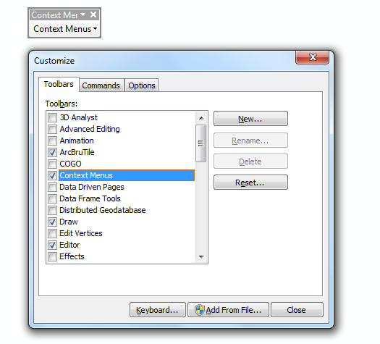

1. In the Commands tab. Choose the Add-In controls then select and drag the ‘Rename Layer’ tool on to the ‘Context Menus’ dialog.

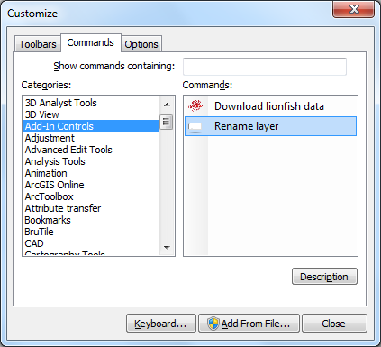

1. The context menu opens up, scroll a long way down and drop the tool into the context menu of the ‘Shapefile Feature Class Context Menu’.

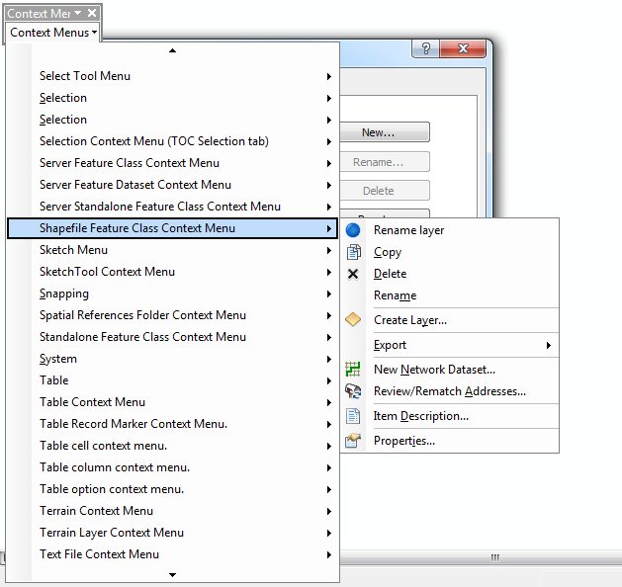

1. Finished installing. Click OK and go back into ArcMap. Right click on a shapefile in ArcMap and rename the layer

