
MapBiomas Alerta Oficial
Step-by-step guide — Indonesia
QGIS plugin
For first-time users: every step has a short explanation and a picture showing where to click.
In the contents, click a title to jump straight to its page.
Guide version: September 2026
Contents
Before you start 4
What you need 4
How to read the pictures in this guide 4
Words used in this guide 4
Part 1 — Install the plugin from the Plugins menu 6
1.1 Open the plugin manager 6
1.2 Search and install 6
1.3 Update or uninstall 7
Part 2 — Open the plugin (and where to find the icon) 8
2.1 From the toolbar icon 8
2.2 If the icon is missing: from the Plugins menu 8
2.3 Bring the icon back to the toolbar 8
2.4 If the plugin doesn't appear anywhere 9
Part 3 — Getting to know the panel 10
Part 4 — Read and accept the information notice 11
Part 5 — Choose the country and language 12
Country 12
Language 12
Part 6 — Sign in with your email and password 13
Part 7 — Say WHERE to search (Area of interest) 14
7.1 Whole country 14
7.2 Biome 15
7.3 Vector layer 15
7.4 Coordinate (point) 16
7.5 Alert code 16
Part 8 — Say WHEN to search (Period) 18
8.1 Filter by (1) 18
8.2 Dates (2 and 3) 18
8.3 Shortcuts (4) 18
Part 9 — Filters and crossings (optional) 19
9.1 Section 3. FILTERS 19
9.2 Section 4. CROSSINGS 20
Part 10 — Search for alerts 22
10.1 While the search runs 22
10.2 When the search finishes 22
Part 11 — Understand the summary and set up the analysis (Statistics tab) 24
11.1 Search summary 24
11.2 Export the summary 25
11.3 Statistical analyses: set up the chart 25
11.4 Ready-made examples 27
Part 12 — View and save the chart (Charts tab) 29
12.1 The three chart types 30
12.2 ENLARGE (1) 31
12.3 Save the chart and the chart's alerts 31
Part 13 — Save the whole layer (Layers tab) 32
13.1 Extra files that may come along 32
13.2 Choose where to save 33
Part 14 — Look at an alert closely (Details tab) 34
14.1 Selected alert: images and report 35
Part 15 — Which button do I use to save? 36
Part 16 — Something went wrong? 37
Need help? 37

Before you start
MapBiomas Alerta Oficial is a plugin for the free mapping program QGIS. It shows, inside QGIS, the deforestation alerts published by the MapBiomas Alerta Indonésia platform. With it you choose a place and a period, see the alerts on the map, read the key figures, make charts and save the data to your computer.

What you need
- QGIS installed on your computer, version 3.22 or newer. QGIS is free and can be downloaded from qgis.org.
- A working internet connection.
- An account on the MapBiomas Alerta Indonésia platform (https://platform.idn.alerta.mapbiomas.org). The plugin uses the same email and password as the website.

How to read the pictures in this guide
- The red boxes show where to look or click.
- When there are numbers in red circles, follow the numbers in order.
- The figures in the pictures (number of alerts, areas, place names) are examples only. Your screen will show the real data from your search.
- The pictures of QGIS screens (menus and windows) are illustrations. In your QGIS version the words and button positions may be slightly different.

Words used in this guide
Word | What it means
QGIS | Free program to view and work with maps on a computer.
Plugin | An add-on installed in QGIS to give it a new function. MapBiomas Alerta Oficial is a plugin.
Panel | The plugin window, which opens on the right side of QGIS.
Tab | Each “page” of the panel: Information notice, Filters, Layers, Statistics, Charts and Details.
Layer | A set of data shown on the map. Each search creates a layer with the alerts found.
Alert | An area where native vegetation was cleared, confirmed with satellite images.
Hectare (ha) | A unit of area. 1 hectare is roughly the size of a football field.
Crossing | When an alert lies fully or partly inside another area, such as a Protected Area.
Report | The full report of an alert, opened on the platform website.
API | The “channel” the plugin uses to talk to the platform and fetch data. You only need to sign in with your email and password.
State | The first administrative level shown by the plugin (the data also show the Municipality).
CSV, XLSX | Spreadsheet file types. They open in Excel, LibreOffice or Google Sheets.
GPKG, SHP | Map file types (GeoPackage and Shapefile). They open in QGIS and other mapping programs.
PNG | Image file type.

Part 1 — Install the plugin from the Plugins menu
You only do this once on each computer. The plugin is in the official QGIS plugin repository, so it is installed from inside QGIS.

1.1 Open the plugin manager
- Open QGIS.
- In the top menu, click Plugins (1).
- Click Manage and Install Plugins… (2). A new window opens.
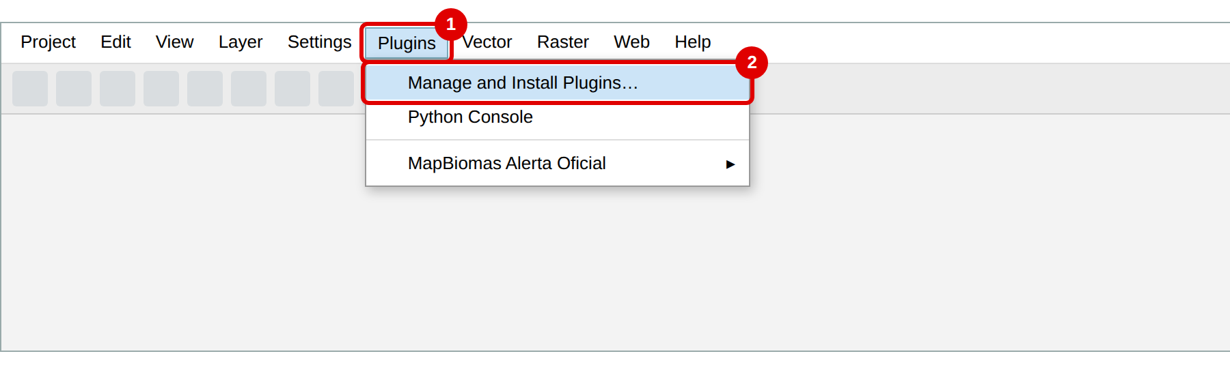
Plugins › Manage and Install Plugins…

1.2 Search and install
- In the left column, click All (1).
- In the search box (2), type MapBiomas Alerta.
- Click MapBiomas Alerta Oficial in the list (3). Its description appears on the right.
- Click Install Plugin (4) and wait a few seconds.
- When it finishes, click Close.
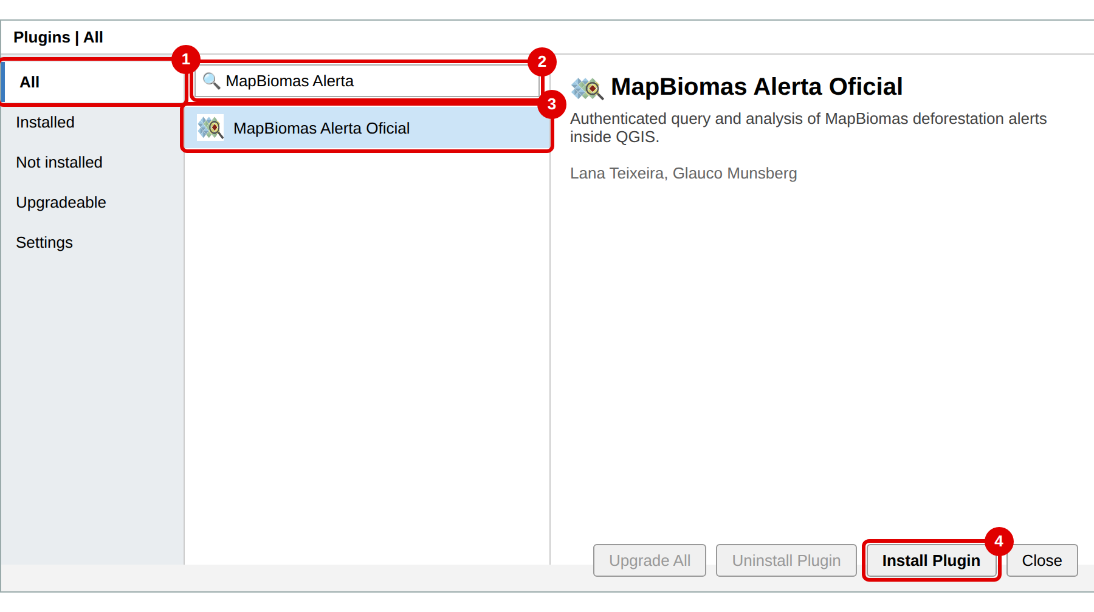
Plugins window: search “MapBiomas Alerta” and click Install Plugin
Done!
Once installed, the plugin icon appears on the QGIS toolbar. The next part shows where it is and what to do if you can't see it.

1.3 Update or uninstall
- Update: when a new version is released, it appears under Plugins › Manage and Install Plugins… › Upgradeable. Click the plugin and then Upgrade Plugin.
- Uninstall: under Plugins › Manage and Install Plugins… › Installed, click the plugin and then Uninstall Plugin.

Part 2 — Open the plugin (and where to find the icon)

2.1 From the toolbar icon
The quickest way is to click the plugin icon (a map with a magnifying glass) on the toolbar, just below the menus. The panel opens on the right side of QGIS.
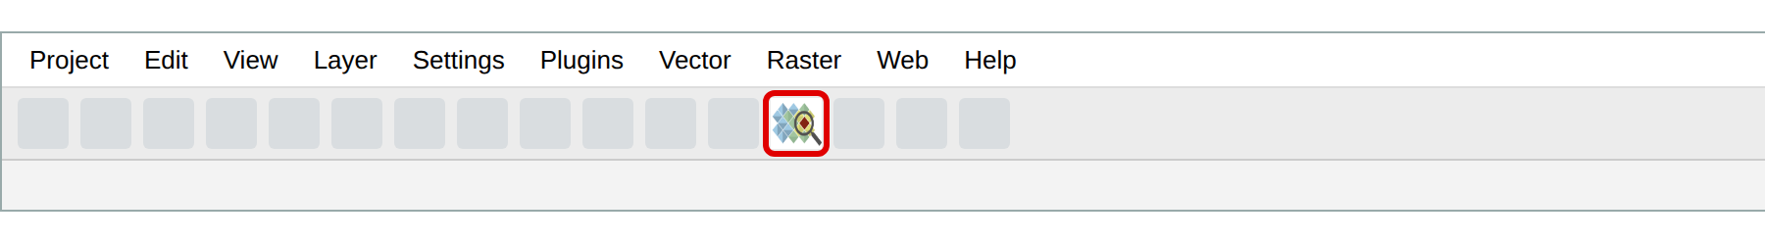
The MapBiomas Alerta Oficial icon on the toolbar

2.2 If the icon is missing: from the Plugins menu
The plugin can also be opened from the menu, even if the icon is not visible:
- Click the Plugins menu (1).
- Hover over MapBiomas Alerta Oficial (2).
- Click MapBiomas Alerta Oficial (3).
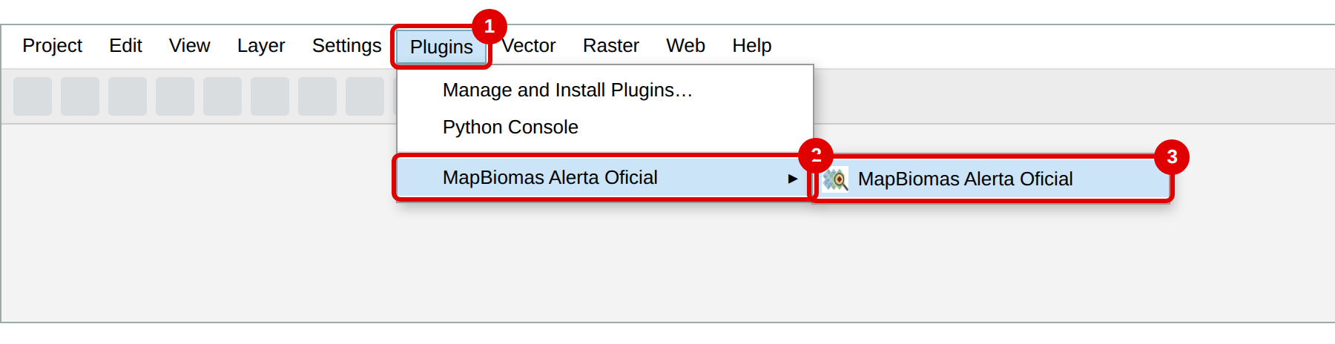
Plugins › MapBiomas Alerta Oficial › MapBiomas Alerta Oficial

2.3 Bring the icon back to the toolbar
If the icon disappeared, the Plugins Toolbar is probably hidden. To show it again:
- Click the View menu (1).
- Hover over Toolbars (2).
- Click Plugins Toolbar (3) so it is ticked ✓.
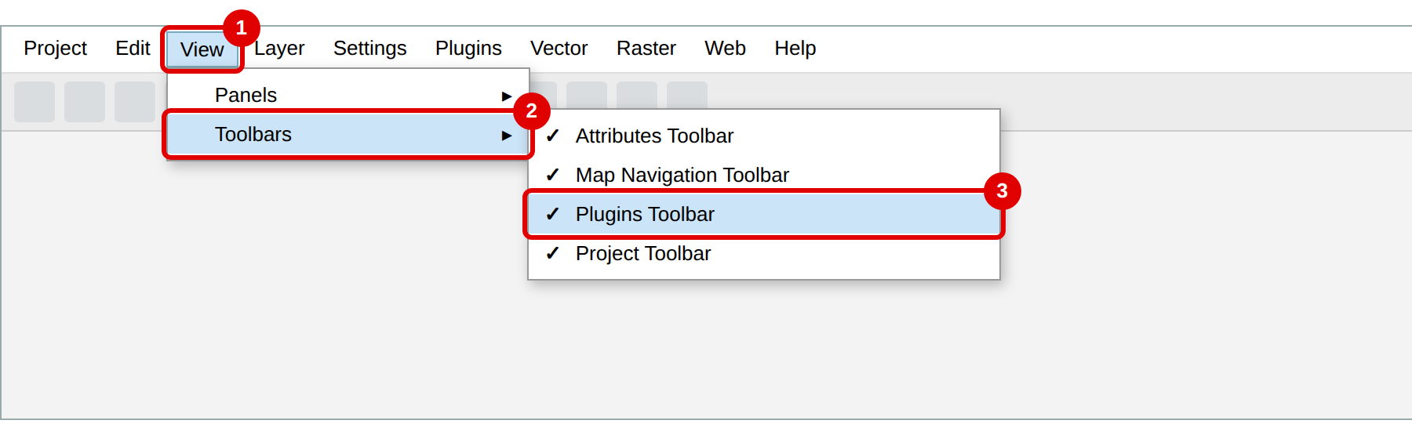
View › Toolbars › Plugins Toolbar
Tip: the toolbar may be squeezed or hidden at the end of the row. If it shows a small » arrow at the corner, click it to see hidden icons.

2.4 If the plugin doesn't appear anywhere
The plugin may be installed but disabled. To enable it:
- Open Plugins › Manage and Install Plugins….
- Click Installed (1).
- Tick the box next to MapBiomas Alerta Oficial (2).
- Click Close. The icon and the menu come back.
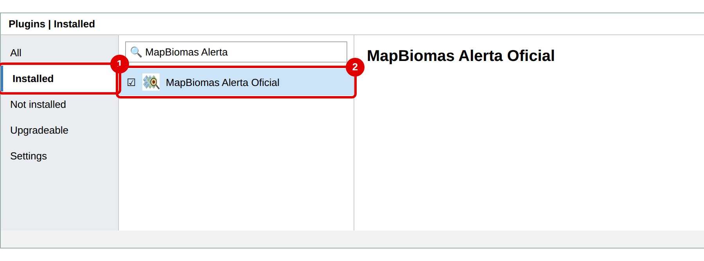
Installed tab: the box next to the name must be ticked
I closed the panel by mistake
No problem. Click the icon again (or Plugins › MapBiomas Alerta Oficial). The panel comes back, and the alert layers already on the map stay there.

Part 3 — Getting to know the panel
The panel has a top area, always visible, and six tabs.
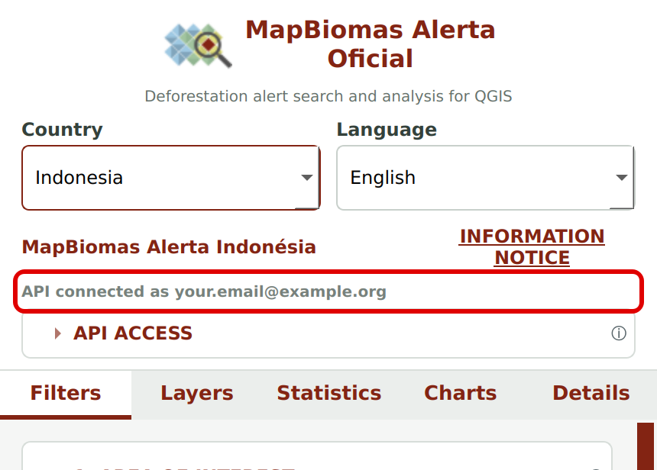
Top of the panel and the tabs
Part | What it is for
Country | Chooses the country of the alerts. See Part 5.
Language | Changes the panel language: Português, Español or English.
MapBiomas Alerta Indonésia | Shows which platform the data come from.
INFORMATION NOTICE | Opens the country's information notice.
API connected / disconnected | Shows whether you have signed in with your email and password.
API ACCESS | Opens and closes the sign-in area. The ⓘ next to it explains the access.
Information notice tab | Shown on first use. You must read and accept the notice.
Filters tab | Where you say where and when to search, and run the search.
Layers tab | Lists the alert layers and exports the table and the layer.
Statistics tab | Shows the search summary and sets up the analysis for the chart.
Charts tab | Shows the chart and exports the chart and the chart's alerts.
Details tab | Shows everything about an alert you click on the map.

The ⓘ symbols across the panel are help balloons: hover the mouse over them to read a short explanation.

Part 4 — Read and accept the information notice
The first time you open the plugin (and whenever the notice changes), the Information notice tab appears. It explains what the data mean and their limits.
- Read the notice. For the full version, click the link to the full notice on the platform.
- Tick I have read and understood this information notice. (1)
- Click I HAVE READ AND AGREE (2). The other tabs are unlocked.
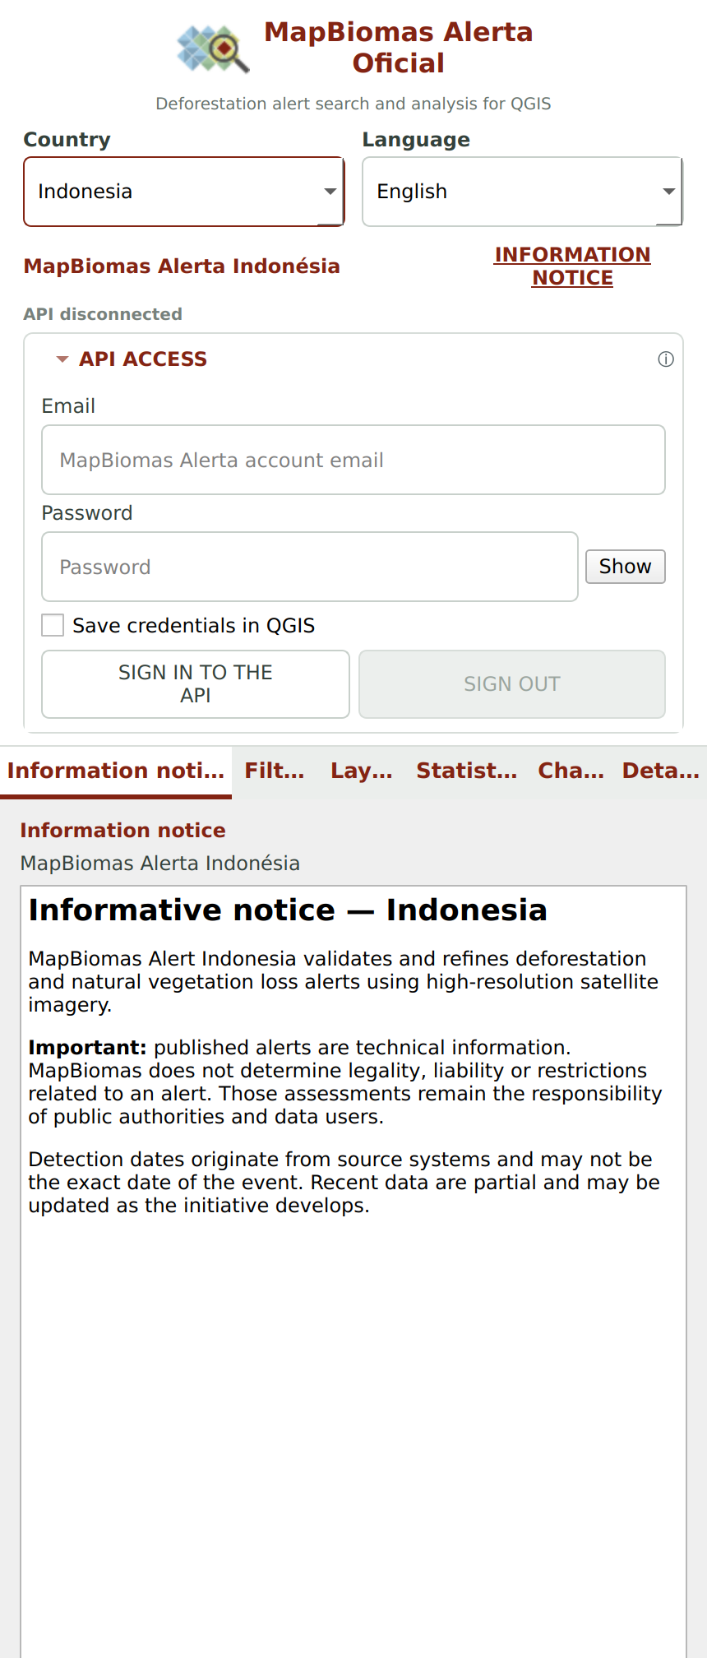
Information notice tab — Indonesia
You can read the notice again at any time by clicking INFORMATION NOTICE at the top of the panel.

Part 5 — Choose the country and language
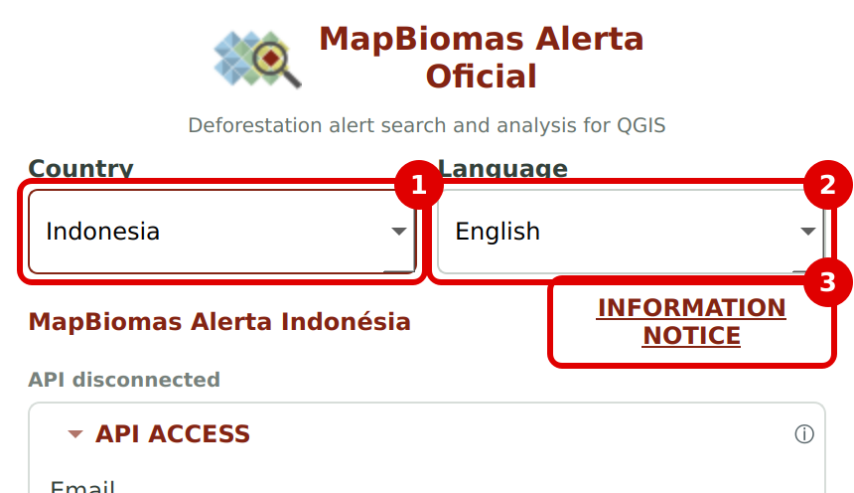
Country (1), language (2) and information notice (3)

Country
Choose Indonesia to see the alerts for Indonesia. The plugin also works with the other MapBiomas Alerta countries:
Country | Platform | Language selected automatically
Brazil | MapBiomas Alerta Brasil | Português
Bolivia | MapBiomas Alerta Bolívia | Español
Colombia | MapBiomas Alerta Colômbia | Español
Peru | MapBiomas Alerta Peru | Español
Indonesia | MapBiomas Alerta Indonésia | English

Careful when changing country
When you change country, the alert layers of the previous country are removed from the map, and you need to sign in again with that country's account. To keep the alerts, export them first (Parts 12 and 13).

Language
Choose Português, Español or English. The whole panel switches language instantly, including the names of exported files. Once you pick a language, it is kept even if you change country.

Part 6 — Sign in with your email and password
To search for alerts, the plugin needs your MapBiomas Alerta Indonésia account.
- Click API ACCESS to open the sign-in area (if it is closed).
- In Email (1), type the email of your platform account.
- In Password (2), type your password. The Show button lets you see what you typed.
- If you want QGIS to remember your access, tick Save credentials in QGIS (3). The password is stored securely in the QGIS authentication manager and next time you are signed in automatically.
- Click SIGN IN TO THE API (4).
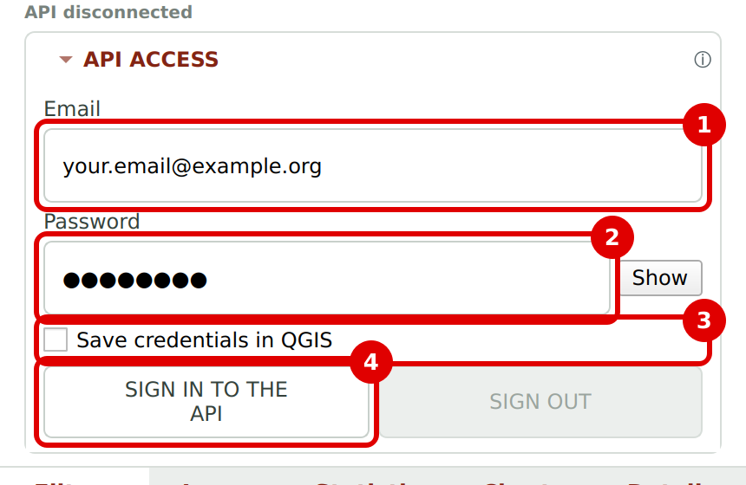
Sign-in area
When it works, API connected as followed by your email appears, and the sign-in area closes by itself.
Signed in: “API connected as …”
- SIGN OUT: open API ACCESS and click SIGN OUT to disconnect (for example, on a shared computer).
- No account yet: create one at https://platform.idn.alerta.mapbiomas.org.
- Forgot your password: recover it on the platform website.

Part 7 — Say WHERE to search (Area of interest)
Click the Filters tab. The first section is 1. AREA OF INTEREST. For Indonesia it has five options. Choose only one:
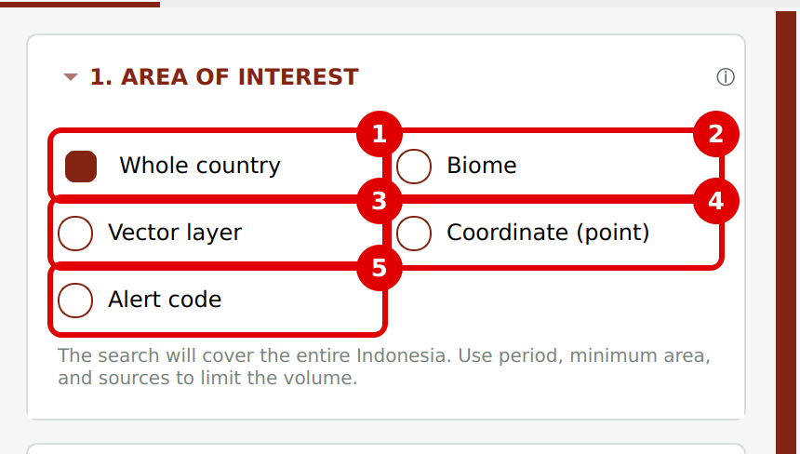
The five area-of-interest options
Option | When to use it | Uses the period?
1. Whole country | See alerts for all of Indonesia. | Yes
2. Biome | See alerts for one or more biomes. | Yes
3. Vector layer | See alerts inside an area of your own (district, concession, watershed…) already open in QGIS. | Yes
4. Coordinate (point) | Check whether there is an alert at an exact point. | No
5. Alert code | Open an alert whose number you already know. | No

The rural property (CAR) search exists only for Brazil, because Indonesia has no rural property registry integrated with the platform. Options 4 and 5 look for something specific: they don't use the period or the filters of section 3.

7.1 Whole country
Select Whole country. The search covers all of Indonesia. As it may return many alerts, use the period, minimum area and sources to limit the amount.
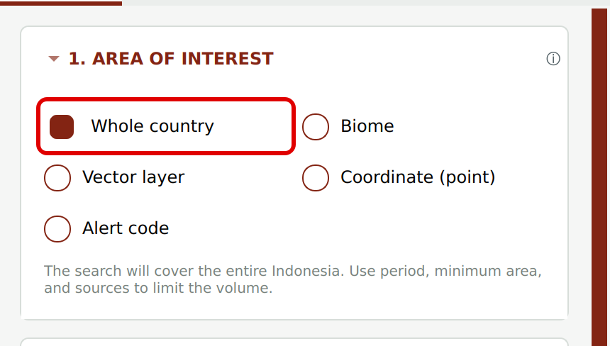
Whole country option
Example: all alerts in Indonesia detected between 01/01/2025 and 30/07/2025.

7.2 Biome
- Select Biome (1).
- Click the box below (2) and tick one or more biomes. Click again to untick.
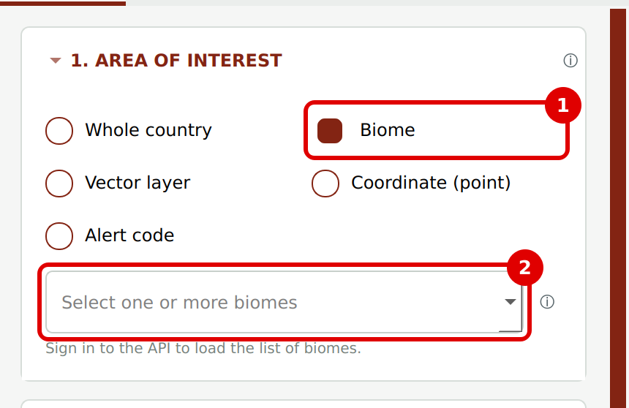
Biome option
The list of biomes for Indonesia is loaded from the platform after you sign in. Before that you see “Sign in to the API to load the list of biomes”. If the country platform doesn't offer the list, the plugin says so under the box.

7.3 Vector layer
Use it when you have an area of your own, such as a district boundary, a concession or a watershed, already open in QGIS as a polygon layer.
- First, open your layer in QGIS (for example, by dragging the .shp or .gpkg file into QGIS).
- In the plugin, select Vector layer (1).
- In the box below (2), choose your layer. The number of features (polygons) is shown underneath.
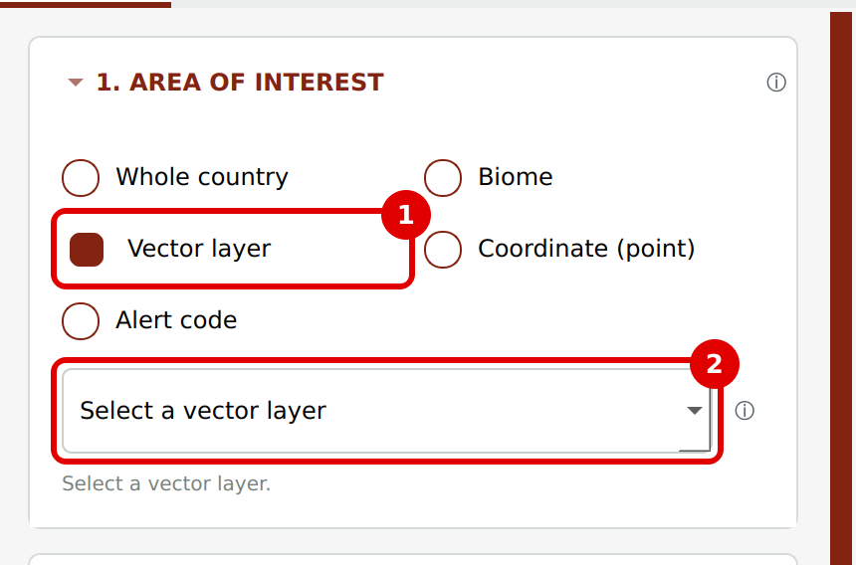
Vector layer option
The plugin returns only the alerts that touch your area. It also calculates how much of each alert lies inside it. These values become the fields Area in the layer of interest (ha) and Percentage in the layer of interest (%), which you can use in charts (Part 11).
Example: open your district boundary and see only the alerts that fall inside it.

7.4 Coordinate (point)
- Select Coordinate (point) (1).
- In Longitude (2), type the longitude. Example for Indonesia: 110.0000
- In Latitude (3), type the latitude. Example: -1.8500
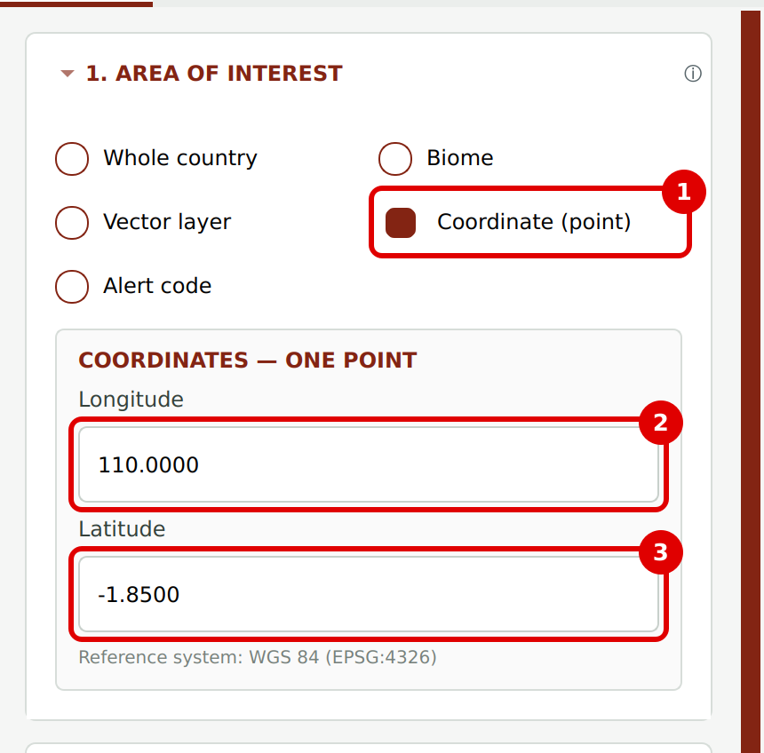
Coordinate (point) option
- Use a dot for decimals and a minus sign for South and West. In Indonesia, longitudes are positive (East); latitudes south of the Equator are negative.
- Coordinates are in decimal degrees, WGS 84 (EPSG:4326), the same as Google Maps.
- The plugin shows the alert (or alerts) that contains the point. If there is none, a message says so.
Tip: in Google Maps, right-click a place. The two numbers shown are latitude and longitude, in that order.

7.5 Alert code
- Select Alert code (1).
- Type the alert number (2). Example: 1370001
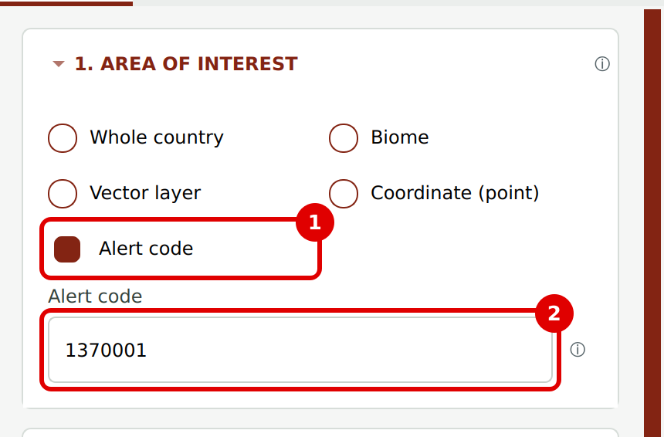
Alert code option
The plugin returns only that alert. If the code doesn't exist, a message says so.

Part 8 — Say WHEN to search (Period)
Section 2. PERIOD is just below. If it is closed, click its title to open it.
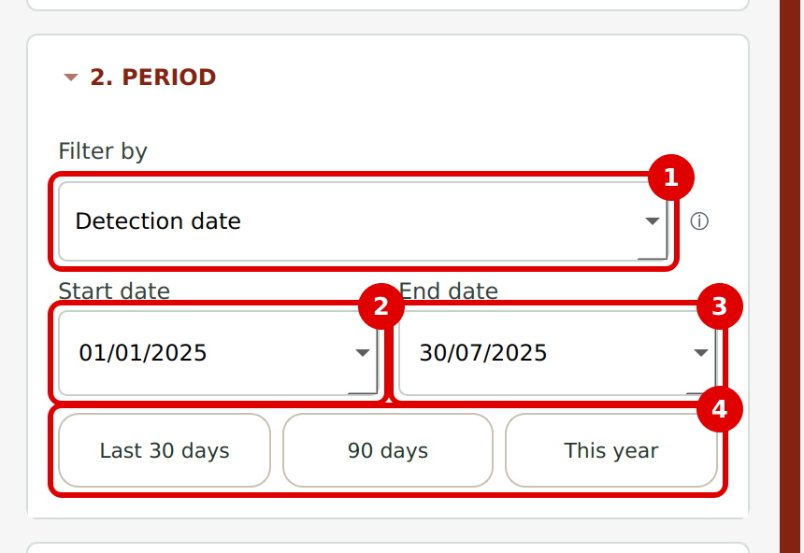
Period section

8.1 Filter by (1)
Option | What it does
Detection date | Searches by the date the source system detected the clearing. This is the most used option.
Publication date | Searches by the date the alert was published on the platform, after validation.

8.2 Dates (2 and 3)
In Start date and End date, click the small arrow to open a calendar, or type the date as day/month/year. Both dates are included in the search.

8.3 Shortcuts (4)
Button | Dates it sets
Last 30 days | From 29 days ago until today.
90 days | From 89 days ago until today.
This year | From 1 January this year until today.

Period limits
• The start date cannot be after the end date.
• The period can be at most 1 year. If you need more, run one search per year.
• Data for the current year are partial and may change.

Part 9 — Filters and crossings (optional)
Sections 3 and 4 refine the search. If you don't need them, skip this part: the search works without them.

9.1 Section 3. FILTERS
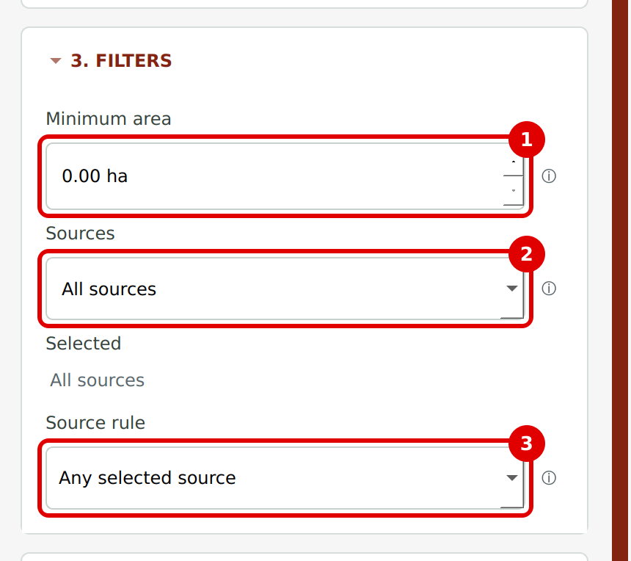
Filters section

Minimum area (1)
Leaves out alerts smaller than the value given, in hectares. With 0.00 ha, all alerts are included.
Example: type 5 to see only alerts of 5 hectares or more.

Sources (2)
A source is the system that detected the clearing. Click the box and tick one or more sources. If you tick none, all sources are included. Ticked sources appear under Selected.
Source available for Indonesia: GLAD. The list is refreshed from the platform after you sign in and may gain new sources.

Source rule (3)
Only matters when you tick more than one source (an alert can be detected by several sources). With a single source, as in Indonesia today, leave it as it is.
Option | What it returns
Any selected source | Alerts with at least one of the ticked sources.
All selected together | Alerts with all the ticked sources (they may have others too).
Exact combination | Alerts with exactly the ticked sources, no more and no fewer.

9.2 Section 4. CROSSINGS
Use it to see only the alerts that are (or are not) inside a type of area, such as Protected Areas.
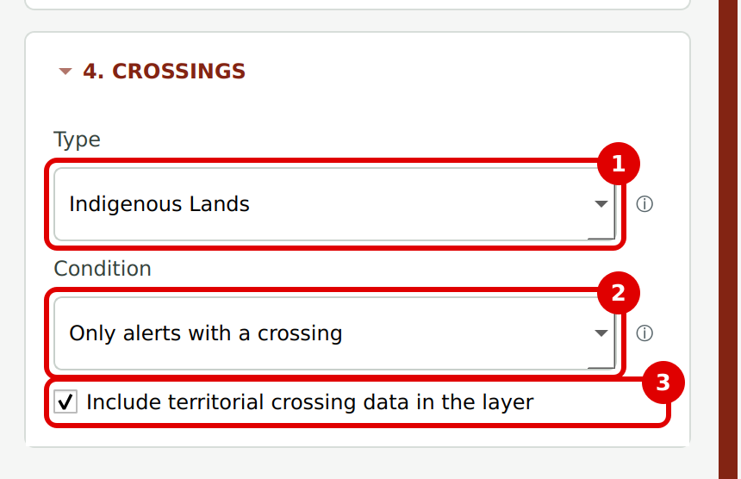
Crossings section

Type (1)
Choose the type of area. The list is loaded from the platform after you sign in and only shows types that have data for Indonesia. It may include, for example:
Crossing types that may appear
Protected Areas (all) · Indigenous Lands · Settlements
Forest management · Legal Reserve · APP · Rural properties
Other Indonesia-specific types configured on the platform

The first option, Any available crossing, considers all types together. If no type has data, the box is disabled.

Condition (2)
Option | What it returns
All alerts | No crossing filter (the default).
Only alerts with a crossing | Only alerts that touch the chosen type. E.g. only alerts inside Protected Areas.
Only alerts without a crossing | Only alerts that don't touch the chosen type. E.g. alerts outside Protected Areas.

Include territorial crossing data in the layer (3)
Leave it ticked (the default). The layer then includes the names and areas of each crossing, used in charts and exports.
Untick it only for a faster search when you don't need these details. The full table export, the crossings table and the “Areas by crossing type” chart are then unavailable for that layer. The crossing filter and the Details tab keep working.
Embargoes and authorizations
Crossings with embargoes, authorizations and enforcement actions are not shown in the plugin. Check them in the alert report on the platform.

Part 10 — Search for alerts
At the bottom of the Filters tab there is a line summarizing your choices (country, area, period and sources) and two buttons.
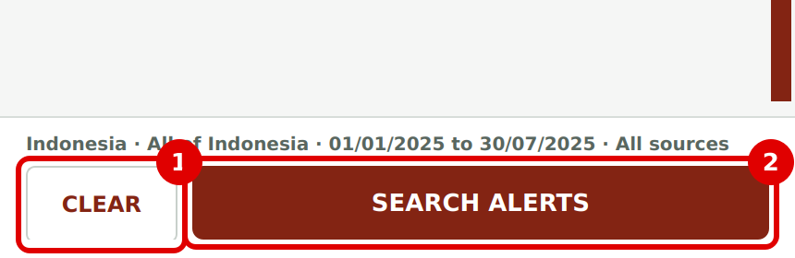
Filter summary, CLEAR (1) and SEARCH ALERTS (2)
- SEARCH ALERTS (2): runs the search. If it says SIGN IN TO SEARCH, you haven't signed in yet (Part 6).
- CLEAR (1): resets every filter. Careful: it also removes the alert layers already on the map. Export them first if you want to keep them.

10.1 While the search runs
The plugin switches to the Statistics tab by itself and shows a progress bar. The summary figures appear right away, before all alerts are downloaded.
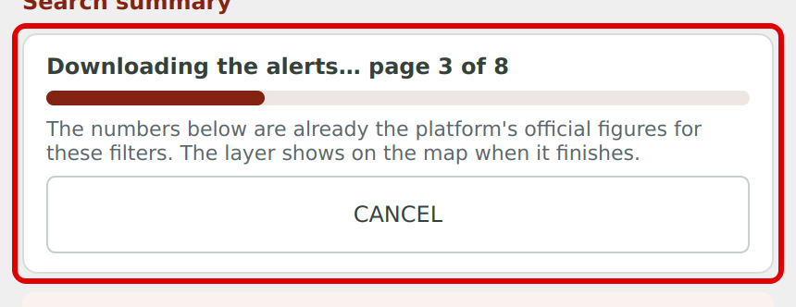
Progress bar with the CANCEL button
If it takes too long or you made a mistake in a filter, click CANCEL.

10.2 When the search finishes
The alerts appear on the map as a new layer. The layer name tells the area and the period, for example:
Alerts - Indonesia, 01/01/2025 to 30/07/2025
Type of search | Layer name
Whole country | Alerts - Indonesia, 01/01/2025 to 30/07/2025
Biome | Alerts - (chosen biome), 01/01/2025 to 30/07/2025
Vector layer | Alerts - (name of your area), 01/01/2025 to 30/07/2025
Coordinate | Alerts - Coordinate 110.0000, -1.8500
Alert code | Alerts - alert 1370001

Each search creates a new layer. You can run several searches and compare the layers on the map.

Part 11 — Understand the summary and set up the analysis (Statistics tab)

11.1 Search summary
At the top of the tab there is a notice: the summary changes with the filters. Then come the cards (1) with the key figures in red.
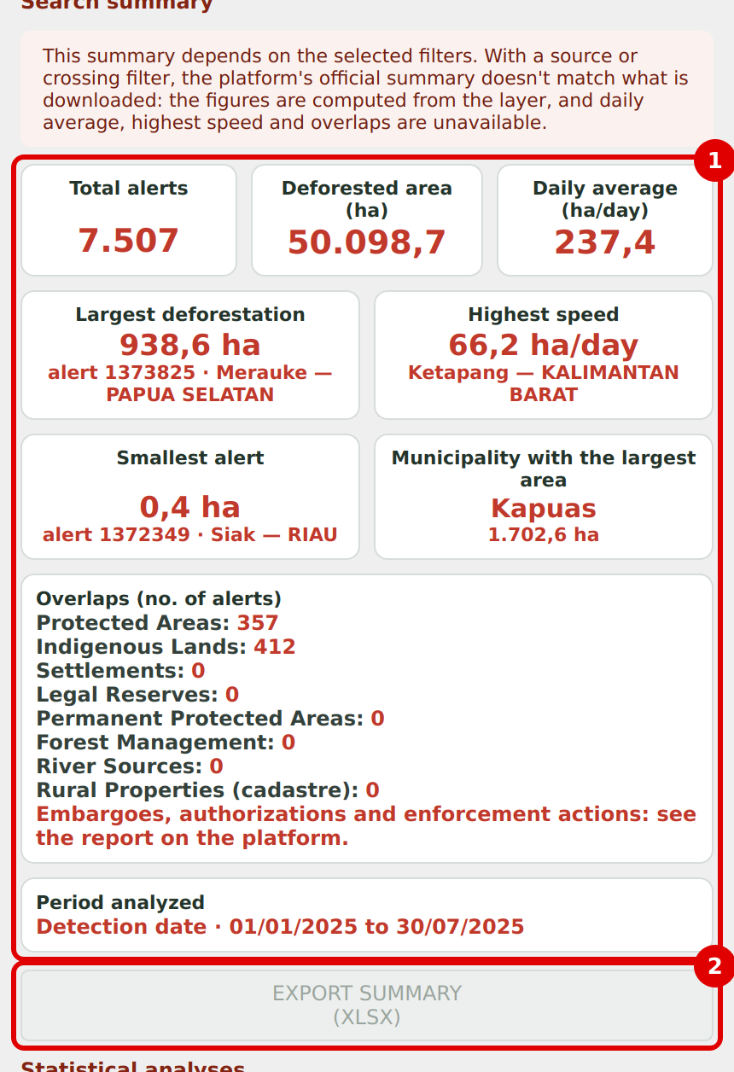
Search summary (1) and EXPORT SUMMARY (XLSX) (2)
Card | What it shows
Total alerts | How many alerts the search found.
Deforested area (ha) | The sum of the area of all alerts, in hectares.
Daily average (ha/day) | The deforested area divided by the number of days in the period.
Largest deforestation | The largest alert: area, code and place (municipality and state).
Highest speed | The alert that cleared fastest (hectares per day), with code and place.
Smallest alert | The smallest alert: area, code and place.
Municipality with the largest area | The municipality with the most deforested area, and how much.
Overlaps (no. of alerts) | How many alerts touch Protected Areas, Indigenous Lands, Settlements, Legal Reserves, Permanent Protected Areas, Forest Management, River Sources and Rural Properties. Types without data for Indonesia show 0.
Period analyzed | The date type and dates used in the search.

When the summary changes
If you used a source or crossing filter, figures are calculated from the downloaded layer. Daily average, Highest speed and Overlaps are then unavailable (shown as “—”).
Embargoes, authorizations and enforcement actions are not in the summary: check them in the report on the platform.

11.2 Export the summary
Click EXPORT SUMMARY (XLSX) (2). Choose the folder and name (mapbiomas_alerta_summary.xlsx is suggested) and click Save. The spreadsheet has two sheets: the summary with the cards and the list of layers.

11.3 Statistical analyses: set up the chart
Further down the same tab is the Statistical analyses area. Here you say which chart you want.
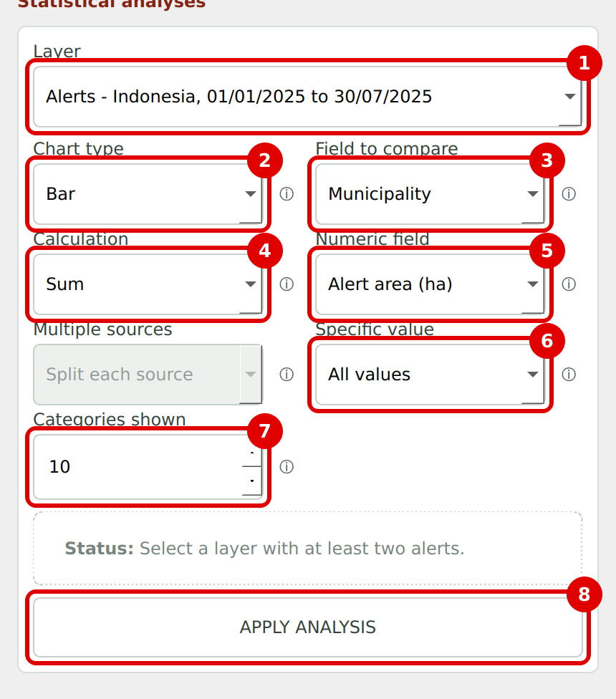
Statistical analysis fields
Field | What to choose
1. Layer | Which alert layer to analyze (when you have more than one search).
2. Chart type | Bar, Pie or Line (see below).
3. Field to compare | What splits the chart into groups (municipality, biome, source, month…).
4. Calculation | Record count, Sum or Average.
5. Numeric field | Which number to add up or average (only for Sum and Average).
Multiple sources | Only used when the field to compare is Source.
6. Specific value | Show one group only (e.g. one municipality) or All values.
7. Categories shown | How many groups the chart shows: 3 to 20 (default 10).
8. APPLY ANALYSIS | Creates the chart. Always click it after changing something.

Chart type
Option | Good for
Bar | Comparing groups: which municipality has most alerts, which source detects most.
Pie | Seeing each group's share of the total.
Line | Seeing change over time (use with Year, Month or Year and month).

Field to compare: all options
The list only shows fields that have data in your layer. For Indonesia you may see:
Option | Groups alerts by
Source | System that detected it (GLAD).
Biome | Biome of the alert.
State | First administrative level of the alert.
Municipality | Municipality of the alert.
Year / Month / Year and month | Alert date. Use it with the Line chart.
Protected Area, Indigenous Land, other crossings | Only if the Indonesia platform has data for those crossings.
Areas by crossing type | Compares the area (ha) of each crossing type. Types can overlap, so bars don't add up to the total area.

Alerts that don't cross the chosen type appear in the No crossing group.

Calculation
Option | What it calculates | Example
Record count | Counts the alerts in each group. | How many alerts per municipality.
Sum | Adds up the numeric field for each group. | How many hectares cleared per municipality.
Average | Averages the numeric field for each group. | Average alert size per biome.

Numeric field
Shown when the calculation is Sum or Average. Options depend on the layer:
- Alert area (ha) — the total area of each alert (the most used).
- Area in the layer of interest (ha) and Percentage in the layer of interest (%) — only when the search used a Vector layer.
- Area in Protected Area (ha), Area in Indigenous Land (ha) and other crossing areas, when there is data.

Multiple sources
Option | What it does
Split each source | An alert detected by two sources counts for each of them.
Group by combination | The same alert goes to a “source A + source B” group.

Specific value and Categories shown
- Specific value: keep All values to see every group, or choose one (e.g. a municipality) to focus on it.
- Categories shown: the chart shows the largest groups. The rest are added into a grey group called Others (X groups). The ENLARGE button (Part 12) shows them all.
Below, Status tells you if something is missing or if you need to click APPLY ANALYSIS.

11.4 Ready-made examples
Question | Type | Field to compare | Calculation | Numeric field
Which municipalities cleared the most? | Bar | Municipality | Sum | Alert area (ha)
How did clearing change month by month? | Line | Year and month | Sum | Alert area (ha)
Which state has the most alerts? | Pie | State | Record count | —
What is the average alert size per biome? | Bar | Biome | Average | Alert area (ha)
How much area is in each crossing type? | Bar | Areas by crossing type | Sum | —

Part 12 — View and save the chart (Charts tab)
After you click APPLY ANALYSIS, the chart appears in the Charts tab.
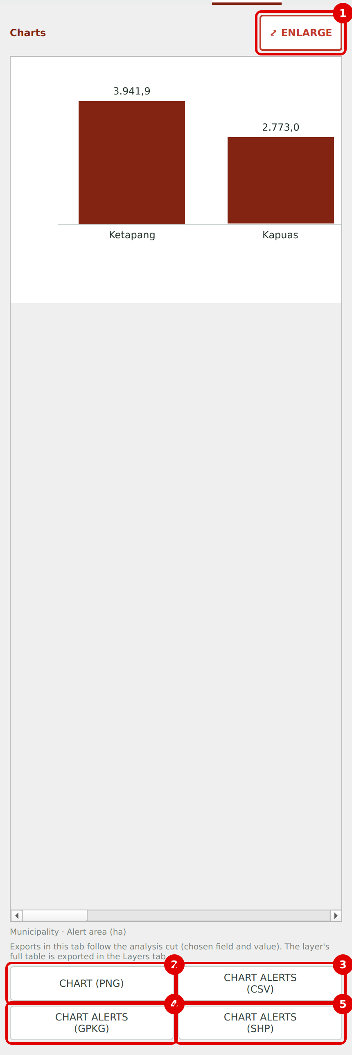
Charts tab: ENLARGE (1) and export buttons (2 to 5)

12.1 The three chart types
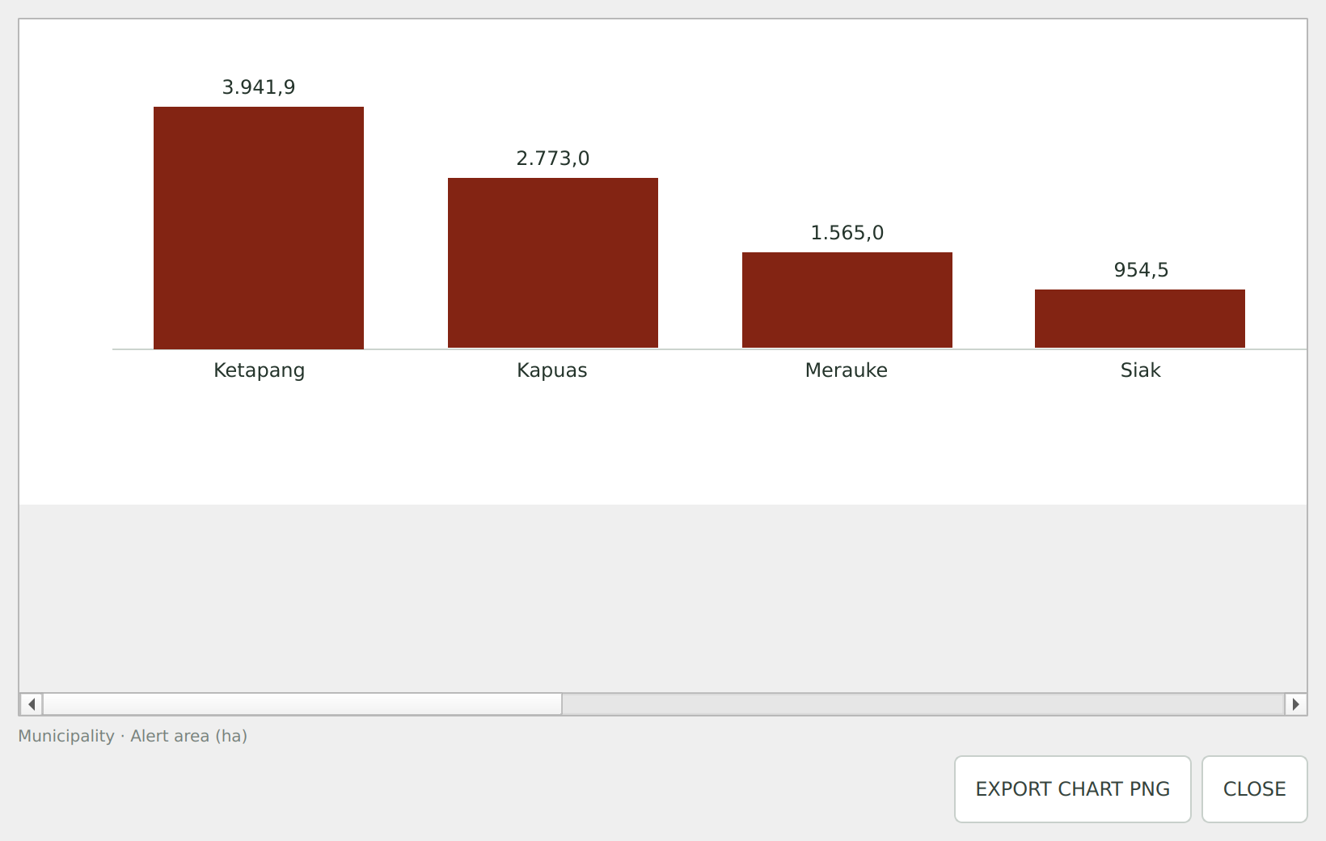
Bar
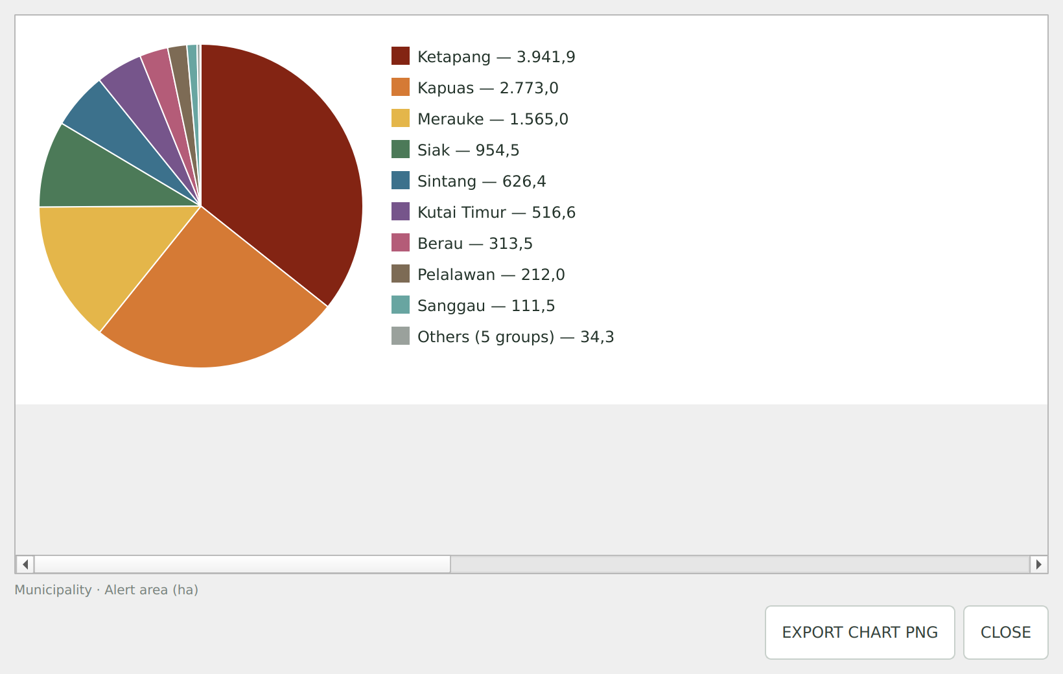
Pie (each colour is a group; “Others” is grey)
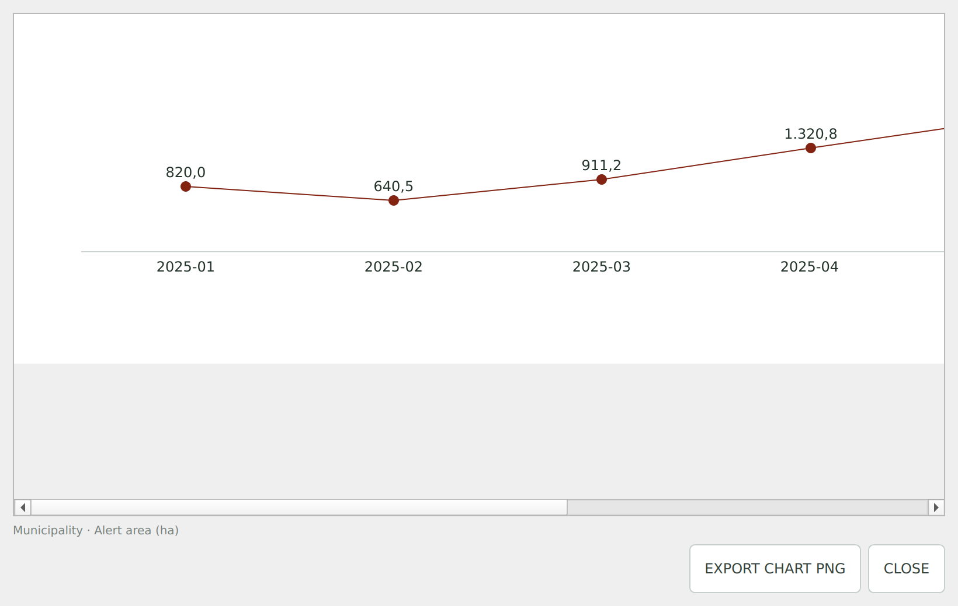
Line (change over time)

12.2 ENLARGE (1)
The red ⤢ ENLARGE button opens the chart in a bigger window that you can resize freely. It shows every category plus the EXPORT CHART PNG and CLOSE buttons.

12.3 Save the chart and the chart's alerts
The buttons in this tab save only what is in the chart (the chosen field and value). To save the whole layer, use the Layers tab (Part 13).
Button | What it saves | Suggested name
2. CHART (PNG) | The chart image, with title, period and legend. | mapbiomas_alerta_chart.png
3. CHART ALERTS (CSV) | Spreadsheet with the chart's alerts: code, area, dates, source, biome, state and municipality, plus a column named after the field used in the chart (e.g. “Protected Area” with the names) and, for Sum or Average, the numeric field. | mapbiomas_alerta_chart_alerts.csv
4. CHART ALERTS (GPKG) | Map file with the polygons of the chart's alerts and all fields. When there are crossings, it includes an internal “cruzamentos” table. | mapbiomas_alerta_chart_alerts.gpkg
5. CHART ALERTS (SHP) | The same as a Shapefile, with extra files: _cruzamentos.csv and _campos.csv (see Part 13). | mapbiomas_alerta_chart_alerts.shp

The chart field column is not repeated when it already exists in the file (for example, Municipality and State are always included).

Part 13 — Save the whole layer (Layers tab)
The Layers tab lists the alert layers you searched, with the period and number of alerts of each. The buttons save the layer chosen in Statistics › Layer.
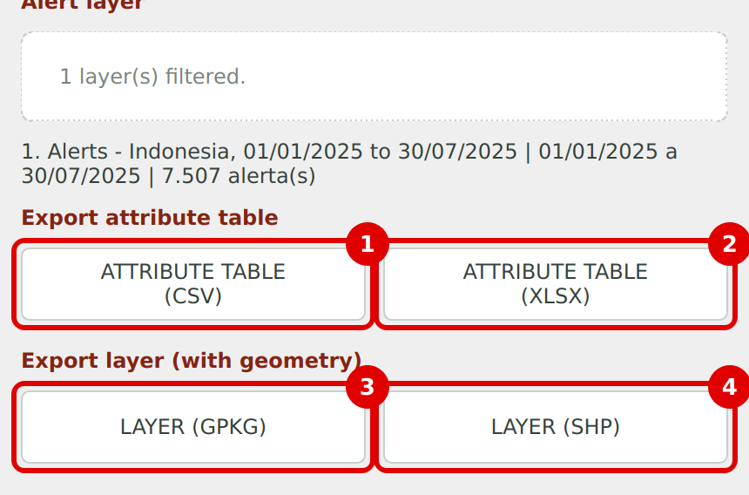
Layers tab
Button | What it saves | Suggested name
1. ATTRIBUTE TABLE (CSV) | Spreadsheet with every field of every alert, one alert per row. | mapbiomas_alerta_attribute_table.csv
2. ATTRIBUTE TABLE (XLSX) | The same table in Excel, with numbers stored as numbers. | mapbiomas_alerta_attribute_table.xlsx
3. LAYER (GPKG) | The whole layer, with polygons and all fields, as GeoPackage (recommended). | mapbiomas_alerta_layer.gpkg
4. LAYER (SHP) | The whole layer as a Shapefile. | mapbiomas_alerta_layer.shp

13.1 Extra files that may come along
File | When it appears | What it is for
…_README.txt | GPKG and SHP with crossings | Explains the difference between the layer table and the crossings table.
“cruzamentos” table (inside the .gpkg) | GPKG with crossings | One row per crossing: alert code, category, territory and area.
…_cruzamentos.csv | SHP with crossings | The same crossings table as a spreadsheet.
…_campos.csv | SHP | Shapefile cuts field names to 10 characters. This file lists the short name, the full name and what each field means.

In CSV files, decimals use a comma and columns are separated by semicolons.

13.2 Choose where to save
Every export opens a window to choose the folder and file name. The plugin remembers the last folder used. If you can't save in a folder, it tells you and suggests another one.

Part 14 — Look at an alert closely (Details tab)
- Click the Details tab.
- Click IDENTIFY ALERT ON MAP. The mouse cursor changes.
- On the map, click an alert. Its information appears in the panel.
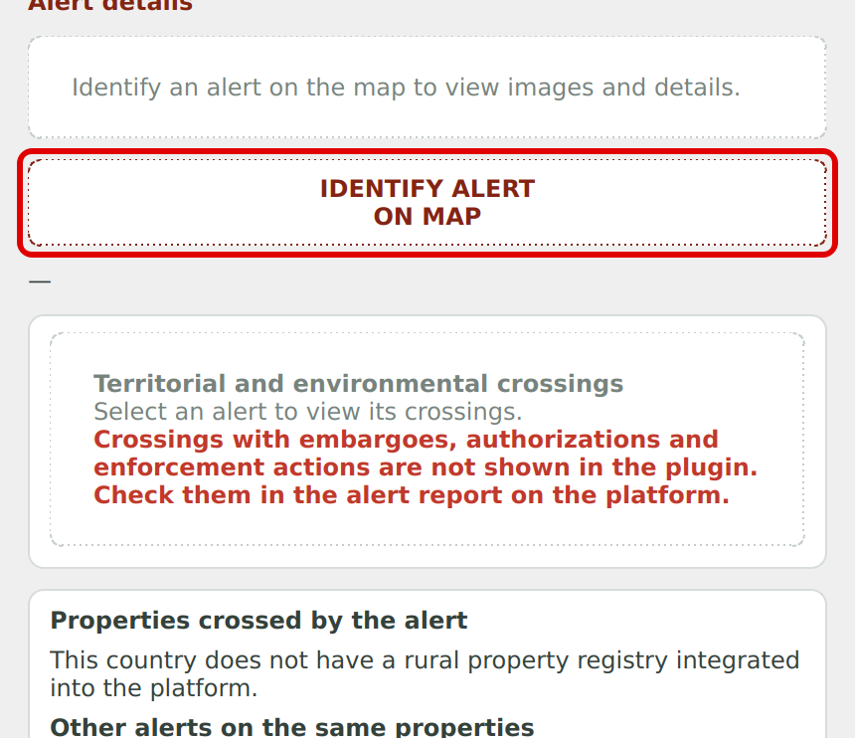
Details tab before choosing an alert
After you click an alert, you see:
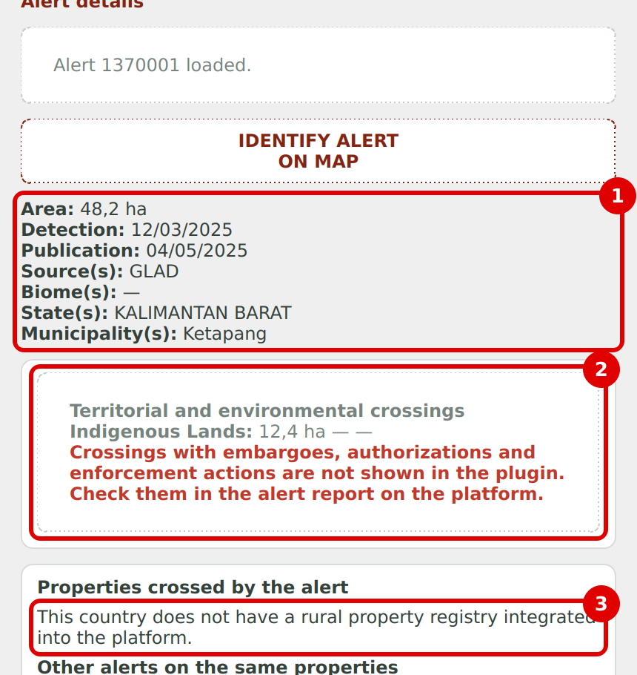
Alert information (1), crossings (2) and properties (3)
Part | What it shows
1. Alert information | Area, detection date, publication date, source(s), biome(s), state(s) and municipality(ies).
2. Territorial and environmental crossings | The types of area the alert touches (Protected Area, Indigenous Land…), with the area and name of each.
3. Properties crossed by the alert | For Indonesia, a message says the country has no rural property registry integrated with the platform.

14.1 Selected alert: images and report
Further down, the Selected alert card shows the satellite image from before and after the clearing (with the date and satellite of each) and two buttons:
- OPEN REPORT ON PLATFORM: opens the full alert report in your web browser. The report shows embargoes, authorizations and other details.
- SEE ON MAP: zooms the QGIS map to the alert.
Remember
Embargoes, authorizations and enforcement actions only appear in the report on the platform.

Part 15 — Which button do I use to save?
I want… | Tab | Button
The key search figures in a spreadsheet | Statistics | EXPORT SUMMARY (XLSX)
The chart image | Charts | CHART (PNG) or, in the enlarged window, EXPORT CHART PNG
Only the chart's alerts, as a spreadsheet | Charts | CHART ALERTS (CSV)
Only the chart's alerts, as a map | Charts | CHART ALERTS (GPKG) or (SHP)
All alerts, as a spreadsheet | Layers | ATTRIBUTE TABLE (CSV) or (XLSX)
All alerts, as a map | Layers | LAYER (GPKG) or (SHP)
The full report of one alert | Details | OPEN REPORT ON PLATFORM

Part 16 — Something went wrong?
What happened | What to do
I can't find the plugin under Plugins | Make sure you are in the All column and type “MapBiomas Alerta” in the search box. Check your internet connection.
The icon doesn't show | See Part 2: Plugins menu, View › Toolbars, or the Installed tab.
The button says SIGN IN TO SEARCH | Sign in with your email and password under API ACCESS (Part 6).
The tabs are grey | Accept the information notice (Part 4).
A message says the period is longer than 1 year | Shorten the period or run one search per year.
The biome list asks me to sign in | Sign in first.
The crossings box is disabled | The Indonesia platform has no crossing types with data, or you haven't signed in yet.
The search takes a long time | Shorten the period, choose a biome or a smaller area, or use minimum area. You can click CANCEL.
The search found no alerts | Check the period, the date type (detection or publication) and the filters.
Daily average shows “—” | Normal when there is a source or crossing filter (Part 11).
The vector layer list is empty | Open your polygon layer in QGIS first.
I can't save the file | Choose another folder (e.g. Documents) or close the file if it is open in Excel.
The layers disappeared from the map | This happens when you click CLEAR or change country. Run the search again.

Need help?
Write to suporte.alerta@mapbiomas.org describing what happened. If you can, attach a screenshot.

