## 泡泡布点法

α = −1.0，β = 0.2，η = 0.2，𝜎2 = 0.5，t = 161.01

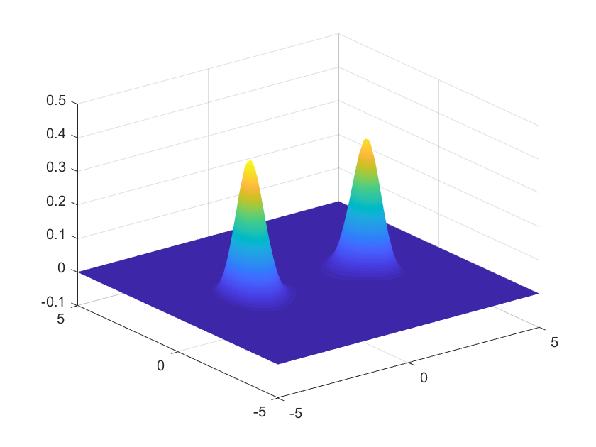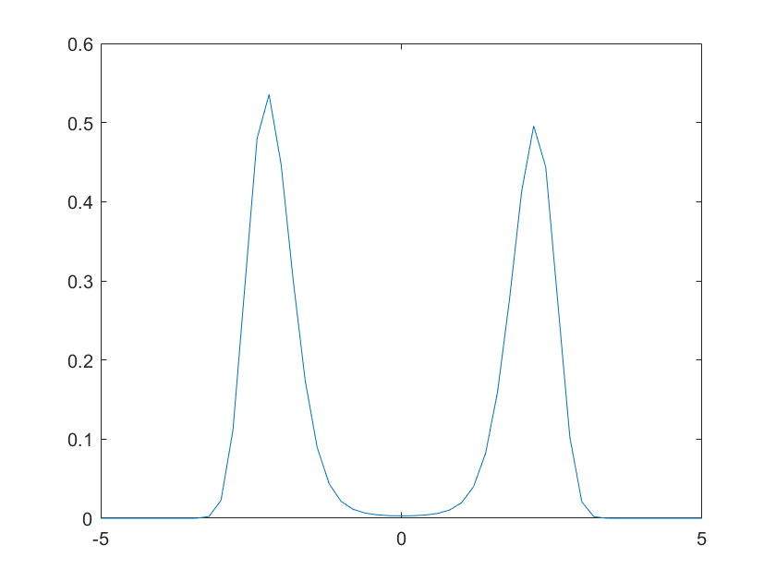

α = −1.0，β = 0.2，η = 0.2，𝜎2 = 0.1，t = 400.55

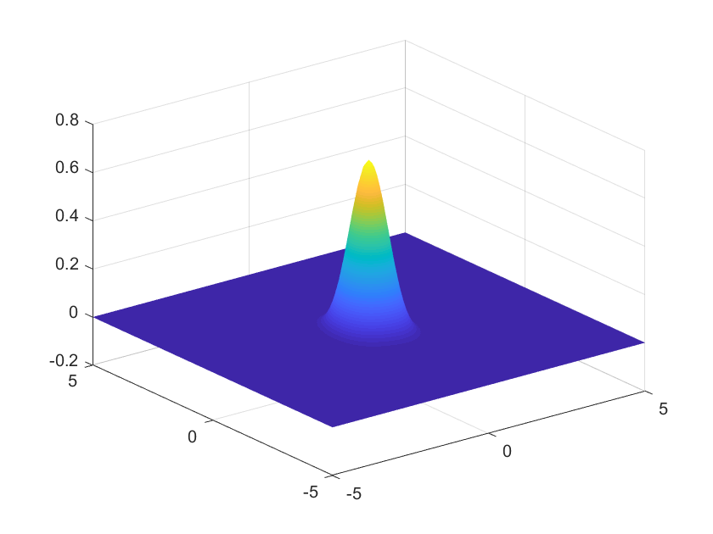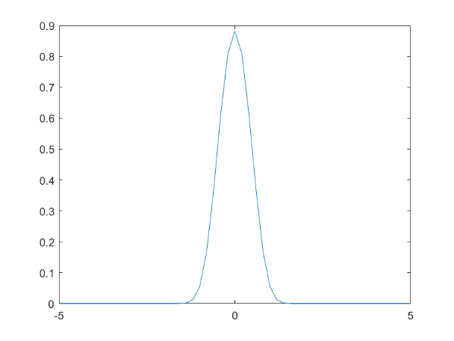

α = 1.0，β = 0.8，η = 0.6，𝜎2 = 0.3，t = 161.01

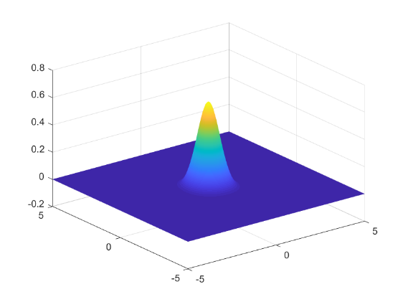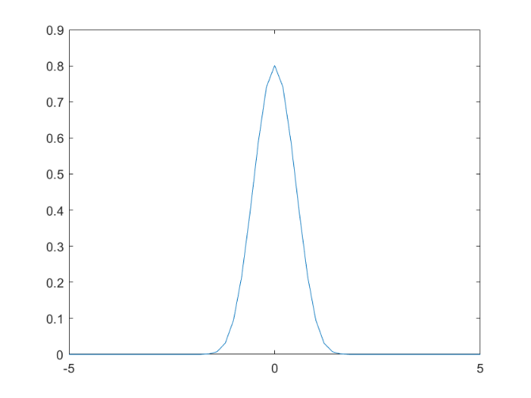

α = 1.0，β = 0.2，η = 0.2，𝜎2 = 0.1，t = 161.01

