


NW Mapbook
User Documentation

Prepared by:

Reed Hunter
rhunter@esri.com
Environmental Systems Research Institute, Inc. (ESRI)
606 Columbia St. NW Suite 300
Olympia, WA 98501
Phone: (360) 754-4727
Fax: (360) 943-6910

Mapping Group ArcGIS Map Book Application 2
Overview 2
Installing the Map Book Application 2
Prerequisites: 2
Installation Steps: 2
Uninstalling the Map Book Application 2
Uninstall Steps: 2
Features 3
- Multiple Map Pages per ArcMap mxd 3
Overview 3
Directions 3
- Postscript Printouts 6
Overview 6
Directions 6
- Circular detail insets, or map “Bubbles” 7
Overview 7
Directions 7
- Identifier Maps 11
Overview 11
Directions 11
- Dynamic Definition Queries 14
Overview 14
Directions 14
- Adjacent Map labeling 17
Overview 17
Directions 17
- Map Page Based Layer Visibility and Layer Visibility Groups 21
Overview 21
Directions 21
- Altering Text Elements per map page 23
Overview 23
Directions 23
- Per map page layout element (legend, north arrow, etc) visibility control 24
Overview 24
Directions 24
- Multiple Dataframe Map Page Extents 27
Overview 27
General Directions 28
Mapping Group Hundred Block Data Directions 29
- Map Page Refresh Command 31
Overview 31
Directions 31
Review 32

NW (Northwest) Map Book Application

Overview

This document describes how to install, use, and uninstall the NW Map Book application for ArcGIS 9.x. NW Mapbook is an enhanced version of DS Mapbook, providing as-is source code for map production tools. Some features described in this document come from DS Mapbook, but most features described here are new to NW Mapbook. There is another document that comes with DS Mapbook that should be part of this distribution, so this document largely avoids repeating instructions from

Installing the Map Book Application

Prerequisites:

NW Mapbook requires a Window PC system with a copy of ArcGIS 9.x installed. NW Mapbook features are the same regardless of the ArcView, ArcEditor, or ArcInfo license level of ArcGIS. DS Mapbook should not be installed on the same system as NW Mapbook.

Typical ArcGIS Desktop requirements at version 9.1 include:
CPU: 1 GHz or better
RAM: 512 MB or better
Hard Drive: 700 MB

Installation Steps:

For a zip file distribution,
- Unzip the zip file contents to a local directory on the installation target computer. This will be a local application, so these files should not reside across a network from the target system, even on a networked drive.
- Locate and run the batch file _INSTALL.BAT. This should execute a .reg file in the distribution.
- Click [OK] in the dialog window that appears to allow the .reg file contents to be added to the registry.
- Start ArcMap.
- Make the “NW Mapbook” TOC tab visible. In the ArcMap interface, select in the main menu Tools ➔ Options ➔ “Table of Contents” tab ➔ put a check mark by “NW Mapbook” ➔ click [OK]
- Make the “NW Map Series” toolbar visible. Select in ArcMap’s main menu, Tools ➔ Toolbars ➔ NW Map Series.

Uninstalling the Map Book Application

Uninstall Steps:
- Run the batch file _UNINSTALL.BAT from the local installation directory.

Alternately, run “REGSVR32.exe /u” with the two application dlls. To accomplish this,
- locate the two DLL files NWMapBookPrj.dll and NWMapBookUIPrj.dll.
- Open a command prompt. One way to accomplish this is click on [Start] ➔ Run ➔ ‘cmd’ ➔ click [OK].
- Enter the following commands. Be sure to do this from the directory where the dlls are located.
  - ‘%windir%\system32\runsvr32.exe /u NWMapBookPrj.dll’
  - ‘%windir%\system32\runsvr32.exe /u NWMapBookUIPrj.dll’

Features

- Multiple Map Pages per ArcMap mxd

Overview

This basic function provided by DS Map Book has not been altered. Like DS Mapbook, NW Mapbook works within ArcMap’s limit of one page layout by dynamically shifting the content of that layout when a new map page is loaded. This application uses a polygon “index” layer to define each map page in a map series. For example, if a layer being used by the application has 5 polygons, then there will be 5 map pages. The polygon layer must have an attribute field containing a unique name for each polygon that can be used for the name of each map page.

After installation, a tab in the table of contents (figure 1) provides an interface to creating and managing map series. Initially, no map pages will have been created (figure 2).

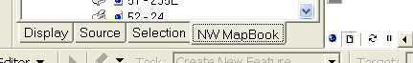
Figure 1 – NW Mapbook Tab in ArcMap

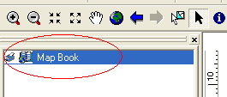
Figure 2 - A new, empty map book

Directions

To create a new map series,
- Right click the “Map Book” text at the top of the NW Map Book tab, and select “Add Map Series…” in the context menu (figure 3).
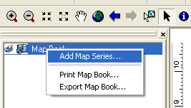
Figure 3 - Menu for adding a new map series

- In the “Map Sheet Wizard” that appears (figure 4), make sure that
  - The correct index layer is selected.
  - The correct attribute field of that layer containing the names of the polygons has been selected for page names.

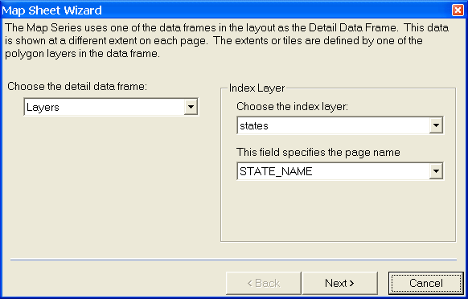
Figure 4 - The initial page of the wizard to create a new map series.
- Select [Next] to proceed to the second page of the wizard (figure 5), [Next] to reach the third page of the wizard (figure 6), and [Finish] to create a new map series (figure 7). Double clicking any of the listed pages will load that map page.

The adjacent label options on the third wizard page are described later in this document as part of the new adjacent labeling features. All other options in the wizard are described in the accompanying DS Map Book document, “Map Book Generation.doc”.

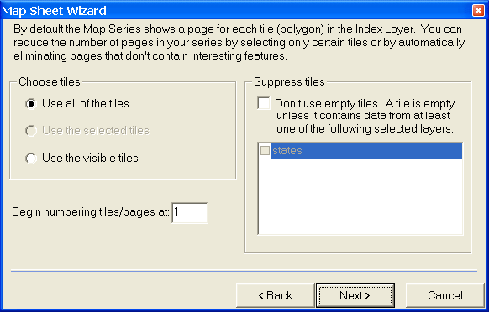
Figure 5 - The second page of the wizard for creating a new map series.

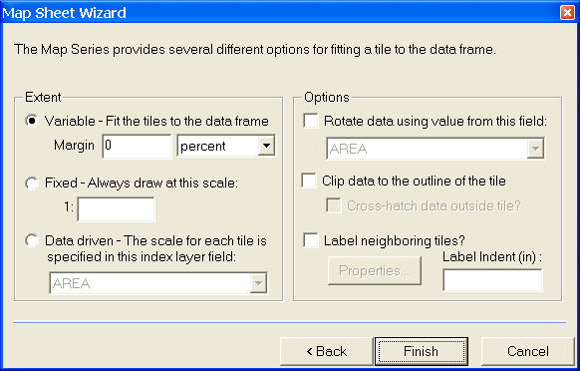
Figure 6 - The third and final page of the wizard for creating new map series. The adjacent label interface in the lower right is described later in this document.
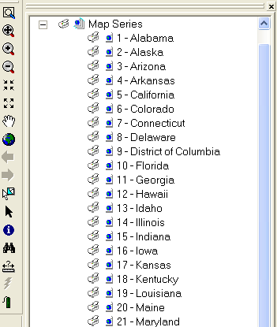
Figure 7 - A completed map series. Many application features will be accessible through right clicking either map pages or the "Map Series" text in this interface.

- Postscript Printouts

Overview

A DS Mapbook inherited feature provides the ability to print an entire map series with a single command. One of the options in the print dialog for a map series is the ability to print to a map series to a postscript file. This option will only appear in the interface when you select a print driver that supports the postscript format. For more details on printing options, please reference the accompanying document “Map Book Generation.doc”. Map Book Generation.doc is an instruction document originating from the original DS Mapbook application.

Directions

- Right click the “Map Series” text within the NW MapBook tab and select “Print Series…”
- In the print dialog that appears, click on the check box option to the right to “Print to file”, then click [OK]. You should be prompted for a file name and location.

Note: if the “Print to file” checkbox is grayed out, then the selected printer or print driver was not detected to support postscript printing. If ArcMap can print a single map to a postscript file, then this interface will allow printing of an entire series to a postscript file.

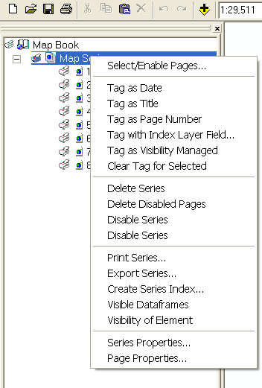
Figure 8 - The right click menu for a map series after the series has been created.

- Circular detail insets, or map “Bubbles”

Overview

Detail insets are a new feature implemented for NW Mapbook. This feature allows the creation and maintenance of circular detail insets, or “bubbles” that show a more detailed view of the main map.

A polygon layer is used to designate locations that will be displayed, and the attribute fields of those polygons tell the software how and where to display the area overlapped by those polygons. Think of each inset polygon as a “you are here magnifying glass”, and each inset generated from that polygon is a “blown up” view of the area covered by the magnifying glass.

The new functionality allows a user to designate a polygon layer as a bubble layer so that map page changes will search for these polygons and create these insets. Detail insets can be edited either by two tools made available on the NW Map Series toolbar, or both the insets and polygons can be clicked and dragged to new locations using the mouse, and committed to the new location by clicking the map refresh button. This last map refresh updates function can be enabled in the map series properties.

Directions

To designate a qualified bubble polygon layer to be used by NW Map Book:
- Load the detail inset polygon layer into ArcMap. A sample detail insets data source called DetailInsets is provided with the NW Mapbook distribution in NWMapbookSample.mdb.
- If a map series does not already exist, create one. (Steps to accomplish this were addressed earlier in this document).
- Right click the “Map Book” text within the NW Mapbook tab of the TOC. In the resulting context menu (figure 8), select the “Series Properties…” menu item.
- The “Series Properties” dialog should appear. Select the “NW Options” tab of this dialog (figure 9).
- Select the check mark for using a detail inset polygon feature class. If this check mark is disabled and the drop down combobox is empty, then no qualifying polygon layers were detected. If more than one qualifying polygon layer is detected, then all such layers will be available in the drop down menu.

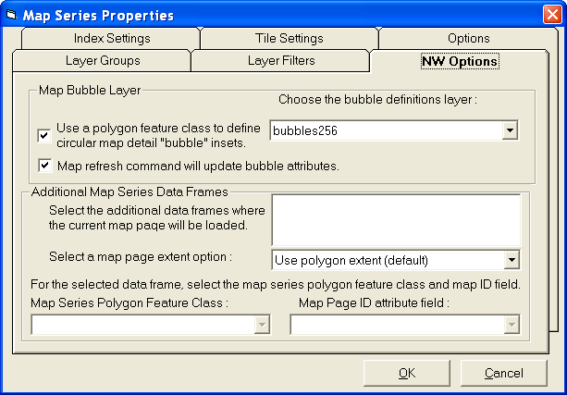
Figure 9 - The Mapping Group Options tab of the map series properties dialog. From this tab, the detail insets polygon layer can be selected.

- Click [OK] to close the series properties dialog. A bubble polygon layer has at this point been designated. Selecting new map pages will cause the detail insets layer to be accessed.

Bubble Detail inset feature class requirements:

In order for a feature class to be detected by the software as qualified for bubble detail insets, it must pass the following tests:
- It must be a polygon feature class.
- The feature class must include the following attribute field names and data types:
  - “XDEST” field of type Double
  - “YDEST” field of type Double
  - “RADIUS” field of type Double
  - “SCALE” field of type Double
  - “XORG” field of type Double
  - “YORG” field of type Double
  - “BUBBLEID” field of type Integer
  - “LAYERS” field of type String
  - “WIDTHORG” field of type Double

To create new bubble detail insets:

- Set up the environment to enable the detail inset creation tool (figure 10)
Figure 10 - The detail inset creation tool's command button (circled in red).
  - Designate a detail inset polygon layer if one has not already been chosen.
  - Start the ArcMap editing environment.
    - In the ArcMap Editor toolbar, select the “Editor” menu.
    - Click on “Start Editing”
- Click on the command button to activate the detail inset creation tool. You are now ready to interact with the map to create a detail inset.
- Left click and drag the mouse from the center of the new polygon to its outer edge, creating a circle in the process (figure 12).

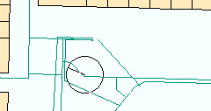
Figure 11 - First circle during detail inset creation. This shows the future location of the inset polygon.

- Release the mouse to create the first circle. A line should now extend from the center of the polygon’s circle to the mouse location.
- Move the mouse to the desired center of the inset location (figure 13).
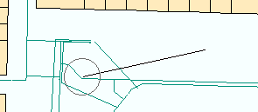
Figure 12 - A line will connect the center of the future inset polygon to the current mouse location. The mouse pointer image was not captured in these screen shots.
- Left click and drag the mouse pointer to create the detail inset circle (figure 14). When you release the left mouse button, a dialog window will be displayed to gather remaining inset creation options (figure 15).
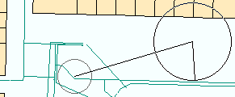
Figure 13 - The detail inset circle as it is displayed before releasing the mouse button.
- Adjust the numerical attributes as desired within the Bubble Properties dialog window. When you click or tab from one number text box to the next, the source and destination graphics will be updated to reflect the changes you made.
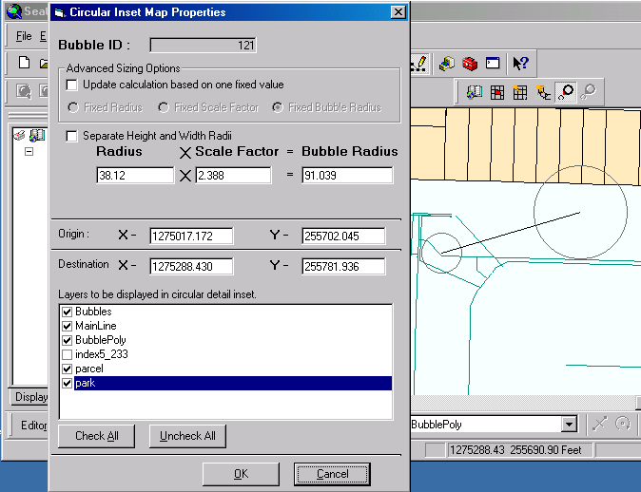
Figure 14 - Inset properties dialog. This window can set spatial aspects of the polygon and its inset. A selection of layers to include in the inset is also managed in this interface.
- Click [OK] to apply the properties. A polygon and detail inset will be created (figure 16).
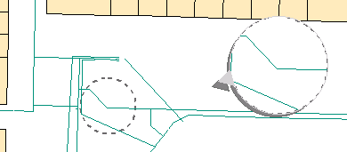
Figure 15 - A completed detail inset and associated polygon.

To edit an existing bubble detail inset:

- Set up the environment to enable the detail inset editing tool (figure 17)
  - Designate a detail inset polygon layer if one has not already been chosen.
  - Start the ArcMap editing environment.
    - In the ArcMap Editor toolbar, select the “Editor” menu.
    - Click on “Start Editing”
  - Select one detail inset polygon using any of ArcMap’s feature selection tools.

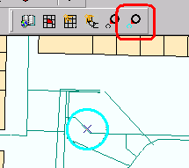
Figure 16 - The detail inset edit tool's command button (outlined in red)

- Click the detail inset editing tool (outlined in figure 17).
- The same dialog that appears for new detail insets will be displayed for the existing detail inset (figure 15). Alter the detail inset settings as desired, then click [OK].
- A detail inset source and destination graphic will appear to reflect the current state of the numeric attributes in the Bubble Properties dialog window. As you click or tab away from the numeric attribute text boxes, the graphics will be updated to reflect the new values.
- Click [OK] to commit changes to the detail inset.

To modify detail insets using map refresh commands:

- Set up the environment to enable the detail insets in a map series as described earlier.
- Create a new detail inset if one does not already exist.
- Enable the map refresh option for controlling detail insets.
  - Open the map series properties dialog. To do this, right click the “Map Series” item in the TOC, and select “properties” from the context menu.
  - Click on the “NW Options” tab.
  - Click the check box for updating bubble attributes with map refreshes.
  - Click [OK] to close the Series Properties dialog and apply this setting.
- Left click and drag a detail inset to a new location.
- Click on the map refresh button in the lower left corner of the map view.
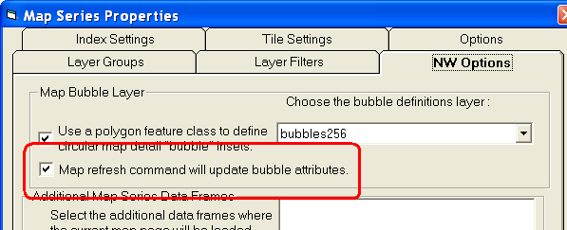
Figure 17 - check box to enable bubble updates with map refresh commands

- Identifier Maps

Overview

The Mapping Group map book project provides the means to maintain more than one identifier map. Identifier maps show a more zoomed out view of the map, but the basic code of DS Map Book provides only the ability to have one such map. In order to support different layouts where an identifier map can be placed in different locations, the Mapping Group Map Book application will supports combining support for multiple identifier maps with the ability to control which layout elements are visible per map page.

Directions

Two features will be described in this section:
- How to view the new support for multiple Identifier Maps
- Per map page control of data frame visibility.

How to view the new support for multiple Identifier Maps
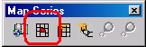
Figure 18 - The identifier map tool
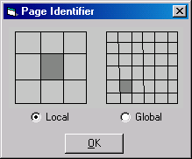
Figure 19 - Local vs Global Identifier Map selection dialog.

- Use the pre-existing tool for adding an identifier map (figure 18)
- Select local vs global identifier map in the resulting dialog. (figure 19)
- In ArcMap’s layout view, click and drag the mouse where the identifier map is to be displayed. A new identifier map will appear in that location.
- Repeat steps 1 through 3 for as many identifier maps as desired.
- Select various map pages, and observe that all identifier maps are updated.

Unlike the original application, each added identifier map will have a slightly different name. The code that fires on map page changes has also been updated to seek out and update the extent of all data frames that have the “LocalIdentifier” and “GlobalIdentifier” naming conventions.

Per map page control of data frame visibility

Given different map pages orientations, it can be advantageous to have identifier maps and other data frames appear on certain map pages, and not appear on others. To manage visibility of identifier maps and other data frames,

- Create some identifier maps as per the directions above.
- Add one or more data frames using the ArcMap main menu’s Insert -> Data Frame command. Add some data to and position the added data frame within layout view so that it can be observed more easily.
- Right click the map series and select the “Visible DataFrames” option (figure 20). The form for managing the visibility of data frames should appear (figure 21).
- Within the “Manage Data Frames” dialog, click in the upper section of the dialog the name of the data frame you wish to manage. The list of map pages in the lower section of the window will have a check mark for every map page on which the data frame will appear.
- Leave check marks only next to map pages where you wish the data frames to remain visible. Unchecking the map page name will cause the data frame to be removed and stored when that map page is loaded.
- Click [OK] to close the data frame management window.
- Load a map page from the map series, and observe the visibility of the data frame(s) you managed.
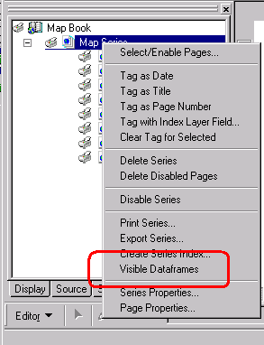
Figure 20 - Visible Dataframes menu item
Note that added data frames and identifier maps are left visible for all map pages until marked to be made invisible within the Manage Data Frames dialog. Data frames not currently visible will still be available in the management dialog window.

Note also that although detail inset “bubbles” are implemented as data frames, they are managed by a bubble definition feature class, and are therefore ignored by this tool. The data frame used by the map series is also exempt from removal since its absence would cause the map series to malfunction.

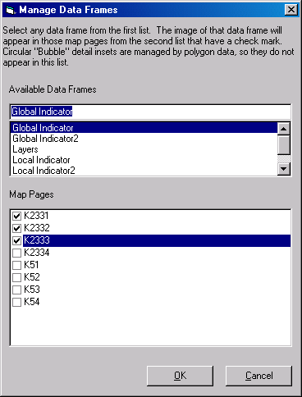
Figure 21 - The form for managing visibility of data frames. Although detail insets are implemented as data frames, such data frames are ignored by this software, and are not listed.

- Dynamic Definition Queries

Overview

In order to support the filtering of hundred block data and a white on grey highlighting of the current map page polygon, dynamic definition queries have been implemented.

The top and right side edges of many map pages display labels showing the incremental address change of streets in that map. The new map production environment permits the automatic display of these hundred block labels. Dynamic definition queries can allow all but the current map page’s hundred block labels to be hidden. Hundred block data provided by the Mapping Group did not have an attribute field indicating the map page on which such data should be displayed. Hundred block attribute data will have to be updated with such map page identifiers before dynamically updated attribute queries can be applied using this function.

The polygon of every map page is displayed with a white background. In order to show the boundary of the current map page polygon, surrounding data is displayed with a grey background. This gives a strong contrast, making the boundary visible at a glance. Dynamic definition queries can filter out all white map tiles except the one corresponding to the current map page. Directions are provided below for the requirement of displaying a white background for the current map page.

Directions

To create a dynamic definition query:
- Create a definition query for an existing layer, and include map page names as part of the definition query. This requires that an attribute field of the feature class to be filtered contains map page names.
- Open the Map Series Properties dialog for the map series, and go to the Layer Filters tab (figure 23). Place a check mark next to the layer with the definition query to be dynamically updated. Close the dialog.
- Load the map page whose name you initially put in the definition query. From this point on, the definition query will be updated on map page changes to reflect the newly selected map page.

Creating a dynamic definition query for a white background polygon.
- Load a second reference to the map page tile polygon layer.
  - Click on ArcMap’s command for adding data ( ).
  - Navigate to and select the data source that has been used for map page polygons, and click the [Add] button.
- Change the layer name for the second map page tile polygon layer. A duplicate layer name can interfere with determining which layer’s definition query to dynamically update.
- Move the second map tile layer near to, or at the bottom of the list of map layers.
  - Open the display tab of ArcMap’s TOC window.
  - Left click and drag the layer down below other layers within the main data frame. If the main map tile layer has an opaque color, then the second reference should be just above the first map tile layer.
- Change the color of the map tile layer.
  - Left click on the color displayed for this polygon layer. This will open the symbol selector dialog.
  - Choose the color for the background polygon. This color should be different than the color used for the other map tile polygon layer. This document assumes that the main map tile layer will be grey, and the second, dynamically filtered reference to the map tile layer will be white.
- Set a definition query on the second map tile layer.
  - Right click the second map tile layer, and select [Properties].
  - In the “Layer Properties” dialog (figure 22), select the [Definition Query] tab.
  - Either directly enter the definition query, or click on the [Query Builder] button.
  - Within the “Query Builder” dialog, double click the field of the map tile layer that was used for the map page names. This will add the text of that field into the where clause text below.
  - Click the [=] button to add ‘=’ to the where clause text box, or alternately type in the text yourself.
  - Click the [Get Unique Values] button to the right in the “Query Builder” dialog. This will provide a complete list of unique values from that attribute field within the “Unique Values:” text box.
  - Double click one of the unique values from the right to add that value to the where clause.
  - Click the [OK] button to close the query builder, then click [OK] on the Layer Properties dialog.

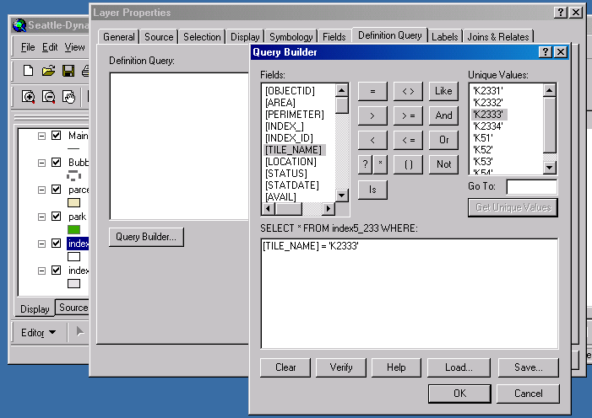
Figure 22 - The query builder from the Layer Properties dialog window. The [Get Unique Values] button has been selected.
- Tell the NW Map Book application to dynamically update that definition query during map page changes.
  - Double click a map page to make sure that one of the map pages has been loaded. This map page name will become the text to be replaced within definition queries.
  - Open the “Series Properties” dialog for the map series.
    - In the ArcMap TOC, select the “NW MapBook” tab.
    - If no map series has yet been created, create the map series.
    - Right click the “Map Series” text, then select “Series Properties” from the context menu.
  - Select the “Layer Filters” tab of the “Map Series Properties” dialog window (figure 23).
  - Choose the data frame in which the map page polygon layer is located.
  - Put a check mark next to the second map page polygon layer. If the currently selected map page is the same as the one you selected earlier in the unique values of the query builder dialog, you will see the text of that name highlighted to indicate what text will be replaced on map page changes.
  - Click [OK] to close the Map Series Properties dialog window.
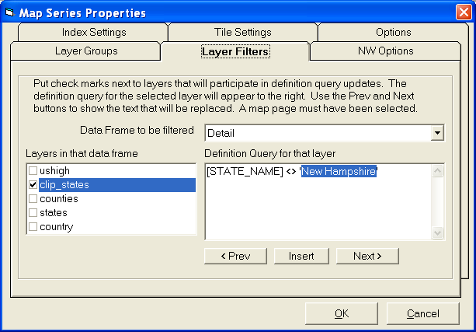
Figure 23 - The Layer Filters tab of theSeries Properties Dialog. From here, definition queries of any data frame can be marked to become dynamic based on map page changes.
- Load the map page that you chose earlier in the unique values section of the query builder. Note that the central polygon of this map page is displayed in white, while the other surrounding polygons of the first map page layer appear underneath in a different color (figure 24). Double click on a different map page, and note that the current page is again highlighted with a lighter color background polygon.

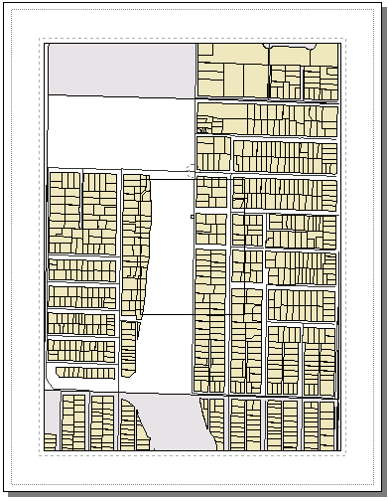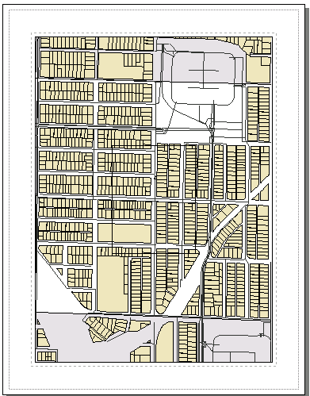
Figure 24 - Evidence of a dynamic definition query on two map pages. Note the white polygon for the current map page against the light grey of the adjacent map page polygons.

- Adjacent Map labeling

Overview

The base DS Map Book application only provided the means to label adjacent map pages with a single default text symbol, and then to only display this at the very edge of the map. The NW Map Book application goes further by providing an interface to
- Indent the adjacent map label either inside or out of the map edge
- define named text symbol types,
- assign a symbol name to any given map page, and
- establish a default symbol to be applied to map pages without an assigned symbol.
The orientation of adjacent map titles has also been altered from the base code to be “right reading”, as required to be consistent with existing NW map books.

Directions

To indent labels of adjacent maps:

- Access a map series properties either by
  - Creating a new map series as described earlier in this document, or
  - right clicking a completed map book and selecting “Series Properties…” from the context menu that appears (figure 8)
- In the third page of the Map Sheet Wizard (figure 5), and in the “Options” tab of the Map Series Properties dialog (figure 26), place a checkmark by “label neighboring tiles”.
- Enter some number into the text box labeled “Label Indent(in):”. This number will be in inches from the edge of the map. An indent value of 0 will cause labels to straddle the map edge. Positive numbers will indent adjacent map labels into the map, negative numbers will push labels out of the map.
- Click [OK] to apply the settings.
- Load some map page so see the indented labels. Be sure to select a map page that topologically touches at least one other map page.

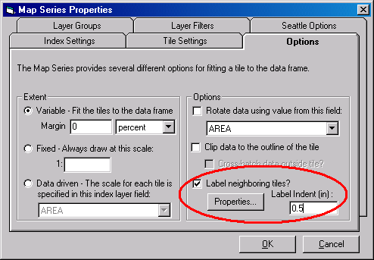
Figure 25 - Interface for managing adjacent labels. This interface is also present in the third tab of the wizard for creating new map series.

To define a text symbol for adjacent map labeling:
- Access a map series properties either by
  - Creating a new map series as described earlier in this document, or
  - right clicking a completed map book and selecting “Series Properties…” from the context menu that appears (figure 8)
- In the third page of the Map Sheet Wizard (figure 5), and in the “Options” tab of the Map Series Properties dialog (figure 16), place a checkmark by “label neighboring tiles”.
- Click the [Properties] button. This will open the dialog for managing adjacent map label symbols (figure 27).
- Within this dialog, you can create, delete, rename, or alter the settings for any text symbol you choose to name. To create a new text symbol, click [Add]. A new listing called “New Label Symbol” is created.

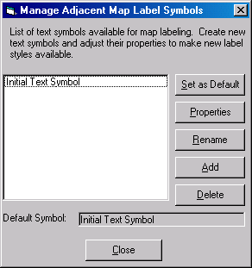
Figure 26 - Dialog for managing properties of adjacent map symbols. The names created here will become available when right clicking individual map pages.
- Click on the “New Label Symbol” entry, then click the [Rename] button. Enter some new name for this label symbol such as “Blue Text”.
- Click the [Properties] button to adjust the symbol colors, sizes, and other properties.
- Click [Close] in the symbol management dialog, then [OK] in the series properties dialog. The newly created symbol should now be accessible to map pages. If accessing these symbols from the new map series wizard, click the [Finish] button.

To create a text symbol similar to those used in NW adjacent maps:
- Follow the steps above to define a text symbol for adjacent map labeling.
- Within the “Manage Adjacent Map Label Symbols” dialog (figure 27), click the [Properties] button.
- In the “Editor” dialog that appears, select the “Advanced Text” tab.
- Click the “Text Background” checkbox, and click the [Properties] button for the text background.
- The property type should be “balloon callout” by default, and should be displayed near the top of the dialog. Change this to “Marker Text Background” in that drop down menu.
- Change the color to white.
- Click the [Symbol] button to open the “Symbol Selector” dialog.
- Within the “Symbol Selector” dialog, select the “Circle1” symbol and click [OK].
- Make the text scale to the symbol by clicking the check box for “Scale marker to fit text”. Alternatively, set the size of the marker for a fixed circle size.
- Click [OK] to return to the main text symbol properties “Editor” window.
- Click [OK] to return to the “Manage Adjacent Map Label Symbols” dialog.

To assign a named text symbol to a map page:
- Follow the steps above to define a text symbol for adjacent map labeling.
- Return to the “NW Mapbook” tab in the table of contents pane of ArcMap.
- Right click a map page, select “Adjacent Page Symbol” -> “Select Other …” (figure 28). The “Select Adjacent Symbol” dialog should appear (figure 29).
- Select the desired text symbol then click [OK].

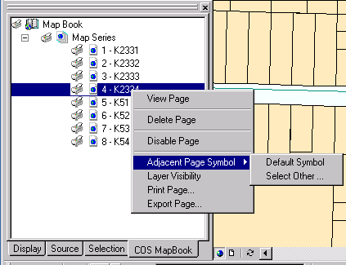
Figure 27 - Context menu for accessing adjacent map symbols.
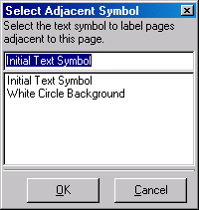
Figure 28 - Dialog for choosing a text symbol for a given map page. Adjacent map labels will be displayed using the selected symbol.

To establish a default text symbol:
- Access a map series properties either by
  - Creating a new map series as described earlier in this document, or
  - right clicking a completed map book and selecting “Series Properties…” from the context menu that appears (figure 8)
- In the third page of the Map Sheet Wizard (figure 5), and in the “Options” tab of the Map Series Properties dialog (figure 26), place a checkmark by “label neighboring tiles”.
- Click the [Properties] button. This will open the dialog for managing adjacent map label symbols (figure 27).
- Select an existing name symbol, or create a new symbol name you wish to make the default symbol.
- Click [Set as Default]
- Click [Close] to close the symbol management dialog.
- Click [OK] to close the Series Properties Dialog, or [Finish] if accessing these symbols from the new map series wizard.

- Map Page Based Layer Visibility and Layer Visibility Groups

Overview

In the basic DS Map Book application, layers that are turned on for one map page remain on for all other map pages. This is a problem for some users, requiring entire new map series to be created whenever certain map pages have a different set of layers that need to be turned on or off. If several patterns of visible layers existed for a map series, that many map series needed to be made in DS Mapbook. The NW Map Book application provides the means to automatically control which layers are visible in any map page within a single map series. It is possible to declare “layer visibility groups” that define certain named combinations of visible map layers, then to assign map pages to that named visible layer combination.

The entire purpose of layer visibility groups is to speed up the update process when layer visibility settings change. Once a large number of map pages are participating in a certain selection of visible layers, sometimes a layer is added to or removed from many map pages. Rather than visiting one map page after another, applying this layer visibility setting repeatedly, you instead make the change once in the visibility group, and the settings are automatically applied to all maps participating in that group.

Directions

To assign visible layers for a single map page:
- Right click a map page. Select the “Layer Visibility” option in the context menu that appears (figure 30).
- A dialog window should appear controlling visible layers for that map page. (figure 31). Leave check marks only next to those layers to keep visible in this map page.
- Click [OK] to save the settings.

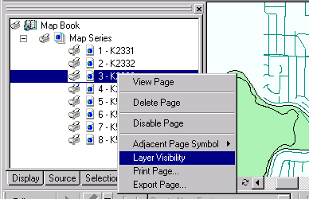
Figure 29 - The layer visibility context menu item.
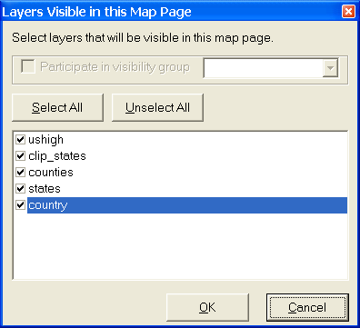
Figure 30 - The map page visible layers dialog. Note that the option to participate in a layer visibility group is disabled. No group was defined at the time of the screen shot.

To create a visible map layer group:
- Right click the “Map Page” section within the ArcMap table of contents “NW MapBook” tab, then select the “Series Properties…” item (figure 8).
- In the series properties window, select the “Layer Groups” tab (figure 32).
- Click [Add Group]. You will be prompted with a new window requesting the name you wish to assign to the group.
- Enter the new layer visibility group name, and click [OK].
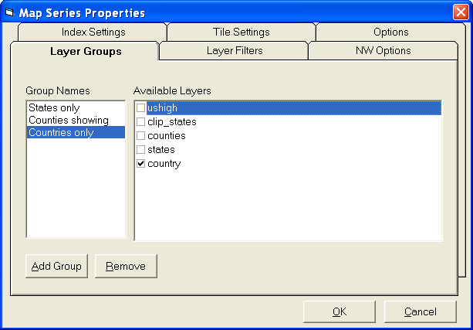
Figure 31 - The layer groups tab of the series properties dialog window. Initially, the list of group names on the left will be empty.
- With the group name selected on the left, choose the layer visibility settings for that group on the right hand side.
- Click [OK] to close the series properties dialog when the desired layer visibility selections are complete.

To assign a map page to a layer group:
- Right click a map page. Select the “Layer Visibility” option in the context menu that appears (figure 30).
- A dialog window should appear controlling visible layers for that map page. (figure 33). Place a check mark next to the option to participate in a layer visibility group.
- Select the desired visibility group in the drop down menu to the right. Options to alter individual layer visibility settings are disabled since this is now group controlled.
- Click [OK] to apply the settings.

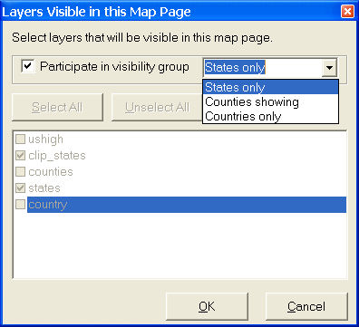
Figure 32 - Layer visibility management dialog with visibility groups enabled.

- Altering Text Elements per map page

Overview

Some text in each map is altered from one map page to the next. The basic DS Map Book application provides some limited support for this, permitting the computer date or the map title to be updated into a map page. A means now exists to expand this support to attribute fields of the polygon layer that defines the map pages. One example use of this is the extended map identification information in the lower right corner of maps in the Mapping Group Water System Map Series.

Directions

- Shift to ArcMap’s layout view. One way to achieve this is through the main menu commands View -> Layer View.
- Insert a text element by running the main menu commands Insert -> Text.
- Position the text element to some desired map location and resize as desired using the mouse.
- With the text element still selected in the layout view of the map, right click the “Map Series” text section within the “NW MapBook” tab of ArcMap’s TOC. In the context menu that appears (figure 8), select the “Tag with Index Layer Field …” menu item.
- In the “Tag with Index layer field” dialog window that appears (figure 34), select the single attribute field that will be used as the data source for the text element.
- Once the attribute field selection is made, click [OK].
- Initially, the text element will contain only the name of the assigned attribute field. To see the attribute field content applied to a text element, load one or more map pages.

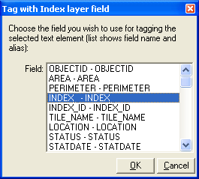
Figure 33 - Index attribute field selection dialog. The text element will be populated with the contents of the selected field whenever a map page change is made.

- Per map page layout element (legend, north arrow, etc) visibility control

Overview

Map series will often contain both portrait and landscape oriented maps. A north arrow or legend well placed aside a portrait oriented set of data will be poorly placed with a landscape oriented set of data. Legends, North Arrows, or other layout element graphics that can appear for certain pages, but be invisible on other map pages allow layout element placement in a mixed orientation map series.

This feature will allow the user to tag certain layout elements to be controlled when a map page is loaded. Only tagged elements will have their visibility managed per map page. Layout elements such as text elements, data frames, and detail insets are managed by other features of the map book application, so this feature was designed to ignore such elements.

Directions

Three steps are required to control the visibility of a layout element.

- Tag the element.
- Set the visibility of that element in one of the two interfaces provided.
- Load a map page.

In more expanded detail, the steps to tag an element are as follows.

- Tag the element
  - In ArcMap’s layout view, click on the element to select it. (figure 34)
  - Once the element is selected, navigate to the NW MapBook tab in ArcMap’s table of contents, and right click the “Map Series” text.
  - In the context menu that appears, select “Tag as Visibility Managed”. (figure 35).
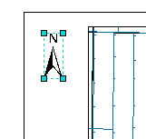
Figure 34 - A selected north arrow layout element.
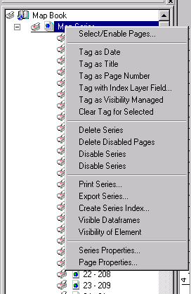
Figure 35 - Map Series context menu. Note the "Tag as Visibility Managed" and "Visibility of Element" menu items.
- Set the visibility of that element in one of the two interfaces provided.
  - “Visibility of Element” tool. This tool controls the map pages where an individual layout will be visible.
    - Select a single layout element
    - Right click the “Map Series” in the NW MapBook tab, and select the “Visibility of Element” menu item. (figure 35).
    - In the dialog that appears (figure 36), leave check marks only for those map pages where the element should be visible. This dialog window can be resized for your convenience in case the number of map pages is large.
    - Click the [OK] button.
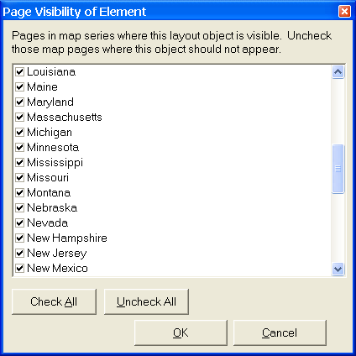
Figure 36 - Dialog window controlling on which map pages a single selected element will appear.
  - “Visible Elements” tool. This tool controls which layout elements will be visible on an individual map page.
    - In the NW MapBook tab, Right click a map page where you wish to control the visibility of layout elements.
    - In the context menu that appears, select the “Visible Elements” menu item (figure 37).
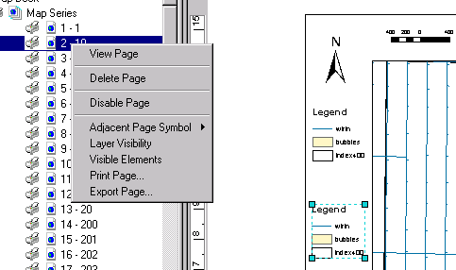
Figure 37 - Context menu for a map page. Note the Visible Elements menu item.
    - In the “Set Visible Objects” dialog window, leave check marks next to only those layout elements that you wish to be visible on this map page.
    - Click [OK] to apply the settings of this dialog.
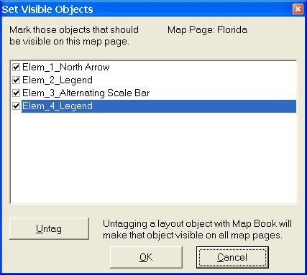
Figure 38 - Dialog window for controlling the tagged layout elements that will be visible on this map page.
- Load a map page

In the NW MapBook tab, double click on a map page to load it and view the settings you have applied. Layout elements should appear or not depending on the settings you made.

- Multiple Dataframe Map Page Extents

Overview

This feature allows users to control extents of data frames beyond just the main map data frame when map pages are loaded. Normally, a map page polygon used in the map series sets the extent only for the main data frame and identifier maps when a map page is loaded. If you wanted to add a general purpose data frame, and have that data frame be updated on page load events, that option was unavailable prior to the creation of this feature.

The polygons defining the extent of other data frames can be the same as the map page polygons of the main data frame, but they do not have to be the same. You just need to have some text based attribute field of the new polygon feature class where the text in the polygons matches the map page names of the main map series. One a map page of a given name is loaded in the main series, the polygon with a matching name is used to set the extent of some other data frame.

General Directions

These directions are focused on the general case of adding data frames, and having the software update their extent based on a map page polygon layer.
- Create a new map series following the standard procedure. Refer to the section at the beginning of this document entitled “Multiple Map Pages per ArcMap MXD” for instructions on this process.
- Add one or more additional data frames to the ArcMap document. This can be accomplished by accessing the main menu => Insert => Data Frame.
- Load a new map page polygon layer into each dataframe you wish to have updated when loading new map pages. This polygon layer should have an attribute field with names of map pages matching those from the main data frame’s map page polygon feature class.
- In the NW Mapbook tab, right click the map series, and select “Series Properties …” to display the Map Series Properties dialog window.
- Select the “Mapping Group Options” tab, and in the “Additional Map Series Data Frames” section, place a check mark next to the names of data frames you wish to control. This will cause the application to load a list of polygon feature classes in that data frame, and will load an initial text attribute field from that feature class.
- Select a feature class to define the map page extents for the current data frame, and select the attribute field that contains map page names that will match the map pages of the main data frame.
- Repeat step 6 for every data frame you select to have updated as map pages are loaded.
- Select a map page extent option that will be applied to all participating data frames. The two options are
  - Use Polygon Extent
This option will set the extent of additional data frames based on the geometry of the polygon whose name matches the current map page in the main dataframe.
  - Use Main Dataframe’s Scale
This option will pan additional data frames to the polygon matching the current map page name in the main data frame, but the extent will be fixed to match the main dataframe’s extent. This can be important for aligning features in another dataframe to the main dataframe.

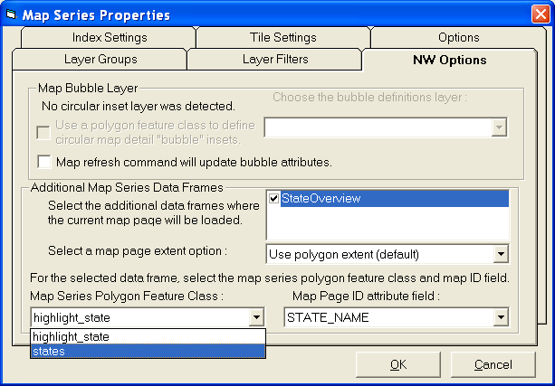
Figure 39 - NW Options tab of the Map Series Properties dialog.

- Map Page Refresh Command

Overview

The Mapping Group Mapbook tools are not part of core ArcGIS functionality. As a result, core tools such as the map refresh command are not built to affect custom cartographic features such as Mapping Group Mapbook detail insets.

This feature will not only delete and recreate detail inset data frames based on current map page polygon attributes, but will also allow users to drag detail insets and/or their source polygons to new locations without the need for the inset editing tool.

Directions

- Create a new map series and enable the feature for loading detail inset bubble polygons. Refer to the “Circular Detail Insets, or map “bubbles”” section of this document for instructions on that process.
- In the ArcMap TOC, select the NW Mapbook tab.
- Right click the Map Series entry, and select “Series Properties …” to open the Map Series Properties Dialog.
- Confirm that the bubble polygons options are set.
- Select the “Mapping Group Options” tab, and set a check mark at the option to “Reload map page when refreshing map.”
- Click [OK] to close the Map Series Properties dialog window.

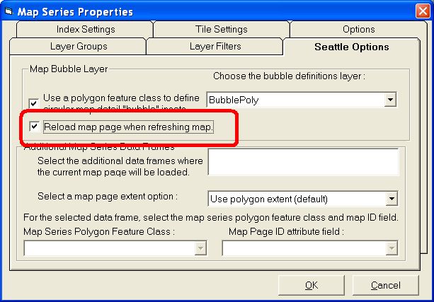
Figure 40 - The option for refreshing the map page when refreshing the map.
- Load a map page with one or more detail insets.
- Select the detail inset dataframe and move it to some other location. Ignore the arrow pointing from where the inset was previously located as that will be moved dependent on the detail inset.
- Click the map refresh command in the lower left of the map window (). Alternately, press the F5 key while ArcMap is selected.
- The detail inset polygon will have been automatically updated to reflect the new location of the detail inset.
- Now move the detail inset source polygon, and refresh the map.
- The contents displayed within the detail inset will reflect the new location of the detail inset source polygon.

Review

The features explained above were built during a budgeted contract with the ESRI Northwest Services Group. The specification of these features was the result of joint efforts between Mapping Group and ESRI Northwest staff. Maintenance and upgrade requests for these features should be directed to the Mapping Group, to be handled by members of their team. Alternately, such modifications to these tools can be contracted with the ESRI Northwest services group.

