NW Mapbook is a tool resulting from several ESRI Northwest RO Services projects. This tool:
- provides some map production capabilities for ArcMap in ArcGIS Desktop
- has more features than DS Mapbook, fewer overall than MPS Atlas, and some unique features
- is customizable, unlike MPS Atlas (so far).
- is free (unlike MPS Atlas), but is not supported by ESRI technical support
Highlights of NW Mapbook:
- Features inherited from DS Mapbook:
  - Ability to create a Map Series where each map pages are defined by polygons in a data layer
  - Multiple Map Pages can be printed or exported with a single command
  - Dynamic Map Text - can change for each map page based on map tile polygon attributes
  - Data driven Map Page extent and rotation
- Features shared with, or similar to MPS Atlas Features:
  - Controlling map pages where layers are made visible
  - Layout element (north arrow, legend, etc.) visibility per map page
  - Dynamic Definition Queries – definition queries are updated when map pages are loaded.
  - Multiple Data Frame Extent Control – more than 1 data frame’s extent updated when map pages are loaded.
- Features unique to NW Mapbook
  - Data Driven Detail Insets – a “bubble” polygon layer tells NW Mapbook where to make detail inset data frames
  - Adjacent Map Label Symbol Control – Assign per map page your own text symbol to adjacent map labels.
  - Synchronize Data Frame Scales – other DFs can fit to a polygon with same name as main DF’s current map tile

Where to Access NW Mapbook: ftp.esri.com, login: nwmapbook password: nwma1456
Please contact rhunter@esri.com if this login does not work. Files will be added to this site throughout this week.
Space is unavailable to showcase all NW Mapbook features, but here are some selected illustrations.

Sample Use of Detail Insets.
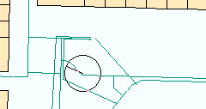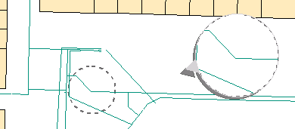
NW Mapbook supports creating and moving insets and source circle polygons with mouse.

Dynamic Definition Query Samples
A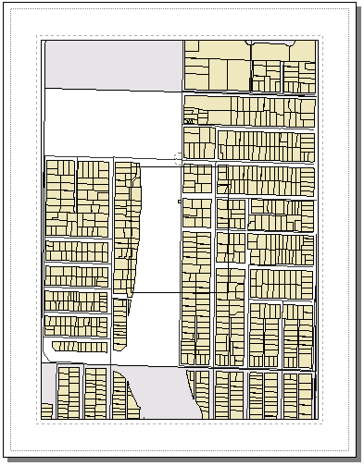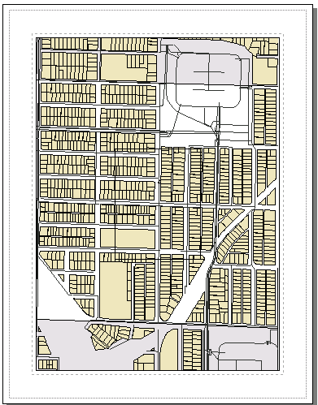 B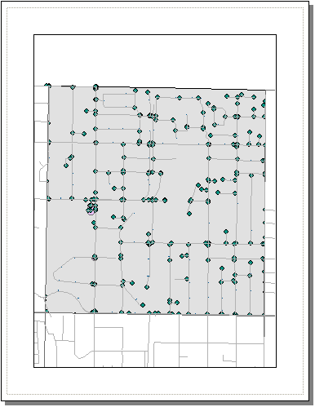 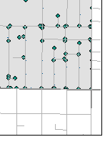
Definition query used to (A) highlight current map page, and (B) filter visible data using two map tile layers.
Multiple Data Frame Control
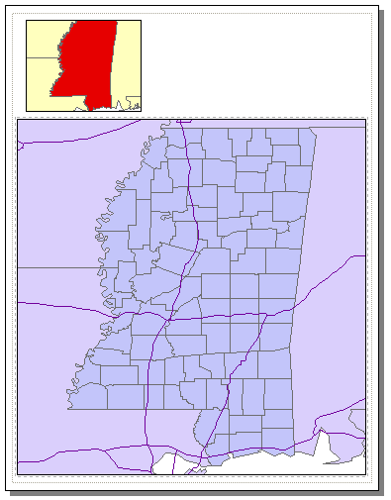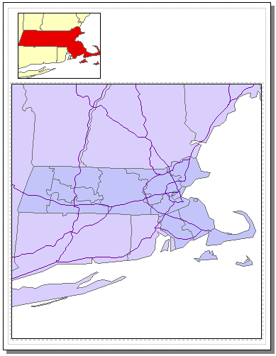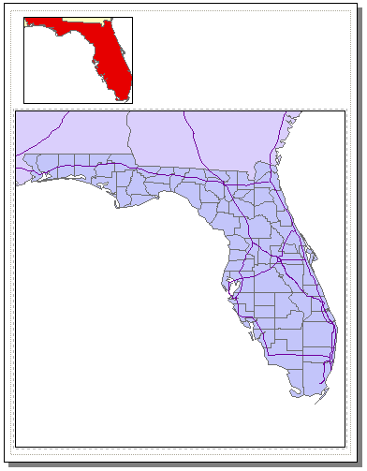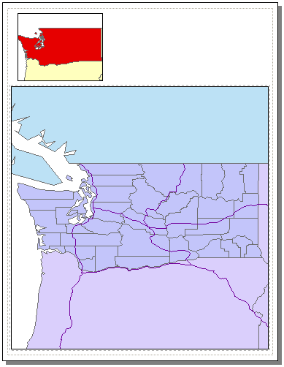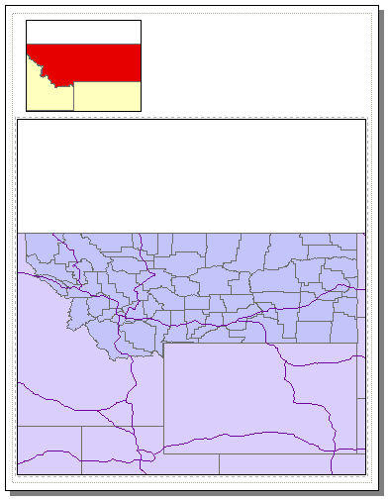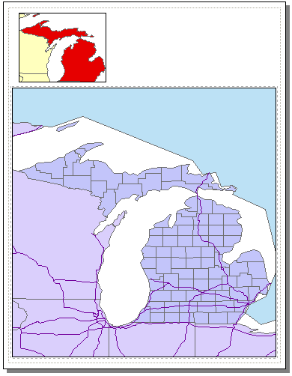
DS Mapbook updates a single data frame when map pages are loaded. NW Mapbook can update many dataframes.

