Many times I wished to copy files to Temp folder using “Send to” menu from Windows Explorer.

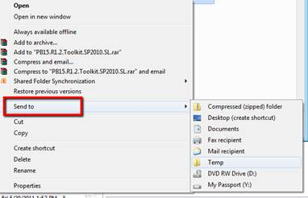

Here is a little trick I found that will do just that.

Type in the Run window:  **%APPDATA%\Microsoft\Windows\SendTo**  and click OK button.

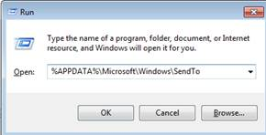

This will open up the following folder. Add shortcut to your “Temp” folder here.

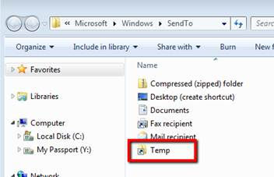

Try your “Send To” menu. Now you can send files or folders directly to your Temp folder.

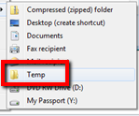

Next, the natural question was can I use the same technique to move files to my SharePoint document library?

This turnout to be even simpler. Just map a drive to SharePoint document library that you want to use as destination. And the mapped folder will appear in “Send to” menu.

Here’s what you need to do, start by mapping a folder to SharePoint document library.



Enter the URL to desired document library, for example I chose “http://myportal/<site_name>/Shared Documents/KB Article”.



After completion, a map drive icon appears under the Computer icon.



Test out by trying to upload a file to SharePoint document library from Windows Explorer.



Now browse to document library from internet explorer. And voila the file is in the SharePoint.

I tried this feature on Windows 7 but pretty sure should work the same way on Vista and Windows 2008. This is a simple trick but can save time and aggravation when piles of files are in question.

Enjoy!