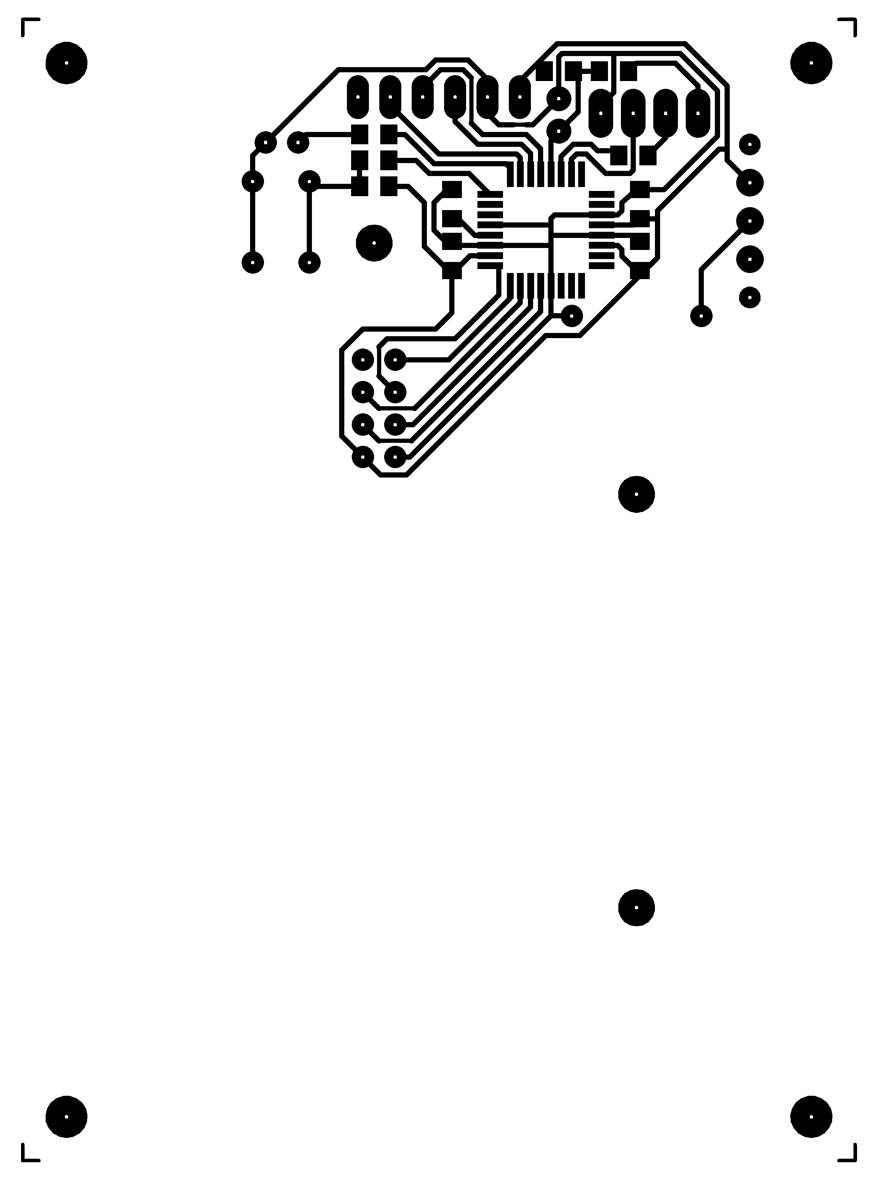 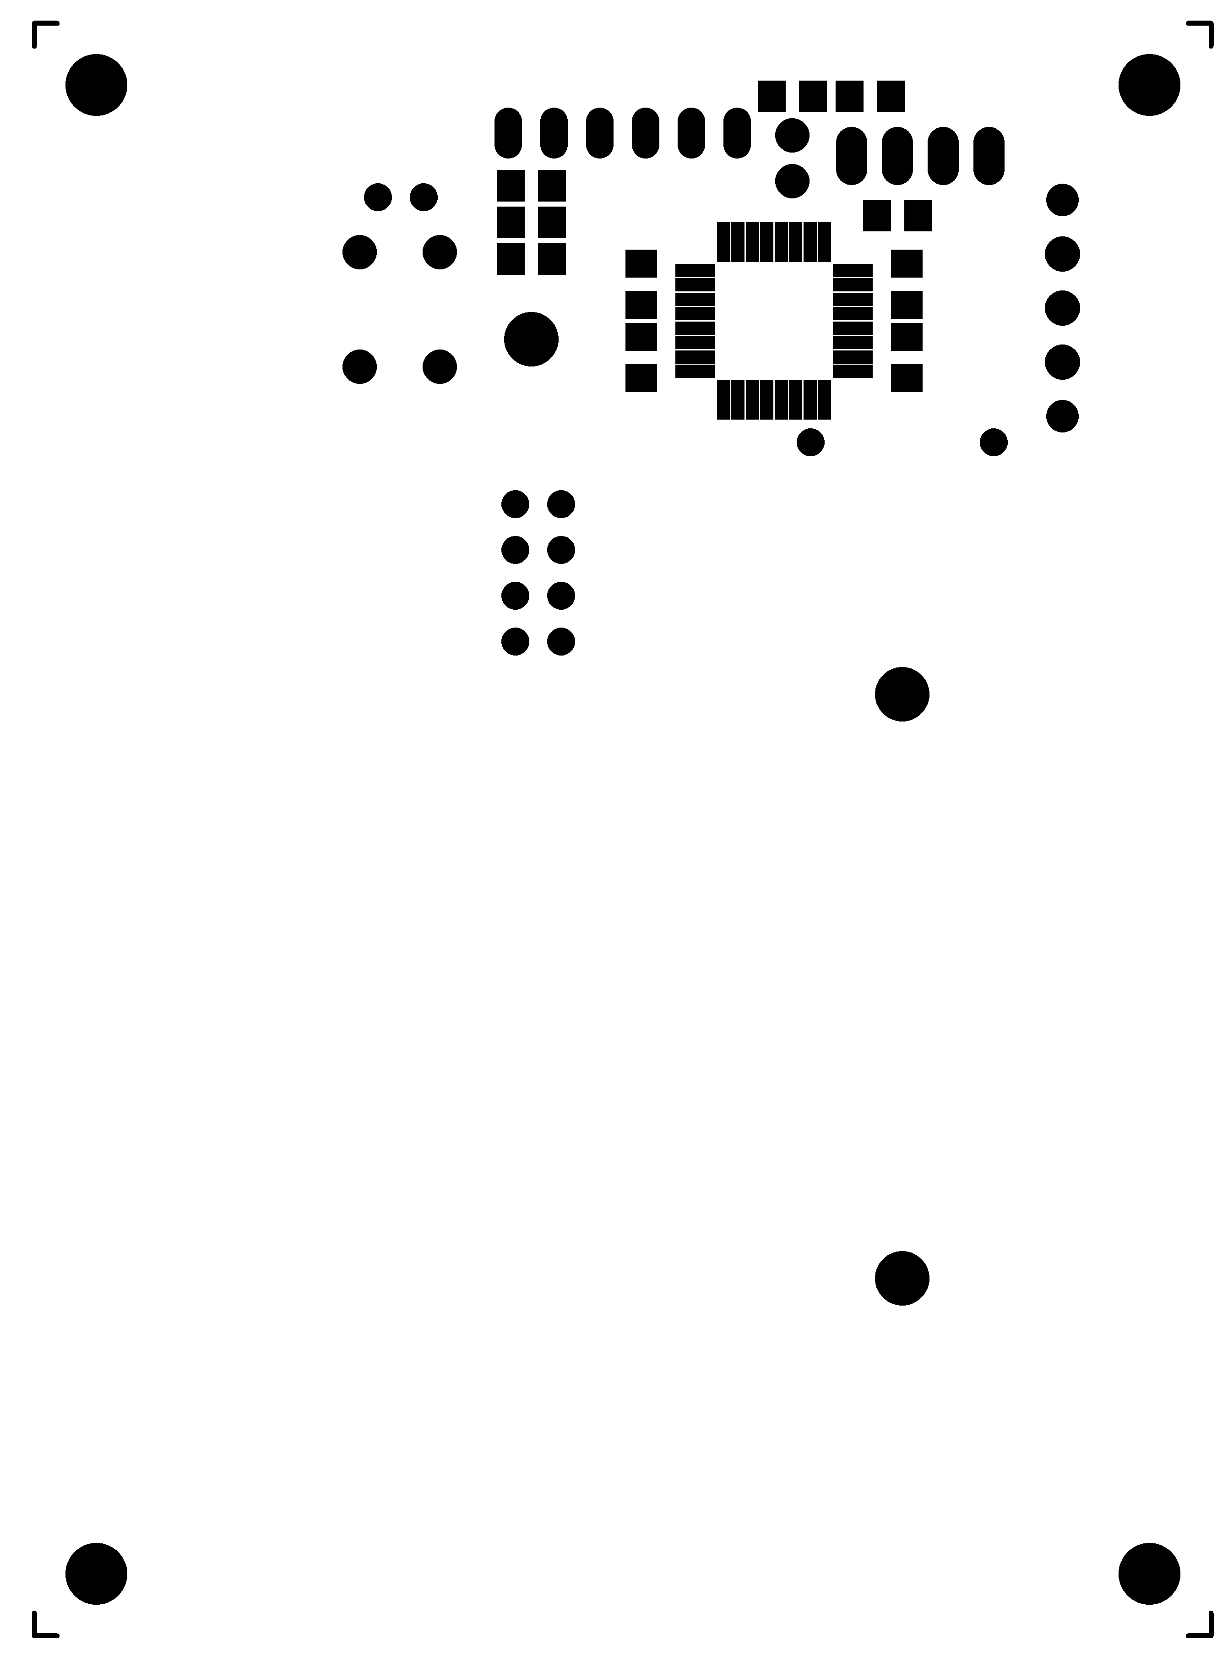

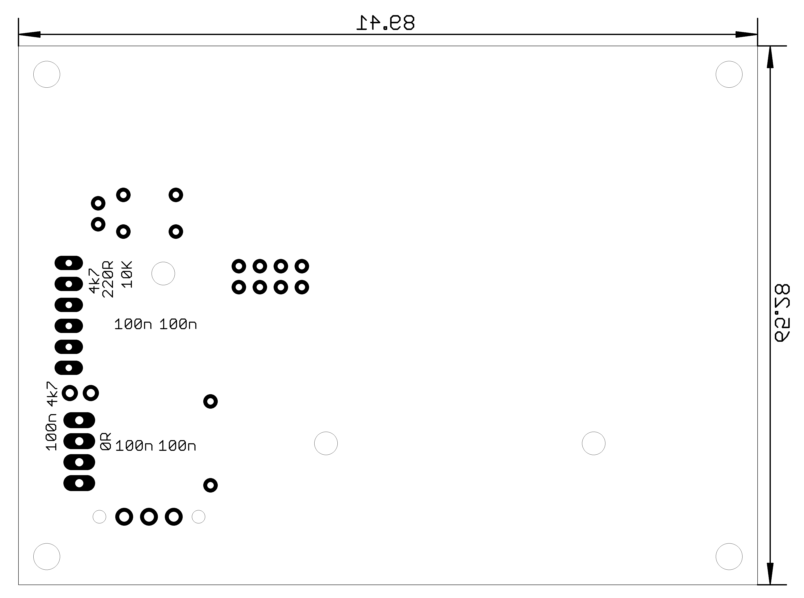

Qty Value Device Package Parts Description

1 LED'3MM' LED3MM LED1

1 0R R'2' R0805 R2

5 100n C-CERAMIC'SMD' C0805 C1, C2, C4, C5, C6

1 10K R'2' R0805 R5

1 220R R'2' R0805 R6

1 2xAA BATTERY_1X'DOUBLE' 2XAA_BATTERY_HOLDER BAT1

2 4k7 R'2' R0805 R1, R9

1 ATMEGA328P-AU ATMEGA328P-AU QFP80P900X900X120-32N U1 8-bit Microcontroller with In-System Programmable Flash

1 BUTTON'THT' BUTTON'THT' BUTTON BUT1

1 CASE'120X80X40' CASE'120X80X40' CASE-120X80X40 U$9

4 CORNER CORNER CORNER U$1, U$2, U$3, U$4

4 HOLE HOLE HOLE U$5, U$6, U$7, U$8

1 NRF24L01 NRF24L01 NRF24L01 U2

1 PINHD2X1 PINHD-2X1 PINHD-2X1 JP2

1 PINHD3X1 PINHD-4X1 PINHD-4X1-90 JP3 PIN HEADER

1 SWITCH_SLIDE SWITCH_SLIDE SLIDE_SWITCH SW1

1 TMP102 TMP102 TMP102 U3