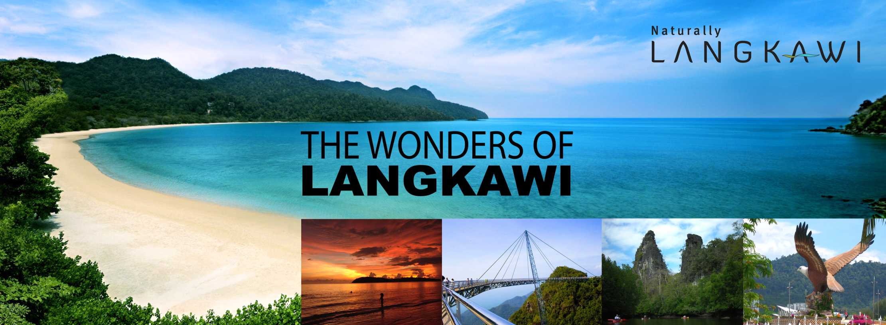
MAXCAP’S LANGKAWI LEADERSHIP SEMINAR (3D2N).
- Period of Promotion. 20/02/2014 till 30/04/2014.
- Venue: Langkawi (Hotel – to be confirmed)
- Date: 28th-30th June 2014. (Subject to change).

How to Qualify?
- Introducer: Direct sponsor will enjoy a full qualification (1 Ticket) When he accumulates USD30K of “DIRECT” sponsor within the period.
- Investor: Any investment of USD20K will qualify a full qualification (1 Ticket).

FULL QUALIFICATION’s ENTITLEMENTS:
CP1 – *150PV for Air Ticket / Transportation Cost to Langkawi & 3D/2N stay in
Langkawi Hotel,
*To attend a Seminar.
*A poolside BBQ (1st night).
*A Gala Dinner in a Hotel (2nd night).
*2 Hotel Breakfast Voucher.

@ (1) All benefits only apply to attendants only!
(2) No replacement / Transfer is allowed in this qualification to attend the trip!
(3) Final confirmation is proved by qualifiers’ air tickets or deposit (usd100CP1).
(4) Failure to attend the event, the qualification / deposit will be forfeited!



“MAXIM PREMIUM GOLD CLUB”

HOW TO QUALIFY AS A CLUB MEMBER:
  - 1st: An Investor must qualify the Langkawi Seminar Promotion within the Period 20/02/2014 – 30/04/2014.

  - Upon Qualified, if the investor invests Additional usd20k (can be under different user’s name – please specify in this case) or more, THEN he/she will qualify as a MPGC member.

  - For SPONSOR: first qualify yourself to Langkawi Seminar, direct sponsor usd30k, after that if you accumulate the direct sponsor to usd60k. CONGRATULATIONS: You will qualify as a GOLD CLUB member, any additional sales after usd60k, for example in 90k or more, there is EXTRA incentive to be given later.

