1. Click on Left Menu “Super e-Share Swap”   
   点击会员专区左侧“超级电子股份转换”

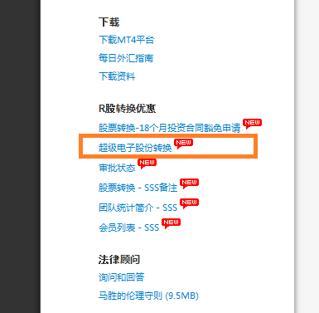

1. Select the MT4 ID that you wish to swap  
   选择需要转换MT4交易账户  
   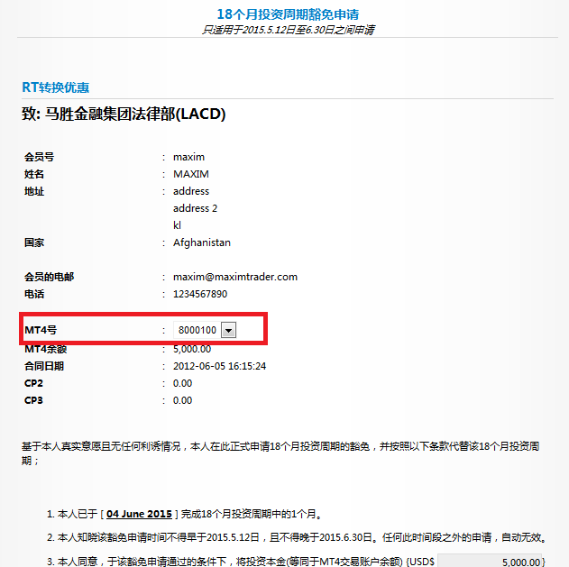
2. SES calculator will show the volume of RT2 after swapping. Enter your security password and click Submit button.
3. 系统会自动计算显示出转换完成之后的RT2数额。输入“安全密码”，并点击“提交”按钮。

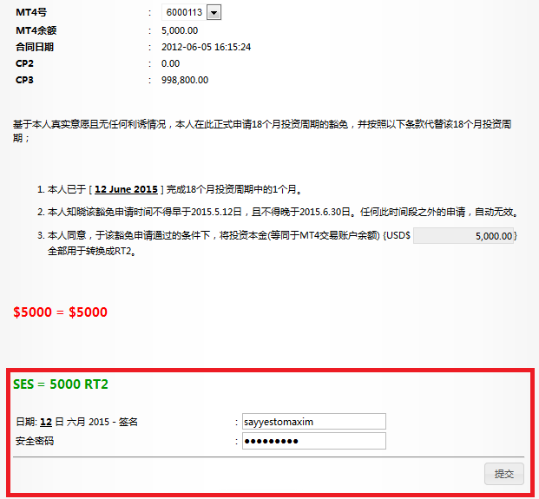

1. Confirmation page

确认页面

1. Click on Submit Button, System will prompt successful message.

点击“提交”按钮，系统会显示提交成功信息。

1. Please kindly note that by opting to Swap, you will cease to earn more Monthly Investment Return within the contract; and the selected CP2 & CP3 amount will be deducted from your account.

请注意：当您选择股票转换之后，您将不再继续享受每月投资分红；您自选的CP2/CP3金额也将会从您的账户中扣除。

