IN THIS UPDATE
• Sections Summary and State Qualifiers
• State Bag Stuffing + Social Hour - TODAY
• State Week Information
• Final Dine2Donate - MONDAY
• End of Year Celebration - TUESDAY
━━━━━━━━━━━━━━━━━━

LEGACY OF SECTIONS
59 athletes competed. 30 boys and 29 girls...

 32 podium performances

 8 Section Championships

37 Personal Bests at the Finals Meet on Friday. 1 school record set!
We look forward to celebrating these and ALL our student athletes on Tuesday. See results here: MGSH Section Results

NEW SCHOOL RECORD
Congrats to the girls 4x200m Relay Team- Sophia, Nora, Eva, Lilly. Putting their name up on the board with MGSH record setters!!
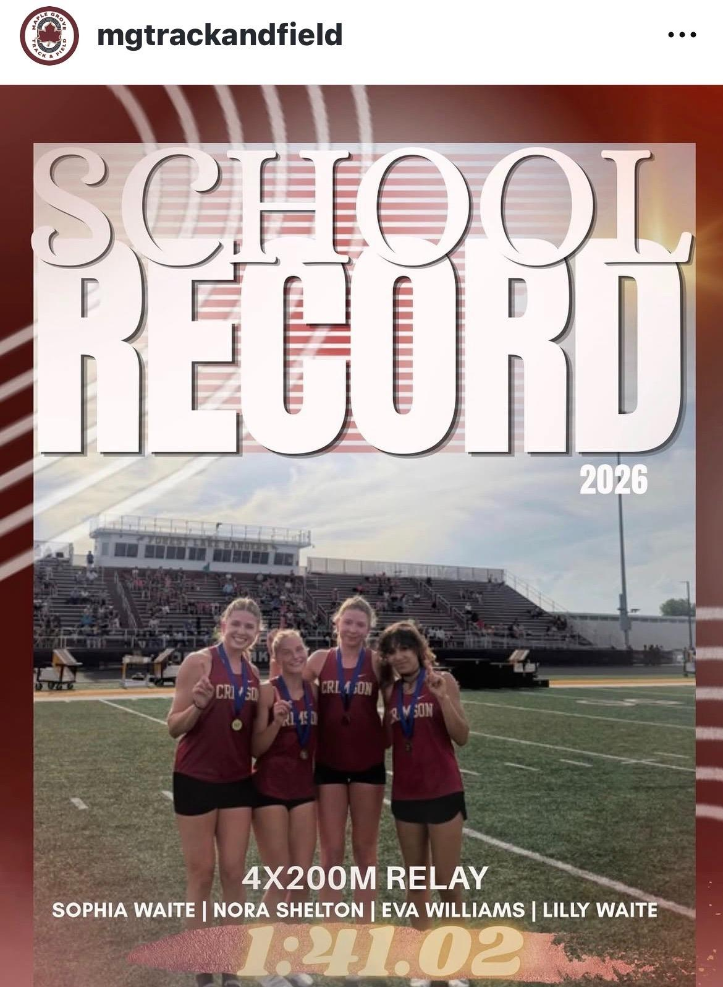
ON TO STATE!
What a week for Crimson Track & Field.
FRIDAY WAS A SIGHT TO SEE! Our student athletes shined by sending 18 athletes to the MSHSL State Meet, including 9 athletes with individual state-qualifying performances and 5 state-qualifying relay teams!
Congratulations to our Crimson State Qualifiers:
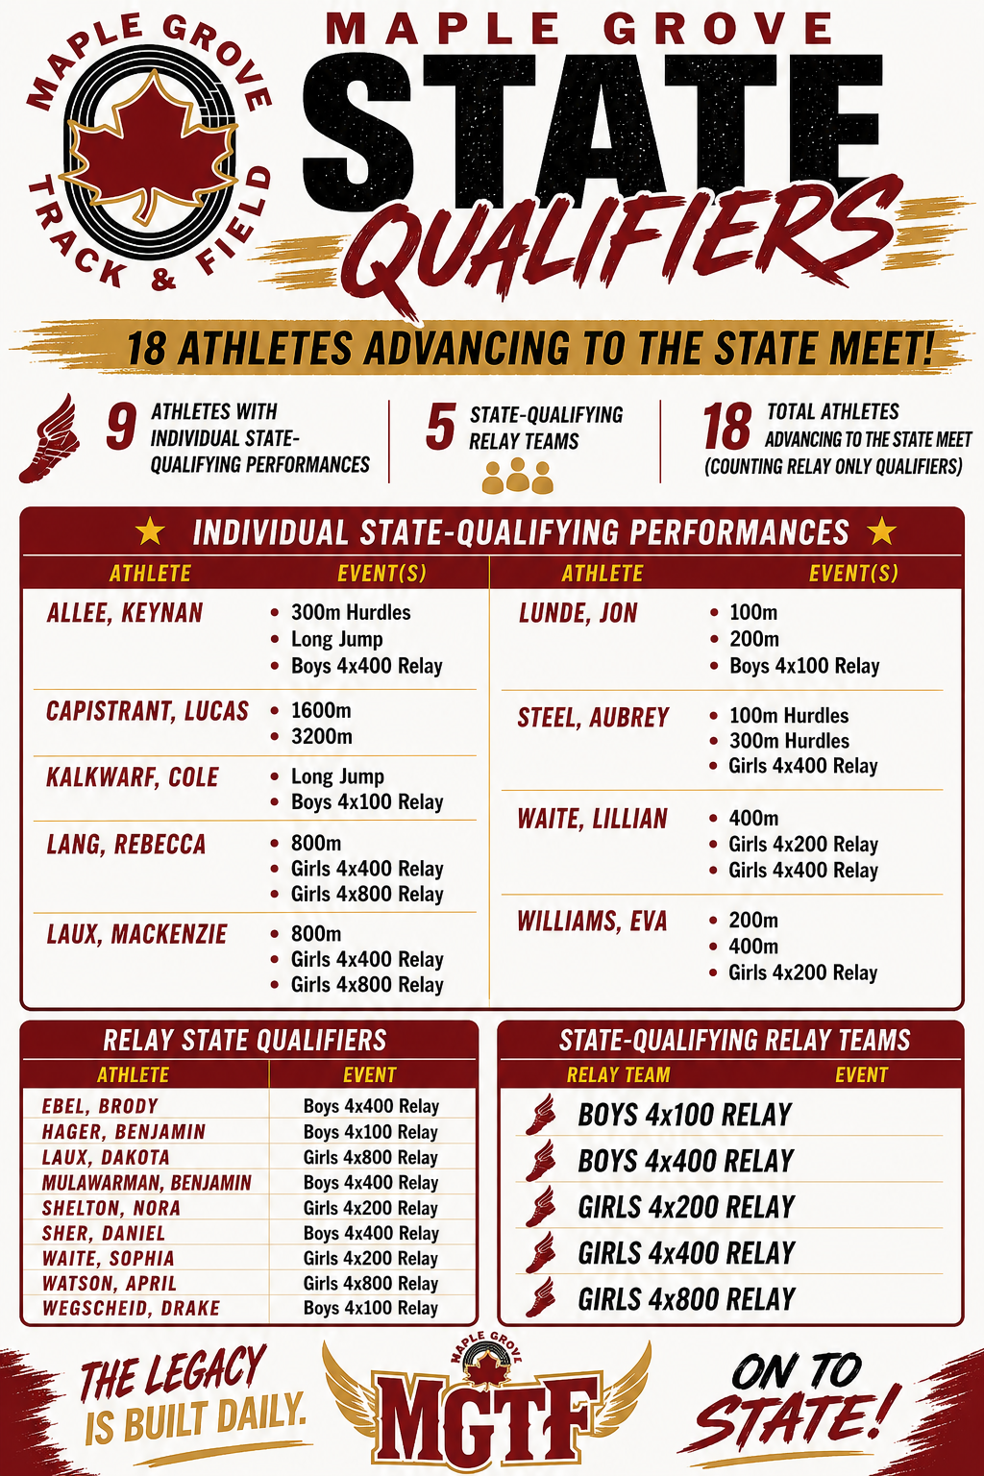
Congratulations to all athletes and coaches on an incredible Sections performance. The hard work, commitment, and daily pursuit of excellence continues to pay off.
The Legacy is Built Daily.
━━━━━━━━━━━━━━━━━━

STATE WEEK INFORMATION
The Crimson will compete at the MSHSL State Track & Field Championships next week. Prelims Thursday AM & Finals Saturday PM.
All info in HelloTeams or on MSHSL website: https://www.mshsl.org/sports-and-activities/track-and-field-girls
Spectator guide: https://www.mshsl.org/sites/default/files/2026-05/2026-track-and-field-spectator-guide.pdf
Let’s pack the stands and cheer on our Crimson athletes as they compete against the best in Minnesota. If you can’t make it join us at bag stuffing to send them on with success.
━━━━━━━━━━━━━━━━━━

STATE BAG STUFFING & SOCIAL HOUR
STATE BAG STUFFING & SOCIAL HOUR TODAY!!!

Sunday (5/31)
7:00–9:00 PM
OMNI Brewing

This is always a fun event to meet more track families, ask about the booster club, give feedback, and support athletes heading to State.

A bag stuffing gift/donation is not required to attend.
━━━━━━━━━━━━━━━━━━

FINAL DINE2DONATE
Monday, June 1, 4-8pm
Jersey Mike’s generously donates 50% of all sales!

Shareable link here.
One final chance to support the team this season. Let’s finish strong with a fundraising PB.
━━━━━━━━━━━━━━━━━━
SENIORS
Senior families, please pass the message along to your athletes: Don’t forget to complete your Senior Board and bring it to the End of Year Banquet!
━━━━━━━━━━━━━━━━━━
Tuesday, June 2, 5-8PM
Maple Grove Senior High
5:00–6:00 PM — Food & Social Time
6:00–8:00 PM — Awards & Program
Food Assignments - we ask all families to bring passing dish:
• 8th Grade — Chips or Cheese & Crackers
• 9th Grade — Salads or Breadsticks
• 10th Grade — Drinks
• 11th Grade — Fruit
• 12th Grade — Desserts
━━━━━━━━━━━━━━━━━━
Thank you to every athlete, coach, volunteer, and family who has helped make this season special.
One more week to chase greatness.
Go Crimson!
-MGTF Boosters

