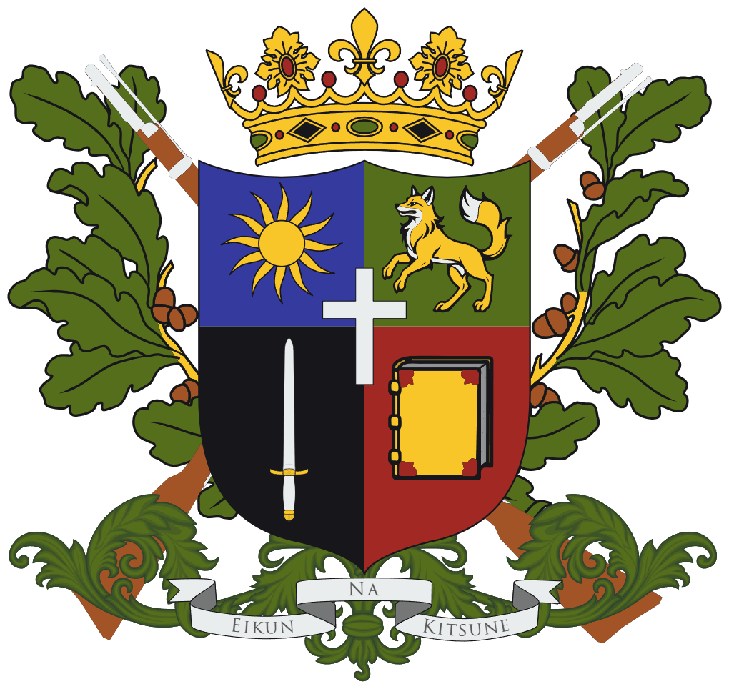
National Catalog for Administrative and Unspecified Offenses
of the Kingdom of Zatsunei

Name: National Catalog for Administrative and Unspecified Offenses
Short Name: NCAUO
GLRI: 2025-08-NCAUO
Area of Application: Nationwide
Legislative Type: Code
Responsible Agency: Ministry of Justice
First Draft: August 14th, 2025
Date of Issue: N/A
Version/Edition: 01
Author(s): King Dezevlo the First

The National Catalog of Administrative and Unspecified Offenses (NCAUO) contains punishable acts defined under laws other than the Criminal Code (CC).

Chapter One
General Regulations

§ 1. Purpose of the Act.
The purpose of this Act is to ensure a higher transparency of actions and decisions in the Zatsunese Government.

§ 2.

