I/ INTRODUCTION

"BVC" is a game modeled after the famous Vietnamese game Flappy Bird. With a high level of inhibition for gamers for a while, a balloon will automatically fly forward and tend to fly up. The player's task is to take the ball over the obstacles or in the game as much cactus as possible to bring the highest record. And the important thing is that the ball cannot touch anything including the sky, ground and cactus which can cause the bubbles to break leading to the end of the game.

II/ GAME RULES

1. PRESS SPACE TO START GAME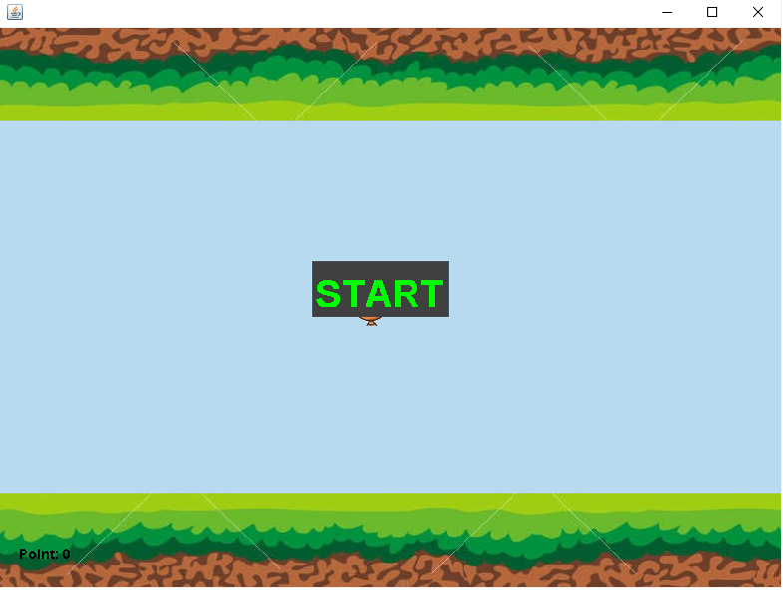
2. PRESS SPACE TO LET IT GET OVER THE OBSTACLES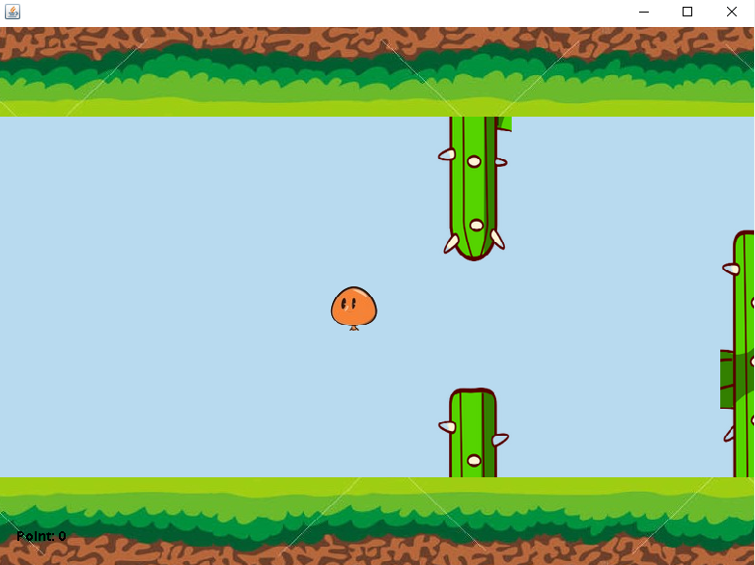
3. YOUR POINT WILL INCREASE 1 AFTER GETTING OVER 1 CACTUS



1. HIT THE OBSTACLE, THEN PRESS SPACE TO REPLAY

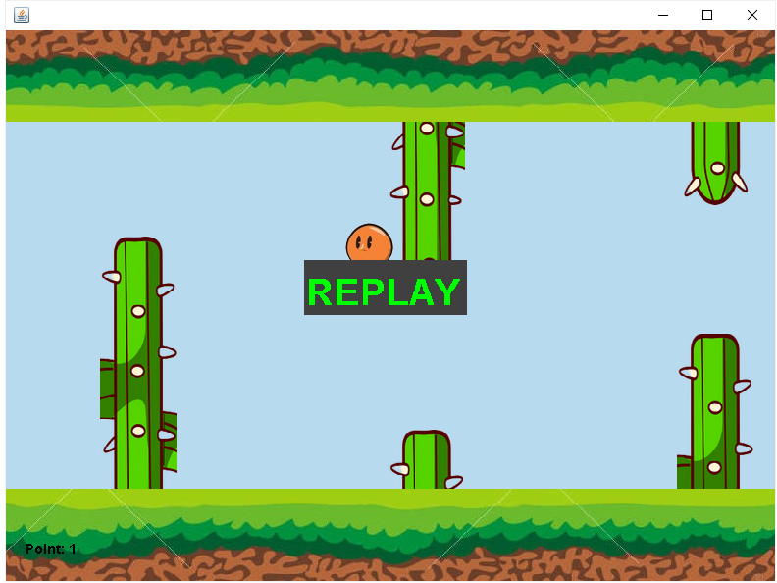

III/ CLASS DIAGRAM

