Set up:
- get assets
- aspect ratio 9 : 16
- canvas 1080 x 1980

Smooth movement: Input.GetAxis("Horizontal");
Making game frame rate independent: Time.DeltaTime (move object at same speed on slow and fast computers)
/// <summary>
/// Move Player horizontally every frame by a deltax, small change in x.
/// Input.GetAxis() increases towards [-1, 1] slowly when you press a, d left or right, thus making movement smooth
/// Will slowly decrease when you let go
/// </summary>
private void Move()
{
float deltaX = Input.GetAxis("Horizontal")*Time.deltaTime;
var newXPos = transform.position.x + deltaX;
transform.position = new Vector2(newXPos, transform.position.y);
}

Boundaries / Clamping movement within the camera: ViewportToWorldPoint
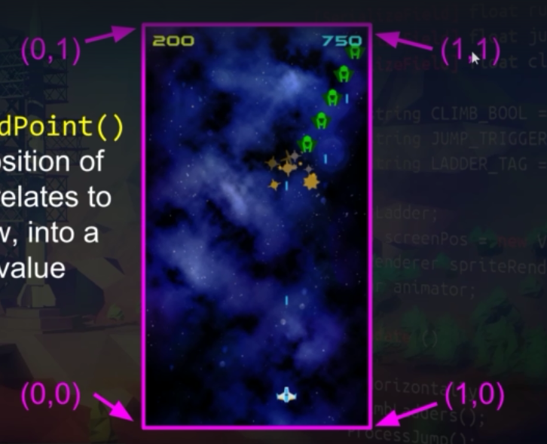
yMin = gameCamera.ViewportToWorldPoint(new Vector3(0, 0, 0)).y;
yMax = gameCamera.ViewportToWorldPoint(new Vector3(0, 1, 0)).y;
var newYPos = Mathf.Clamp(transform.position.y + deltaY, yMin, yMax);

Coroutine: doing something once a condition is met
Ex1
/// <summary>
/// Example co routine : call by StartCoroutine(DoSomething());
/// does something once a condition is met.
/// </summary>
/// <returns></returns>
IEnumerator DoSomething()
{
Debug.Log("hil");
yield return new WaitForSeconds(3);
Debug.Log("sass");
}
Ex2 Firing continuously
private void Fire()
{
if (Input.GetButtonDown("Fire1"))
{
firingCoroutine = StartCoroutine(FireContinously());
}
if (Input.GetButtonUp("Fire1"))
{
StopCoroutine(firingCoroutine);
}
}
/// <summary>
/// Fires forever until corountine is stopped, making a delay of a few milliseconds so it's not 100000 a one second.
/// </summary>
/// <returns></returns>
IEnumerator FireContinously()
{
while (true)
{
GameObject laser = Instantiate(laserPrefab, transform.position, Quaternion.identity) as GameObject;
laser.GetComponent<Rigidbody2D>().velocity = new Vector2(0, projectileSpeed);
yield return new WaitForSeconds(projectFiringPeriod);

}

}

Collisions / trigger
- Add box collider on anything you want to check if they hit
- private void OnTriggerEnter2D(Collider2D collision)
{
Destroy(collision.gameObject);
}
Pathing for enemies: use way points (see EnemyPathing.cs)
Creating waves of enemies (see Enemy Spawner and Wave Config)
Wave config is scriptable object (containing data for each wave and code) that you add to spawner

Dealing with collisions (Collision matrix) or could use tags to say if you have this tag then take damage from collision

Adding scrolling background
- create quad 3d object
- get a background sprite, change to default on texture type
- wrap mode clamp -> repeat
- add texture to quad, change shader to unlit/texture
add script to quad
[SerializeField] float backgroundScrollSpeed = 0.5f;
Material myMaterial;
Vector2 offset;
// Start is called before the first frame update
void Start()
{
myMaterial = GetComponent<Renderer>().material;
offset = new Vector2(0f, backgroundScrollSpeed);
}

// Update is called once per frame
void Update()
{
myMaterial.mainTextureOffset += offset * Time.deltaTime;
}
Particle System

VFX
- get sprite
- add material
- albeido add sprite to material
- shader: standard alpha blended
- add particle system -> renderer change material to material just made
- since it’s a sprite sheet, in particle system, texture sheet animation, change tiles to cols x rows
- change duration, take away looping
- change emission rate, change speed randomly , start lifetime (closer life),start size randomly, add start color as a gradient( so chooses randomly between).change shape to sphere
- add to enemy script to create the particles on death
private void TriggerSparklesVFX()
{
// another object that instantiates the first object at the block's position
GameObject sparkles = Instantiate(sparklesVFX, transform.position, transform.rotation);
Destroy(sparkles, 1f);
}

Audio: see how to game
Add other scenes: see how to game
Use singleton to keep same music playing over scenes, keep same score
Add sorting layer to make laser under player (go into player laser prefab add sorting layer)

