**Title: How Do I Mark my Ballot?**

**Component: ContentPage**

**Published: Published**

**Weight: 4**

**Section: How Do I Vote?**

**Priority: Minor**

**Level: California**

**How do I mark my ballot in the polling place?**

**4. Take ballot to ballot box**

**2. Mark ballot**

**3. Place ballot in secrecy folder**

**1. Sign roster**

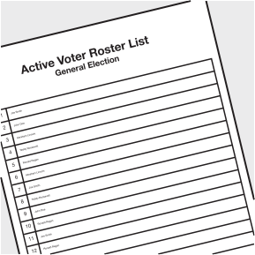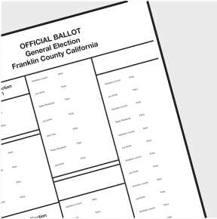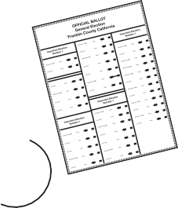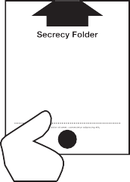

2. Mark Ballot

**Always connect the arrows, even on a write-in**

**Don’t voter for**

**too many**

**Vote for the number allowed**



**How do I mark my vote-by-mail ballot?**

Follow the instructions provided with your vote-by-mail ballot.

1. Mark the vote-by-mail ballot in the manner instructed above for polling place ballots.
2. Place the vote-by-mail ballot in the special envelope provided by your county’s election office.
3. Don’t forget to fill out the required information on the envelope, seal, and SIGN the back of the envelope!
4. If a postage stamp is required then make sure that you put appropriate postage amount on the envelope.