**Title: How Do I Vote at the Polling Place In Person?**

**Component: ContentPage**

**Published: Published**

**Weight: 3**

**Section: How Do I Vote?**

**Priority: Minor**

**Level: California**

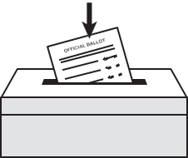**Vote at the polling place in person**

Polls are open on Election Day from 7am to 8pm.

If you provided your voting address, then your polling location is printed here in the “Where do I vote?” section above.

Or, you can contact your County Elections Office to find your polling place.