**Title: How Do I Vote by Mail?**

**Component: ContentPage**

**Published: Published**

**Weight: 1**

**Section: How Do I Vote?**

**Priority: Minor**

**Level: California**

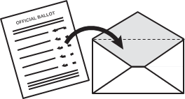**Vote by mail**

Request a vote-by-mail ballot from your County Elections Office.

Make sure that you send in your request so that it’s received by the Elections Office ***no later*** than 7 days before the election by 5 PM.

Follow the directions to fill out your ballot and don’t forget to sign & seal the special envelope provided. You can return the ballot:

* By mail
* Drop it off at a location designated by your county
* Drop it off at any polling place in your county by 8 pm on Election Day.

If you mail it back don’t delay! Mailed ballots must be ***sent*** before or on Election Day and the Elections Office must ***receive*** it no later than 3 days after Election Day.