Background

Step: Collect
While Project Locations can be represented by different types of geometries (e.g. points, lines, polygons), all locations are associated with metadata (i.e. data that provides more details about the location). The latest version of the Project Locations Model (PLM) should be downloaded and used to collect this information.
The PLM should first be validated with the online, browser-based OGM validator tool to ensure that the metadata is error free. The validator tool can also be used to display the Project Locations in the embedded map and conduct a feasibility check to verify whether the locations are displayed correctly. Once verified, the tool generates a GeoJSON file with a unique timestamp and filename that can be downloaded.
Regardless of the Project Locations geometry (i.e. point, line, or polygon), a single prepared file is updated to the online validator. The difference lies in how the file is prepared.
For point-based Project Locations, the two columns, latitude and longitude, need to be completed in the PLM. For multi-geometry-based Project Locations (e.g. lines and polygons), single or additional files containing the geometry features should be prepared in geoJSON format, together with the completed PLM. Columns must be properly filled in the PLM to establish a connection to the features.

Step: Uploading Project Locations to ODP and assigning access
For all Project Locations, the valid GeoJSON file generated by the validator tool can be directly uploaded onto the Open Data Platform (ODP), either by the operations team member responsible for updating Project Locations or with the support of Geodata-Desk. If support from Geodata-Desk is preferred, please send an email with the following information:
- For points-based Project Locations: validated GeoJSON as an attachment
- For Project Locations as lines and/or polygons: validated GeoJSON and geometry files as an attachment
- A list of emails of KfW colleagues who should have access to the dataset. Please ensure that each member has signed in on the ODP at least once, since only members who have accessed the ODP before will appear in the sharing list
- Any urgent deadlines by which the dataset and/or map need to be prepared by
If there are errors in the PLM (Excel template) that cannot be resolved, please also contact Geodata-Desk for further support.
3. Once Project Locations are uploaded onto the ODP, a link to the data resource is generated.
4. To modify access to the dataset afterwards (e.g. sharing with additional colleagues), select Resource - Share functionality. (In German: Ressource > Teilen). Colleagues need to have signed onto ODP at least once for their accounts to be visible and assigned access.
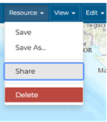
5. A pop-up window will appear where the permissions can be updated for individuals or groups.
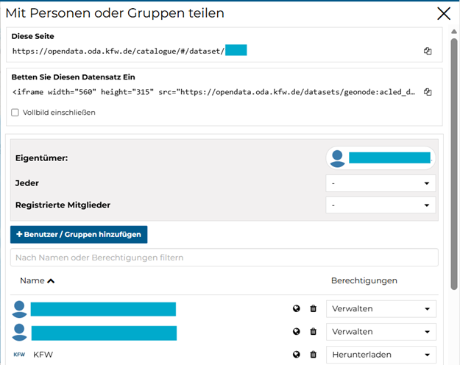
6. Once each individual user has been assigned their permissions, the dataset must be saved (In German: Ressource > Speichern)
