[_map_title_]

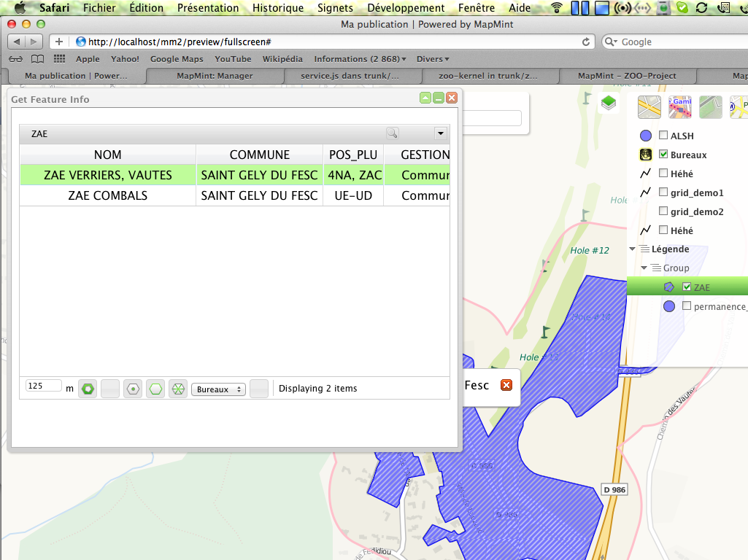 | [_Legend_]

