[_map_title_]

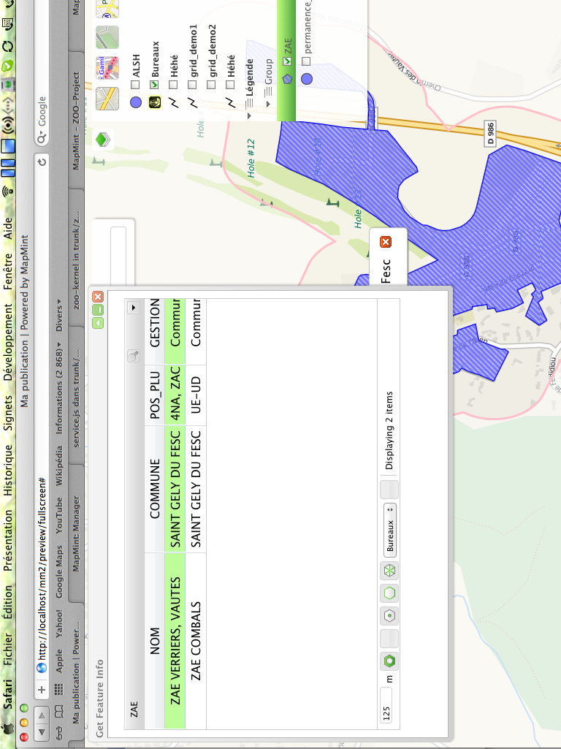
[_Legend_]

