# GIS Data Creation and Workflows

Stacey Maples – Geospatial Manager – Stanford Geospatial Center – [stacemaples@stanford.edu](mailto:stacemaples@stanford.edu)

David Medeiros – GIS Instruction & Support Specialist - Stanford Geospatial Center - [davidmed@stanford.edu](mailto:davidmed@stanford.edu)

This workshop serves as follow-on to the Introductory and Intermediate GIS Skills workshops. Some level of familiarity with ArcGIS is assumed, and a high level of Windows OS competency is required. In this exercise you will use the goal of producing a publication quality map of sugar plantations in Madagascar as the vehicle for introducing some of the more advanced skills necessary to have when working on extensive GIS projects. Topics will include:

* Creation of File Geodatabases.
* Importing GIS Data into a Geodatabase.
* Conversion of XY coordinates data to a Geodatabase feature class.
* Creating Custom ArcToolbox Geoprocessing Tools using ModelBuilder
* Georeferencing of scanned map images
* Creation and editing of Geodatabase Feature Classes
* Using Definition Queries
* Working with Annotation Classes
* Managing Multiple Data Frames
* Customizing Map Elements
* Using Extent Rectangles to link Data Frames

## GIS Resources:

Stanford Geospatial Center website - <http://gis.stanford.edu/>

Stanford GIS Listserv - <https://mailman.stanford.edu/mailman/listinfo/stanfordgis>

Esri ArcGIS 10.2 Help - <http://resources.arcgis.com/en/help/main/10.2/>

## Download Tutorial Data

1. In a browser, go to <https://stanford.box.com/SGCIntroGIS> and click on the drop-down arrow to the right of each folder to download individual datasets. Save the Datasets to your Desktop.
2. Right-click on the resulting \***.zip** and select Extract All…
3. Accept all defaults to extract the data file.

## GIS Data Formats: Shapefiles, Rasters and **Geodatabases**

### Shapefiles

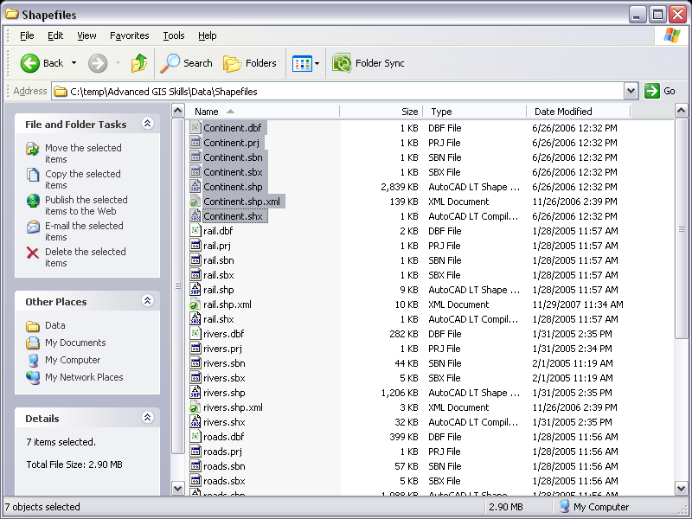First, we will briefly examine one of the most commonly encountered GIS data formats: The “shapefile.” In quotes, because a “shapefile” is not really a file, but a collection of files which, taken together, contain all of the information necessary to correctly display, overlay and analyze spatial data in the ArcGIS Suite. Because a “shapefile” is not really a file, but a collection of files related to one another by the fact that they have the same filename (save for their individual file extensions), it is difficult (and dangerous) to manage shapefiles using the Windows Explorer interface. To demonstrate this, we will take a look at the files provided for this tutorial within both Windows Explorer and ArcCatalog, which is the ArcGIS Suite’s equivalent to Windows Explorer.

1. **Open My Computer** and **Browse** to **\Data Creation and Workflows\Data\Shapefiles**

*Note that there are dozens of individual files in this folder. If you examine these files, you will find that they represent 6 different “****shapefiles****,” since there are* ***six sets of unique filenames****.*

### D:\Patrons_and_Projects\Stacey.Maples\Workshops\2009 Workshops\03 - Advanced GIS Skills\ScreenCaps\Windows_Explorer_GRID_View.pngRaster (GRID) Data

Raster datasets are even less amenable to management using Windows Explorer. In fact, managing raster datasets in the ESRI Grid format is essentially impossible outside of ArcCatalog. This is because the Grid format doesn’t store raster data in a “set of files” as is the case with “shapefiles,” but in a set of files AND folders. The tricky part is that, if you have more than one GRID file in a folder, the format “shares” one of the essential folders among all of the GRID files.

1. Browse to the **\Data Creation and Workflows\Data\Raster** folder.

*Note that the situation is a bit more complex than with the shapefiles… here we are presented with one folder and one \*.aux file for each raster dataset, however, there is only ONE “****info****” folder!*

1. **Browse** into the **\Data Creation and Workflows\Data\Raster\info** folder

Note that there is no apparent indication of what files in this folder pertain to either of the GRID datasets we have in this dataset.

## D:\Patrons_and_Projects\Stacey.Maples\Workshops\2009 Workshops\03 - Advanced GIS Skills\ScreenCaps\ArcCatalog_Shapefiles_View.pngViewing Geospatial Data in ArcCatalog

Clearly, attempting to manage these datasets outside of the ArcGIS Suite presents some difficulties. Now, examine these same data folders in ArcCatalog:

1. On the **Windows Taskbar**, go to **Start>All Programs>ArcGIS>ArcCatalog**.
2. Once **ArcCatalog** has opened, Create a Folder Connection (if necessary) and **Browse** to **\Data Creation and Workflows\Data\Shapefiles**, in the **Catalog Tree** panel on the left.

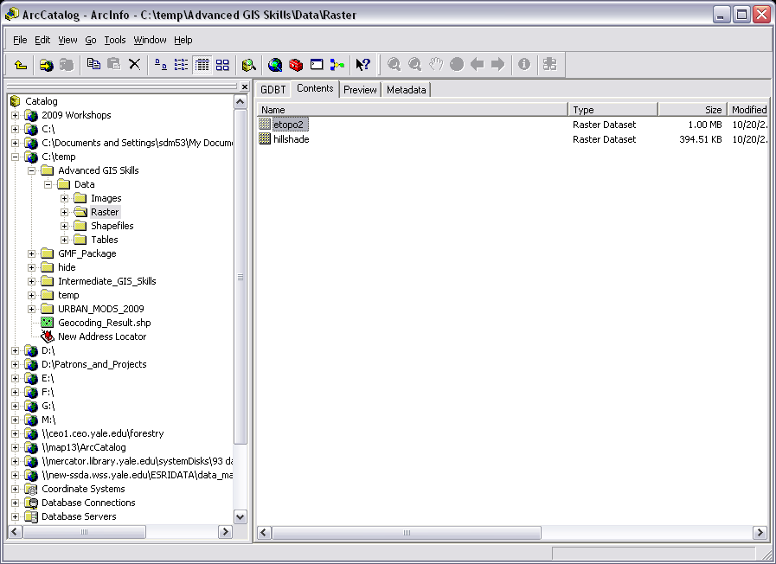Note that, in **ArcCatalog**, the view of this folder is substantially simplified. Those ***dozens of files are now reduced to the six “shapefiles” that they compose***. **The ArcGIS Suite** “knows” that shapefiles are actually collections of files and simply shows you the single **\*.shp** file as a representative of each collection. Actions

1. **Right-Click** on the **Continent.shp file**, shown in the **Contents Tab**, and take a look at the **available options**. The basic file management options are all there.
2. In the **Catalog Tree** on the left, **Browse** to the **\Data Creation and Workflows\Data\Raster** folder to display it’s contents.
3. Note that we simply see the **two GRID files** contained by this folder.
4. **Right-Click** on the **etopo2\_mad GRID file** and **select** “**Rename**.”
5. **Change** the name of the **GRID File** to “**etopo2**” by removing the “**\_mad**” suffix. Hit the **Enter Key to apply the change.**

### Creating a Geodatabase

Now we will explore the **Geodatabase**. We will do so by creating one from the files we have examined thus far. **Geodatabases** provide a number of advantages over the standalone **shapefile** format: File Management… a single structure, within which all types of spatial (and some non-spatial) data can be placed; Scalability… shapefiles are limited in size by the .dbf table’s 2GB files size. File Geodatabases support 1TB of data by default, and can be configured to contain up to 256 TB of data; Speed…; Speed… geoprocessing speeds within the geodatabase are vastly improved over the shapefile model. In an old version of the Introduction to ArcGIS workshops there is a Union function run on two shapefiles that took nearly 3 minutes for some users to perform… in the new version of the workshop, using file geodatabase-based feature classes the same Union function required 15 seconds.

***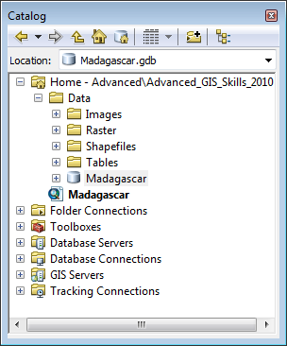***

1. Close **ArcCatalog** and Open **ArcMap**.
2. Click Cancel when presented with the **Getting Started Dialog Window**  to start with a **New Empty Map Document.**
3. **Save** your blank **Map Document** as **Madagascar.mxd**, in the **\Data Creation and Workflows** folder.
4. **Go to Main Menu>Windows>Catalog** to **Open** the **Catalog Window** in **ArcMap**.
5. **Right-click** on the **\Data Creation and Workflows\Data** and select **New>File Geodatabase**.
6. A new empty **File Geodatabase** will be created. It should be highlighted to allow you to rename it, if so **Rename** it **Madagascar.gdb**. If not, **right-click** on the New File **Geodatabase.gdb** and **select rename** in order to rename the gdb.

### Importing Feature Classes from Shapefiles

Now that you have a new empty geodatabase, you will load the shapefile data you previewed earlier into it. We can do this quickly, and en masse, by using the “Feature Class to Geodatabase (Multiple)” Tool.

1. **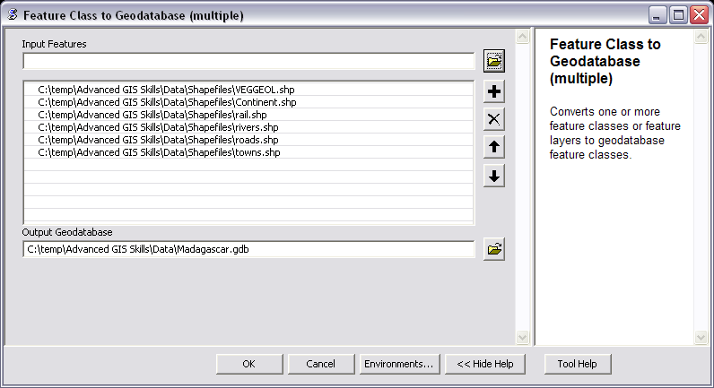**Toggle the Contents Panel by clicking on the  button at the top of the **Catalog Window**
2. **Right-click** on the **Madagascar.gdb** and **select** **Import>Feature Class (Multiple).**
3. **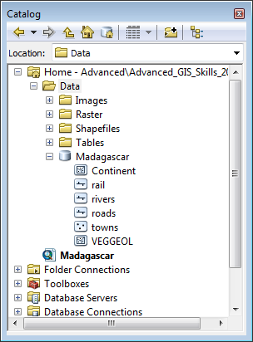**Once the **Feature Class (Multiple) dialog box** has opened, click on the **\Data Creation and Workflows\Data\Shapefile** folder so that it’s shapefiles are shown in the Contents Panel.
4. **Holding down the Ctrl Key**, **select all** of the **shapefiles** in the **\Data Creation and Workflows\Data\Shapefile** folder and **drag** them into the **Input Features box** of the **Feature Class to Geodatabase (Multiple) dialog**.
5. **Click OK**. **Click Close** once the **Import** has completed.
6. **Click** on the **Madagascar.gdb** to show its contents in the **Content Tab** of **ArcCatalog**.
7. **Right click** on the **Madagascar.gdb Geodatabase** and select ‘**Make Default Geodatabase.’** This option will make your **Madagasdcar Geodatabase** the **Default Output Workspace** for most geoprocessing tools you use with this **Map Document.**

### Raster Data in the Geodatabase

Remember that we also have Raster (GRID) data in our project. However, we will not import this data into our geodatabase, even though geodatabases can contain raster and imagery. The reason is that, while geodatabases are capable of containing raster data (in several useful ways, in fact), the tools in Spatial Analyst and 3D Analyst that are used to process raster data require that data to be in GRID format. This means that, while you can use geodatabase-based rater data in Spatial Analyst, ArcGIS must convert that data to GRID before processing which adds to the processing overhead. So, if your raster data is simply for cartographic (display) purposes, it can and should be placed into geodatabase. ***If your raster data is meant to be used in Spatial Analyst, or other ArcToolbox tools, you should leave it in GRID format.***

## C:\Users\sdm53\Pictures\ScreenCaps\Advanced\MyTools Properties.pngUsing ModelBuilder to Build New Tools in ArcGIS

1. In the **Catalog window** on the right, **Right-Click** on the **Madagascar.gdb** and **select New>Toolbox.**
2. **Right-Click** on the **new Toolbox** and **open** its **properties**. **Rename** this new toolbox “**MyTools**” ***without a space***. Set the **Label** as “**My Tools**” ***with a space***.
3. **Right-Click** on your “**My Tools**” **toolbox** and select New>**Model**. The **ModelBuilder** interface will appear.
4. **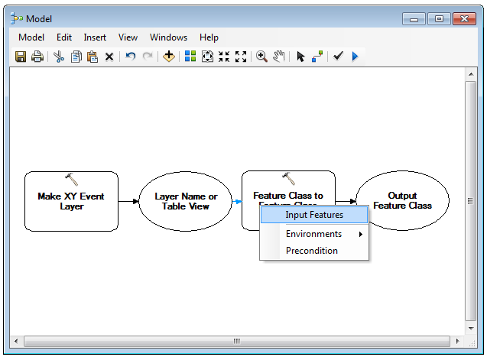Move** and **resize** the **ModelBuilder** window so that you ***are still able to see the Search and Catalog Windows*** at the right side of **ArcMap**, since you will be dragging tools into **ModelBuilder** from **ArcToolbox**.
5. **Search** for the “**Make XY Event Layer” tool**
6. In the search results, **Click-Hold-Drag** the “**Make XY Events Layer**” tool into **ModelBuilder**.
7. **Search** for the “**Feature Class to Feature Class” tool.**
8. **Click-Hold-Drag** the “**Feature Class to Feature Class**” tool to the right of the “**Make XY Events Layer” tool.**
9. **Click** on the “**Add Connection: tool**  to **activate** it. **Using the wand**, **click** on the “**Layer Name or Table View**” **Oval model element** then **click** on the “**Feature Class to Feature Class**” **Rectangle model element** to **connect** them.
10. **When prompted**, select **“Input Features (Parameter)”** and click **OK**.
11. 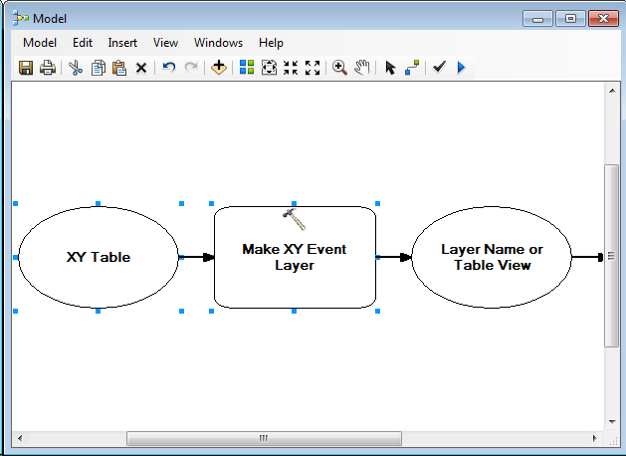**Change** to the **Select Elements tool**  and **right-click** on the “**Make XY Event Layer**” **Object**. **Select** **Make Variable>From Parameter>XY Table**.

Note that there is now a **New Object** in your Model, connected to the **Process Object**. In “programming speak” you are ***declaring a variable*** in your Model, here. If you want, you can assign that variable a value, or you can make it a parameter of your model so that a future user can provide the value for this variable. We will make this variable, and most other variables in the model, a **Model Parameter.**

1. **Repeat** the previous step for the **remaining 3 parameters** for the “**Make XY Events Layer” Object**.

### Variables and Parameters in a Model

As mentioned before, you’ve just declared variables for all of the Inputs of the Make XY Events Layer geoprocessing tool, in your model. Most of these variables, we will make Model Paramenters, so that users can input the values for them an runtime. However, let’s pretend that we know that this tool is only going to be used to input GPS data to a geodatabase, and that we know that the Geographic Coordinate System of the Input Coordinates will always be WGS 1984. We don’t have to expose ALL of the variables in our model for the end user to have access to. In fact, in some cases, it is desireable to hide some variables, and assign their value, as part of the model. Here is how to assign a value to a variable in your model.

1. 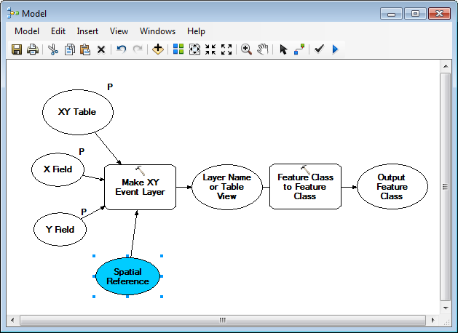**Double-Click** on the **Spatial Reference Variable Object** to **open** its **properties**.
2. **Click** on the **Properties** **Button** to the right of the **Input Box**.
3. **Click** on **Select…**
4. **Set** the **Spatial Reference** to **Geographic Coordinate Systems>World>WGS 1984.prj**
5. **Click OK three times** to **set** the **Spatial Reference** and return to **ModelBuilder.** ***Note that the object is now blue***.

Now we will declare the remaining variables “**Parameters**” of our model. The result of this will be that they will show up as Inputs and Options in the ArcTOolbox Tool that is ultimately going to be the result of our model.

1. **Right-click** on the **XY Table variable object** and select “**Model Parameter.**”

Note that a **P** appears next to the variable object. This indicates that this variable will show up in your ArcToobox tool for the model and will be editable by the end user.

1. Repeat step 19 for the “**X Field**” and “**Y Field**” **variables**.

### **C:\Users\sdm53\Pictures\ScreenCaps\Advanced\final model.png**Finishing the Model

1. For the Feature Class to Feature Class” Object , make the following parameters variables:
   1. **Output Location.**
   2. **Output Feature Class**
2. Make both of these variables parameters of your model by right-clicking and selecting “**Model Parameter**”

### Cleaning Things Up a Bit

Now we’ve essentially got a working ModelBuilder model and could run the tool from the Catalog Window and input our values for variables. However, if we want to share this tool with others, there are still a few things we can do to make the user’s experience a bit better. First, let’s rename a few of the Objects in the model so that their corresponding ArcToolbox Input Boxes will have more meaningful labels.

1. 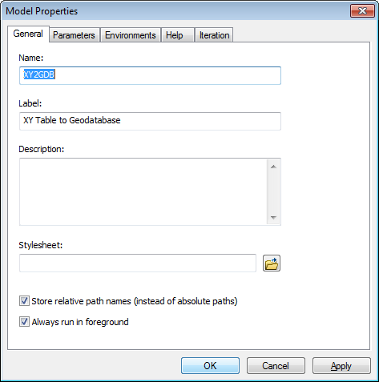**Right-click** on the “**Output Location**” Object, connected to the **Feature Class to Feature Class Object** in your **model** and **select Rename…** Rename the object “**Destination Geodatabase**” and hit **enter**.
2. **Rename** the **Output Feature Class (2)** Object (You may have to resize the object to see it’s label, fully) as **Output Feature Class Name,** using the same method
3. On the **Main Menu** of the **ModelBuilder** **Window**, go to **Model>Model Properties**.
4. In the **General Tab**, **change** the **Name** of the **Model** to “**XYtoGDB**.” **Change** the **Label** to “**XY Table to GDB.**”
5. **Check** the **Option** to **Store Relative Paths.**
6. 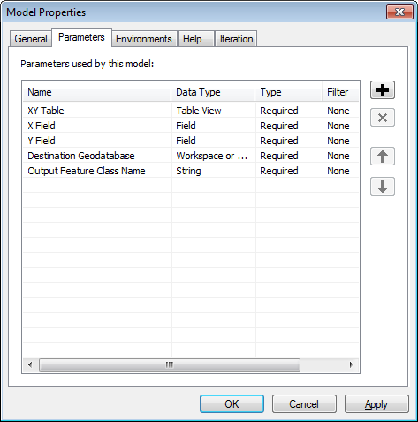**Click on** the **Parameters Tab** and make sure the order of the parameters is as follows:  
   1. **XY Table**
   2. **X Field**
   3. **Y Field**
   4. **Destination Geodatabase**
   5. **Output Feature Class Name**
7. **Close** the Properties Dialog
8. On the **Main Menu**, go to **View>Auto Layout**. Then, **View>Zoom>Full Extent**.
9. **Click OK**. **Click** on the **Save Icon to save your changes**.
10. **Close ModelBuilder.**

### Running the Model as an ArcToolbox Tool

Now that we’ve completed the model, we are ready to run it and have it perform the processing we’ve designed it for. Note that, while this is a very simple model, you’ve just learned many of the tasks that will allow you to create incredibly complex and useful models that can streamline your work in ArcGIS. You can also share your models. Because we’ve embedded the model inside of

1. **Return** to the **Madagascar.gdb** and find your **My Tools>XY Table to Geodatabase Tool**.
2. **Double-click** the “**XY Table to Geodatabase**” tool to launch the ArcToolbox tool.
3. **Browse** to **the \Data\Tables Folder** and **double-click** on the **World\_Cities.xls** file to “**Browse**” into it and select the “**World\_Cities$” worksheet**. **Click Add**.

*“Browsing into” the Excel File deserves some explanation, here. Excel files are able to contain multiple tables as* ***Worksheets.*** *ArcGIS is only able to add single, freestanding tables to a Map Document. SO, ArcMap, perhaps a little confusingly at first, treats Excel files as if they were “Folders of tables.” To add an Escel Worksheet to a Map Document, we “Browse into” the Excel files and select the table we are interested in.*

1. **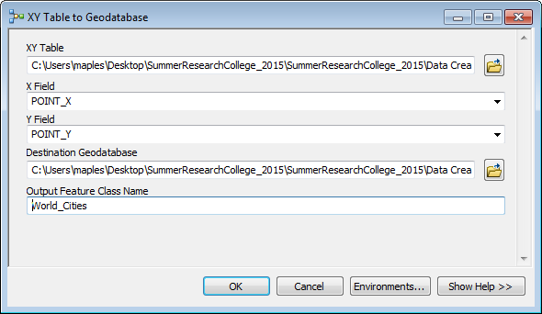Set** the “**X Field**” and “**Y Field**” to **POINT\_X** and **POINT\_Y**, respectively, using the **Drop-down arrows,** which should **auto-populate** once you have assigned the **XY Table**.
2. **Browse** to the **SummerResearchCollege\_2015\Data Creation and Workflows\ Folder,** select the **DataMadagascar.gdb** and click **Add** to set the **Destination Geodatabase**.
3. Enter “**World\_Cities**” (with the underscores, you can’t use spaces or most special characters in Geodatabase object names) for the **Output Feature Class Name**.
4. **Click OK** (maybe, after crossing your fingers).
5. **Click Close** (assuming all went well).
6. In the **Catalog Window of ArcMap**, you should now see that a **World\_Cities point feature class** has been added to your **Madagascar.gdb** (If you don’t see it, Right-click on the **Madagascar.gdb** and **Select Refresh**).
7. **Drag** the **World\_Cities** and feature class into your **Madagascar.mxd Data Frame**.

If all went well, you should see something like this:

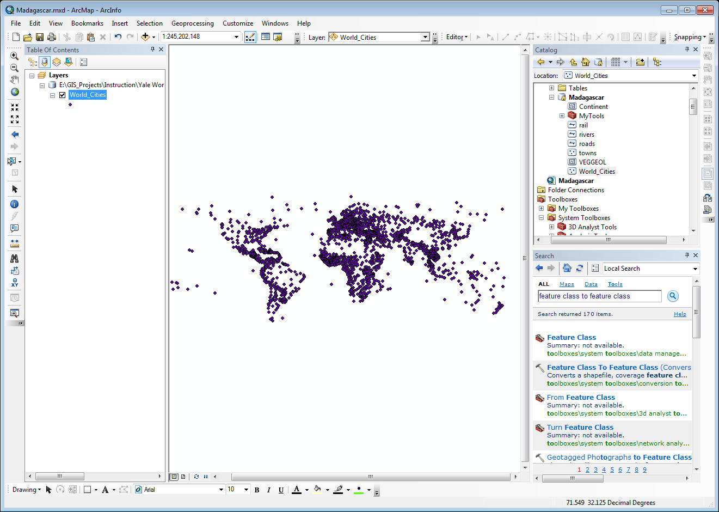

### Using a Definition Query to limit the Features Shown from a Feature Class

We’re going to use the features in the World\_Cities layer to ‘Georeference’ a scanned map image that currently has no geographic reference associated with it. However, we don’t need the city features for the entire world, only those for Madagascar. We could use Select by Attributes to select a subset of the features and export them to a new feature class, but that would create a redundant dataset in our Geodatabase. Instead, we will use one a very useful property of the layer called a ‘Definition Query.’ A definition Query is a SQL statement that tells ArcMap what part of the feature dataset we want to use in our Map Document. Once it has been set, ArcMap will act on the layer as if the defined subset of the data is the only data present. We can even add the feature class to the Map Document again, creating a different Definition Query on the layer and treating each of the layers as independent datasets.

1. **Open** the **Properties Dialog** for the **World\_Cities Layer** and **click** on the **Definition Query Tab**.
2. **Type** in, or **use the Query Builder**, to **enter** the **SQL Statement**:   
     
   **"CNTRY\_NAME" = 'Madagascar'**

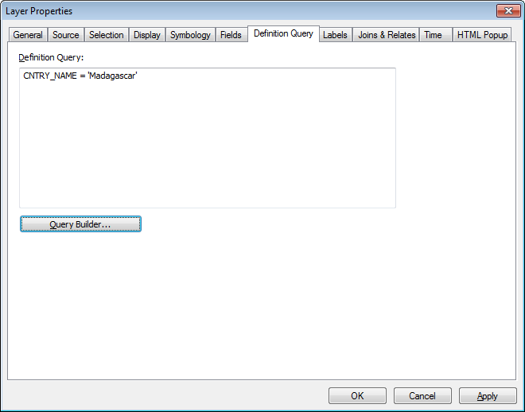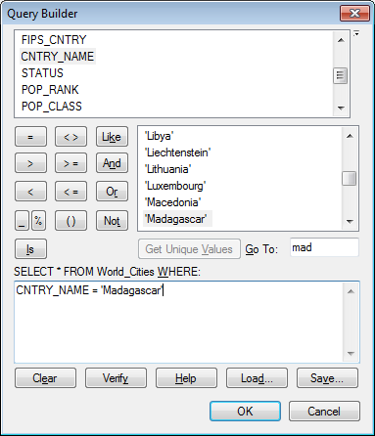

1. **Click OK** to **apply** this **Query** and **close** the **properties dialog**.
2. **Right-Click** on the **World\_Cities Layer** and **select** **Zoom to Layer**.
3. **Right-Click** on the **World\_Cities Layer** and **Open** it’s **Attribute Table.**

Note that both the spatial and attribute data respect the definition query you have created. Definition queries provide a means of sub-setting feature classes without exporting to a new feature class, thereby saving storage space and reducing render times.

1. **Close** the **attribute table**.

## Georeferencing of Spatial Images

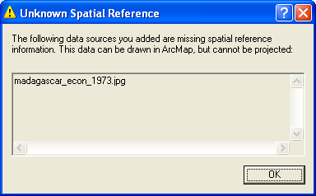Often, the data that you need to use in your GIS projects will not exist in digital format. Perhaps you are studying historical boundary changes, mapping 18th Century postal routes or some other analysis for which modern, digital data does not exist. Perhaps the data you need is contained only in paper maps. The process of moving data from paper to vector data can take many routes, but the most straightforward is to scan, or otherwise digitize, the paper source and “georeference” the resulting image to modern reference data. It is then possible to “Heads up” digitize the desired data, based upon this, now georeferenced, scanned source. In the following steps you will follow this exact path in order to produce a new points feature class containing the locations of sugar plantations on the Island of Madagascar.

## Georeferencing of Images

The process of Georeferencing an image for use in a GIS application is, essentially, the process of telling the software the certain pixels in the image correspond to a specific set of geographic coordinates. This is done by ‘linking’ features in the ‘dumb’ image to features that are already georeferenced. In this case, we will be referencing the cities pictured in the scanned map of Madagascar to the cities in our World\_Cities layer using ‘Control Points.’

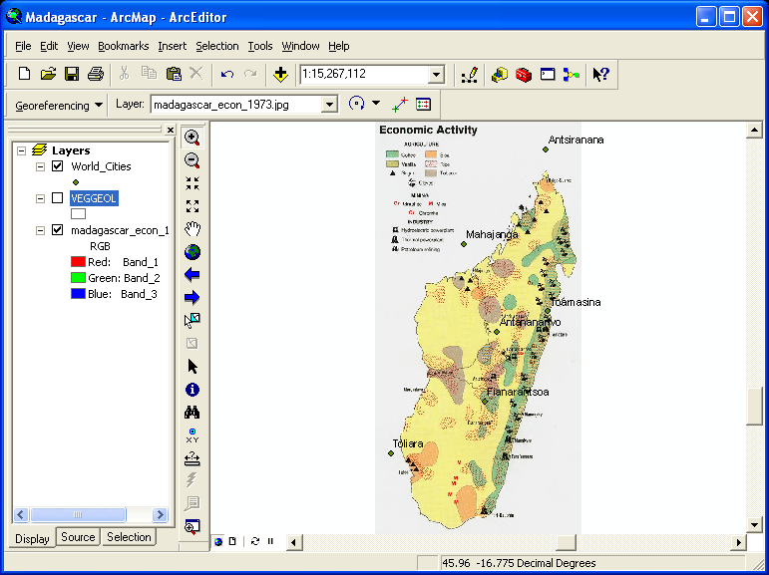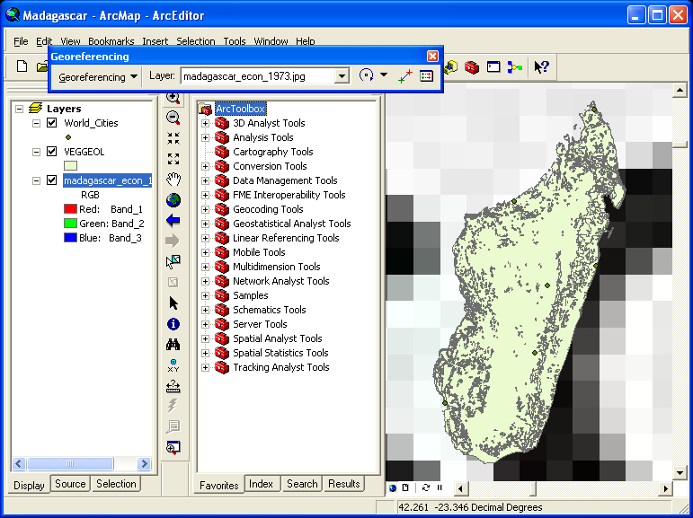

1. In the **Catalog Window**, expand the **\Data Creation and Workflows\Data\Images** Folder and Drag-and-drop the **Madagascar\_econ\_1973.jpg** image into the Data Frame.
2. **Click OK** when you are **warned** that the data you are adding has an **unknown spatial reference**.
3. **Right-Click** on the **World\_CIties Layer** and **select Zoom to Layer**
4. **Right-click** in an empty part of the toolbar area to bring up the **Toolbar Menu.** **Select** the **Georeferencing Toolbar** to make it visible. (you can drag it to the toolbar area and drop it there to get it out of the way, of you want to)
5. **Click** on the **Georeferencing Button** and **select** “**Fit to display**.”
6. **Right-Click** on the **World\_Cities Layer** and **select** “**Label Features**.”
7. 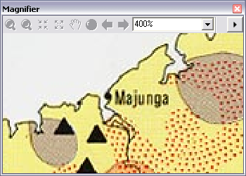On the **Main Menu**, **Select Window>Magnifier**. Set the **Magnification to 400%**
8. **Move** the **Magnification Window** so that the crosshairs are above the city of **Majunga**, in northwestern part of the **scanned image** you have added.
9. **Select** the “**Add Control Points**” **Tool** C:\temp\Advanced GIS Skills\ScreenCaps\ArcMap Add Control Point Button.png and **click once** on the **City of Majunga’s symbol** *in the scanned image* (***always set control points FROM: the image to be georeferenced TO: the reference data***).
10. 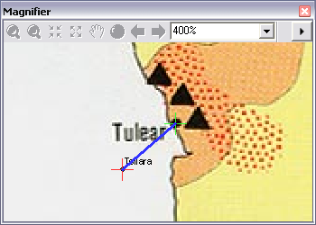With your first control point placed, move the **Magnifier Window** northeast until the crosshairs are positioned above the **city of Mahajanga** *in the* ***World\_Cities feature class***.

*Notice that when you hover the cursor over the point feature for Mahajanga, the Control Points Tool will ‘snap’ to the point once you get within a certain number of pixels. If you find that the snapping is too sensitive, you can increase the magnification setting in the Magnifier Window to effect it’s sensitivity.*

1. **Click** on the **point** for the **city of Mahajanga** to place the **second control point** and complete the **link**.

*Note that the madagascar\_econ\_1973.jpg scanned image adjusts to close the link between the two points you just placed.*

1. Now move the **Magnification Window** to the southwest part of the island so that the crosshairs are positioned above the city of **Tulear** in the scanned image. You should also be able to see the corresponding city of **Toliara** in the **World\_Cities layer**.

*It is import, particularly when starting a Georeferencing job, to distribute the initial 3-5 control points widely across the image, placing points at opposing positions until you have achieved an initial ‘rough’ reference. This is because if you place control points too close together, you will find the remainder of the image will become so distorted that it may be difficult to find corresponding points to add accuracy to your georeferencing job.*

1. **Place another set of control points**, again ***starting with the feature in the scanned image*** and then the reference feature from the **World\_Cities layers**.
2. **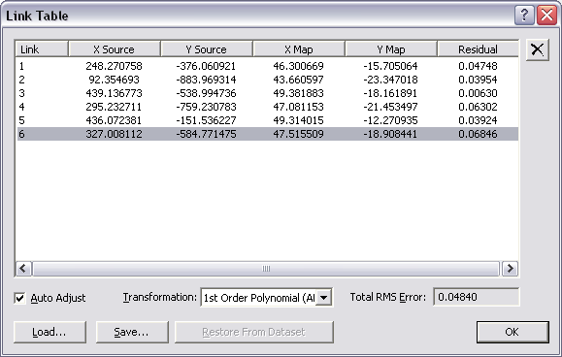**Again, you should see the image adjust slightly to close the link placed between the two features.
3. Move to the city of **Tamatave/Toamasina** and **place another set of control points**.
4. Place **control point sets for the remaining city sets** that you are confident correspond to one another (despite the name differences).
5. **Close** the **Magnifier Window** once you have **finished** placing control points.
6. **Click** on the **View Link Table Window** C:\temp\Advanced GIS Skills\ScreenCaps\ArcMap Control Point list.png **button** to see the list of links you have placed.

Note that you have the option to **highlight** and **delete** link sets you have placed, as well as the option to **Save** and **Load control point sets** so that you can continue complex georeferencing projects, or apply the same control point sets to sets of coregistered images.

1. **Close** the **Link Table**.
2. On the **Georeferencing Toolbar,** select **Georeferencing>Update Georeferencing.**
3. In **Windows Explorer**, browse to the **\Data Creation and Workflows\Data\Images** folder to view the changes made.

Note that two new files have been added to this folder: an XML document, containing basic metadata and a \*.jgw file, both of which have filenames the same as the madagascar\_econ\_1973.jpg image. The madagascar\_econ\_1973.jgw file is referred to as a “World File” and it functions in much the same way as a \*.prj file does for a shapefile in that it contains the spatial reference information needed for ArcMap to correctly overlay the madagascar\_econ\_1973.jpg image with other spatially referenced data.

1. **Close Windows Explorer** and **save your Map Document**.

## Creating an Empty Feature Class and Populating it with Features in Edit Mode

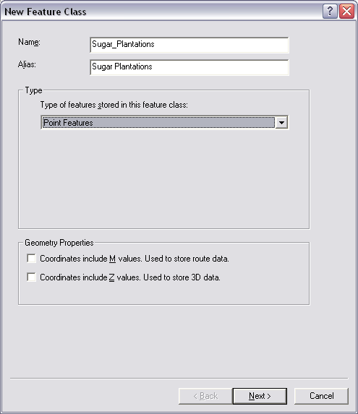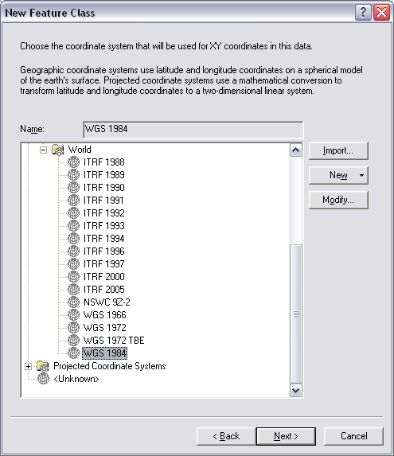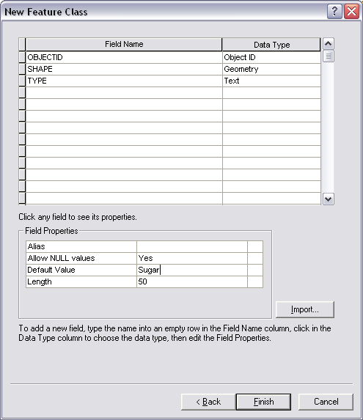

Now that we have a georeferenced image, we are ready to create a new dataset by “heads up” digitizing features that are in the scanned image. In this case, we will create a new point feature class that will contain spatial data for the sugar plantations depicted in the scanned map image.

1. **Return** to the **Catalog window**.
2. **Right-click** on the **Madagascar.gdb** and **select** **New>Feature Class**.
3. **Name** the **New Feature Class “Plantations”** and set its **Alias** as “**Sugar Plantations**”.
4. **Change** the **Type** to “**Point features**.” **Click Next>.**
5. **Set** the **Coordinate System to Geographic Coordinate System>World>WGS 1984. Click Next>.**
6. **Accept** the defaults for **XY Tolerance** and **Resolution** by clicking **Next>.**
7. **Accept** the **default** for **Configuration Keyword** by clicking **Next>**.
8. Place your **cursor** in the **Field Name cell** directly **underneath SHAPE**. **Create** a **Field named Type**, with a **Data Type of Text**.
9. **Click Finish**.

### Setting Domains in the GDB for use in Editing Features

**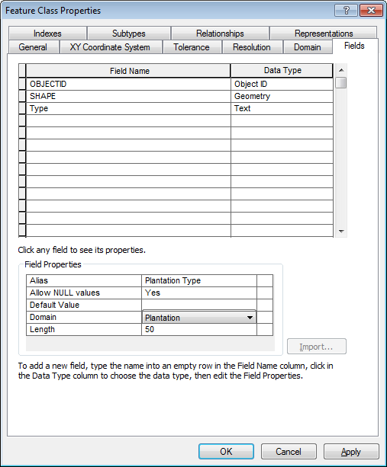***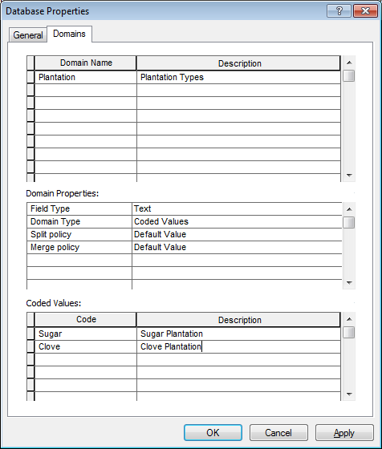*Now that you have created a feature class, you will create a Domain in the Geodatabase to make editing the feature class easier. Domains help you in several ways, but the two most important are that they enforce rules about how attributes can be entered into the table of a feature class, and they help generate editing templates, that can speed editing and even reduce the need to enter attributes, at all. Domains are, essentially, lists of values that a particular attribute may have. Rather than storing domains in the feature class, they are stored at the Geodatabase level, so that they can be recycled across multiple feature classes, for instance, if you have a True/False domain, you can use this single domain across many feature classes within a Geodatabase.

1. **Right-click** on the **Madagascar.gdb** in the **Catalog Window**, and select **Properties**.
2. **Click** on the **Domains Tab**.
3. **Create** a **new Domain** named **Plantation**, give it a **Description** of **Plantation Type**.
4. **Change** the **Field Type** to **Text** and note that the **Domain Type defaults** to **Coded Values**.
5. Under the **Coded Values Section**, put two **Codes** in:
   1. **Sugar** (with a Description: **Sugar Plantation**)
   2. **Clove** (with a Description: **Clove Plantation**)
6. **Click OK**
7. **Right-click** on the **Plantations feature class** in the **Madagascar.gdb** and **open** its **properties**.
8. **Click** on the **Fields Tab** and **select** the **TYPE field** entry to **edit** its **properties**.
9. **Click** in the blank box to the right of the Domain option and select the Plantation Domain.
10. Click OK.

What you have just done is provided yourself with a “template” for the attributes you will enter as you digitize the features in the georeferenced map. This will express itself as dropdown’s of possible values in the attribute editing window, as well as providing the editing templates a set of features to offer as you edit.

### Adding Features to Your New Feature Class

1. **Open** the **Properties** of the **Plantations Layer** from the **Table of Contents**
2. Go to the **Symbology Tab** and **select Categories**. **Set** the **Value field** as the **TYPE/Plantation Type** **field**.
3. **Click** the **Add All Values** button.

Note that, even though you have not yet entered any features in your feature class, because you have a Domain assigned to the feature class, ArcMap recognizes that you have ***possible*** attribute values, and uses the Domain values to create the symbology for the layer.

1. Give the two **Plantation Type** values **distinct symbols** (I’ve used a **red 12 point Circle 1** and **red 14 point Triangle 1**) and click **OK** to apply the changes.

### Starting an Edit Session and creating an Editing Template

Because we have created a symbology for the layer before starting the edit session, our Editing Template should already created and should appear when we start the edit session. For some reason, this sometimes doesn’t happen, so below I’ve included the instructions for creating an editing template for you Plantation layer.

1. **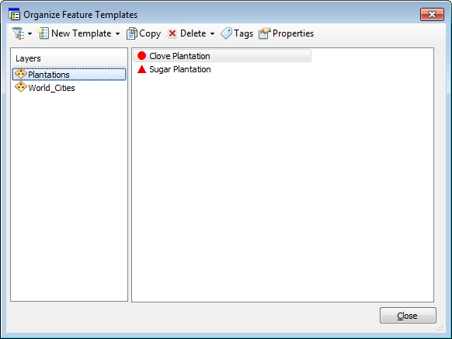Right-click** on the **Plantations Layer**, in your **Table of Contents**, and select **Edit Features>Start Editing.**
2. 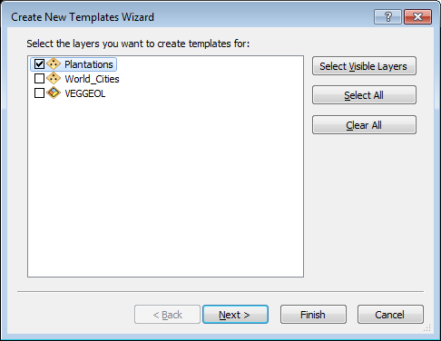In the resulting **Create Features Window**, you should see the **Plantations Editing Template**, using the **symbology** you just created. If so, you can skip to Step 8.
3. If you don’t see the **Editing Template** for your **Plantation feature class**, **click** on the **Organize Feature Templates** button C:\Users\sdm53\Pictures\ScreenCaps\Advanced\Organize Feature Templates.png.
4. In the resulting **Organize Feature Template Wizard**, **click** on the **New Template button** C:\Users\sdm53\Pictures\ScreenCaps\Advanced\New Template.png.
5. Make sure that **Plantation**s is **checked** and **click Finish**.
6. Note that your Symbology has been used for the template. **Click Close.**
7. The new template should now be visible in the **Create Features Window**.
8. **Open** the **Attribute Table** of the **Plantations Layer** and dock it at the bottom of the application.
9. From the **Main Menu**, open the **Magnifier Window**.
10. Move the **Magnifier Window** over the northern part of the island, so that you can see the first cluster of **Clove** or **Sugar Plantation symbols**.
11. **Click** on one of the **Plantation Symbols** to select the **template** for that **TYPE** and ***begin placing plantations based upon the scanned map***.
12. **Select** the other **template** to digitize the second feature type. Note that for each feature you place, depending upon the template used, ***the TYPE field is automatically populated.***
13. Continue Placing Points until all Plantations have been digitized.
14. When all points have been placed, **click** the **Editor Button** and **select Save Edits**. **Click** the **Editor Button** again and **select Stop Editing**.

In this case, we simply placed point features in an empty feature class, with default values for the primary attribute field. More complete instruction on editing features (including polygons and lines) in ArcGIS can be found in the ArcGIS Help System under the “Editing and data compilation” section.

<http://resources.arcgis.com/en/help/main/10.2/index.html#/Introduction_to_the_Editing_tutorial/01m600000020000000/>

## C:\temp\Advanced GIS Skills\ScreenCaps\ArcMap Frame Properties Frame.pngCreating a Map Layout in ArcMap

Now that we have digitized a dataset that we want to create a map of, it is time to begin building our Map Layout. This map layout will be a simple one, highlighting the locations of plantations. The assumption will be that we are designing this map for publication in Black & White, but even if we were publishing in color, all design decisions should be made based upon the assumption that the map might eventually be viewed in Black & White.

### Adjust the Properties of the Data Frame

1. 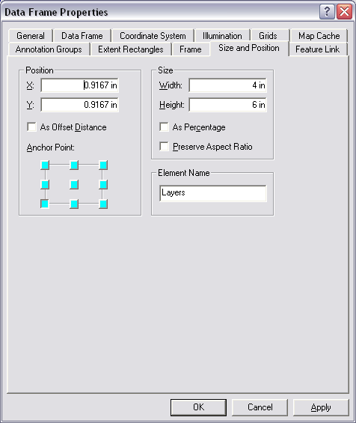In the **lower left corner** of the **Data Frame**, find the **View Toolbar** C:\temp\Advanced GIS Skills\ScreenCaps\ArcMap View Toolbar.png and **click** on the **Layout Button** (It looks like a piece of paper) to **switch** to **Layout Mode**.
2. **Right-Click** on the **madagascar\_econ\_1973.jpg layer** and **select Remove**.
3. Use the **Select Elements** **Tool**  to **click** within the **Data Frame** on the **Layout Page**. **Right-click** and **open** the **Data Frame’s Properties**.
4. **Click** on the **Frame Tab** and **select** the **Double-Line Border** from the **Drop-Down**. Set an **X&Y Gap** of **5 points**.
5. Set the **Background** to **Grey 10%.**
6. **Click** on the **Size and Position Tab**. Set the **Width** to **4 inches** and the **Height** to **6 inches**. **Click** **OK** to **apply** the **Changes**.
7. **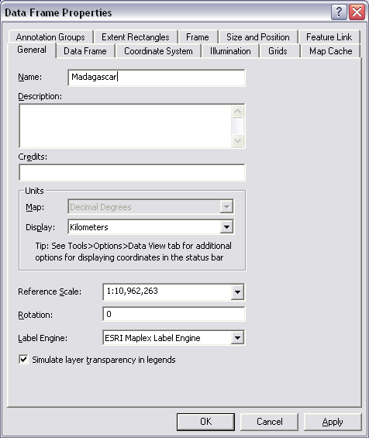Use** the **Layout Zoom Tool**  to **zoom** to the **newly resized Data Frame**.
8. From the **Madagascar.gdb**, **drag and drop** the **VEGGEOL** **feature class** to the **data frame** to **add** it to your current layout.
9. **Right-click** on the **VEGGEOL layer** in the **Table of Contents** and **select** **Zoom to Layer**.
10. **Open** the **Data Frame Properties** again and bring the **General Tab** to the **Front**.
11. 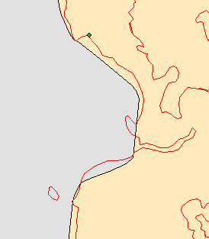**Name** the **Data Frame “Madagascar.”** **Change** the **Display Units** to **Kilometers**. **Set** the **Reference Scale** to **“<Use Current Scale>”.** **Change** the **Label Engine** to **ESRI Maplex Label Engine**. **Click OK**.

### Using Dissolve to Create an Outline Layer

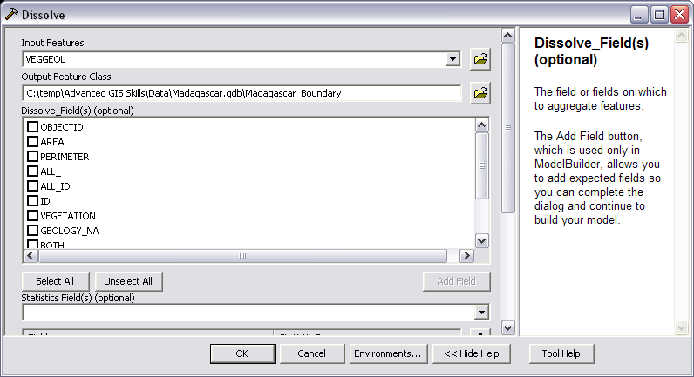The **VEGGEOL feature class** you added to the map document contains detailed information about the vegetation and geology of Madagascar. You don’t need this information since this will simply be an overview map of the country. However, as in many cases, the detail of the coastline in the **VEGGEOL** layer is much greater than in the readily available political boundaries layers (as shown on the left). Rather than using the less detailed political boundary layer for your map, you will create a blank coastline polygon layer from the **VEGGEOL** layer for your map. To do this, you will use the **Dissolve Tool.**

1. On the **Main Menu,**  **Select Geoprocessing>Dissolve**.
2. Select the VEGGEOL Layer as the Input Features.
3. **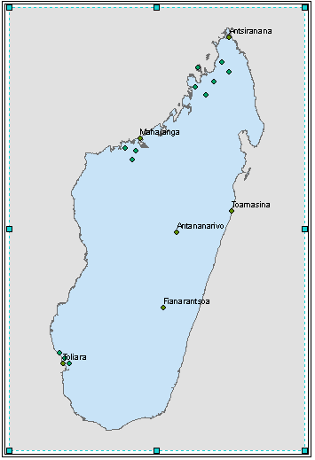Do not select** any value for the **Dissolve Field**.
4. **Change** the **Output Feature Class** to **Madagascar.gdb\Madagascar**
5. **Click OK**.

A new **Madagascar layer** will be added to your **Table of Contents** and **map layout**. The new layer should only have the outline of the country, without the vegetation & geologic features of the previous layer.

1. **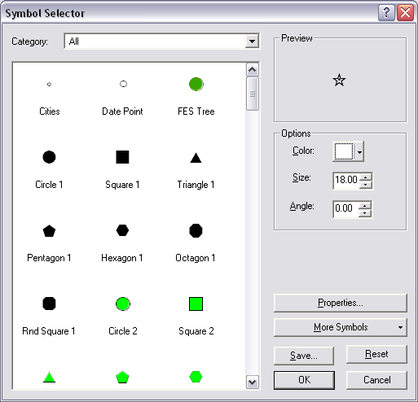Right-click** on the **VEGGEOL** **layer** and **Remove** it.

## Applying Symbology to the Features in your Map

1. **Double-Click** the **World\_Cities Layer** in the **Table of Contents** to **open** its **Properties** (shortcut!).
2. Bring the **Symbology** **Tab** to the front.
3. 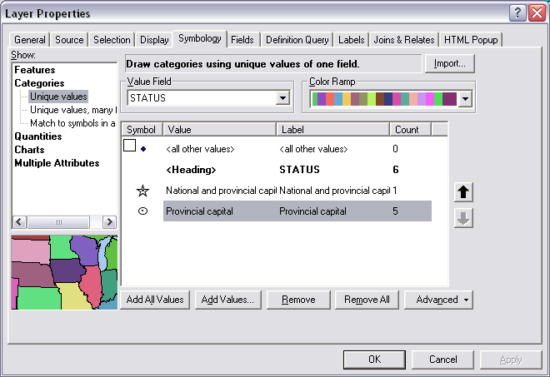In the **Symbology** **Tab**, click on the **Categories** item in the “**Show**:” **panel** on the left. **Unique values** should be the highlighted selection for this section.
4. **Change** the **Value Field** to **STATUS** and **click** the “**Add All Values**” **button**.
5. **Uncheck** the **<all other values>** item.
6. **Double-click** on the **point symbol** next to the “**National and Provincial Capital**” item to **open** the **Symbol Selector** **dialog**.
7. **Select Star 4** and **change** its **color** to **White**.
8. **Click OK**.
9. **Double-click** on the **point symbol** next to the “**Provincial Capital**” item to open the **Symbol Selector** dialog.
10. **Select Circle 3** and change its **color** to **White**. Change its **size** to **10**.
11. **Click OK.**
12. **Click OK** to **Apply** the **Symbology** to the **map layout**.
13. **Right-click** on the **symbols** for each of the **Plantation Types** in the **Table of Contents** and change them from their current **colors** to **Black**.
14. R**ight-click** on the **color patch** under the **Madagascar Layer** and change it to **White**.

### Labeling Using Graphics

Sometimes you would like to label a geographic feature with more control than the ArcMap Labeling engine provides. In this case, we will place the label for Madagascar along the central part of the island, on a spline curve. It is much easier to do this as a graphic than to tweak the label settings.

1. **Switch** back to **Data View** by **clicking** on the **Data View button** on the **View Toolbar** (**lower left corner** of the **Layout Window**).

The reason we change back to **Data View** in order to place a **Graphic Label** is that, in **Layout Mode**, **Graphics** are placed on the **Layout Page**, rather than in the **Data Frame**. This means that is we change the extent of our map, we will have to adjust the label we placed, since it is not tied to the geography of the features. In **Data View**, Graphics ARE tied to geography, so that if the extent of our map changes, the **Graphic** will reposition with the feature it is placed on.

1. **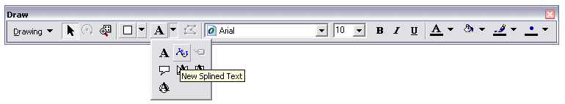Right-click** in an empty area of the **main toolbar** and enable the **Draw Toolbar**. **Dock** it at the **bottom** of the **ArcMap Application Window**.
2. On the **Drawing Toolbar**, **click** the **drop-down** arrow for the Text tool and select the **New Spline Text tool.**
3. **Place three vertices** within the outline of Madagascar, **with the center vertex offset from the two ends to create a curve** (as shown, below). **Double-click** to place the **third vertex** and **finish** the **new spline**.
4. 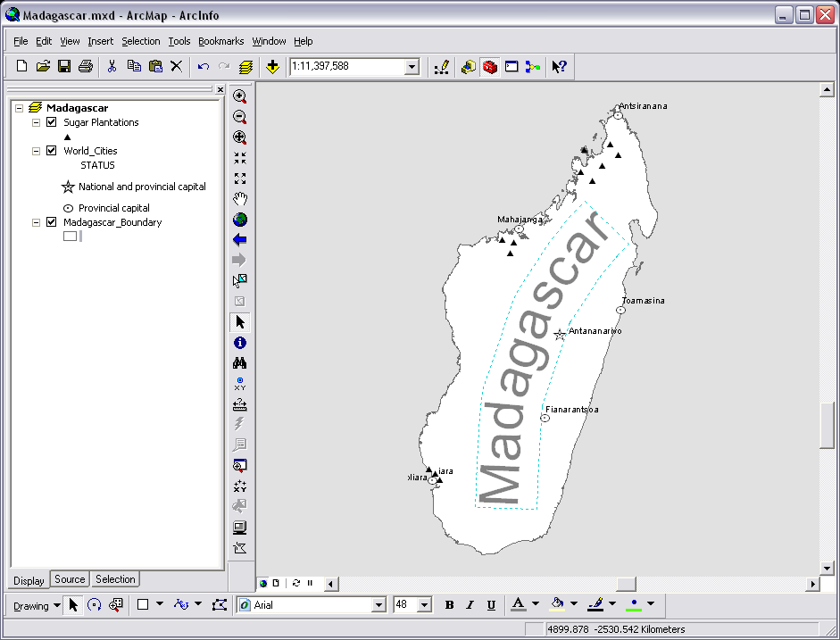You will be presented with (a very small) **text box** to enter the country name “**Madagascar**” into. Press the **Enter key** to finish your text entry and **snap** the **text** **to the spline**.
5. A blue dashed box should highlight the text you just added. On the **Drawing Toolbar,** **change** the **Text Size** to **48** and the **Text Color** to 50% **Grey**.
6. **Activate** the **Select Elements** **tool** C:\temp\Advanced GIS Skills\ScreenCaps\ArcMap Select Elements.png and use it to **reposition** the **spline text** within the boundary of Madagascar.
7. **Return** to **Layout Mode** using the **View Toolbar**.
8. **Save Layout-76 your work**.

## Using Annotation Layers to Create Customizable Labels

***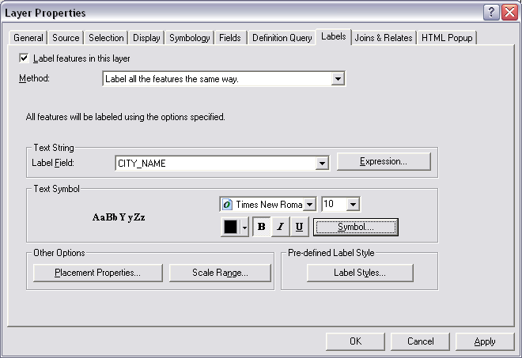***You may notice that some of your **World\_Cities Layer** labels have disappeared with the placement of the Madagascar Label along the center of the island. This is because ArcMap is making decisions in the background about when and where to place labels based upon possible conflicts with other features and labels. Frankly, some of these decisions are less than optimal and result is labels disappearing, or being placed in awkward locations. Fortunately, there is a means to take control of your labeling, at the individual level and force ArcMap to put labels where you want them.

### First, Make Global Changes to your Labels

If there are changes (to Fonts, Sizes, etc…) that you would like to make to your fonts, globally, you should make those before converting to

1. **Right-click** on the **World\_Cities Layer** and **open** its **Properties**.
2. 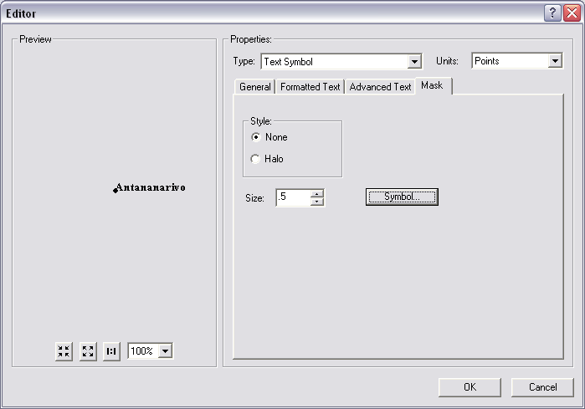Bring the **Labels Tab** to the front.
3. Set the **Text Symbol** to **Times New Roman**, **8 point** and **Bold**.
4. **Click** on the **Symbol Button**.
5. **Click** on the **Properties Button** in the **Symbol Selector**.
6. Bring the **Formatted Text Tab** forward and set the **Character Spacing to 10**.
7. Bring the **Mask Tab** forward and **select** the **Halo radio button**. Set the **halo size to 1 point**.

### C:\temp\Advanced GIS Skills\ScreenCaps\ArcMap Convert to Annotation.pngConverting to Labels to Annotation

1. **Right-click** on the **World\_Cities Layer** and **select** “**Convert Labels to Annotation**.”
2. **Accept** all of the **default settings** and **click Convert**.

### Editing Annotation Layer Labels, Individually

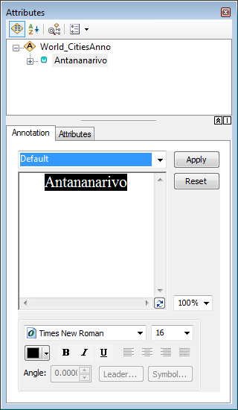Note that you should now have a new layer in your Table of Contents (as well as in your Geodatabase) called **World\_CitiesAnno**. This Layer contains the labels for the City features and treats them much like any other feature class. They are stored in your Madagascar.gdb; You must be in an Edit Session to alter them, now; BUT, you are now able to manually position them, or change the format of individual labels, independent of the formatting of all other labels.

1. **Right-click** on **World\_CitiesAnno** and **select Edit Features>Start Editing…**
2. Use the **Edit Annotation Tool**  to **select** and **move** **each** of the **World\_CitiesAnno Labels** so that they do not conflict with other features.
3. Use the **Edit Tool**  to **select** the **annotation label** for the **city of Antananarivo**. **Right-click** on the **label** and **open** its **Attributes**.
4. **Change** the **size** of the **Antananarivo label** to **10**, click **Apply** and **close** the **Attribute Window**.
5. **Save** your **Edits** and **Stop Editing**.
6. **Save your work**.

## Inserting and Customizing Map Elements

### Layout-65Adding an Overview Inset with an Extent Box for Orientation

1. On the **Main Menu**, go to **Insert>Data Frame**. A new empty **data frame** will be **added** to your **map layout**.
2. **Right-Click** on the **New Data Frame layer** name and **select Add Data**. **Browse** to the **Madagascar.gdb** and **select** the **Continent feature class**.
3. Click **Add** to **add** this **layer** to the **new data frame**.
4. 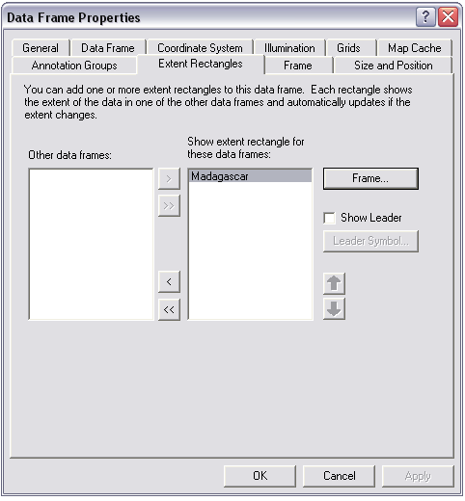In the **Table of Contents**, **right-click** on the **New Data Frame** and **open** the **Properties** dialog.
5. In the **General Tab**, **change** the **Layer Name** to “**Inset**.”
6. In the **Frame Tab**, **Change** the **Border** to **3.0 points** and give the **data frame** a **black** **background**.
7. In the **Size and Position** **Tab**, change the **Width & Height** to **1.5 inches**.
8. In the **Extent Rectangles Tab**, **select** the **Madagascar** **data frame** name and **add** it to the “**Show extent rectangle…**” list.
9. 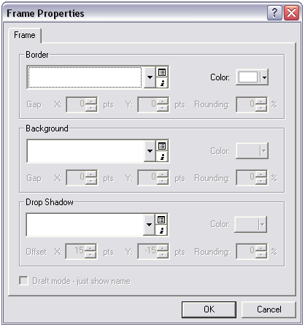Also in the **Extent Rectangles Tab**, **click** on the **Frame Button** and **change** the **border** to **2 point**, then **change** the **color** to **white**. **Click** **OK** **twice** to **apply** the **changes** and **exit** the **Data Frame Properties** dialog.
10. Use the **Select Elements** **tool** to **move** the **Inset Data Frame** to the **upper left** part of the **map layout.**
11. Use the **Data Zoom Tool** layout-3 to **zoom** (in the Inset Data Frame) into the **African Continent**, taking care to **ensure** that **Madagascar** and the **Extent Rectangle** are **visible**.
12. **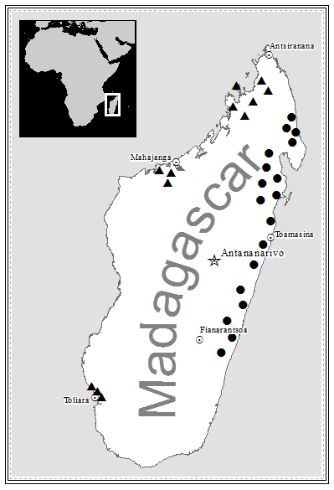Click once** on the **color patch** for the **Continent layer** to **open** the **Symbol Selector**. **Change** the **Fill Color** to a **Grey 20%** and the **Outline Color** to “**No Color**.”
13. **Save Layout-76 your work**.

## Inserting and Formatting a Legend

In this section, you will use the Legend Wizard to create a basic legend for your map layout, but will convert the legend to a graphic. The disadvantage of this is that the legend will no longer be linked dynamically to the Table of Contents. The advantage is that you have more control over the layout.

1. **Right-click** the **Madagascar Data Frame** name in the **Table of Contents** and select.  
   **Activate**
2. On the **Main Menu**, select **Insert>Legend** to launch the **Legend Wizard**.
3. **Select** the **Madagascar and World\_CIties Layers** in the **Legend Items list** on the right and use the **Remove Selected Button**  to **move** it into the **Map Layers list** so that they will not be included in the final legend.
4. **Click** **Next >** on the remaining Legend Wizard Steps until you have placed the legend in your layout.
5. **Right-click** on the **Legend** and **select** **Convert to Graphics**
6. 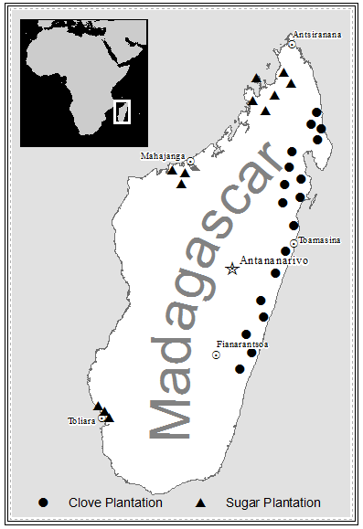**Right Click** on the **Legend Graphic** and **Select Ungroup**
7. Use the **Select Elements Tool** C:\temp\Advanced GIS Skills\ScreenCaps\ArcMap Select Elements.png to **select and delete** all **Legend elements** *except* the Symbol and Label for **Sugar Plantations** and **Clove Plantations.**
8. **Reposition** the two remaining items along the **lower inside edge** of the **Data Frame**.
9. **Use the Control Key and the Select Elements Tool** C:\temp\Advanced GIS Skills\ScreenCaps\ArcMap Select Elements.png **to select both remaining Legends items**
10. **Right-Click** on one of the **selected elements** and **select Align>Align Bottom.**
11. **Right-click** on the **selected elements** and **Group** them
12. **Repositions** the **legend items,** if necessary**.**
13. **Save your work.**

### Customizing a Scale Bar

Scale bars are absolutely necessary in any map layout, and are quite easy to customize in the ArcMap interface. Just remember to keep it simple, when it comes to scale bars. At the scale we are creating this map, a very simple scale bar is sufficient, and so we will take one of the ArcMap default Scale Bar designs and simplify it further to meet our needs. Note that you can also save a particular Scale Bar customization, so that you can reuse it across several map layouts/

1. On the **Main Menu**, go to **Insert>Scale Bar** to open the **Scale Bar Selector**.
2. 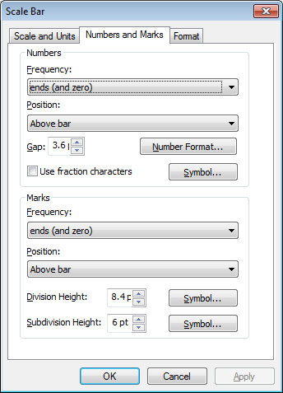Select **Scale Line 1** and **click** on the **Properties Button**.
3. In the **Scale and Units Tab**, change the **Number of Divisions** to **1**. Change the **Number of Subdivisions** to **0**.
4. Under the item “**When resizing…**” use the drop-down to change to ‘**Adjust Width’**. The “**Division value**:” item will become active. Make sure it has a value of **200** units (you will change the units in a moment).
5. Change the **Division Units** to **Kilometers** and the **Label:** to ‘**km’**
6. Click on the **Numbers and Marks Tab**, and change the **Numbers Frequency** to ‘**ends (and zero)**’.
7. 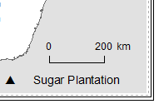Change the **Marks Frequency** to “**ends (and zero)**”
8. **Click OK once** to return to the Scale Bar Selector.
9. Use the **Select Elements Tool** to **Move** the inserted **Scale Bar** to the **lower right** of the Map Layout.

### Inserting a North Arrow

*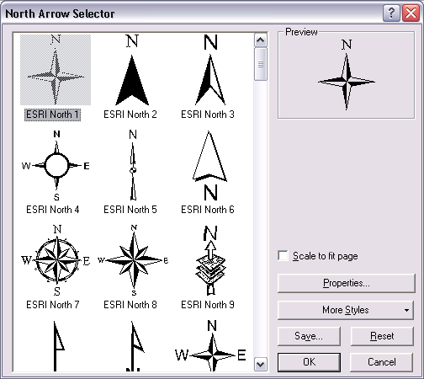*North arrows should be used rather judiciously, in most cases. Convention dictates that a map is oriented with the top of the map at North. If, for some reason, you need to produce a map that does not observe this convention (for instance a map that is oriented in the early cartographic convention with East at the top of the layout), you should perhaps include a North arrow. We will include a North arrow on this map, simply to introduce the workflow.

1. On the Main Menu, go to **Insert>North Arrow.**
2. **Select** a **North Arrow** from the **North Arrow Selector** and **click OK** to **insert** it into your **map layout**.
3. Use the **Select Elements Tool** to **move** the **North Arrow** **above** the **Scale Bar**.
4. **Adjust** the size of the **Scale Bar** using the **blue Resize Handles**, if needed.

### Inserting & Rotating Descriptive Text

Often, you will need to insert text into a map layout. Narrative text, Data source, etc.… all will require the insertion of text elements in to your map document. There are myriad tools for dealing with text in ArcMap, most of them not terribly useful for those used to dealing with text with all of the tools of modern word processing software at our disposal. In this case, we will simply place text into the map and change it’s orientation to highlight the ability to manipulate text in ArcMap

1. In the **Main Menu**, go to **Insert>Text**. A **textbox** will be inserted.
2. **Insert** the **text**: “**Cartographer: *YOUR NAME* / Stanford University**” into the text box and **press** the **enter key**.
3. On the **Drawing Toolbar**, **change** the **Font size** to **8** and the **Font Color** to **50% Gray.**
4. On the **Drawing Toolbar**, click the **Drawing Button** and **select >Rotate or Flip>Rotate Right**.
5. Use the **Select Elements Tool** to **reposition** the **text** at the **left margin** of the **map layout**.
6. **Save Layout-76 your work**.

### Insert an Invisible Neatline to ‘Buffer’ Your Frame

This is actually necessary because there is a bug in another movie?ArcMap that has remained for years. This bug appears when you are exporting a map layout to an image format using the ‘Clip Output to Graphics Extent’ option in the Export Map dialog that causes ArcMap to ‘Clip Output to Graphics Extent’ minus a few pixels. Those few pixels will be important if your Frame is a very fine line, or if you have text placed outside your Frame. Here, you will place a 4 point neatline with a color of white (so that it is invisible to us, but visible as a graphic to ArcMap).

1. 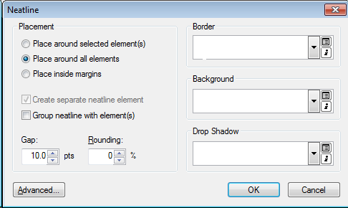On the **Main Menu**, select **Insert>Neatline**.
2. Set the Placement Option to ‘**Place Around All Elements**’
3. **Click** the **Style Selector Button**  to open the **Style Selector**, and then click on the **Properties Button**. **Change** the **Border Color** to **White**.
4. **Change** the **Background Color** to **White**, if necessary.

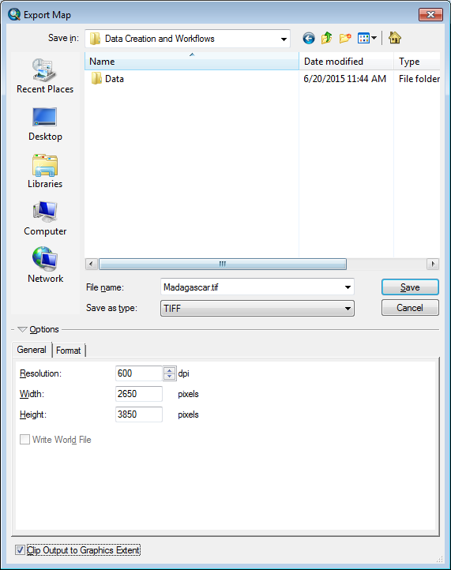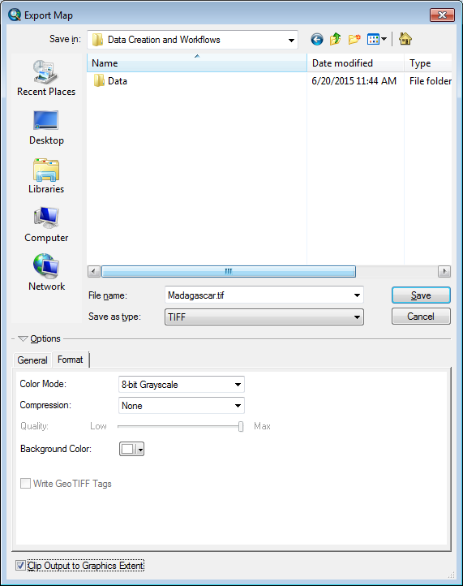

1. **Click OK** and note that the **New Neatline is not visible,** but is in evidence based upon the **blue selection handles.**

## Exporting to High Resolution Format for Submission

Finally, you will want to Export to a high resolution lossless image format for submission. In general, TIFF format is universally accepted, and publishers vary on their resolution requirements, but between 600 and 1200dpi is common.

1. On the **Main Menu, select File>Export.**
2. **Change** the “**Save as Type**” dropdown to “**TIFF (\*.tif)**.”
3. Browse to the **\Data\_Creation\_and\_Workflows\ folder** (just click on the Home Button to return to the folder where your \*.mxd document is saved) and leave the File name as the **Default** **Madagascar.tif**.
4. 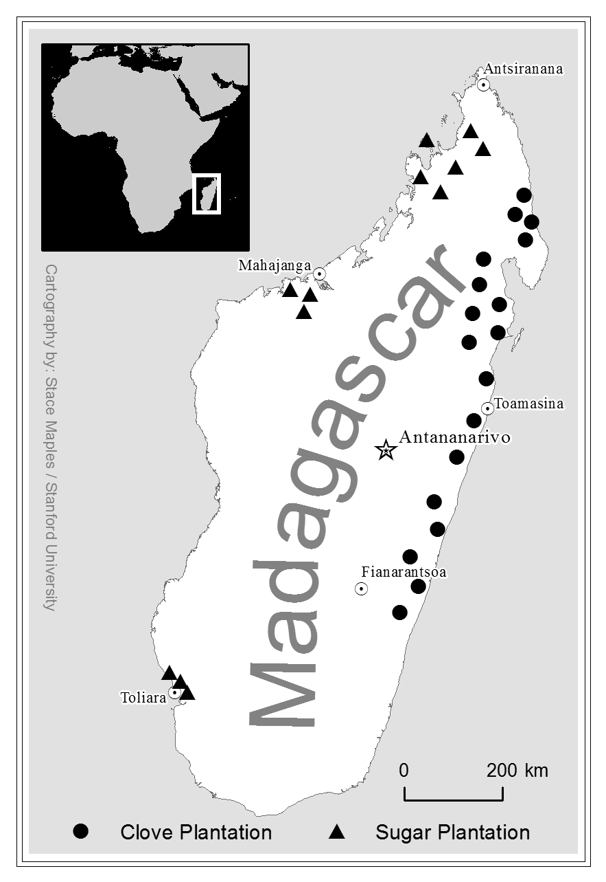**Change** the **Resolution** **setting** to **600dpi.**
5. Check the **“Clip Output to Graphics Extent”** option at the bottom of the window.
6. **Click** on the **Format Tab and Set** the **Color Mode** to **8-bit Grayscale** (this will drastically reduce the file size).
7. **Click Save**.
8. **Browse** to the **\Data\_Creation\_and\_Workflows\ folder** and open the resulting **Madagascar.tif** to **preview your results**.

Congratulations! You are finished with this tutorial, and you have a well-made map to show!