# Avenza PDF-Maps app for Android

## Use Guide for Ten Mile River Scout Camp Workshop

This guide is intended to get you up and running using Avenza's PDF-Maps for Android.

### Sign up for DropBox and connect to the Shared Folder

You should have received an email invitation to join the ScoutMap Dropbox Folder from Sid Miller of Stace Maples.

1. Simply click on the "View Folder" link in the email and you will be presented with the **DropBox Signup page** (Unless you already HAVE a DropBox account and are signed in, in which case you will be taken to the TMPScouts Folder and can ignore the remainder of this section).

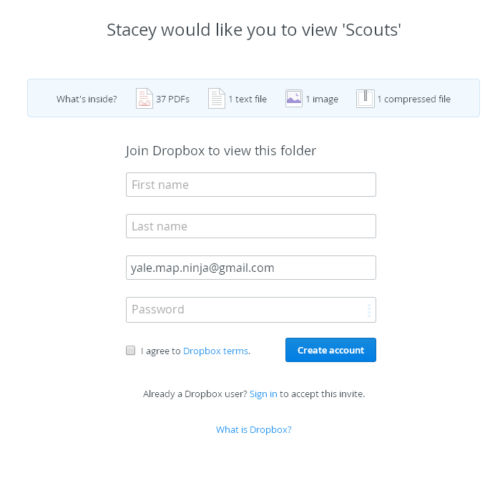

Android Screenshot

1. Fill in your information and click on the "**Create Account**" Button.

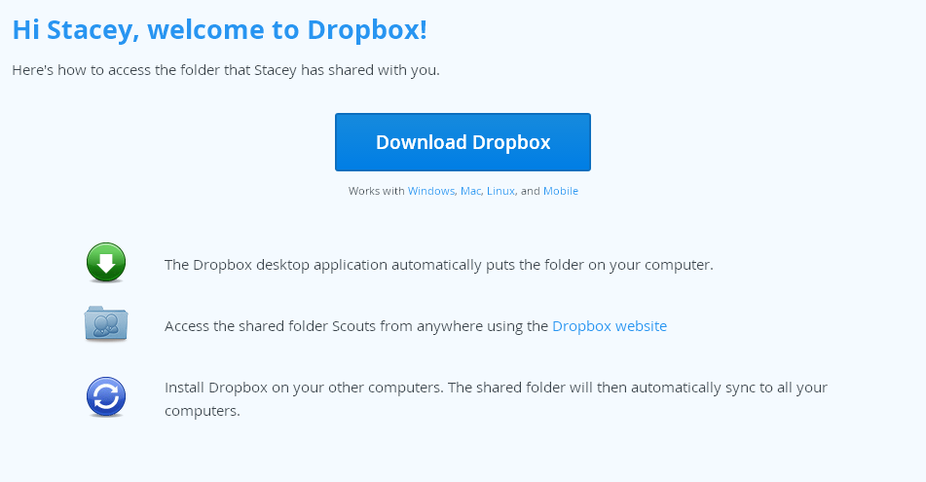

Android Screenshot

1. If you created your account successfully, you should see a **Welcome Page**". Find the "**Dropbox Website**" link and click on it to access the shared folder.

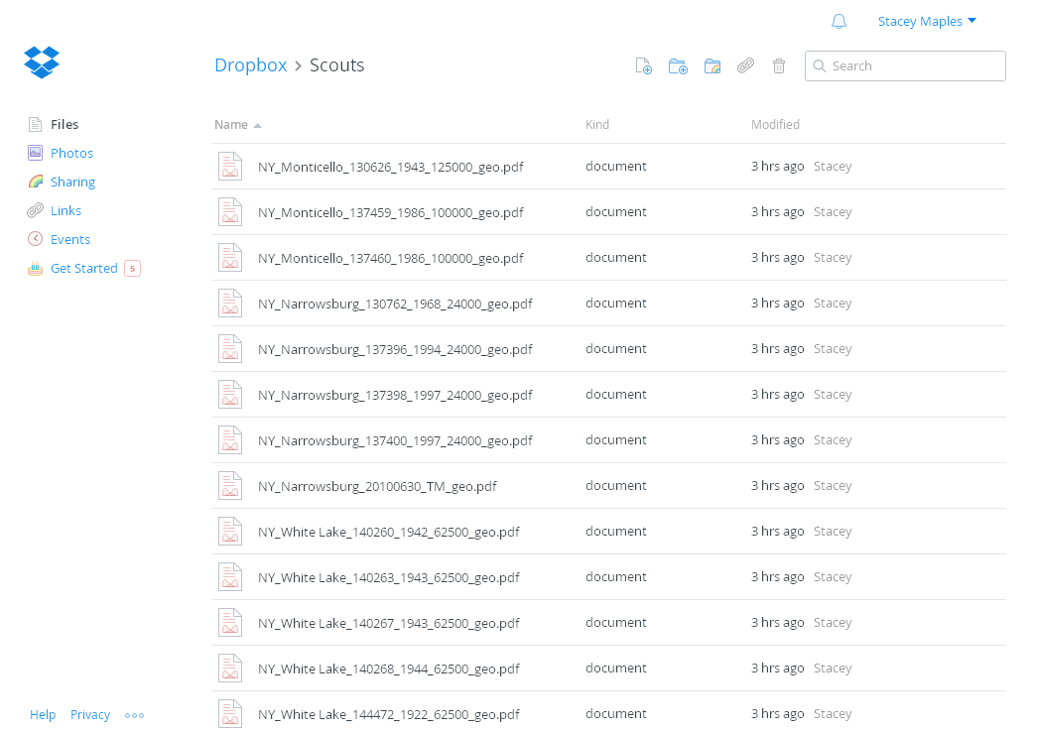

Android Screenshot

1. You should see the **TMRScouts Folder** contents at this point and, if so, you have successfully set up your Dropbox account.

**NOTE** ***that it is not necessary for you to download the Dropbox Desktop application offered to you on the Welcome Screen, mentioned above. Instead, you will need the Mobile App for your device.***

### Install the DropBox App on Your Phone

PDFMaps integrates well with DropBox and makes it easy to move PDF Basemaps onto your phone and also allows you to export your collected map data directly to DropBox. For this integration to work properly, however, you need to have the DropBox App installed on your phone. Once you have created a Dropbox account as described above, do the following:

1. For Android, Search the Google Play Store for Dropbox and install the app, or go to [This Link](http://play.google.com/store/apps/details?id=com.dropbox.android&hl=en) from your phone.
2. Touch the Install Button to install the application on your phone

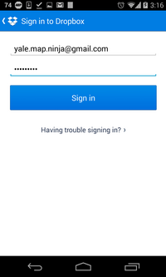 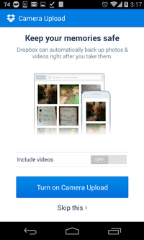 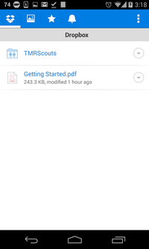

1. Once installed, Open Dropbox on your Phone and **sign in** using the credentials you used to create your account, above.
2. Once signed in, you will be prompted to set some options (Photo Backup, etc...). These are totally up to you, and not necessary for the workshop.
3. Finally, you should see the TMRScouts folder displayed in your list of Dropbox Folders.

### Install the Avenza PDF-Maps App

1. First, go to Google Play or follow [This Link](https://play.google.com/store/apps/details?id=com.Avenza&hl=en), to install PDF Maps by Avenza.

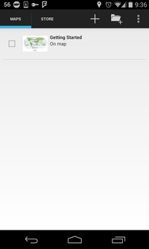 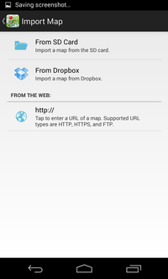 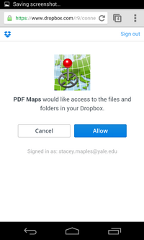

1. Once installed, open the PDF Maps Application and press the Add Maps button at the top of the application
2. Select the option to Import Maps from Dropbox.
3. Go through the dialog to allow PDF Maps to access your Dropbox account.

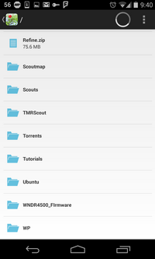 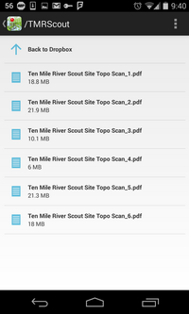 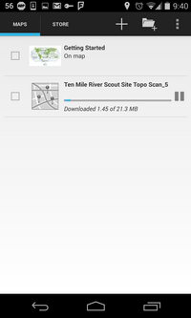

1. Once you have approved PDF Maps' access to your Dropbox account, you should be presented with a view of your Dropbox folders. Browse into the **TMRScout** Folder.
2. Select a map and PDF Maps will import the PDF and process it for use in PDF Maps. Once processed, the map will be available in PDF Maps for use in the field.
3. Please Download all maps in the **TMRScout** folder. We have provided several different basemaps for each location of interest.

#### Note that the tutorials on using the basic features in PDF Maps that follow were written for the Yale School of Forestry's Field Exercises at Great Mountain Forest, but should be useful in learning the basics of PDF Maps for your personal use, as well.

### Opening a Map in PDF Maps

1. Once the import process has completed, tap on the map to open it.

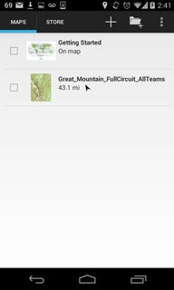 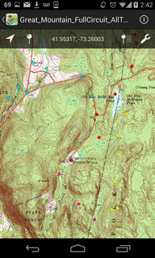

Navigation in the application works as you would expect, with double-taps, pinch-in and out, etc... Once you've got your map open, you will see a toolbar the top with 5 items...

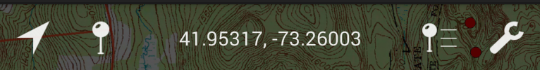

Android Screenshot

## Individual Map Toolbar Functions:

### GPS Tool

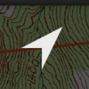

Android Screenshot

1. The GPS Tool enables the GPS on your device and centers the map on your location. ###Placemark Tool  
    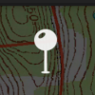
2. The Placemark Tool places a new Placemark into the map at the center of the map (marked by crosshairs). If you want the point placed at the GPS location you are at, you should click on the GPS Tool, first. Once a Placemark is placed, you can changed it's position on the map by long-pressing the placemark and dragging it around.

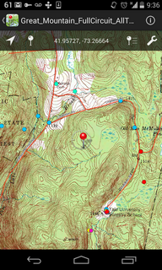

Android Screenshot

### Coordinates Tool

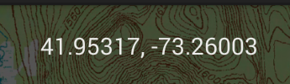

Android Screenshot

1. The Coordinate Tool allows you to see the coordinates in the app using one of several different Datum/Projections, including UTM, NAD83 and WGS84 ###Placemark Collections Tool 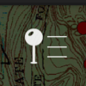
2. The Placemark Collections Tool takes you to the Placemark Collections Explorer, which allows you to organize your Placemark into folders for exporting and management.

### Map Tools Button

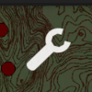

Android Screenshot

1. The Map Tools button provides access to a number of other tools for managing your PDF Maps Application.

### Starting a Track Log recording

1. Touch the Map Tools button and select "**Record GPS Tracks**"
2. Touch the "**Play**" Button that appears at the bottom of the screen to begin recording your track.
3. Use the Pause button to pause Tracklogging temporarily, and the "Done" link to stop recording the Track, altogether, and save it to the device.

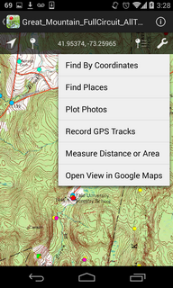

Android Screenshot

## Editing Placemark Attributes/Adding Photos

Once you have added a placemark, using the method described above, you can click on the Pop-Up to bring the Placemark Editor forward.

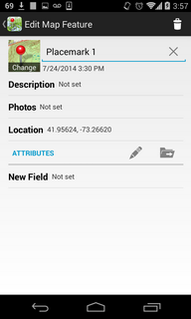

Android Screenshot

Clicking on any of the items in the Placemark Editor Screen will provide you with the ability to edit those fields. By Default, placemarks have Name, Description Photo and Location fields you can populate with the values you need. If you find that you would like to add more fields, you can create a custom schema using the tools at the bottom of the Placemark Editor Screen. For this exercise, it will not be necessary to do so, but you are free to experiment.

### Adding Photos to a Placemark

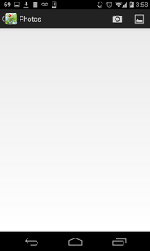 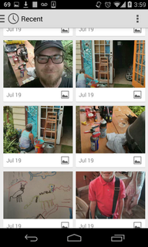 

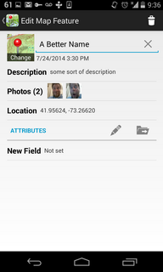

Android Screenshot

Clicking on the Photos Item in the Placemark Editor will bring a screen that allows you to select an existing photo, or use the device camera to take a new one. Note that you are able to attach multiple photos to each Placemark. As a best practice, it is a good idea to go into the camera settings on your device to set the photos to a low or medium resolution (whichever is sufficient for your purpose), in order to economize on the size of your Placemark Collections.

### Exporting a Collection of Placemarks

There are a great number of options for exporting your placemarks, in terms of format, method, etc... Here, you are provide with the most expedient method, that preserves the photos embedded in your placemark collection.



Android Screenshot

1. To Export Placemarks, click on the Placemark Collection Tool.

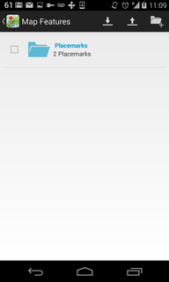

Android Screenshot

1. Click on the Export Button

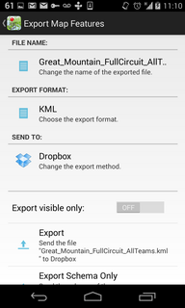 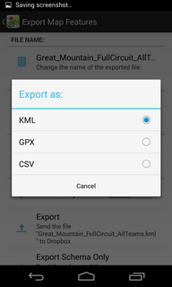 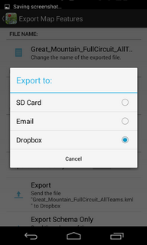

1. Change the FILE NAME, if desired.
2. Change the EXPORT FORMAT to KML, if it is not, already (CSV and GPX are perfectly reasonable formats, but do not bring the photos with them, in the export).

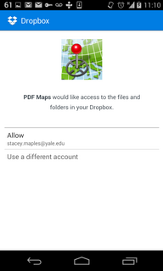 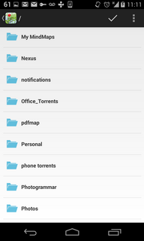 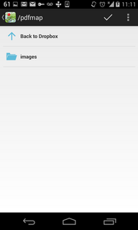

1. Change the SEND TO Option to the one most convenient for you (Email, SD Card and Dropbox are options). Note that the Dropbox option will require that you have Dropbox App installed on your device. If you are working remotely, and network connectivity is an issue, you may find that using the SD card option, and then sending the resulting file through Bluetooth connection or using a USB cable is the best option.
2. Click on the Export Item to begin the export for the method you have chosen. Dropbox is described/shown, here.
3. Authorize PDF Maps to access Dropbox on your device.
4. Browse to the folder you want to save the KML file to.
5. Click on the Check Mark to Export the Placemark Collection to DropBox.

For more detailed information about setup and use, please see the Avenza Webpage for the app at http://www.pdf-maps.com/