The Role of Encryption in Data Protection in Software Systems
Leo Petrović¹
¹Faculty of Mechanical Engineering, Computing and Electrical Engineering University of Mostar, Bosnia and Herzegovina

Abstract  Software systems collect, process, transmit, and store data at scale – and when that data is exposed, the harm reaches individuals, organizations, and public trust alike. Encryption addresses this risk directly: it converts readable data into ciphertext that is meaningless to anyone without the corresponding key. This paper approaches encryption in data protection from three angles. The first covers how symmetric and asymmetric encryption underpin everyday software services – secure communication, storage protection, and mobile device security among them. The second addresses cryptanalysis and implementation failures, making the case that encryption cannot be assessed in isolation from the larger system it operates within. The third looks ahead to the quantum computing threat and what the shift toward post-quantum cryptography requires in practice. Taken together, the paper argues that encryption is an ongoing discipline rather than a fixed feature – one whose effectiveness rests on algorithm quality, key management, correct implementation, and willingness to migrate when the landscape changes. | Article history  Received: xx month 20xx  Revised: xx month 20xx  Accepted: xx month 20xx
Keywords
Encryption,
Data protection,
Software systems,
Cryptanalysis,
Post-quantum cryptography

Introduction
Modern software systems are built around data. A banking application carries account balances and payment instructions; a messaging service transports private conversations; a medical platform stores records that may remain sensitive for a lifetime. In each case, the value of the system depends not only on collecting and processing information, but also on preventing that information from being read by the wrong party. Data protection is therefore not an optional layer added after development – it is a basic condition for trustworthy software.
Encryption plays a central role in this protection. In simple terms, encryption changes readable data into a form that is useless without a key. It can be understood as a controlled access mechanism: data may still pass through networks, storage devices, cloud services, and backups, but its content is not meant to be intelligible outside the intended trust boundary. In software, this principle appears in several forms: data may be encrypted in motion while it travels across a network, encrypted at rest while it is stored on a disk or in a database, or protected by application-level mechanisms designed for specific fields and workflows.
Everyday examples show how ordinary encryption has become. HTTPS relies on Transport Layer Security (TLS) to protect web traffic between clients and servers, making online banking, shopping, and API communication practical on untrusted networks [1]. Storage encryption protects laptops and mobile phones when devices are lost or stolen, while the Advanced Encryption Standard (AES) remains a widely used foundation for symmetric encryption in software and hardware systems [2]. These mechanisms are often invisible to users, yet they shape whether a stolen backup, intercepted packet, or compromised storage device becomes a serious data breach.
At the same time, encryption is not self-sufficient. A strong algorithm can be weakened by poor key storage, outdated configuration, flawed implementation, or an attacker who targets the surrounding software rather than the mathematics itself. Cryptanalysis studies weaknesses in cryptographic systems, but practical failures often arise from engineering choices: keys left exposed in memory, obsolete protocols kept for compatibility, or passwords handled as if encryption and authentication were the same problem. For this reason, encryption must be discussed together with software design, operational practice, and attacker capabilities.
The third theme of this paper is the future of encryption under quantum computing. Large quantum computers would threaten widely deployed public-key systems such as RSA and classical Diffie-Hellman key exchanges because their security depends on mathematical problems that Shor's algorithm is designed to solve [3]. This does not mean that all encryption becomes obsolete at once, but it does mean that long-lived software systems need cryptographic agility: the ability to identify, replace, and test cryptographic components before they become liabilities.
This paper therefore approaches encryption as both a technical method and a practical discipline. Section 2 explains the main types of encryption and where they appear in software systems, section 3 examines cryptanalysis and implementation attacks as forces that drive algorithm migration and better engineering practice, and section 4 introduces post-quantum cryptography and the preparation required for future-resistant systems. The overall argument is that encryption protects data most effectively when it is treated as a maintained part of the software architecture.

Encryption in Software Systems
Encryption in software systems is best understood as a practical control over who can read data, when, and under what conditions. It does not replace access control, secure coding, monitoring, or backups, but it changes the consequences of exposure. If an attacker intercepts traffic, steals a database copy, or obtains a lost device, well-implemented encryption can turn readable information into material that is computationally impractical to interpret.

Basic Concepts and Types of Encryption
At its simplest, encryption transforms plaintext into ciphertext. Plaintext is the original readable message, while ciphertext is the protected form that should appear meaningless without the correct key. The process can be written as $c=E_{k}\left(m\right)$, where $m$ is the message, $k$ is the key, $E$ is the encryption algorithm, and $c$ is the resulting ciphertext. Decryption reverses the process. The algorithm defines the transformation, while the key determines who can perform or reverse it.
The first major type of encryption is symmetric encryption. In a symmetric system, the same secret key is used for encryption and decryption. This makes it fast and suitable for files, database pages, backups, or network traffic after a secure session has been established. The Advanced Encryption Standard (AES), standardized by NIST, is the most important modern example and supports key sizes of 128, 192, and 256 bits [2]. Its strength in practice also depends on correct modes of operation, random nonces or initialization values where required, and careful key management.
The second major type is asymmetric, or public-key, cryptography. Instead of one shared secret, it uses a key pair: a public key that may be distributed, and a private key that must remain secret. Diffie and Hellman showed that two parties could establish a shared secret over an insecure channel [4]. RSA then showed how public-key methods could support encryption and digital signatures based on the difficulty of factoring large numbers [5]. In software systems, public-key cryptography often authenticates parties and establishes a temporary shared secret; symmetric encryption then protects the bulk data because it is more efficient.
It is important not to treat encryption as a synonym for all security. Encryption mainly protects confidentiality: it answers the question, “Can an unauthorized party read this data?” Authentication and integrity answer different questions: “Who created or approved this data?” and “Has it been changed?”. Digital signatures, message authentication codes, and cryptographic hashes therefore complement encryption rather than replace it. This distinction also matters for passwords: a password database should normally store salted password hashes, not “encrypted passwords” that can simply be decrypted by the service.

Encryption in Practice: Where It Lives in Software
In everyday software, the most visible use of encryption is traffic protection, for example in a web browser. When a user sees the padlock icon in a browser, the underlying protection is usually Transport Layer Security (TLS). TLS 1.3 protects web pages, API calls, mobile application traffic, and many service-to-service connections by combining public-key mechanisms for authentication and key establishment with symmetric encryption for application data [1]. In an online shop, the payment form, authentication cookies, and order details should travel through an encrypted channel so that a network observer cannot read or modify them (known as a “Man-in-the-middle attack”).
Encryption also protects data at rest. Full-disk encryption tools such as BitLocker and FileVault, mobile device encryption, encrypted database columns, and encrypted backups address the same basic problem: secure storage media that can be copied, lost, or stolen. Research on mobile device confidentiality shows that modern platforms combine hardware-backed keys, user credentials, and file-level protection classes [6]. The difference from network encryption is not the basic goal of confidentiality, but the operational context: stored data may remain exposed for long periods and may need to be decrypted repeatedly by local users, applications, or recovery processes.
Application-layer encryption appears when the software itself decides that particular fields or documents need protection even inside a broader system. A health application may encrypt notes, identifiers, or medical attachments before storage. A cloud service may encrypt files before upload so that the provider cannot read the content. This form can be powerful, but it moves more responsibility into application design: developers must decide where keys live, when data is decrypted, how recovery works, and what happens when a user loses access.
Table 1 summarizes the practical differences between symmetric and asymmetric encryption.
Table 1 Experimental results
Aspect | Symmetric encryption | Asymmetric encryption
Key model | One shared secret key | Public key and private key pair
Speed | Fast; suitable for large data volumes | Slower; used for smaller operations
Typical examples | AES for files, disks, backups, and session traffic | Diffie-Hellman key exchange, RSA encryption or signature
Main software use | Bulk confidentiality after a key is available | Authentication, key establishment, and secure exchange
Main risk | Secret key distribution and storage | Private key protection and trust in public keys or certificates

A concrete backup example shows the difference encryption can make: if an attacker steals an unencrypted database backup, the records can be opened like any other file. If the same backup is encrypted with AES-256 and the key is stored separately in a controlled key-management system, theft of the storage copy alone is far less useful for the attacker. This does not make the system invulnerable: malware, exposed credentials, or weak procedures may still defeat the protection. However, encryption changes the attack from simple copying into a harder problem that also requires key compromise.
Figure 1 illustrates this relationship between public-key establishment and symmetric protection in a typical TLS session.
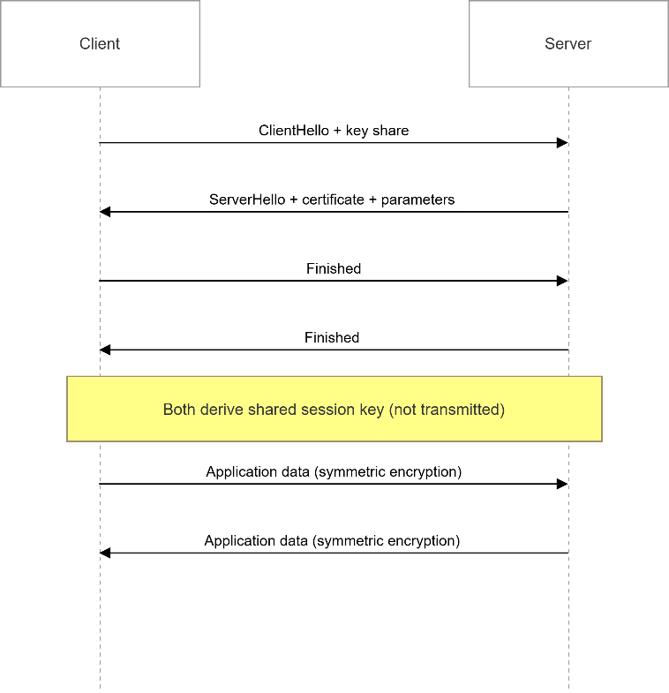
Figure 1 Simplified TLS handshake and use of a symmetric session key.

Cryptanalysis – Breaking the Protection
Encryption is often presented as a direct barrier against unauthorized reading, but its strength depends on the algorithm, protocol, implementation, and key-management environment together. Cryptanalysis is the discipline that evaluates those assumptions. It asks whether an attacker can recover plaintext, discover a key, forge a valid message, or otherwise reduce the security promised by a cryptographic system. This does not mean that every successful attack “breaks encryption” in the sense of instantly reading all protected data – more often, cryptanalysis narrows the attacker's work, exposes unsafe assumptions, or shows that an algorithm that was once acceptable no longer provides enough resistance.

What Is Cryptanalysis and What Affects Security
Cryptanalysis studies weaknesses in cryptographic algorithms and protocols, usually under the assumption that the attacker knows how the system works but does not know the secret key. This assumption is important for software systems: security should not depend on hiding the algorithm (“security through obscurity”).
A cipher used in a public standard must remain secure even when its design is open to researchers, implementers, and attackers. In this sense, cryptanalysis is not the enemy of encryption; it is one of the main processes by which encryption becomes trustworthy.
It is also important to distinguish cryptanalysis from nearby forms of failure. A mathematical attack on a block cipher is different from a programming error that reuses a nonce, a server that stores keys in a public repository, or a phishing email that tricks an administrator into revealing credentials. All of these may defeat data protection, but they do so at different levels (also known as “side-channel attacks”). Cryptanalysis targets the specific cryptographic construction itself or the assumptions around it, implementation flaw abuse targets the way the construction is coded and configured, and social engineering targets people and procedures. Real incidents often combine these levels, which is why encryption must be evaluated as part of a complete system (chain of security) rather than as a single library call – it is often said that the chain of security is only as strong as its weakest link.
Several factors determine whether encrypted data is secure in practice. The first is key length: if an attacker can do no better than trying every possible key, then an $n$-bit key gives a key space of $2^{n}$ possibilities. The difference between e.g. 56 bits and 128 bits is therefore not a small technical detail – it is a change from a space that became searchable with specialized effort to one that is far beyond a practical exhaustive search with classical computers. This is why modern symmetric encryption relies on key sizes such as those standardized for AES, including 128, 192, and 256 bits [2].
The second factor is algorithm design. A long key does not save a cipher whose internal structure leaks useful information. Differential cryptanalysis showed how statistical differences between pairs of plaintexts and the corresponding ciphertexts could be used against DES-like block ciphers [7]. Linear cryptanalysis later demonstrated another method for exploiting approximate linear relationships among plaintext, ciphertext, and key bits [8]. These attacks are not merely historical curiosities – they shaped how later ciphers were evaluated and helped explain why modern standards must survive public analysis before they are trusted.
The third factor is key management. In software, keys must be generated with sufficient randomness, stored in controlled systems, rotated when necessary, and kept separate from the encrypted data they protect. Brute force may be mathematically unrealistic against AES-256, but a stolen encryption key can make all the ciphertext generated using the same key readable immediately. For this reason, the security of encryption depends as much on operational discipline as on cryptographic theory.

Historical and Modern Attacks — Lessons for Software
The history of cryptanalysis shows that encryption strength is temporary unless systems are maintained. The Data Encryption Standard (DES), adopted in the 1970s, illustrates this lesson clearly. DES was designed for a different computing era and used a 56-bit key [9]. For its time, it was an important standard. Over time, however, increases in computing power and public cryptanalytic research made that key length too small for long-term protection. The DES standard was later withdrawn, and NIST transition guidance now directs systems away from weaker algorithms and shorter key lengths [9] [10].
Cryptanalysis also teaches that a protocol can fail even when it contains a recognizable encryption algorithm. Software systems do not use ciphers in isolation: they combine algorithms with modes of operation, random values, handshakes, certificates, passwords, error messages, and recovery processes. Legacy algorithms such as WEP are useful examples because they show that weak configuration and unsafe protocol design can expose data without requiring an attacker to defeat a modern cipher such as AES directly. This is one reason modern standards such as TLS 1.3 removed many older cryptographic options and simplified the set of acceptable mechanisms for secure communication [1].
Side-channel attacks provide another practical lesson: instead of attacking the abstract algorithm, a side-channel attack observes information leaked by the implementation, such as timing, power consumption, cache behavior, or electromagnetic emissions. If a cryptographic operation takes slightly longer depending on secret data, an attacker may be able to infer part of a key by measuring those timing differences. Research on side-channel cryptanalysis has shown that such leakage can be modeled and exploited, especially in embedded and hardware-assisted environments [11]. The lesson for software is that “using a strong cipher” is not the same as using it in a constant-time, leakage-resistant way.
Key theft is even more direct. Cold boot attacks demonstrated that encryption keys may remain recoverable from DRAM for a short time after power loss, allowing an attacker with physical access to extract material that software assumed had disappeared [12]. This example is powerful because it does not contradict the mathematical strength of encryption – AES can remain secure while the surrounding machine fails to protect the key. Similar lessons apply to cloud secrets, mobile devices, backup systems, and continuous integration pipelines. An attacker who compromises a key-management service, reads an environment variable, or downloads an unprotected backup, may bypass cryptanalysis entirely.
For developers and system designers, the central message is that attacks drive migration: DES gave way to stronger symmetric algorithms, public analysis of block ciphers improved design criteria, side-channel research changed implementation practice, and protocol failures encouraged simpler and more modern configurations. NIST guidance on algorithm transitions makes this maintenance perspective explicit: cryptographic choices must be reviewed over time, not frozen at the date a system is first deployed [10].
Figure 2 summarizes this evolution as a timeline of technical and operational improvement: DES represents an older baseline; 3DES is an intermediate step; AES represents the modern symmetric standard; and good practice adds key management, side-channel resistance, and timely algorithm migration above the algorithm itself.
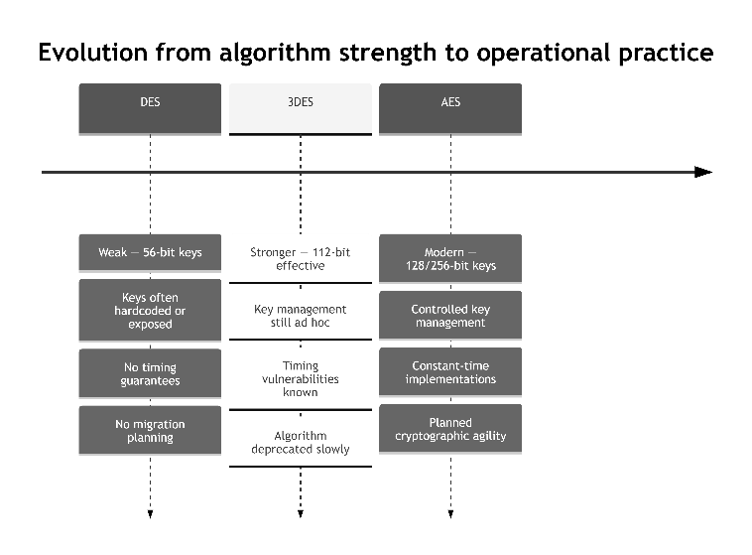
Figure 2 Evolution from algorithm strength to operational practice

Post-Quantum Cryptography and the Future of Protection
The previous sections treated encryption as protection for current software: web traffic, stored files, backups, and application data. The future of protection adds another question: what happens when attackers can solve cryptographic problems in fundamentally different ways? Quantum computing does not make every encryption method useless, but it places public-key cryptography, long-lived data, and hard-coded choices under pressure.

The Quantum Threat to Traditional Encryption
Classical computers attack cryptography through ordinary computation steps. If no shortcut is known against a symmetric cipher, the simplest model is exhaustive search: try one key, then another, until the correct key is found. For a well-designed cipher with a large key space, this quickly becomes unrealistic. AES-256, for example, is far beyond practical brute force with classical computers [2].
Quantum computers change this discussion because they can run algorithms that do not behave like ordinary step-by-step search. The most important result for traditional public-key systems is Shor's algorithm, which gives an efficient quantum method for integer factorization and discrete logarithms [3]. These are the mathematical problems behind RSA, finite-field Diffie-Hellman, and elliptic-curve cryptography. A sufficiently large and reliable quantum computer could therefore derive private keys from public information in systems considered secure today.
This threat is mainly a threat to asymmetric cryptography. RSA depends on factoring large composite numbers, while many Diffie-Hellman and elliptic-curve systems depend on discrete logarithm problems. Shor's algorithm directly targets these mathematical foundations. It does not compromise every encryption method, but it changes the expected security of widely deployed public-key systems once the required quantum hardware exists.
Symmetric encryption is affected differently. Grover's algorithm gives a quadratic speedup for an unstructured search [13]. If a classical exhaustive search over an $n$-bit key requires about $2^{n}$ trials, Grover's algorithm reduces the scale to about $2^{n/2}$ quantum operations. This matters, but it is not as destructive as Shor's algorithm is for RSA or ECC. In simplified security terms, a 128-bit symmetric key provides a smaller quantum search margin than a 256-bit key. Resource estimates for applying Grover's algorithm to AES support this nuanced view: AES is not simply “broken”, but larger keys become prudent for long-term protection [14].
The practical risk is sharpened by “harvest now, decrypt later”. An adversary may record encrypted traffic today even if it cannot be decrypted yet. If the traffic contains medical records, government material, trade secrets, source code, or identity data that remains sensitive for years, the adversary can store it until future technology makes decryption possible. This is especially relevant to TLS, VPNs, messaging systems, and backup transfer systems that use quantum-vulnerable public-key methods for key establishment.
Figure 3 shows the distinction software teams must keep clear: quantum computing places immediate strategic pressure on public-key migration, while symmetric encryption can often be strengthened with larger keys and sound implementation.
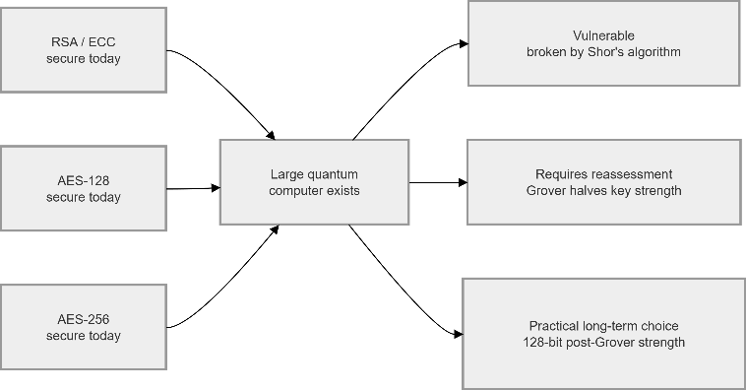
Figure 3 Quantum impact on asymmetric and symmetric encryption

Post-Quantum Methods and Preparing Software Systems
Post-quantum cryptography is the response to this threat. The term does not usually mean cryptography that runs on quantum computers – it refers to algorithms designed for classical hardware while resisting known attacks from both classical and quantum computers [15]. In software terms, the goals remain familiar: establish shared secrets, authenticate servers, sign software updates, and protect identities. The mathematical assumptions, however, must not be the same assumptions that Shor's algorithm defeats.
Several families of post-quantum algorithms have been studied. Lattice-based methods are prominent because they can support efficient key establishment and digital signatures from problems believed to remain hard for quantum attackers. NIST's ML-KEM standard, derived from CRYSTALS-Kyber, provides post-quantum key encapsulation for shared secrets [16] [17]. NIST's ML-DSA standard, derived from CRYSTALS-Dilithium, provides post-quantum digital signatures for authentication, software signing, and integrity protection [18] [19]. Hash-based signatures rely on conservative assumptions about hash functions, and NIST's SLH-DSA standard, derived from SPHINCS+, gives a stateless option [20] [21].
These methods are promising, but migration is not only a simple algorithm replacement. Post-quantum keys, ciphertexts, and signatures may be larger than the classical values they replace. A protocol that easily carried an elliptic-curve public key may need testing before it carries a larger post-quantum object. Databases that store certificates, devices with limited memory, strict packet sizes, and embedded systems with small processors may all experience practical effects.
One near-term strategy is hybrid cryptography. In a hybrid key exchange, a system combines a classical algorithm with a post-quantum algorithm and derives the final shared secret from both. The purpose is continuity: if the post-quantum component later receives more cryptanalytic scrutiny, the classical component still contributes present-day security; if a quantum attacker later breaks the classical component, the post-quantum component protects long-term confidentiality. Hybrid deployment is useful when old clients, third-party libraries, hardware appliances, certificates, and compliance requirements cannot all change on the same day.
Preparing software systems begins with a cryptography inventory. Teams need to know where RSA, Diffie-Hellman, elliptic-curve keys, certificates, signatures, and key-exchange mechanisms appear. This includes TLS termination, VPN gateways, identity providers, code-signing pipelines, backup tools, mobile SDKs, device provisioning flows, license files, and archived data formats. Without an inventory, post-quantum migration becomes guesswork.
The second step is crypto agility: designing systems so that algorithms can be replaced without rewriting the entire product. This includes using maintained cryptographic libraries, avoiding custom protocol design, storing algorithm identifiers with protected data, supporting key rotation, and testing compatibility and performance. NIST standards such as ML-KEM, ML-DSA, and SLH-DSA provide reference points for that gradual transition [16] [18] [20].
Finally, software teams should treat post-quantum migration as planned maintenance rather than emergency replacement. Waiting until large quantum computers are already available would compress years of protocol design, interoperability testing, certificate updates, and operational change into an emergency. Starting early allows systems to protect long-lived data, test hybrid modes, measure performance, and update dependencies with less disruption. Encryption has always evolved as attacker capabilities improved; post-quantum cryptography is the next stage of that responsibility.

Conclusion
This paper has examined encryption as a practical foundation for data protection in software systems. Across web traffic, stored files, database backups, mobile devices, and sensitive application fields, encryption reduces the harm caused by interception or unauthorized copying by making exposed data dependent on key access and cryptographic strength. The value of encryption is therefore both technical and operational: the algorithm matters, but so do key generation, storage, rotation, implementation quality, and protocol configuration.
The discussion also shows why encryption must be evaluated over time. Symmetric and asymmetric methods serve different roles, and each can become unsuitable if assumptions change. Cryptanalysis contributes to this process by identifying weak designs, insufficient key lengths, protocol errors, and implementation leakage. The movement from DES to AES, the tightening of modern TLS configurations, and the attention given to side-channel and key-extraction attacks all show that data protection depends on continuous review rather than one-time deployment.
The same logic applies to the quantum transition. Large quantum computers would create a serious challenge for traditional public-key systems, while symmetric encryption can generally be given a stronger margin through larger keys and careful implementation. Post-quantum cryptography is therefore not a rejection of encryption, but its next phase of maintenance. Standards for post-quantum key encapsulation and digital signatures provide a direction, but practical adoption still requires cryptographic inventories, hybrid testing, performance evaluation, certificate updates, and library support.
For developers and system owners, the central responsibility is to treat encryption as part of software architecture rather than as an isolated feature. Systems should use maintained cryptographic libraries, avoid obsolete algorithms, protect keys, configure protocols carefully, and plan migrations before weaknesses become urgent. Encryption remains one of the most important tools for protecting data, but its effectiveness depends on disciplined adaptation to changing software environments and attacker capabilities.
Conflicts of Interest: The author(s) report there are no competing interests to declare;
Data availability statements: The data presented in this study are available on request from the corresponding author;
References
[1] E. Rescorla, “The Transport Layer Security (TLS) Protocol Version 1.3,” Aug. 2018. doi: 10.17487/RFC8446.
[2] National Institute of Standards and Technology, “Advanced Encryption Standard (AES),” 2001. doi: 10.6028/NIST.FIPS.197-upd1.
[3] P. W. Shor, “Algorithms for Quantum Computation: Discrete Logarithms and Factoring,” in Proceedings of the 35th Annual Symposium on Foundations of Computer Science (FOCS 1994), 1994, pp. 124–134. doi: 10.1109/SFCS.1994.365700.
[4] W. Diffie and M. E. Hellman, “New Directions in Cryptography,” IEEE Trans. Inf. Theory, vol. 22, no. 6, pp. 644–654, 1976, doi: 10.1109/TIT.1976.1055638.
[5] R. L. Rivest, A. Shamir, and L. M. Adleman, “A Method for Obtaining Digital Signatures and Public-Key Cryptosystems,” Commun. ACM, vol. 21, no. 2, pp. 120–126, 1978, doi: 10.1145/359340.359342.
[6] M. Zinkus, T. M. Jois, and M. Green, “SoK: Cryptographic Confidentiality of Data on Mobile Devices,” Proceedings on Privacy Enhancing Technologies, vol. 2022, no. 1, pp. 586–607, 2022, doi: 10.2478/popets-2022-0029.
[7] E. Biham and A. Shamir, “Differential Cryptanalysis of DES-like Cryptosystems,” Journal of Cryptology, vol. 4, no. 1, pp. 3–72, 1991, doi: 10.1007/BF00630563.
[8] M. Matsui, “Linear Cryptanalysis Method for DES Cipher,” in Advances in Cryptology – EUROCRYPT 1993, in Lecture Notes in Computer Science, vol. 765. Springer, 1994, pp. 386–397. doi: 10.1007/3-540-48285-7_33.
[9] National Bureau of Standards, “Data Encryption Standard (DES),” 1977.
[10] E. Barker and A. Roginsky, “Transitioning the Use of Cryptographic Algorithms and Key Lengths,” 2019. [Online]. Available: https://nvlpubs.nist.gov/nistpubs/SpecialPublications/NIST.SP.800-131Ar2.pdf
[11] W. Schindler, K. Lemke, and C. Paar, “A Stochastic Model for Differential Side Channel Cryptanalysis,” in Cryptographic Hardware and Embedded Systems – CHES 2005, in Lecture Notes in Computer Science, vol. 3659. Springer, 2005, pp. 30–46. doi: 10.1007/11545262_3.
[12] J. A. Halderman et al., “Lest We Remember: Cold Boot Attacks on Encryption Keys,” Commun. ACM, vol. 52, no. 5, pp. 91–98, 2009, doi: 10.1145/1506409.1506429.
[13] L. K. Grover, “A Fast Quantum Mechanical Algorithm for Database Search,” in Proceedings of the 28th Annual ACM Symposium on Theory of Computing (STOC ’96), 1996, pp. 212–219. doi: 10.1145/237814.237866.
[14] M. Grassl, B. Langenberg, M. Roetteler, and R. Steinwandt, “Applying Grover’s Algorithm to AES: Quantum Resource Estimates,” in Post-Quantum Cryptography 2016, in Lecture Notes in Computer Science, vol. 9606. Springer, 2016, pp. 29–43.
[15] L. Chen et al., “Report on Post-Quantum Cryptography,” 2016. doi: 10.6028/NIST.IR.8105.
[16] National Institute of Standards et al., “Module-Lattice-Based Key-Encapsulation Mechanism Standard,” 2024. doi: 10.6028/NIST.FIPS.203.
[17] J. W. Bos et al., “CRYSTALS-Kyber: A CCA-Secure Module-Lattice-Based KEM,” in IEEE European Symposium on Security and Privacy (EuroS&P 2018), IEEE, 2018, pp. 353–367. doi: 10.1109/EuroSP.2018.00032.
[18] National Institute of Standards et al., “Module-Lattice-Based Digital Signature Standard,” 2024. doi: 10.6028/NIST.FIPS.204.
[19] L. Ducas et al., “CRYSTALS-Dilithium: A Lattice-Based Digital Signature Scheme,” IACR Transactions on Cryptographic Hardware and Embedded Systems, vol. 2018, no. 1, pp. 238–268, 2018, doi: 10.13154/tches.v2018.i1.238-268.
[20] National Institute of Standards and Technology, “Stateless Hash-Based Digital Signature Standard,” 2024. doi: 10.6028/NIST.FIPS.205.
[21] D. J. Bernstein et al., “SPHINCS: Practical Stateless Hash-Based Signatures,” in Advances in Cryptology – EUROCRYPT 2015, in Lecture Notes in Computer Science, vol. 9056. Springer, 2015, pp. 368–397. doi: 10.1007/978-3-662-46800-5_15.

