Regression Modeling in Practice

**Assignment – Week 4**

**Test a Logistics Regression Model**

**By** [mapolarbear@gmail.com](mailto:mapolarbear@gmail.com)

This week's assignment is to test a **logistics regression model** for the association between your primary explanatory variable and response variable, **when both variables are categorical binary** (values 0 or 1), and if there is a relationship between primary variables. The goal is also to test logistics model additional explanatory variables added to model, and to describe results. The other purpose of logistics regression test is to find confounding explanatory variables, and if there are such, how found confounder variable/s affect relationship between primary response and explanatory variables.

**About My research**

My major interest is in demographics combined in **GAPMINDER** dataset [www.gapminder.org](http://www.gapminder.org) project.

My main research/study question is about **factors affecting female and male suicide rates in different countries** and possible affect, association and correlation of variables like: **employment**, breast cancer, urban rates, alcohol consumption, geographical region, and if there is a difference between female and male statistics.

**This assignment will test logistics regression model for association of 2004 employment and suicide rates for female or male genders and possible confounders.**

**Sample**

The sample is taken from the GAPMINDER dataset with combined various collections of observational data provided by [www.gapminder.org](http://www.gapminder.org) for 213 countries (N=213). The combined GAPMINDER dataset created to study **female and male suicide and other ratings, with sample data for 2002 and 2004**, for reported countries across the globe.

**Procedure**

Data were collected during 2002 and 2004 by various sources, including the US Census Bureau’s International Database, Institute for Health Metrics and Evaluation, United Nations Statistics Division, International Labor Organization and the World Bank. Each country presented with corresponding rating, including breakdown by female and male gender.

**Measures (current study)**

**fsuicides2004bv** (**binary response variable**) - Female 2004 suicides ratings per 100,000 standard population, age adjusted, collected by WHO Global Bureau of diseases and Valance and Injury Prevention. Values are: 0 – rate below average, 1 – average and above average

**msuicides2004bv** **(binary response variable**) - Male 2004 suicides ratings per 100,000 standard population, age adjusted, collected by WHO Global Bureau of diseases and Valance and Injury Prevention. Values are: 0 – rate below average, 1 – average and above average

**employrate_f2004bv** (**binary explanatory Variable**) - Female 2004 employment rates (% of total population) of employed female for age 15+ that has been employed during the given year collected by International Labor Organization. Values are: 0 – rate below average, 1 – average and above average

**employrate_m2004bv** (**binary explanatory Variable**) - Male 2004 employment rates (% of total population) of employed male for age 15+ that has been employed during the given year collected by International Labor Organization. Values are: 0 – rate below average, 1 – average and above average

**urbanratebv** (**binary explanatory Variable**) – Urbanization rate in the country. Values are: 0 – rate below average, 1 – average and above average

**incomeperpersonbv** (**binary explanatory Variable**) – Income per person in the country. Values are: 0 – rate below average, 1 – average and above average

**hivratebv** (**bynary explanatory Variable**) – HIV rate per 100,000 standard population in the country. Values are: 0 – rate below average, 1 – average and above average. Values are: 0 – rate below average, 1 – average and above average

**alcconsumptionbv** (**binary explanatory Variable**) – Alcohol consumption 100,000 standard population rate in the country. Values are: 0 – rate below average, 1 – average and above average

**Centering binary explanatory variables**

The **logistics regression requires to binary variables only**, meaning both response and explanatory variables must have values of 1 (as positive answer) or 0 (as negative answer). The GAPMINDER contains only quantities variables and because of that we have to bin each variable into 2 categories (1 and 0), which is very artificial, but we still need to run this study to complete assignment.

**Program code to create binary variables out of quantitative:**

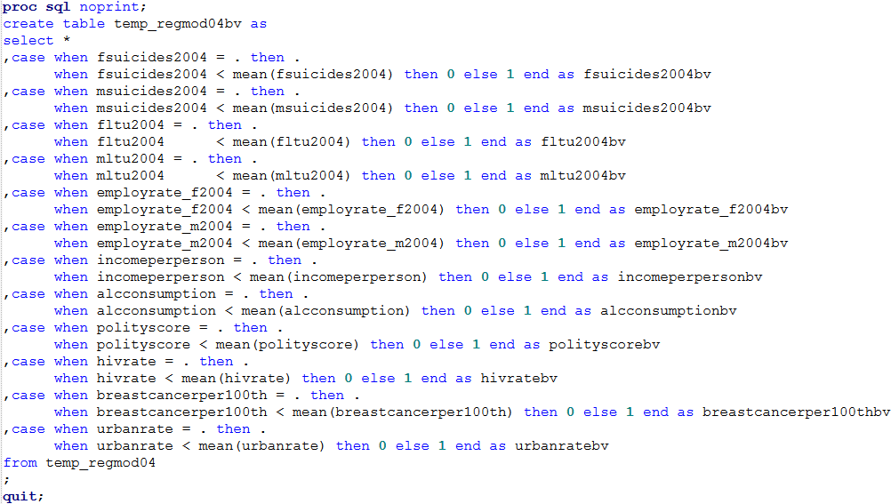

**Code to run logistics regression** with all listed binary variables against female and male suicides ratings:

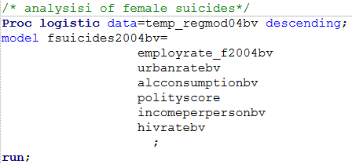

**Logistics Regression Model outputs and interpretations**

* **Female suicides ratings model – with ALL binary explanatory variables (finder confounder)**

As we can see total of **220 observations with 129 observations of complete data** were used in our model. It looks like 1/3rd of observations containing one or more observations with missing data were dropped, decreasing **variation of model sample size**. Parameter estimates and P-value table shows that there is only one variable: **HIVRATEBV with significant estimate value of 1.29 (beta= 1.29) and signioficant p-value of 0.0255** in the model, **all other variables have non sognigicant p-value > 0.05**. Based on results of logistics regression model we can conclude that **HIVRATEBV variable is the major confounder**.

**Odds Ratio estimates**

In general terms, odds ratio is probability of event occuring in one group comparing to probability of event occuring in another group. Based on Odds Ratio Estimates table we can conclude that **females with (1) HIVRATEBV estimate of 3.63 are 3.6 times more likely to commit suicide than without (0).** The **95% Confidence limits of Odds Ration Estimates** also shows that in **95%, or samples will be in between values 1.17 and 11.25**. Another interpretation and **conclusion of odds ration limits** can be: **females with HIV in countries with HIV ratings from 1.17 to 11.25 are more likely commit suicide that without HIV.**

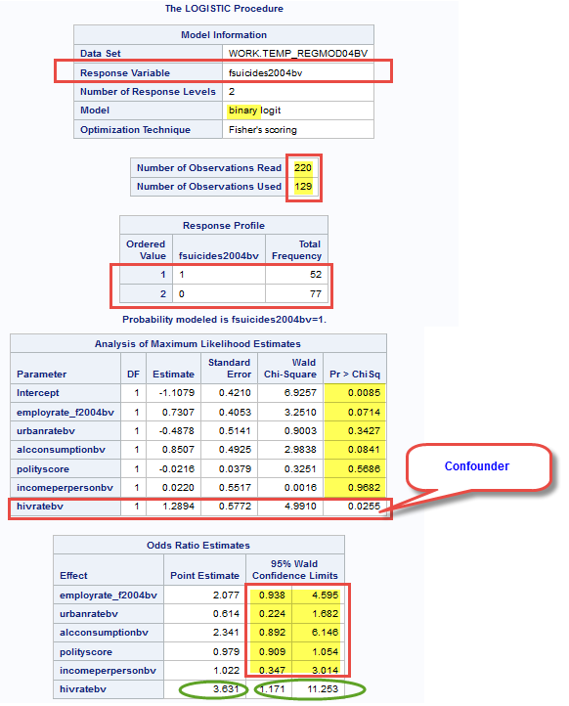

* **Female suicides ratings model – with MAIN binary explanatory variables and confounder**

**Program code:**

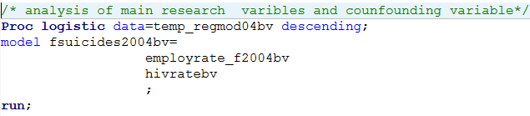

As we can see total of **220 observations with 139 observations of complete data** were used in our model. It looks like 1/3rd of observations containing one or more observations with missing data were dropped, decreasing **variation of model sample size**. Parameter estimates and P-value table shows that both variables **employrate_f2004bv** and **hivratebv** are independently significant:

**employrate_f2004bv with significant estimate value of 0.83 (beta= o.83) and significant p-value of 0.0241**  **hivratebv with significant estimate value of 1.02 (beta= 1.02) and significant p-value of 0.0362**

We can ignore NULL hypothesis and accept alternate hypothesis that

**Odds Ratio estimates**

Based on Odds Ratio Estimates table we can conclude that **females in countries with Employment rate of 2.3 are 2.3 times more likely commit suicides.** We can also create prediction that at the same time, females in countries **with (1) HIV rate estimate of 2.3 are 2.3 times more likely to commit suicide than without (0).** The **95% Confidence limits of Odds Ration Estimates** also shows that in **95%, or samples will be in between values 1.16 to 4.74 and 1.1 to 7.25**. But because of overlapping sample confidence limits, we cannot say that HIV rate is more related to female suicide rates that employment rate. Another interpretation and conclusion of odds ration limits can be: **Controlling female employment rate and HIV rate can affect female suicide rate in countries with female employment rates in between 1.1 to 4.5 and with HIV in countries with HIV ratings from 1.1 to 7.25.**

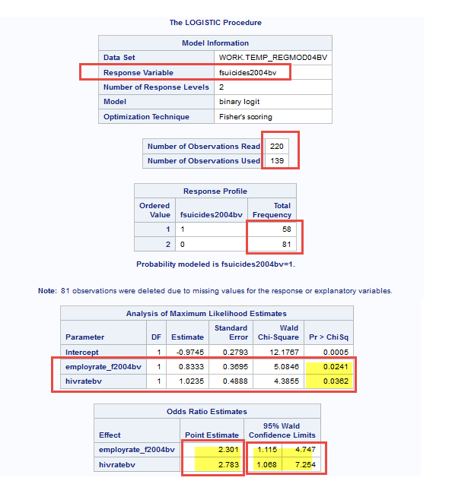

**Display/print means:**

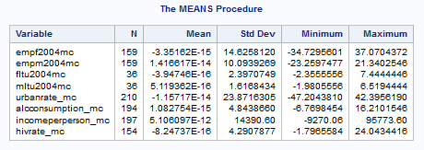

Based on **observed results of MEANS procedure**, we can conclude that mean values of all centered variables **are very close to corresponding center mean=0**.

**Multiple regression models – interpretation of results**

1. **Male model results.**

**Conclusion: Using Multiple Regression Test, Report does not support hypothesis that male suicide rating is related to corresponding employment rate. Instead, it shoes strong relationship of male suicide rating with alcohol consumption rate.**

The model shows variability of test sample **R-square= 0.30%** which is far enough from center of 0 and overall p-value of model in less than 0.05. Based on output results we can conclude that **alcconsumption_mc** (centered explanatory variable) **is the confounder with estimated positive beta value = 1.30 and significant p-value > 0.0001**, showing strong effect and relationship with **msuicides2004** (male 2004 suicide rate). The **F-Value** of confounder **urbanrate_ms = 12.04** which is very strong and provides additional support to the effect of confounding. Multiple regression model results **also clearly show that relationship between 2004 male suicide (fsuicides2004) and male employment rate (empm004mc) is weak having beta value = (-0.03 and p-value > 0.7560 and we cannot reject NULL Hypothesis.**

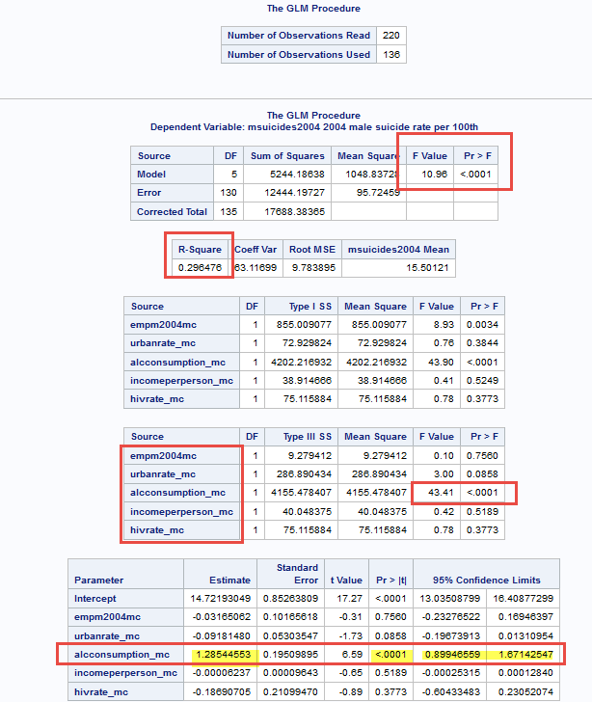

**Interpretations of plots and graphs (with confounding variable alcconsumption_mc)**

Visual output of **GLM procedure** sows that majority of data is **within 95% limits with few outliners** and have increasing slope and **strong change per unit Beta value = 1.06 and very strong p-value > 0.0001** and we can safely **reject NULL hypothesis and accept alternate hypothesis that male suicide rating (msuicides2004) has strong relationship with confounder urban rate variable (alcconsumption_mc).** Here output results with highlighted findings:

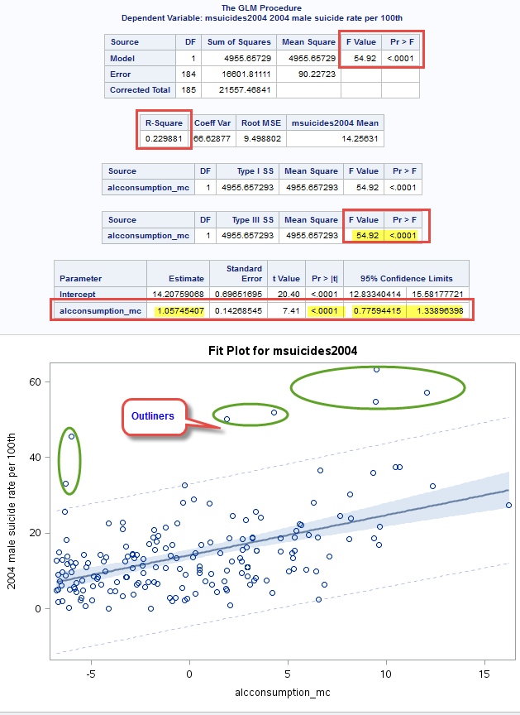

Visually examination of **GLM** procedure plots (linear regression) also show that data may have has some curvature, data distributed uneven on both sides of main linear regression line and we may **polynomial regression model**, including additional squared **alcconsumption_mc** value into the model, including **SGPLOT** procedure.

The output results are showing that **data fit well polynomial regression model** expectation, **data have curve**. The **R-square value** of variation of sample was **improved from 0.22 to 0.28**, but not significantly. The squared **alcconsumption_mc** **has beta value of 0.81 and p-value > 0.0001 and the square of alcconsumption_mc has beta value of 0.087 and p-value > 0.0003 and we can safely reject NULL Hypothesis and accept alternate hypothesis: male suicides are related to alcohol consumption.**

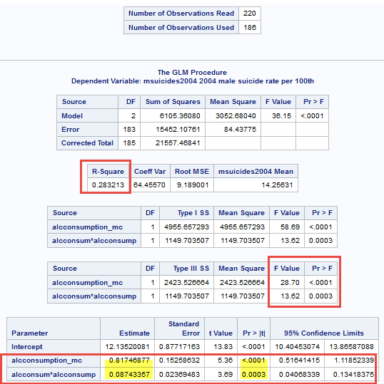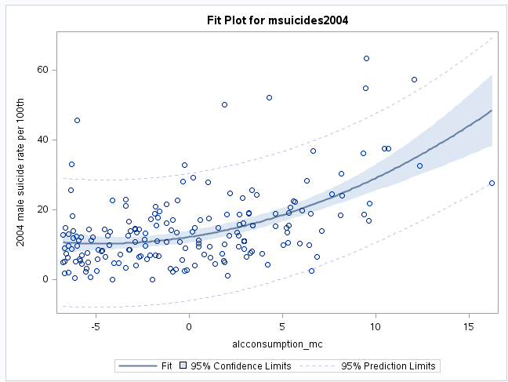

**Output of SQPLOT procedure with CLM (confidence limits parameter) and without:**

Result of **multivariate polynomial regression** with degree=4 shows the best fit without much bias or overfitting.

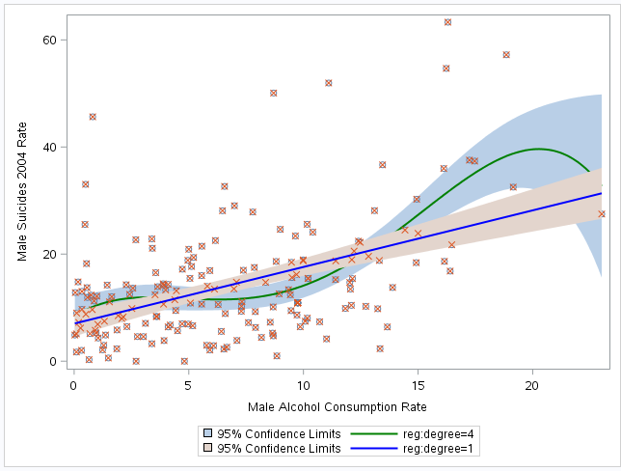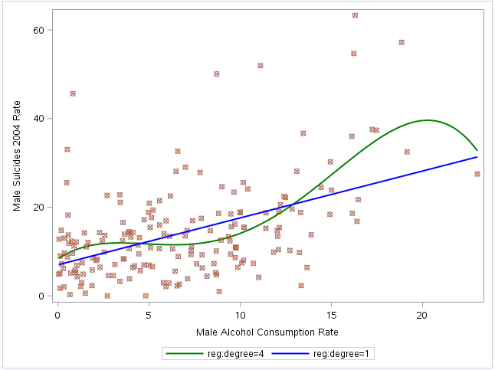

**Program code related to above tests:**

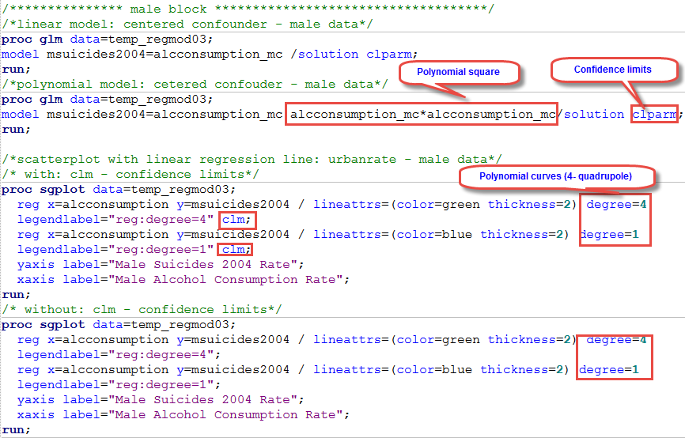

**Interpretation of regression diagnostic plots**

**Program code:**

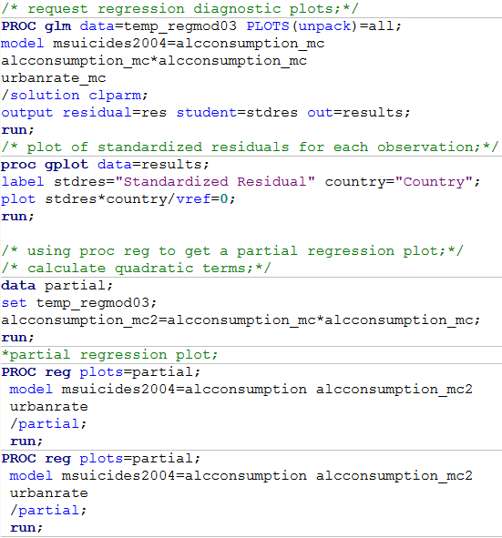

Variable **urbanrate_mc** added to multiple regression model test and corresponding statistics of GLM procedure show **improvements in R-Square test variability increase to 0.30%** as well as **in beta values for all variables to 0.93, 0.07 and negative -0.07 for urbanrate_mc with significant p-value > 0.0269**, which definitely improves model fit.

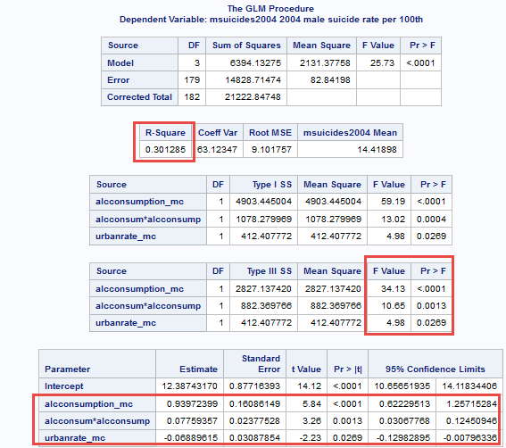

**Q-Q Plot interpretation**

Taking in consideration outliners, affecting distribution, general distribution of data around linear regression line is acceptable, mostly around line.

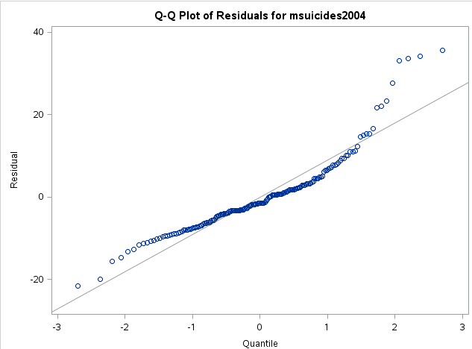

**Standardized residuals for all observations**

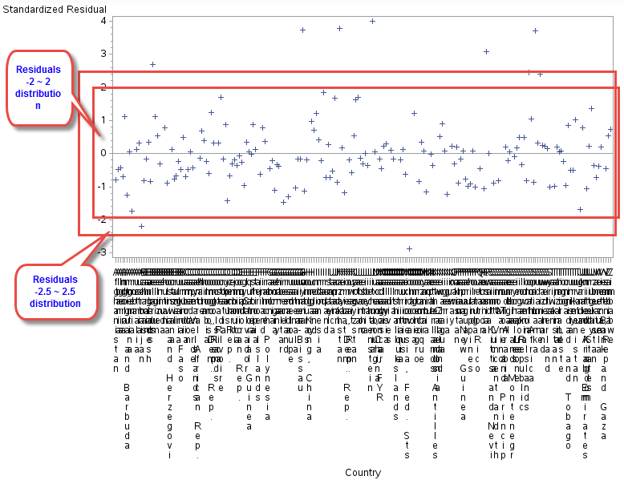

Residuals very well distributed within **-2 to 2** **64%** range with few outliners **in -3 to 3** range and few in above **95%** coefficient range and we may conclude that proposed model fit well data.

**Leverage Plot interpretation**

With some outliers data/residuals distributed well, fit model assumptions.

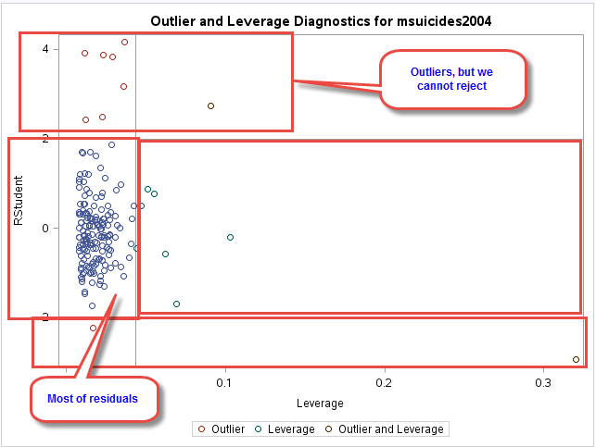

1. **Female model results.**

**Conclusion: Report does not support hypothesis that female suicide rating is related to corresponding employment rate. Instead, it shoes strong relationship of female suicide rating with urban rate.**

The model shows variability of test sample **R-square= 0.14.31%** which is far enough from center of 0 and overall p-value of model in less than 0.05. Based on output results we can conclude that **urbanrate_mc** (centered explanatory variable) **is the confounder with estimated negative beta value = (-0.07) and significant p-value > 0.0007**, showing strong effect and relationship with **fsuicides2004** (female 2004 suicide rate). The **F-Value** of confounder **urbanrate_ms = 12.04** which is very strong and provides additional support to the effect of confounding. Multiple regression model results **also clearly show that relationship between 2004 female suicide (fsuicides2004) and employment rate (empf2004mc) is weak having beta value = 0.01 and p-value > 0.4766 and we cannot reject NULL Hypothesis.**

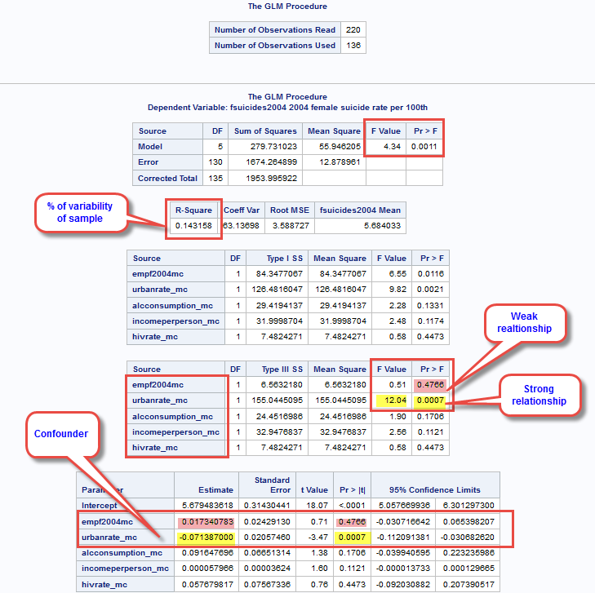

**Corresponding program** code can be found in **Appendix A**.

**Interpretations of plots and graphs (with confounding variable urbanrate_mc)**

Visual output of GLM procedure sows that majority of data is **within 95% limits with very few outliners** and have decreasing slope and strong change per unit Beta value = (-0.058) and very strong p-value > 0.0001 and we can safely reject NULL hypothesis and accept alternate hypothesis that female suicide rating (fsuicides2004) has strong relationship with confounder urban rate variable (urbanrate_mc). Here output results with highlighted findings:

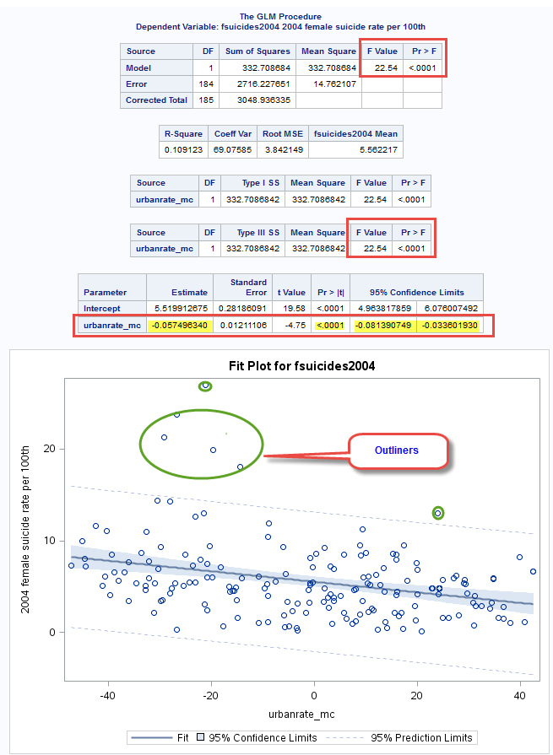

Visually examination of plots also shows that data may have has some curvature, data distributed uneven on both sides of main linear regression line and we may **polynomial regression model**, including additional squared **urbanrate_ms** value into the model, including SGPLOT procedure.

The output results are showing that data does not fit polynomial regression model expectation, **data does not have curve**. The **R-square value** of variation of sample was **improved from 0.10 to 0.11**, but not significantly. The squared **urbanrate_mc** **has beta value of 0.000 and p-value > 0.3096 and we can safely say that data does not polynomial regression model.**

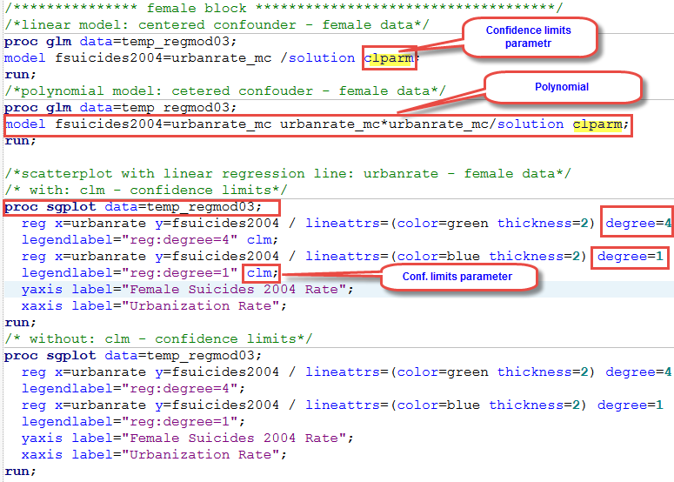

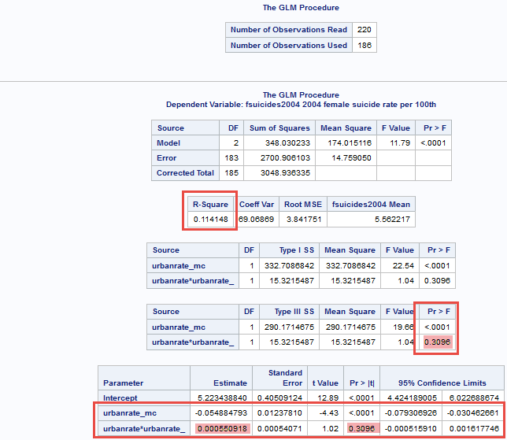

**Output of SQPLOT procedure with CLM (confidence limits parameter) and without:**

Result of multivariate polynomial regression with degree=4 shows evidence of data bias and overfitting.

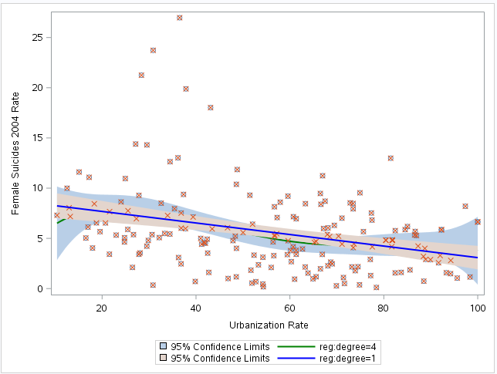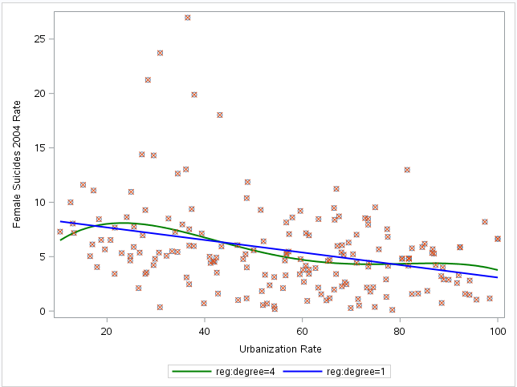

Plots are not presented because of multiple regression model failure. **Plots described in male section only.**

*********************************** end of week 3 **************************************************