**Practice Peer-graded Assignment: Milestone Assignment 1: Title and Introduction to the Research Question**

Ready for the assignment?

You will find instructions below to submit.

i

It looks like this is your first peer-graded assignment.

1. [Instructions](https://www.coursera.org/learn/data-analysis-capstone/peer/Dxj34/milestone-assignment-1-title-and-introduction-to-the-research-question)
2. [My submission](https://www.coursera.org/learn/data-analysis-capstone/peer/Dxj34/milestone-assignment-1-title-and-introduction-to-the-research-question/submit)
3. [Review classmates](https://www.coursera.org/learn/data-analysis-capstone/peer/Dxj34/milestone-assignment-1-title-and-introduction-to-the-research-question/give-feedback)
4. [Discussions](https://www.coursera.org/learn/data-analysis-capstone/peer/Dxj34/milestone-assignment-1-title-and-introduction-to-the-research-question/discussions)

**Instructions**

Submit a blog entry with a ***draft*** of 1) your project title, 2) your research question, and a few sentences describing 3) your motivation or rationale for wanting to try to answer the research question, and 4) some potential implications of answering the research question (how you think the answer might help you, your industry or field, or society as a whole).

Review criteria

This is an **UNGRADED** assignment. The goal of this assignment is to keep learners on track to complete their capstone project on time, and to get constructive feedback that could help them to improve the quality of their final reports.

As a reviewer, it is your job to review the assignment blog entries for **four** of your peers. Failure to review 4 of your peers will result in a penalty applied to your final report grade. Please provide feedback for the following prompts, writing a few sentences for each prompt. If you identify some weaknesses, make sure that you describe why you think they are weaknesses. Below is the rubric that will be used for the Module 4 Final Assignment grading for this section of the final report. You can use this is as a guide for identifying strengths and weaknesses in your peers' assignment.

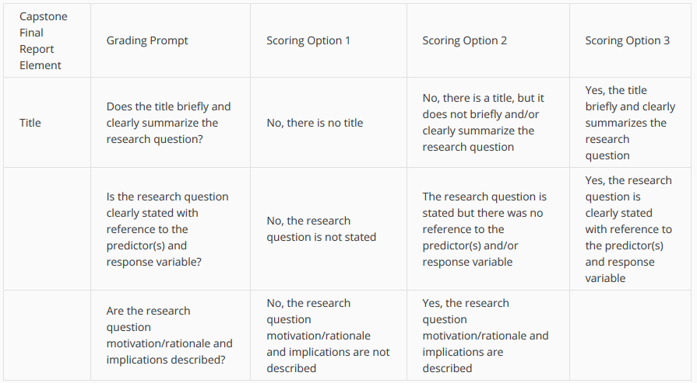

Predict Dengue Disease Cases in Association with Temperature, Precipitation and Vegetation index in Tropical and Sub-tropical Parts of the World

Introduction to the Research Question

The purpose of this study was to predict the number of dengue cases each week for each location (city, year and week of year in San Juan and Iquitos) based on environmental variables and find best predictor factors describing how changes in maximum, minimum and average air temperatures, total precipitation, relative and specific humidity and satellite measured vegetation index affect number of disease cases.

As data analyst, my current task is to predict the number of dengue cases each week (in each location) based on environmental variables describing changes in temperature, precipitation, vegetation and other factors.

The research to identify factors associated to epidemic diseases is very important to the public health and may help to better understand if in these case factors are related to climate change. These days many of the nearly [half billion](https://www.cdc.gov/dengue/) dengue cases per year are occurring in Latin America, in many cases dengue disease causing severe health problems and even death. Accurate dengue predictions would help public health workers and people around the world take steps to reduce the impact of these epidemics. Although the relationship to climate is complex, a growing number of scientists argue that climate change is likely to produce distributional shifts that will have [significant public health implications worldwide](http://rstb.royalsocietypublishing.org/content/370/1665/20140135.full).