Solar Panel Cleaning Robot
As climate change and global warming threaten the future of our planet, it is becoming increasingly crucial to find sustainable ways to fulfill our energy requirements. One of the most efficient ways of moving towards renewable and non-polluting energy sources is to generate electricity using solar panels to harness the sun’s energy.
Since they have no moving parts, solar panels are one of the most cost-effective and low-maintenance ways of generating.
Despite all their benefits, the efficiency of solar panels can plummet if dust, dirt, and grime are allowed to accumulate. If maximum efficiency in power generation is to be maintained, solar panels need to be cleaned timely. However, manually cleaning solar panels is hazardous and time-consuming.
This Solar Panel Cleaning Robot aims to maintain the efficiency of Solar power production by making sure the Solar panels are kept clean without putting humans at risk.
This robot comes equipped with a roller brush and a water sprayer to clean all dirt and grime from the surface of the panels. The sprayer gets its supply of water through an onboard tank. The rubber caterpillar tracks ensure that this robot can adhere to the slick surface of solar panels. This robot operates remotely and wirelessly.
Along with large-scale industrial applications such as dedicated solar power plants, this robot can also help boost the efficiency of solar panels in smaller applications such as rooftop solar panels in homes and offices.
Features of Solar Panel Cleaning Robot:
- Maintains efficiency of solar panels by keeping them clean.
- Remote and wireless operation ensures workers aren’t put in danger
- Roller brush cleans all dust, dirt, grime, and debris.
- Equipped with water sprayer supplied with onboard water tank.
- Compact, portable, and user-friendly design.
The solar panel cleaner robot makes use of a water tank with motorized pump along with 4x DC motors to achieve vehicle motion using caterpillar wheel motion. The robotic vehicle is built over a metal chassis with a controller circuitry operated over RF wireless remote.
A remote controller is used to wirelessly transmit control movement data to the robotic vehicle. The controller receives the data and operates the wheel motors in desired directions to achieve the desired movement. The front brush is fixed to the main chassis front and operated by a geared DC motor. The front panel also has an integrated water pipe that is used to drive water for cleaning using a dc pump to the front of the brush. The system thus allows for easy solar panel cleaning using wireless control.

Components:
- Robotic Chassis
- DC Motors
- Wheels
- Rubber Tracks
- Pump Motor
- Water Tank
- Piping
- Controller Circuitry
- RF Remote
- Motor Shafts
- Mounts & Couplings
- Screws & Bolts
- Supporting Frame

Applications:
- Large scale solar power producing plants
- Rooftop solar panels at homes and offices

Advantages:
- Maintains efficiency of solar panels by keeping them clean.
- Remote and wireless operation ensures workers aren’t put in danger
- Roller brush cleans all dust, dirt, grime, and debris.
- Equipped with water sprayer supplied with onboard water tank.
- Compact, portable, and user-friendly design.

Disadvantages:
- Not entirely autonomous, requires human operators.

Block Diagram:

Front View
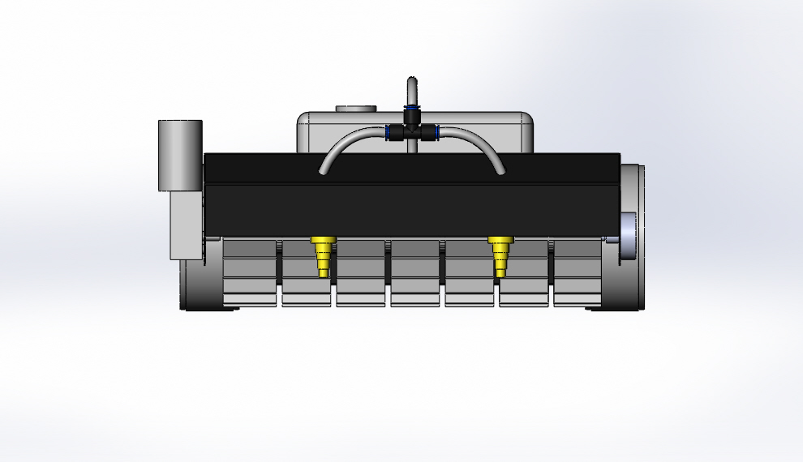

Side View
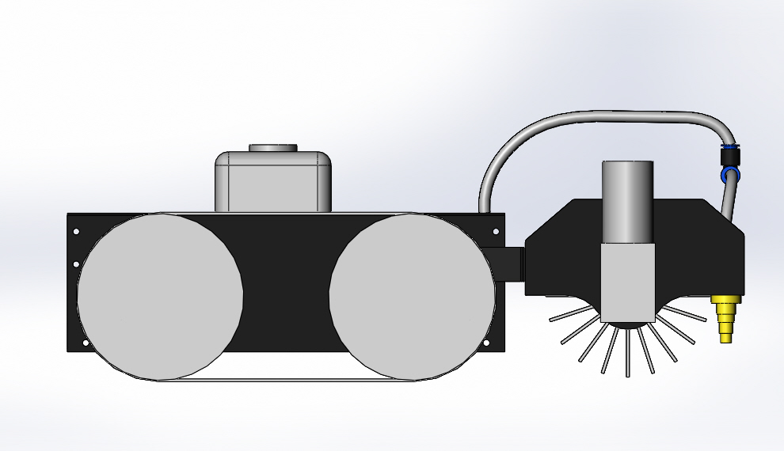

3D View

