Template: PollMap Application Template for ArcGIS 10

Version: 1.0

Date: April 28, 2011

# Introduction

This PollMap Application allows you to capture and map public opinion on any issue or topic you configure. It encourages participation through a user experience that focuses on simple things: reading the question, choosing among the options presented, and then viewing results immediately on the map. This gives the visitor instant feedback and an option to explore the map to see how their vote fits within local, regional and even national contexts.

This map is known simply as PollMap, or as the Esri FanMap™ when applied to sports topics. You can see an example of this template at work in the Esri [FanMap™: Bracketography Edition](http://fanmap.esri.com/collegehoops).

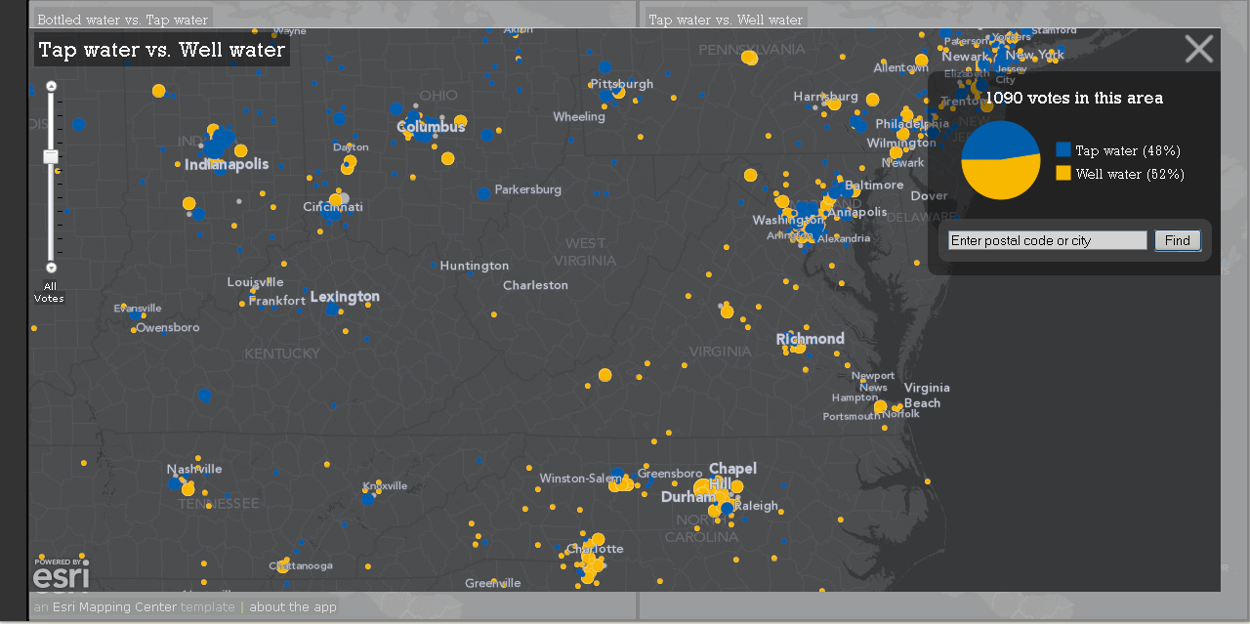

*Figure 1: Sample PollMap about water.*

# What is included?

This is version 1.0 of the PollMap application template. It supports a basic type of “A vs. B” question and all documentation is written with that in mind.

This JavaScript application is built using the ArcGIS API for JavaScript. It contains an interactive map intended for use in a standard web browser. It does not require browser plug-ins or installs. This application accesses several map services and geoprocessing services.

The template includes sample data to record votes by postal code in the U.S. and Canada, and map documents (MXDs) to edit their symbology on the map. Note: it is possible to substitute other point data to gather the votes, e.g. see the Esri [Earth Day Poll Map](http://pollmap.esri.com/earthday) which uses cities of the world. That level of customization is not described in this document.

The template includes two geoprocessing scripts: one to record incoming votes and another to summarize those votes by location.

The template includes three map services: one service (zips_winkel) to provide access to the postal codes to geoprocessing scripts, and two services (Question01 and Question02) to symbolize the dominant vote count at each location.

The template uses a simple multi-scale basemap hosted by Esri for use by this application. The map is in the Winkel-Tripel projection, centered on North America. See details about this projection [here](http://blogs.esri.com/Support/blogs/mappingcenter/archive/2011/02/17/an-alternative-to-web-mercator-winkle-triple.aspx). If you to deploy this template in a site which may attract more than 100 visitors an hour, please [contact us](mailto:jherries@esri.com) so that we can work with you to arrange proper support.

# Web Configuration

* Microsoft Internet Explorer 8/9, Mozilla Firefox 3.6 or higher, Google Chrome 10 or higher
* 1024x768 screen resolution recommended

# Software Environment

The following software must be installed and configured:

* ArcGIS Desktop 10 with Service Pack 1
* ArcGIS Server 10 with Service Pack 1 for the Microsoft .Net Framework – Standard or Advanced

Note: This template has been optimized for ArcGIS Server the Microsoft.Net Framework. Other configurations have not been tested.

Additional software you may want to use:

* Notepad, Notepad++, DreamWeaver, IDLE (for editing .js files, .html files, .py scripts)
* ColorPic (for checking and choosing RGB color values and converting them to HEX values for web pages)
* Firefox browser with the Firebug plug-in (to help diagnose issues with the application)

# Template Contents

The following files are provided in the PollMap Application template ZIP file, which by default will unzip to

* <your_directory>\PollMapTemplate (e.g. D:\GIS\ArcGISTemplates\PollMapTemplate)

There are three folders underneath the PollMapTemplate directory. Significant items are listed below.

|  |  |  |
| --- | --- | --- |
| **Template Directory** | **Item** | **Description** |
| PollMapTemplate | Getting Started with the PollMap Application Template.pdf | A PDF document that describes how to configure template and changes made with each release. |
| /Application | /PollMap subdirectory | Directory containing the application pages, javascript, style sheets, images. |
| /Tools/gp subdirectory | Directory containing the geoprocessing scripts. |
| /Documentation | DataDictionary.html | An HTML document that contains a description of the Votes.gdb content. |
| Question01.html | An HTML document that describes the contents of Question01.mxd |
| Question02.html | An HTML document that describes the contents of Question02.mxd |
| Zips_Winkel.html | An HTML document that describes the contents of Zips_Winkel.mxd |
| /MapsandGeodatabase | Question01.mxd | The map document used to author the Question01 map. |
| Question01.msd | The map service definition used by the Question01 map service. |
| Question02.mxd | The map document used to author the Question02 map. |
| Question02.msd | The map service definition used by the Question02 map service |
| Zips_Winkel.mxd | Simple map service to serve postal code points to the geoprocessing scripts. No symbology editing needed. |
| Zips_Winkel.msd | The map service definition used to author the Zips_Winkel map service. |
| Votes.gdb | The Votes geodatabase contains a simple votes table to record each vote as it comes in, and a point layer to record the summary of votes for each choice in that location. |
| Votes_samples.gdb | Contains sample tables and layers for testing. |

# How to configure and use the PollMap Template

First, you will get the sample PollMap up and running on your machine. You will configure the PollMap template for your environment, and in doing so, learn how to publish and serve your own poll maps using ArcGIS Server and your organization’s data. Then, the second set of steps outlines how to customize the PollMap to contain your questions, choices and symbology for the maps and charts.

To complete these steps, you will need experience with ArcGIS Server and Microsoft’s Internet Information Server (IIS). If you are new to JavaScript applications, this template will demonstrate a pattern you can use to deploy your own JavaScript application and publish web maps using ArcGIS Server.

# Implementation Steps

Follow the six implementation steps below to publish and serve the PollMap template in your organization.

# Step 1 – Extract the ZIP File Contents

1. Extract the contents of the PollMap Application Template you downloaded from ArcGIS.com in a directory on your computer.

* <your_directory>\PollMapTemplate (e.g. D:\GIS\ArcGISTemplates\PollMapTemplate)

# Step 2 – Publish Map Services ( Zips_Winkel, Question01 and Question02)

1. Copy everything from the <your_directory>\ArcGISTemplates\PollMapTemplate\MapsandGeodatabase directory to a directory location that is accessible to your ArcGISSOC Account on your ArcGIS Server computer. The ArcGISSOC Account will need read [permissions](http://help.arcgis.com/en/arcgisdesktop/10.0/help/index.html#//002v0000000p000000.htm) to this directory.

Or, use Windows Explorer to grant read permissions to the ArcGISSOC Account for the following directory:

* <your_directory>\ArcGIS Templates\PollMapTemplate\MapsandGeodatabase

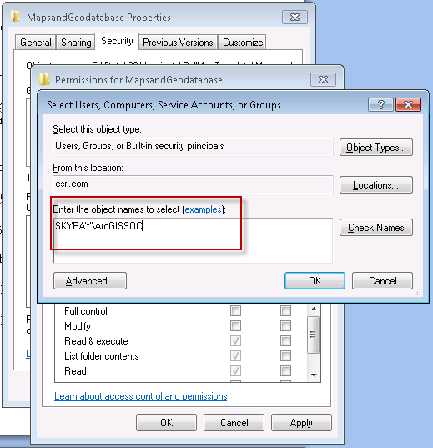

*Figure 2: Grant read permissions to the ArcGISSOC Account*

1. Next, you will publish the sample maps as map services. Later on, you will modify those maps, but for now, just publish them “as is.” Using ArcCatalog, navigate to the MapsandGeodatabase directory and publish the three dynamic map services needed by the PollMap Application:

* Publish the Zips_Winkel.msd as a map service. Use a folder if desired, and accept all other defaults.
* Publish the Question01.msd as a map service. Use a folder if desired, and accept all other defaults.
* Publish the Question02.msd as a map service. Use a folder if desired, and accept all other defaults.

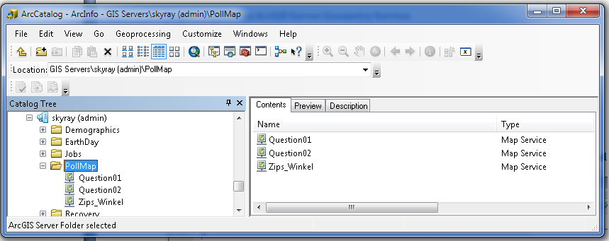

*Figure 3: Sample services running in ArcGIS Server*

1. Go to the ArcGIS Services Directory and record the REST End Points (full URL paths) of each service. Note: The [ArcGIS Services Directory](http://help.arcgis.com/en/webapi/javascript/arcgis/help/jshelp_start.htm) is typically found at: http://<yourserver>/ArcGIS/rest/services

# Step 3 – Publish a Geometry Service

Using ArcCatalog, publish a [geometry service](ttp://help.arcgis.com/en/arcgisserver/10.0/help/arcgis_server_dotnet_help/index.html) to ArcGIS Server:

1. Right-click on the server in ArcCatalog, and select “Add a New Service”
2. For type, select a geometry service. This sets the name automatically (see Figure 4).
3. Accept all other defaults. Click Finish.

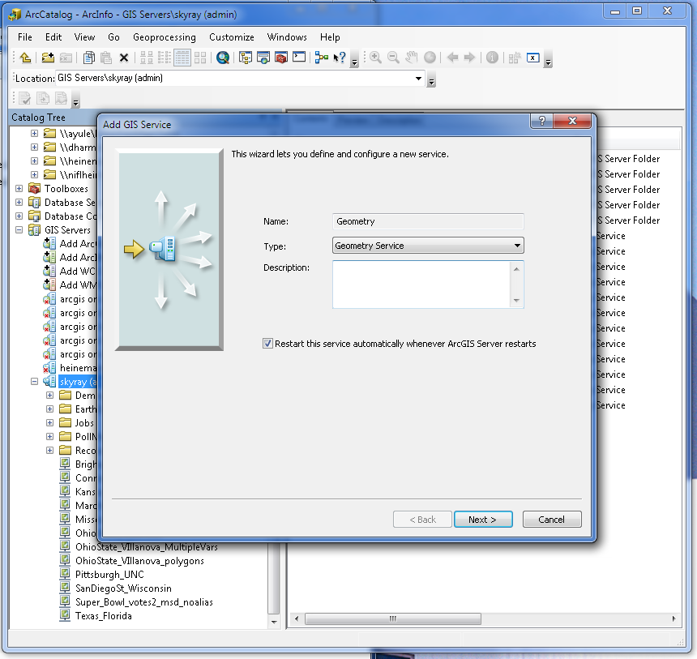

*Figure 4: Publish a geometry service*

# Step 4 –Configure the voting script tools

1. Using Windows Explorer, navigate to the tools directory:

* <your_directory>\ArcGIS Templates\PollMapTemplate\Application\Tools\gp

1. Open the summarize.py file using Notepad, Notepad++, or a python editing tool such as IDLE. One line of code needs to be changed in this configuration. Set the path of the database (db) to the location of your Votes.gdb (see Figure 5).

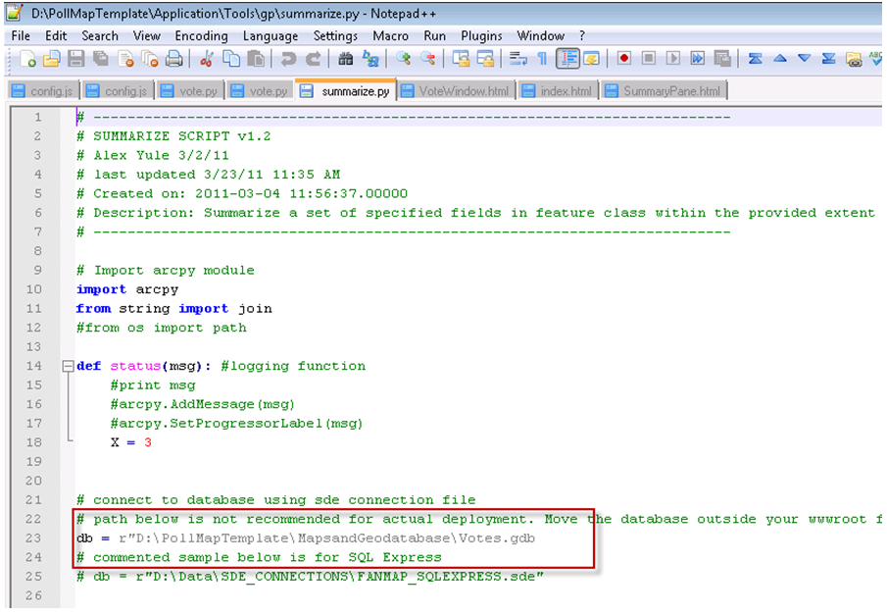

*Figure 5: Edit the path to the geodatabase*

1. Open the votes.py file in a python editing tool. One line of code needs to be changed in this configuration. Set the path of the database (db) to the location of your Votes.gdb (see Figure 6).

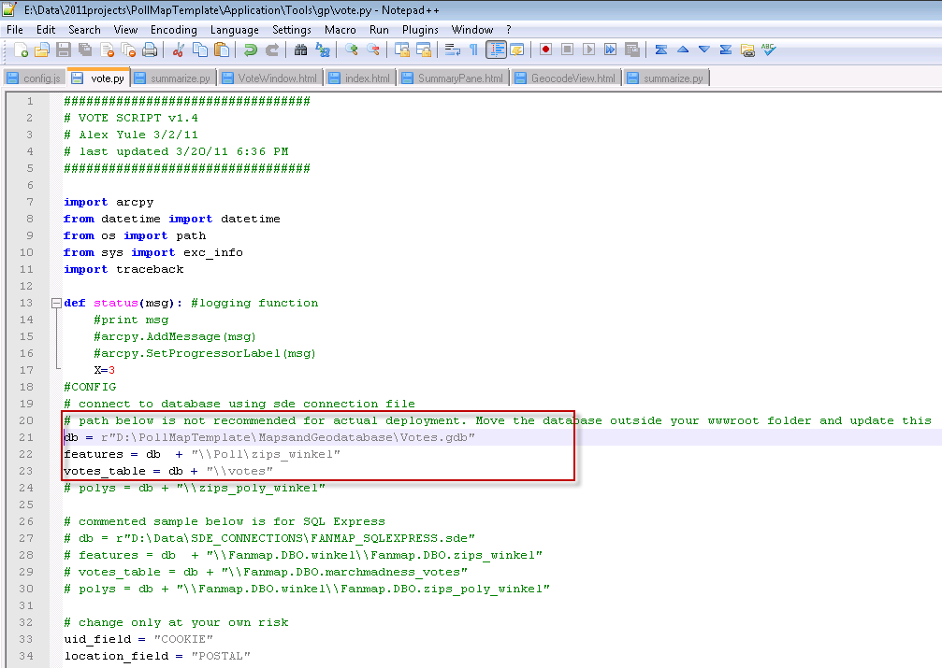

*Figure 6: Edit the path to the Votes geodatabase*

# Step 5 –Publish the Vote Geoprocessing Services

1. After editing the scripts, copy everything from

<your_directory>\ArcGISTemplates\PollMapTemplate\Tools\gp to a directory location that is accessible to your ArcGISSOC Account on your ArcGIS Server computer.

Or, use Windows Explorer to grant the ArcGISSOC Account access to the following directory:

* <your_directory>\ArcGIS Templates\PollMapTemplate\Tools\gp

1. Using ArcCatalog, publish the Vote.tbx as a [geoprocessing service](http://help.arcgis.com/en/arcgisserver/10.0/help/arcgis_server_dotnet_help/index.html) in ArcGIS Server.

* Right-click on your “PollMap” folder in the ArcGIS Server instance in ArcCatalog, and select “Add a New Service.” If you are not using a folder, right-click on the server instance instead.
* For type, select geoprocessing service. Name the geoprocessing service “Vote” (singular). See Figure 7. Click Next.

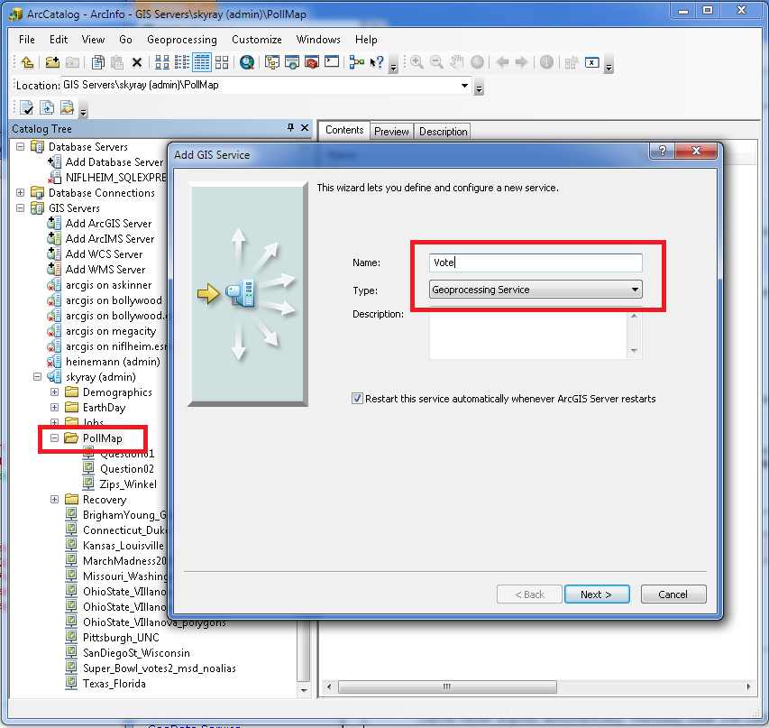

*Figure 7: Choose where to publish the Vote toolbox.*

* Select execution type as synchronous. See Figure 8.
* Select “A toolbox” and enter the location of the Vote.tbx .
* Accept all other defaults and click Next. Accept all other defaults the rest of the way.

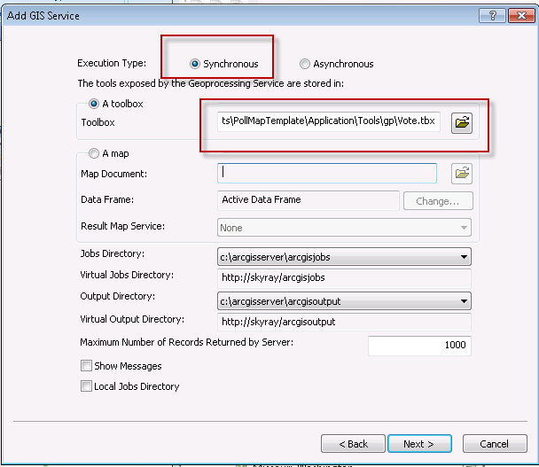

*Figure 8: Setting up Vote Geoprocessing Services*

# Step 6 –Publish the Application

1. Copy the folder <your_directory>\ArcGISTemplates\PollMapTemplate\Application\PollMap to your wwwroot directory, typically c:/inetpub/wwwroot.
2. Go to your web browser and check if the URL works, e.g. http://<yourserver>/PollMap. If the site works, but you don’t see any maps, continue to the next step below. If you don’t see any application page at all, check that IIS is running.
3. Go to c:\inetpub\wwwroot\PollMap\js and edit the config.js file to point to all the services you just created in the previous five steps. Change the six service URLs below to match the URLs you created earlier. See the next two figures for examples. *(Note: Version 1.0 of the template does not utilize the identifyService in the config.js file).*

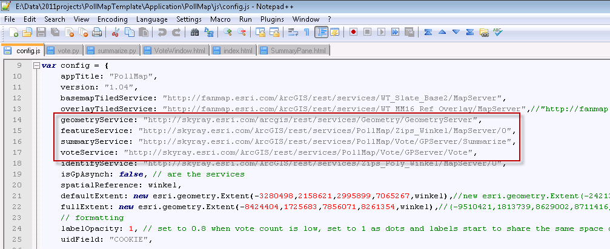

*Figure 9: Edit these URLs in config.js to match your actual services.*

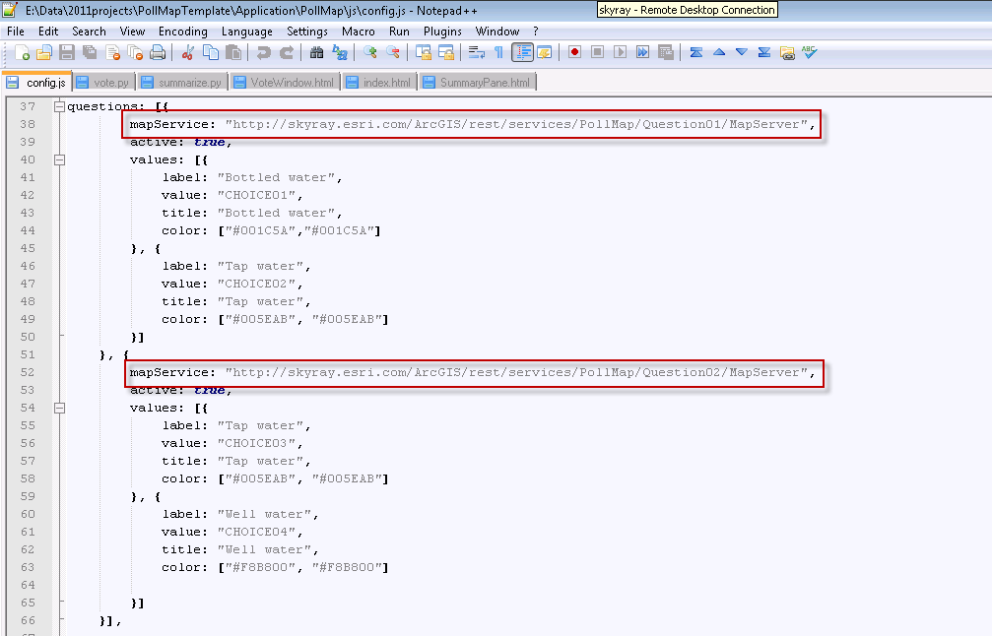

*Figure 10: Edit these URLs to match your actual sample services for Question01 and Question02.*

1. Go to your web browser and check if the URL works, e.g. http://<yourserver>/PollMap. You should see something similar to that below, with two maps and a vote window.

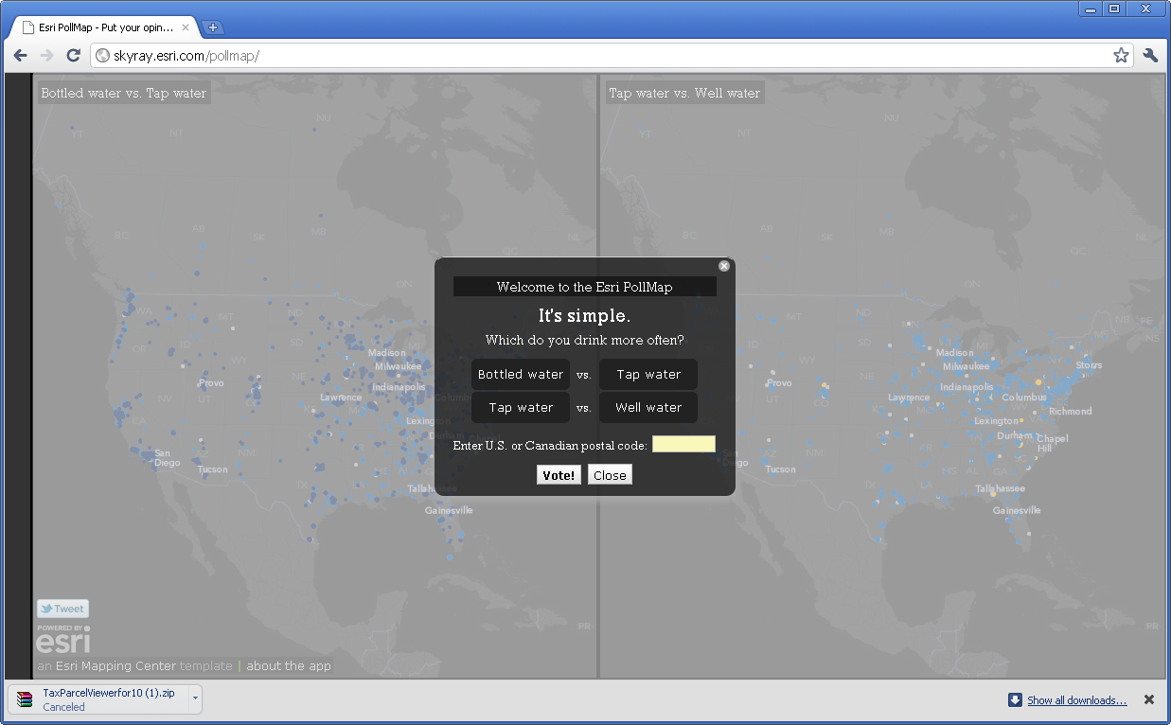

*Figure 11: The sample application with two working maps.*

Test the vote dialog box to see that the vote works. If you get an “I’m sorry” message, the first thing to do is [refresh your REST cache](http://resources.esri.com/help/9.3/arcgisserver/apis/rest/index.html?admin.html) on your machine. Reload the page and try to vote again. If the “I’m sorry” message persists, the next thing to verify is that the config.js file points to the correct geoprocessing service URLs. Copy and paste the URLs from the config.js file to a browser to verify that a service is running.

# Customization Overview

After you’ve confirmed that the site is basically working (as in, you can submit a vote and see a map afterwards with no error messages), then you can start modifying the questions, choices, colors and names, map services and data.

The general sequence is:

* Mock up your question and responses up in the UI, e.g. “Which do you favor?” or “Choose one of the following:”
* Modify the colors of the maps and pie charts to match, by choice01, choice02 etc.
* Reset the votes table and start voting to see how things are working.

Steps 7-11 below are the basic customization steps to follow.

# Step 7 –Edit Your Questions and Responses

1. Go to C:\inetpub\wwwroot\PollMap\js\esri\fanmap\templates\ directory in Windows Explorer.
2. Edit the VoteWindow.html to tweak the title, prompt-title and subtitle (see Figure 11 below). Decisions you make here flow into subsequent edits in other files, so it is good to get this squared away early.

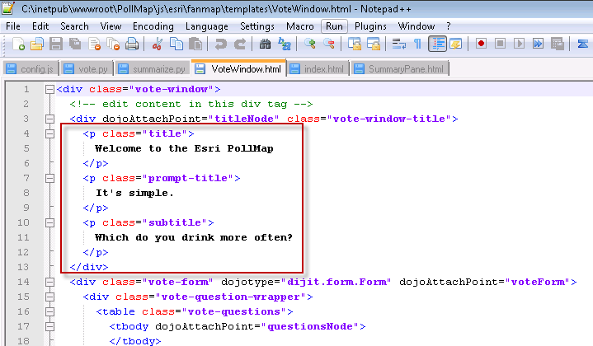

*Figure 12: VoteWindow.html changes.*

1. Go to c:\inetpub\wwwroot\PollMap\js and edit the config.js file to edit the questions, their options and colors.
2. For each set of choices, change the label to control what appears on the chart.
3. Change the title to control what appears on the VoteWindow.html page.
4. Change the value to the field you wish to represent that particular response in that particular pairing of choices. In the sample below, “Tap Water” is CHOICE02 in the first pairing, and CHOICE03 in the second pairing.
5. Set the colors. The first value is the color of the pie slice, the second is the color of the outline for that slice. Most of the time, using the same color for both works best.

In general, you want the colors to suit your subject, and you want the charts’ colors to match the dots’ colors that appear on the map. ColorPic is a great tool for checking colors onscreen and converting RGB values (used in ArcMap) to HEX values (used in the web pages).

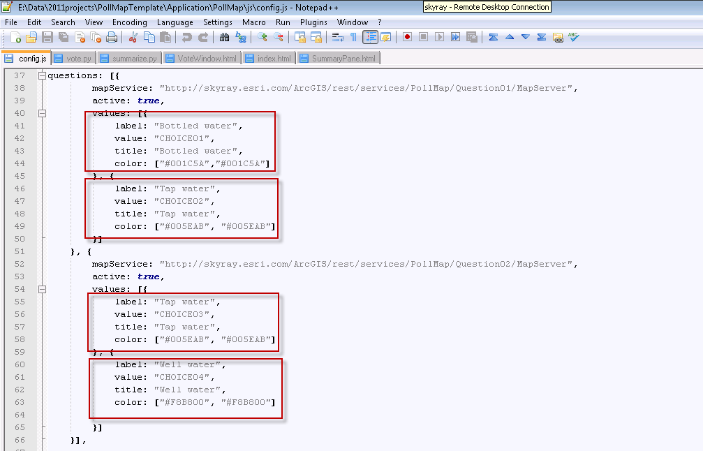

*Figure 13: config.js file.*

1. Go to C:\inetpub\wwwroot\PollMap\ directory in Windows Explorer.
2. Open index.html to edit the page title, description, tags etc. to suit your situation.

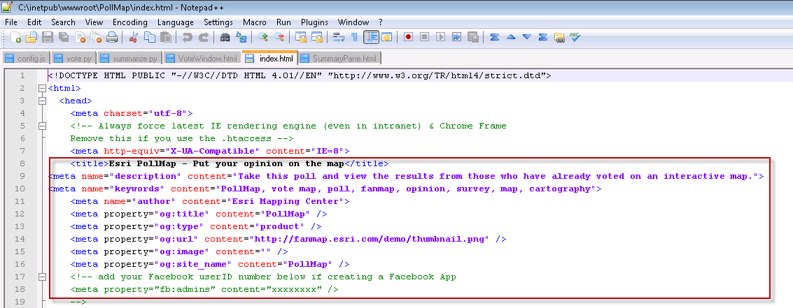

*Figure 14: index.html*

1. Go back to C:\inetpub\wwwroot\PollMap\js\esri\fanmap\templates\ directory in Windows Explorer.
2. Edit GeocodeView.html to tweak the text that currently says “Enter postal code or city”, if needed. This is the FIND box on the user interface underneath the chart.

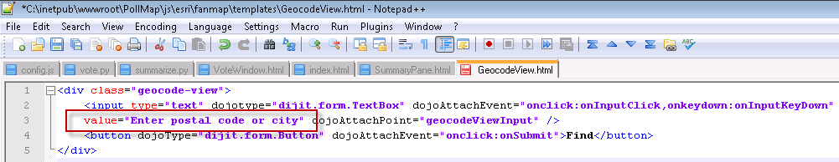

*Figure 15: GeocodeView.html*

1. Edit AboutWindow.html to change Facebook, Twitter, etc. All new text needed here to suit your messaging.

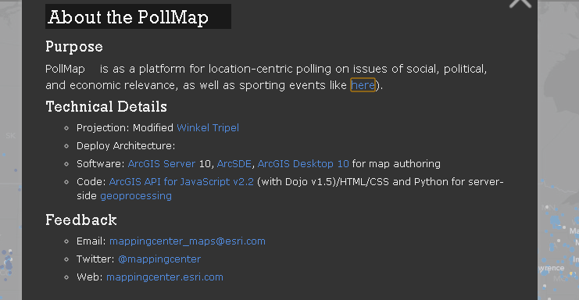

*Figure 16: AboutWindow.html*

# Step 8 –Examine the Data

While you are changing the questions and choices available, you can use the sample data provided to simulate votes that have come in. If you have completed Steps 1-5 above, those map services are already running.

After you have stopped editing everything and want to start recording real votes in a test, you can “zero out” the votes tables and start with a clean slate (described in a later step). For now, just have a look at the data in ArcCatalog to get familiar with the schema and content.

Votes.gdb contains:

* Poll feature data set
* zips_winkel point data
* votes attribute table, which contains the actual votes as they come in

Votes_samples.gdb contains a “blank” and a “test” version of the above.

* Poll feature data set
* zips_winkel_blank point data. This is the same as the zips_winkel point data above, except that all fields named “CHOICExx” have “0” in them. When you are ready to start recording real votes, you can swap this layer in for the sample votes data provided.
* zips_winkel_sample attribute table. This is the same as zips_winkel point data above, but many records have values >0 in “CHOICExx” fields so that you can experiment with colors and symbology as needed.
* votes_blank attribute table, which is empty and ready to swap in for launch.
* votes_sample attribute table, which is populated and ready to swap in for testing.

# Step 9 – Edit Map Services to Match Your Questions and Responses

The Question01 map and Question02 map use graduated circles to represent the locations. Color is set by the choice with the highest vote count at that location. Size is set by the vote count for that choice. Follow these steps to edit these MXDs, create fresh .MSD files, and refresh the services.

1. Using ArcCatalog, go to <your_directory>\ArcGISTemplates\PollMapTemplate\MapsandGeodatabase
2. Open Question01.mxd and rename the data frame, group names, and each layer name as needed to match your question and choices.
3. Modify colors of the symbols as needed. Use ColorPic or another tool to determine the web value for your symbol colors, so that you can update the config.js file with each choice’s value.
4. Look at the Definition Query in each layer to see how that controls which postal codes get symbolized in that layer. Modify as needed, e.g. if your question pairs up CHOICE05 and CHOICE06, you want each layer to reflect that in the definition query.
5. When ready to serve your modified map, turn on the Map Service Publishing toolbar and check that your aliasing is set to “Best/Force.”
6. From the Map Publishing toolbar, preview your map. This triggers ArcMap to correctly apply PNG settings before you save to MSD file. Then save an .MSD file to the same directory as the .MXD. Go refresh the services to see your changes. You may need to refresh your cache, e.g. from http://<yourserver>/arcgis/rest/admin.

.

Edit Question02.mxd in the same manner. If you rename any services, you will also need to edit the config.js file listed earlier so that the application knows where to obtain its maps.

# Step 10 – Reset the Votes Database

Once you validate that the maps look OK using the sample data, it’s time to “zero out” all the tables so that you can start recording votes.

1. Stop all ArcGIS Server services that use this data – be sure you’ve stopped Question01, Question02, zips_winkel and the Vote geoprocessing service.
2. In ArcCatalog, rename the votes table and the zips_winkel data to votes_test and zips_winkel_test. If you cannot rename the service, it is likely because some other application has a connection open (e.g. ArcMap).
3. In ArcCatalog, copy votes_blank and zips_winkel_blank to votes and zips_winkel.
4. Restart ArcGIS Server services.

# Step 11 – Additional Branding

1. Go to C:\inetpub\wwwroot\PollMap\js\esri\fanmap\img in Windows Explorer.
2. Edit file 1sidebar.png with your content, and rename it to “sidebar.png” to have the app pick up and display it. Result appears on left side of app.



Template: PollMap Application Template for ArcGIS 10

Version: 1.0

Date: April 28, 2011

# Release Notes

The April 28, 2011 release is the first release of the PollMap Template for ArcGIS 10.

**New Functionality**

N/A

**Resolved Problems**

**N/A**

**Known Issues**

Internet Explorer 7 is not currently supported. The application advises the viewer with Internet Explorer 7 that the application is not supported in that browser.

On vote, you are limited to the postal codes in this particular database, which comes directly from the Esri Data & Maps DVD for ArcGIS 10. There is always the chance that someone will use a postal code they are 100% sure is real, and it very well may be real, but just isn’t in this particular database. Most of the time, they will try a similar postal code and continue. The “Find” tool on the chart works with a much larger gazetteer online, so users can type in a pretty wide variety of place names, universities, towns, postal codes, etc.

Thanks for using this template. Send comments about this template to [jherries@esri.com](mailto:jherries@esri.com)