We assigned you the following Linux VM:    
**VM Remote Access**

IP address: ~~xxxx~~  
Username: xxxxx  
Key file: attached to the mail

**NOTE**: Your user has sudo permissions  
Connect by SSH to the VM with the key file.  
The VM already has Jenkins server installed and the following tools installed - **az CLI, helm, kubectl, kubelogin**  
Login to the azure using “managed identity” with the command - **az login -i**  
Connect to the Kubernetes cluster with the following command -

* AKS name: devops-interview-aks
* Resource group: devops-interview-rg

**az aks get-credentials -n devops-interview-aks -g  devops-interview-rg**  
**export KUBECONFIG=~/.kube/config**  
**kubelogin convert-kubeconfig -l msi**

**TASK**

1. Create and deploy helm chart for the following application:  
   Image: simple-web  
   Registry: [acrinterview.azurecr.io](http://devopsinterviewacr.azurecr.io/)  
   You will have permission to create resources only for the "mark” namespace

** Please add the Helm chart to your own private Github repo   
** Check that the access is working with from public IP to the simple-web

1. Add to the helm charts Ingress rule and KEDA auto-scaler (Ingress and Keda deployments already installed on the cluster)   
   KEDA should auto-scale by:

* memory + CPU metrics.
* Schedule between 8:00 AM - 12:00 AM.
* Ingress rule path should be /mark

3. Create a Jenkins pipeline for deploying the helm chart from the GitHub repo with the deploy/destroy options.

**Answer:**

Git Source – can be found here: <https://github.com/maprager/helm-training>

Jenkins pipeline for deploy/destroy – can be found here:   
<https://github.com/maprager/helm-training/blob/main/Jenkinsfile.helm>

Requires Jenkins be set up prior.

Current Jenkins username/password: admin/admin

Destroy/Deploy Example:

Following Deploy – this is what you see in k8s:

**root@mark-interview-vm:~/helm-training# helm list**  
NAME NAMESPACE REVISION UPDATED STATUS CHART APP VERSION

simple-web mark 1 2022-12-28 09:18:51.352322294 +0000 UTC deployed helm-chart-test-0.1.0 1.0

**root@mark-interview-vm:~/helm-training# kubectl get all**

NAME READY STATUS RESTARTS AGE  
pod/simple-web-helm-chart-test-6d77c985c8-f58rr 1/1 Running 0 2s  
pod/simple-web-helm-chart-test-6d77c985c8-mqhz5 1/1 Running 0 18s

NAME TYPE CLUSTER-IP EXTERNAL-IP PORT(S) AGE  
service/simple-web-helm-chart-test-lb LoadBalancer 10.0.238.193 20.103.2.0 80:31785/TCP 18s  
service/simple-web-helm-chart-test-local ClusterIP 10.0.24.17 <none> 80/TCP 18s

NAME READY UP-TO-DATE AVAILABLE AGE  
deployment.apps/simple-web-helm-chart-test 2/2 2 2 18s

NAME DESIRED CURRENT READY AGE  
replicaset.apps/simple-web-helm-chart-test-6d77c985c8 2 2 2 18s

NAME REFERENCE TARGETS MINPODS MAXPODS REPLICAS AGE  
horizontalpodautoscaler.autoscaling/keda-hpa-simple-web-helm-chart-test-keda Deployment/simple-web-helm-chart-test 2/1 (avg), <unknown>/70% + 1 more... 1 5 1 18s

Output of screen – going via External Load Balancer:  
  
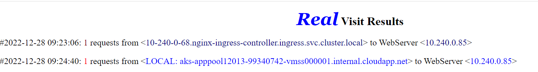

Output of screen -going via External Ingress:

