**First model run: sfbay_1.png**

The model correctly identified 10 ships in the scene and misclassified 4 areas – 2 of land as ships (Fig 1, Fig 4) and 2 sections of piers as ships (Fig 2, Fig 3). This visual check gives us an **accuracy of ship classification of** **71%**. This misclassification has been verified through a visual check of more recent imagery available for the same area of interest in Google Maps (Fig 5, Fig 6).

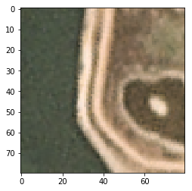

Figure : X:2400 Y:0 [[0.04527112 0.9547289 ]]

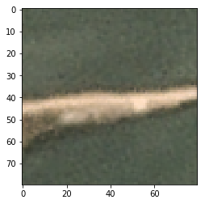

Figure 2: X:1320 Y:1650 [[0.04042681 0.9595732 ]]

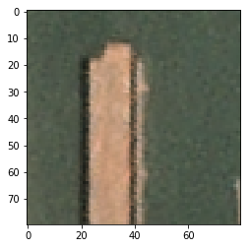

Figure : X:960 Y:690 [[0.0869388 0.9130612]]

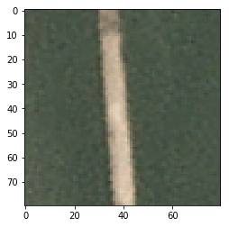

Figure : X:1010 Y:780 [[0.0022693 0.9977307]]

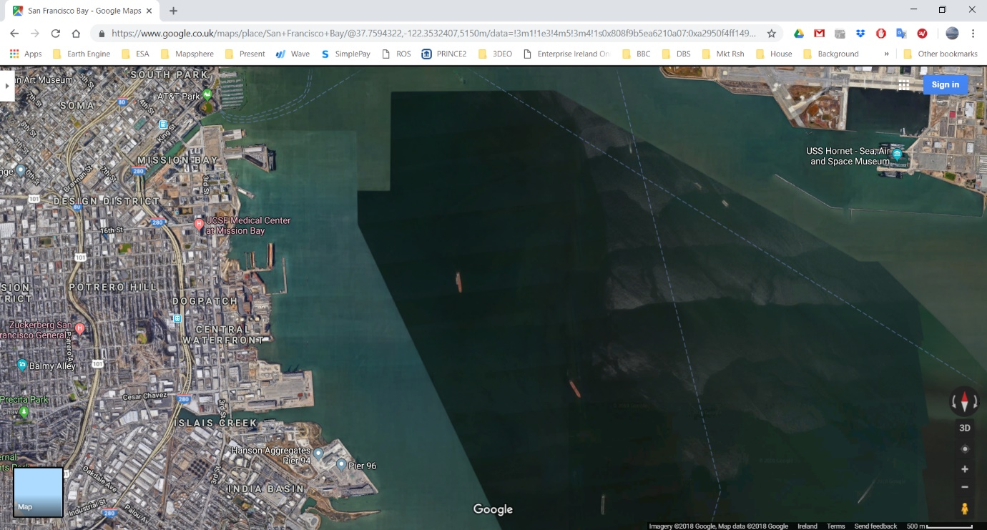

Figure : Same AOI checked on Google Maps to ground truth the model classification

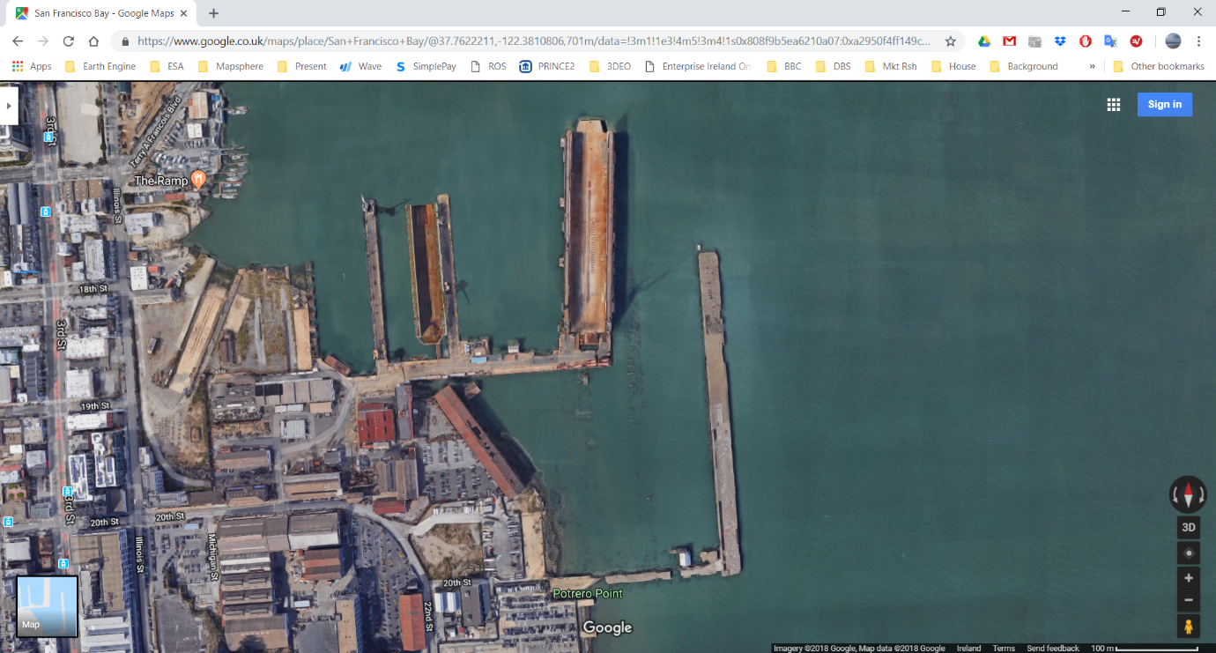

Figure : Close up of the two piers misclassified as ships with an accuracy of >0.99

**Second model run: sfbay_2.png**

The model correctly identified 9 ships in the scene and misclassified 9 areas – 2 of land as ships (Fig 7, Fig 8) and 7 sections of piers as ships (Fig 9 - Fig 14). This visual check gives us an **accuracy of ship classification of 50%**. This misclassification has been verified through a visual check of more recent imagery available for the same area of interest in Google Maps (Fig 16).

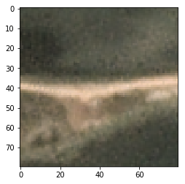

Figure : X:1220 Y:130 [[0.03308497 0.9669151 ]]

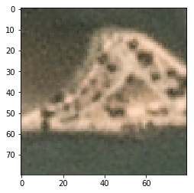

Figure : X:1060 Y:1210 [[0.09733345 0.9026665 ]]

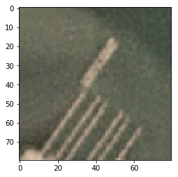

Figure : X:1370 Y:310 [[0.05465791 0.94534206]]

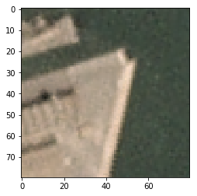

Figure : X:1610 Y:490 [[0.05329443 0.9467055 ]]

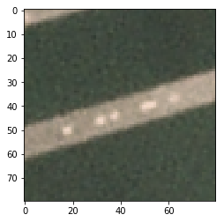

Figure : X:1550 Y:630 [[0.0041544 0.9958456]]

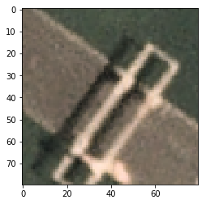

Figure : X:1500 Y:790 [[0.09521437 0.90478563]]

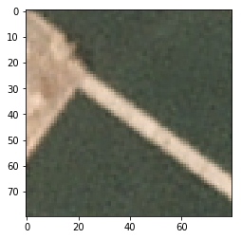

Figure : X:1480 Y:880 [[0.03763811 0.9623619 ]]

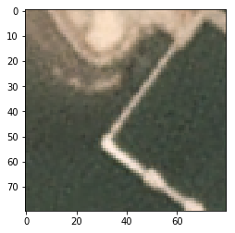

Figure : X:1390 Y:960 [[0.03541527 0.96458477]]

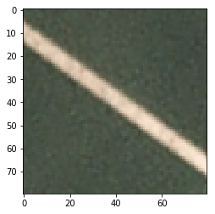

Figure : X:1490 Y:970 [[6.716660e-04 9.993284e-01]]

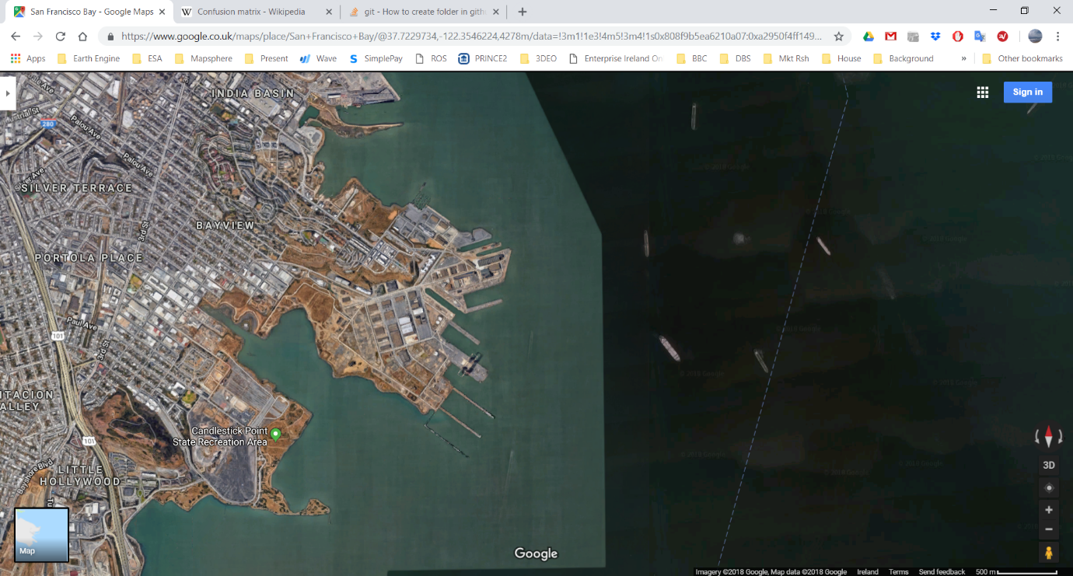

Figure : Same AOI checked on Google Maps to ground truth the model classification

**Third model run: sfbay_3.png**

The model correctly identified X ships in the scene and misclassified X areas – X of land as ships (Fig X, Fig X) and X sections of piers as ships (Fig X, Fig X). This misclassification has been verified through a visual check of more recent imagery available for the same area of interest in Google Maps (Fig 5, Fig 6).

**Fourth model run: sfbay_4.png**

The model correctly identified X ships in the scene and misclassified X areas – X of land as ships (Fig X, Fig X) and X sections of piers as ships (Fig X, Fig X). This misclassification has been verified through a visual check of more recent imagery available for the same area of interest in Google Maps (Fig 5, Fig 6).