**Gendered participation in community-level water governance in Syrian refugee host communities in Jordan**

Laura Mapstone Scott

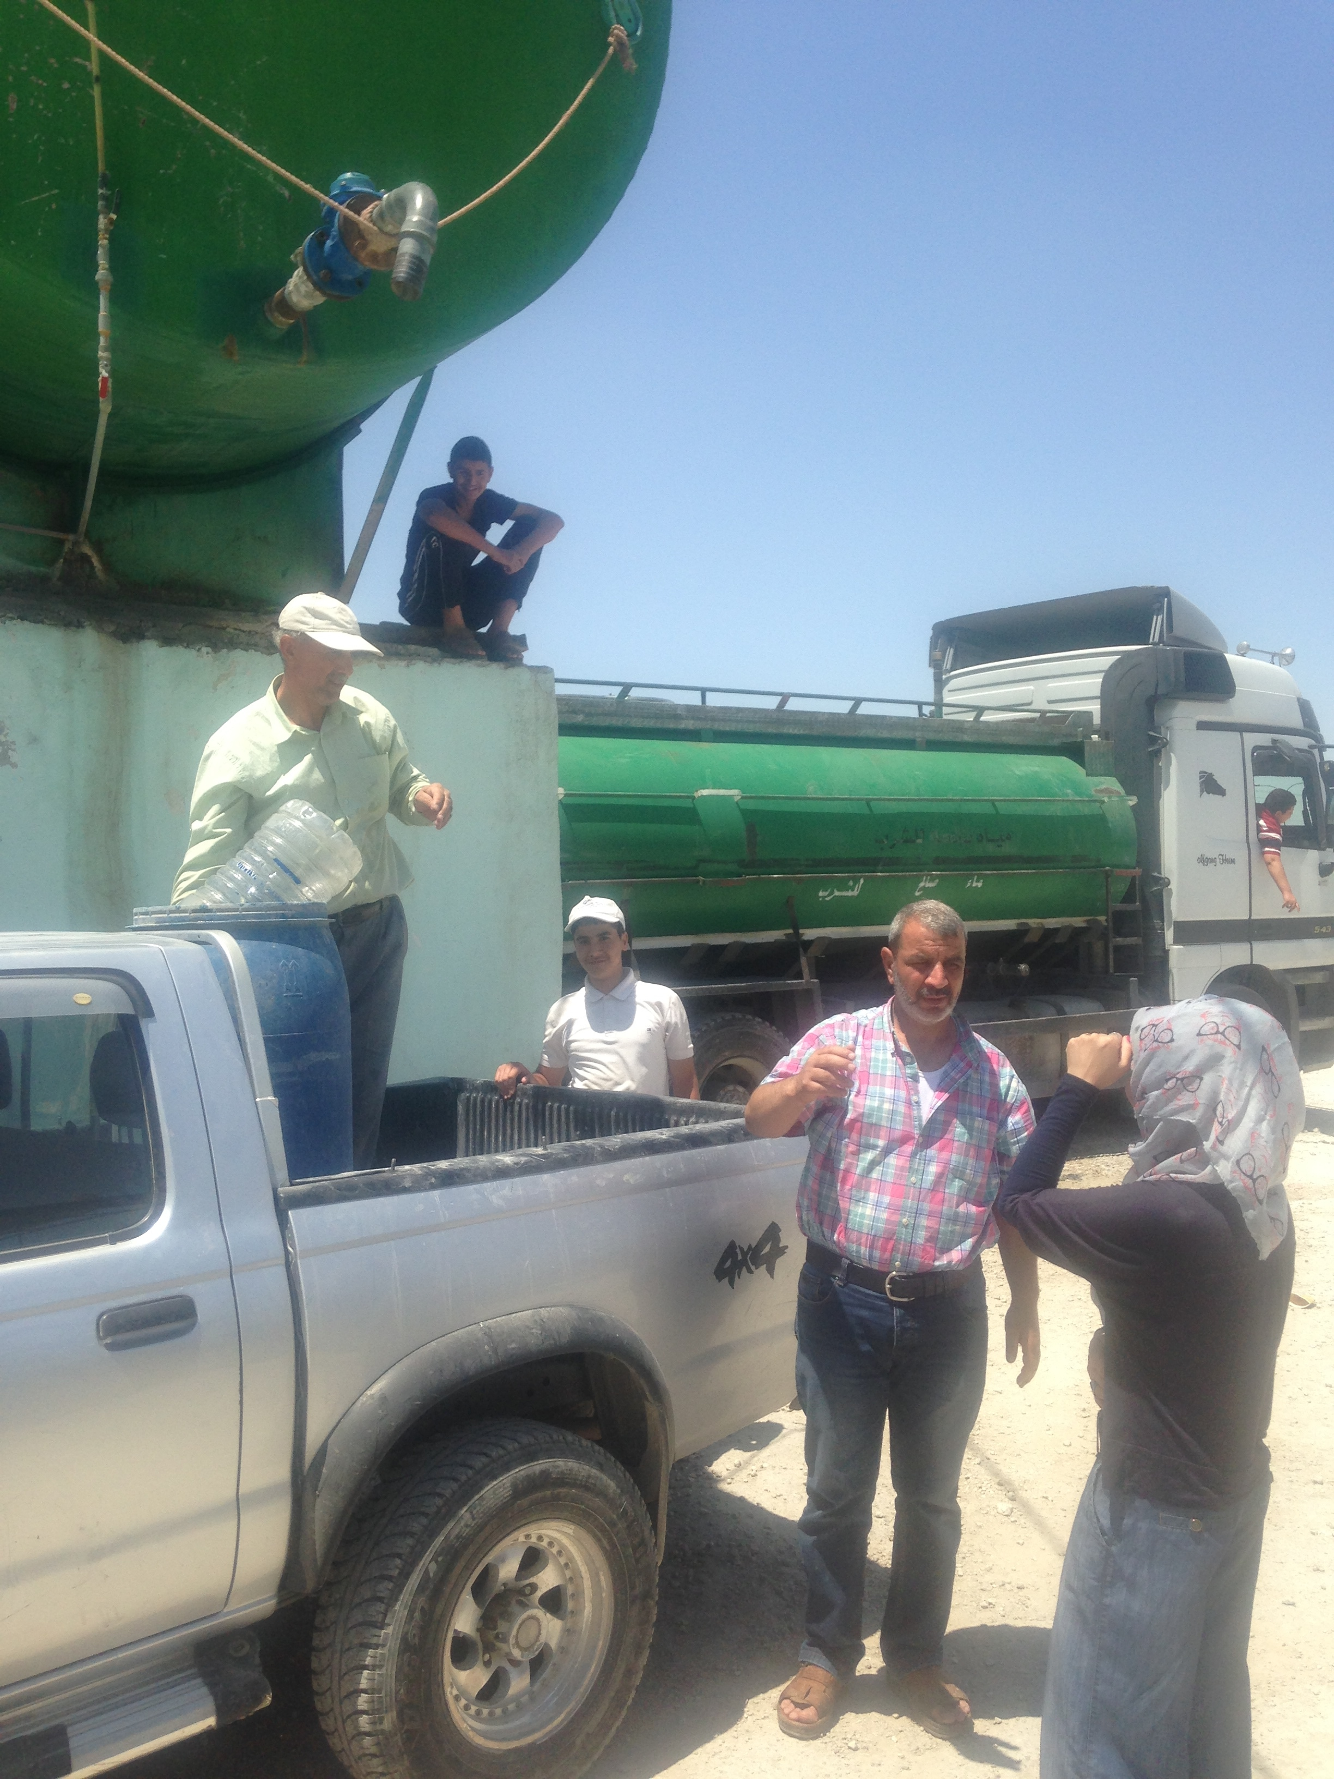

*Photo by Author*

This research is submitted as part of an MSc degree from the

Department of Geography at King’s College London, Sept 2015

For more information contact: Laura@Mapstone.org



# Abstract

This thesis analyses gendered household and community relations and management systems over water in the Russeifa District of the Zarqa Governorate in Jordan to predict how the creation of new participatory spaces for community-level water governance would be received and utilized. Gendered power structures between water users, service providers and the government are analysed and mapped based off receptivity to community participation. The paper argues that women’s participation in water committees would be restricted by social norms and socioeconomic status and that in order to foster more substantive participation, programs should focus on developing institutional support, women’s solidarity and a spatial context for participation in the community.

***Keywords****: Water Governance, Participatory Spaces, Community Participation, Water Committee’s, Gender Analysis, Syrian refugees, Zarqa Governorate, Jordan*

# 

# 

# Table of Contents

Abstract iii

Table of Contents iv

List of Tables v

List of Figures v

List of Abbreviations v

Acknowledgements vi

Introduction 1

Literature Review 1

The Hegemony of Participation in Water Governance 1

Gender, Marginalisation and Power Relations in Participatory Spaces 2

Inclusive Spaces for Participation in Water Governance 3

Conceptual Framework 4

The Jordan Context: Water Governance and Participatory Spaces 6

Methodological Approaches 8

Research Locations 8

Data Collection and Sampling 10

Research Limitations 11

Research Findings 11

Gendered Roles and Social Norms in Household and Community Water Management 11

Gendered Relations with Water Service Providers 12

Gendered Spaces for Community Participation 15

Donor-Driven Community-Level Water Governance 16

Community Receptivity to Participatory Spaces for Water Governance 16

Institutional Support for Participation 18

Analysis: Constraining and Motivating Factors for Participation 21

Conclusions 23

Appendix I: Ethics Screening 25

Appendix II: Risk Assessment Form 28

Appendix III: Information Sheet in English 30

Appendix IV: Fieldwork Photos 31

List of References 32

# List of Tables

Table 1. Typology of Participation (Agarwal, 2001) 4

# List of Figures

Figure 1. Map of Water Sector Institutions 7

Figure 2. Framework for evaluating women’s participation in urban water projects 5

Figure 3. Map of Jordan with population density 9

Figure 4. Map of Russeifa in the context of Jordan by Governorate 9

Figure 5. Map of stakeholder support for Women’s Participation in Community Water Management 18

# List of Abbreviations

CBO - Community-Based Organization

FGD - Focus Group Discussion

GoJ – Government of Jordan

GWA - Gender Water Ambassador

IWRM - Integrated Water Resource Management

JVA - Jordan Valley Authority

MWI – Ministry of Water and Irrigation

NGO - Non-governmental Organization

NRW - Non-Revenue Water

PD – Participatory Development

PMU - Project Management Unit

WAJ – Water Authority of Jordan

WASH - Water, Sanitation and Hygiene

WUA – Water User Association

# 

# Acknowledgements

I am very grateful for the support of the Royal Geographical Society (with IBG) as this research would not have been made possible without the Geographical Fieldwork Grant.

I would like to thank the Oxfam GB team for their in-country support and Ehabiddean Jayussi (IRD), Bashar Shunnaq (Arabteq) and Rawan Sabbah (Working Women’s Association) for assistance in data collection, translation and community introductions. Thank you to the many individuals and organizations in Russeifa that were so welcoming and generous in sharing their knowledge and passion for improving community water management.

I would like to extend a heartfelt thank you to my advisor, Professor Tony Allan, for his advice and guidance throughout this process, to the soon to be Dr. Amiera Sawas for sharing all her knowledge of water and gender with me over the past year, and to Dr. Daanish Mustafa from whom I learnt how best to conduct water fieldwork in the Jordanian context.

Lastly, thank you to my family for their tremendous support and motivational speeches and to *mansaf* and *kunafa* for being so delicious after a long day of fieldwork.

# Introduction

Water governance refers to the political, economic and administrative processes that shape the ways in which water is used, allocated and managed (WFG, 2015). This research focuses on water governance in Syrian Refugee Host Communities, Jordanian cities typically in the North of the country that house a high number of refugees, where 66% of Jordanians and 55% of Syrians are dissatisfied with water management services (REACH, 2014).

International donors are encouraging Jordan to take a decentralised, participatory approach to water governance to increase the efficiency and accountability of water service providers to communities (GIZ, 2015). There are currently few forums for community-level participation in urban water resource management and instead policy and governance structures are determined at a national and corporate level (Masharqa, 2012). Oxfam is one of several civil society organisations attempting to build the capacity of communities to participate in water governance and it will soon pilot water committees and gender water ambassador programs in the Russeifa District of the Zarqa Governorate.

This thesis analyses gendered household and community relations and management practices over water to predict how the creation of new participatory spaces by international donors would be received and utilized by communities. The research seeks to understand whether creating new participatory spaces would be effective in empowering community voices to influence water governance and to seek accountability from water service providers. I argue that motivating factors to Jordanian and particularly Syrian women’s participation in community-level water governance in Russeifa would be outweighed by constraining factors leading to shallow spaces for ‘nominal’ or ‘consultative’ participation. Following a conceptual framework developed by Das (2014), I argue that women’s participation is restricted by social norms and socioeconomic status and that in order to foster more substantive participation programs should focus on developing institutional support, women’s solidarity and a spatial context for participation.

# Literature Review

## The Hegemony of Participation in Water Governance

In efforts to remedy centralised, standardised, top-down development practices, participatory development emerged to allow “local people to identify, express and achieve more of their own priorities” (Chambers, 1997). Participatory approaches aim to take advantage of local knowledge and understanding while offering the “promise of inclusion, of creating spaces for the less vocal and powerful to exercise their voices and begin to gain more choices” (Cornwall, 2003). The inclusion of poor and marginalized groups in water project decision-making, implementation and evaluation is promoted to increase efficiency and equity in water resource management (Sultana, 2009). The need for a ‘participatory approach’ is recognized internationally as one of the central requirements to make Integrated Water Resource Management (IWRM) effective and equitable (GWP, 2015). Community participation has now become a powerful mainstream discourse in the water sector and is embraced by local and multinational development organizations across the world, often instrumentalised through the creation of ‘Water User Association’s or ‘Water Committees’ (Sultana, 2009). It is seen as best practice in development to encourage the creation of new ‘invited spaces’ for participation “into which people (as users, citizens or beneficiaries) are invited to participate by various kinds of authorities, be they government, supranational agencies or non-governmental organisations” (Cornwall, 2002). The hegemony of the participation discourse led Cornwall and Brock (2005) to label it a new ‘buzzword’ which development organizations use to market, ‘rebrand’ (Kapoor, 2005) or ‘rubber stamp’ their programs (Mohan, 2001).

### Gender, Marginalisation and Power Relations in Participatory Spaces

Participatory approaches are criticized for failing to account for existing power relations or to transform prevailing social, political and economic power structures that prevent the inclusion of marginalized groups (Hickey and Mohan, 2005). Participatory spaces can be monopolized by local elites and serve to reproduce existing inequalities and social norms (Mosse, 2001). Powers-that-be can intimidate and curb the potential to expand discussion to include concerns of all stakeholders (Sultana 2009). “Power relations help to shape the boundaries of participatory spaces, what is possible within them, and who may enter, with which identities, discourses and interests” (Sultana 2009).

Participatory approaches can overlook the constraints that inhibit marginalized individuals’ agency and ability to participate and the patterns of inequality that shape their behavior (Cleaver and Hamada, 2010). Daily negotiations over access and management of water serve to produce, consolidate and contest these social relations and to reconfigure the urban waterscape (Ahlers et al, 2014). Hydro-social processes are gendered, classed and spatialised and failure to recognize this can exacerbate gender, class and social disparities (Sultana, 2009).

A gender perspective is needed to assure that the distinct needs, interests and priorities of men and women are taken into account for them to benefit equally from water projects (GWP, 2015). The formal inclusion of women in participatory projects doesn’t take into account gender roles and structured gendered hierarchies that can reinforce or exacerbate existing gender inequalities (Miraftab, 2004). “The technocratic approach to women’s participation presents an oversimplified view that links their participation with improvements in efficiency and empowerment while neglecting the social complexity and diversity of their livelihoods concerns, or their situations, motivations, and strategies” (Cleaver, 1998 cited in Adu-Ampong 2012).

Individual abilities to participate in public spheres are often tied to power in the household – and can depend on household bargaining power, division of labor and control of assets (Meinzen-Dick & Zwarteveen, 1998). Internationally, women often face high opportunity costs to participate due to their domestic responsibilities and mobility restrictions – this can be compounded with high societal costs of having to challenge social norms to participate (Meinzen-Dick et al, 2006). As such, women often state that they do not see the need to participate formally and can benefit through representation by male neighbours or relatives (Meinzen-Dick et al, 2006). Yet formal participation in institutions is more secure from elite capture and give women more bargaining power (Meinzen-Dick et al, 2006, Adu-Ampong 2012). The larger the degree of gender inequality, the higher the transaction costs will be to overcome gender barriers to establish mixed gender participatory spaces and will require building women’s capacity in all-women groups as a first step (Sultana and Thompson, 2005). Sultana and Thompson’s (2005) study in Bangladesh found that all-male community floodplain management organizations took less time to establish than mixed gender committees but this was offset by a faster implementation of activities and fewer conflicts and rule-breaking in the mixed-gender committees. Westerman, Ashby, and Pretty (2005) also found that women’s inclusion in natural resource management committees led to more collaboration, solidarity, and conflict management. Programs that understand and employ women’s capabilities while recognizing and overcoming restraints are more likely to be effective, sustainable and socially impactful (GWP, 2014). It is necessary to narrow the gap between women’s motivation to participate and their ability to do so to engendersubstantive and effective participatory processes(Reed, 2008). Yetwomenare not a homogenous group and their ability to participate is based on socio-economic factors such as income, ethnic group religion, and urban versus rural residence (Meinzen-Dick et al, 2006).

### Inclusive Spaces for Participation in Water Governance

Cleaver (1999) criticizes the technocratic, procedural ‘means to an end’ methodology of empowerment through participation. Instead, it is necessary to have an approach that envisions the process of participation as an end that is “underpinned by a philosophy that emphasizes empowerment, equity, trust and learning.” (Reed, 2008) More than ‘gathering views’, participatory processes should provide opportunities for exploration, analysis and debate (Cornwall and Coelho, 2004). Greater inclusive deliberation is needed in the consultative process so citizens are transformed from ‘users and choosers’ to ‘owners’ or ‘makers and shapers’ of services (Cornwall and Gaventa, 2000). There must be a re-conceptualization of participation as a right that can be claimed by marginalized groups to develop stronger political, legal and moral agency (Hickey and Mohan, 2005).

Advocating for participation as a form of citizenship allows communities to take advantage of ‘new democratic spaces’ (Cornwall and Coelho, 2004) to gain political, social and community agency to demand accountability and transparency from the government and service providers. Gaventa (2004) notes how state-society relations can be transformed from distrust to collaboration if an active and engaged civil society is met by a responsive state. Capacity-building activities to train state officials how to listen and engage community groups are often needed along with efforts to tackle exclusionary elements in the institutional structure of participatory spaces (Cornwall, 2007) To make participatory spaces inclusive of marginalized or excluded non-citizen groups such as refugee populations, there must be clear rules of representation and engagement to transform the power relations that exclude them and help them establish a voice (Cornwall, 2007).

## Conceptual Framework

 Agarwal (2001) presents a typology of participation in formal institutions for natural resource management which range from nominal (group membership) to empowering (influencing decisions), to which Das (2014) adds the category of substantive participation, which is empowering participation that can be sustained beyond project prescription.

|  |  |
| --- | --- |
| **Form/Level of Participation** | **Characteristic Features** |
| **Nominal Participation** | **Membership in the group** |
| **Passive Participation** | **Being informed of decisions *ex post facto; or* attending meetings and listening in on decision-making without speaking up** |
| **Consultative Participation** | **Being asked an opinion in specific matters without guarantee of influencing decisions** |
| **Activity-specific participation** | **Being asked to (or volunteering to) undertake specific tasks** |
| **Active Participation** | **Expressing opinions, whether or not solicited, or taking initiatives of other sorts** |
| **Interactive (empowering) participation** | **Having voice and influence in group decisions** |
| **Substantive Participation** | **Voice and influence in decisions sustained beyond project prescription** |

**Table 1 Typology of Participation based on Agarwal, 2001 and Das, 2014**

This thesis uses this typology of participation with a conceptual framework from Das (2014) to evaluate prospects for interactive and substantive participation in community-level water governance in Jordan. Figure 1 depicts how the interaction of motivating and constraining factors impact forms of participation. Following an analysis of gendered roles and structures existing in informal water governance in Russeifa, this thesis uses this model to analyse how marginalised groups, particularly women and Syrian refugees, would be able to participate in formal institutions for water governance.

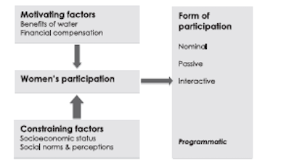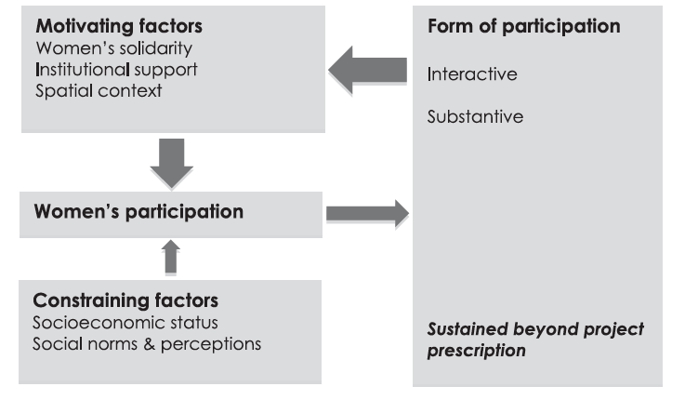

Figure 1. Framework for evaluating women’s participation in urban water projects (Das 2014)

In formal spaces for the participation of women and marginalized groups, constraining factors often overpower motivating factors leading to weaker participation. Das (2014) developed this conceptual framework in the context of urban spaces for water management in Bangladesh and I argue that it can be applied to Jordan to explain how women and Syrian refugees would not be able to substantively participate in donor-driven spaces for participation in the current climate.

Constraining factors to participation include social norms and perceptions and socioeconomic status. More than technical program design to ‘induce’ participation through financial compensation and the benefits of water, Das (2014) found that it was external societal and structural factors that had more impact on women’s successful participation, such as solidarity, institutional support, and the material spaces of participation. The ability of individual women to participate is limited but women’s solidarity through their collective action and organization in groups improves their ability to overcome entrenched power structures (Cleaver, 1998; Das, 2014). Group membership can foster solidarity by bringing together poor women who are not usually able to socialize beyond family circles and by giving them a sense of connectedness, self-efficacy and leverage (Sanyal, 2009 cited in Das, 2014).

In more conservative communities where women’s presence in public places among men is discouraged, spatiality is the biggest setback to substantive participation (Das 2014). “Patriarchal social structures and institutions create embodied female identities, and these in turn limit women’s spatial mobility’ (Laws 1997, cited in Sultana 2009). To develop substantive forums for women’s participation it is necessary to create safe spaces where both genders can interact together and overcome the public–masculine and private–feminine gendered constructions of space (Sultana, 2009) Lastly, institutional support is necessary to link these community level participatory spaces to national and regional decision making structures so that they have leverage and respectability (Das, 2014).

Das (2014) notes how women’s success and confidence in attaining interactive participation has feedback loops that in turn further build solidarity, institutional support and a spatial context for participation.

This framework will later be applied to analyze power relations and governance structures in Russeifa and to assess prospects for participation by marginalized groups.

## The Jordan Context: Water Governance and Participatory Spaces

This section introduces the context of Jordan’s water crisis and provides an overview of institutional and governance structures in the water sector along with existing forums for increasing participation and accountability.

Jordan is one of the driest and most water scarce countries in the world. While the international ‘absolute water scarcity’ standard for renewable freshwater is 500m3 per capita, Jordan reached 106m3 per capita in 2013 (World Bank, 2013). Demand for water and pressure on strained water supply services has rapidly increased due to population growth and the influx of an estimated 1.4 million Syrian refugees since 2011, 629,128 of which are currently registered with UNHCR (JRPSC, 2015). Despite the eminent need for water conservation, over 45 percent of Jordan’s water supply is lost as Non Revenue Water (NRW) due to technical and administrative losses (MWI, 2013). Operations and maintenance expenditures and capacity-building to prevent losses are needed as the government continues to subsidise water and wastewater services to maintain socially acceptable tariff limits, leading to an aggregate loss of one percent of GDP per year (MWI, 2013).

Jordan is highly dependent on international donors for project funding and they wield considerable influence in the sector. To adapt to this water crisis, international donors have encouraged Jordan’s government to launch a series of structural and institutional reforms to improve water governance and enhance service delivery. Development organisations internationally have advocated for a move from large-scale, standardised service delivery to small-scale decentralised forms through private sector participation (Ahlers et al, 2014) and Jordan has begun to embrace neoliberal policy mechanisms through the decentralisation and corporatization of its water sector (GIZ, 2015). Three private water companies have now taken over water services provision in different parts of Jordan, the most relevant to this study is the *Miyahuna Water Company* which has operated in Amman since 2007 and which expanded into the Zarqa and Madaba Governorates within the past year.

The responsibilities of the main governing institutions and water service providers are depicted in *Figure 2*. *The Ministry of Water and Irrigation* (MWI) is the main institution responsible for formulating national water policies and strategies along with sector-wide planning, tariff setting, resource monitoring, outreach and information sharing. *The Water Authority of Jordan (WAJ)* is responsible for the management and development of water resources, though responsibility for water service delivery has now been taken over by private water companies in most of the country (OECD, 2014).

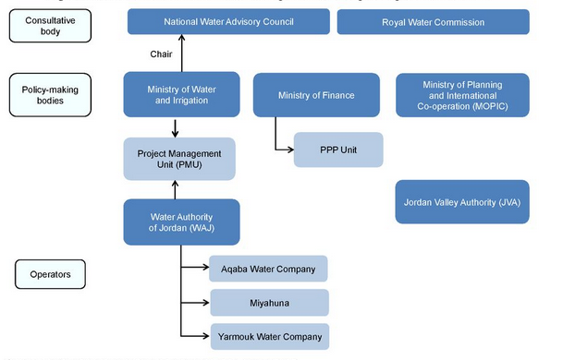

Figure 2. Map of Water Sector Institutions (OECD, 2014)

The *Project Management Unit* (PMU) was established within MWI to oversee and monitor the water companies, however it does not yet have the ability to issue performance related penalties on the companies (OECD, 2014) While Article 17 of the Constitution states that Jordanians are “entitled to address the public authorities on any personal matter affecting them or on any matter relative to public affairs,” water service officials often resist this transparency and require “a lawful interest or a legitimate reason” for information or consultation and there are few other forums for citizens to demand accountability from service providers (Albuquerque, 2014).

Successful in encouraging the privatization of Jordan’s water sector, donors now seek to spread international best practices of stakeholder engagement and local participation in water governance. The biggest experiment involving local participation, supported by GIZ, has been the creation of Water User Association’s in the Jordan Valley, which allocate bulk irrigation water purchased from *Jordan Valley Authority* (JVA) to farmers. Critics challenge their efficacy in impacting water allocation beyond the association level and their ability to act independently of JVA, while suggesting that they are susceptible to elite capture by big landowners and powerful tribal families (Molle et al, 2008; Mustafa et al, 2016). It is worth noting that WUA’s in Jordan Valley fail to include almost any representation of women (Field notes, 2014), yet WUAs represent the first attempt at decentralisation to the stakeholder-level in the water sector and their success will impact receptivity to future participatory water institutions. Outside of the agricultural sector there are few institutionalised forums for community participation in water governance or ways. Jordanians can participate in consultations over environmental impact assessments for infrastructure projects and WAJ is slowly expanding community involvement in planning, design and implementation phases (MWI, 2013).

In the host communities, inter-communal tensions over water are very high; 71% of Jordanians and 61% of Syrians stated that access to water caused tension in their community. Female respondents identified the main source of community tension to be shortages (32%) whereas male respondents highlighted uneven access to water between Jordanians and Syrians (31%). REACH suggests that women are more cognizant of scarcity because of their greater daily water use in the household and that men are more aware of tension because of their more public community interactions (REACH, 2014). There is a clear need for inclusive dialogue in community water management to abate tensions.

# Methodological Approaches

## Research Locations

This study focuses on urban water services specifically in Russeifa, one of the three municipalities in the Zarqa Governorate. Known for it’s heavy industrial presence and as a former phosphate mining hub, Russeifa is now home to 348,867 people – and one of the most densely populated and low-income municipalities in Jordan (Department of Statistics, 2014). It is a Salafist stronghold in one of the most conservative governorates, home to fundamentalist clerics like Al-Maqdisi and Zarqawi (Alami, 2015).

Russeifa is home to a large Palestinian community including 58,000 UNRWA-registered refugeesin the Marka Refugee camp, known locally as Schneller or Hitteen Camp (JRPSC, 2015). In the Zarqa Governorate there are 77,188 UNHCR-registered Syrian refugees, of which 20,105 reside in the Azraq Refugee Camp and 51,076 are based in urban host communities like Russeifa (UNHCR, 2015).

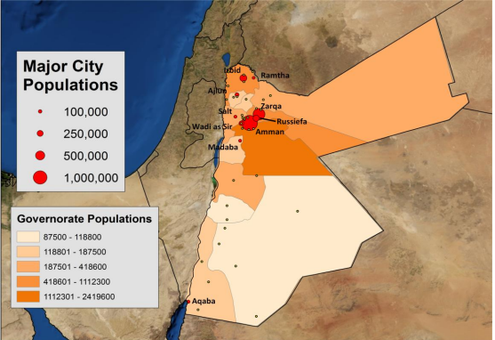

Figure 3 A map of population density in 2012 from Altz Stamm 2012

Neighbourhoods in Russeifa where the study was conducted are depicted in Figure 2a. All the neighborhoods where the research was conducted have intermittent piped water connections, with the exception of Abu Saya, an area just beyond the boundaries of the Municipality of Russeifa, which neither Miyahuna or WAJ service.The rest of Russeifa is serviced by Miyahuna with water mostly from the non-renewable Disi Aquifer.

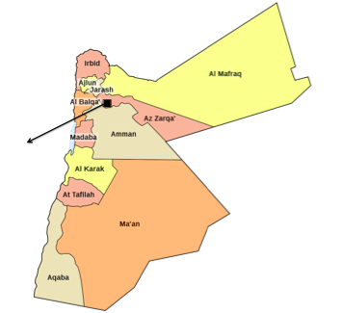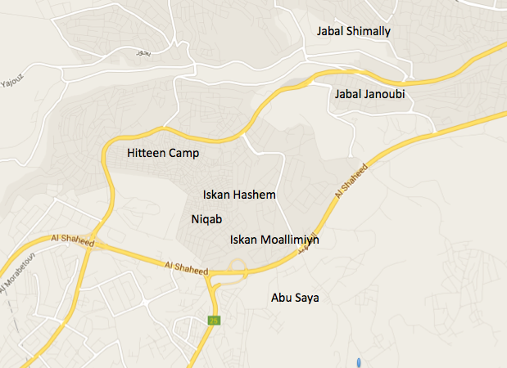

Figure 4. Map of Russeifa (by author on Google Maps) in the context of Jordan by Governorate (Worldofmaps.net, 2015)

## Data Collection and Sampling

All qualitative data was gathered through semi-structured interviews and focus group discussions (FGD’s) in Russeifa and Amman in June and July, 2015.

8 FGD’s were held primarily in Community Based Organisation’s (CBO’s) with one FGD’s in a ‘Koran Club’ in a Mosque and another in a *Madafa*, or tribal community meeting room. Spatially the research focused on the centre of Russeifa, particularly in Jabal Shimally/Ganouby, Iskan Hashem, Niqab and Iskan Moallimiyn. One focus group was conducted in the periphery of the city, in Abu Saya, for comparison and a greater understanding of coping mechanisms of communities without piped water supply. No focus groups were conducted in Hitteen Camp, which would have required a permit from UNRWA.

Initially, nine focus groups were scheduled, however two focus groups with Jordanian men was cancelled due to low attendance. Many of these men explained that they were unable to attend due to busy work schedules in the lead up to Ramadan.

The list below details each of the FGD’s.

1 Syrian Men from Jabal Shimally in CBO

2 Syrian Women from Jabal Shimally in CBO

3 Jordanian women from Jabal Ganouby in CBO

4 Jordanian Women from Iskan Moallimiyn in Mosque

5 Jordanian women from Iskan Hashem and Niqab in CBO

6 Syrian Women Iskan Hashem and Niqab in CBO

7 Jordanian women from Abu Saya in Madafa

Following the focus groups, 16 semi-structured interviews were conducted with targeted members of the community. As Jordanian men were not adequately represented by the focus groups, the interviews sought to target Jordanian men as well as women with mobility restrictions who could not attend the focus groups in public spaces. Interview participants were selected randomly by walking around different areas of Russeifa asking individuals on the street if they had time for an interview or knew someone with whom we would be able to meet that met our target criteria. These interviews were then conducted in the courtyards of the individual’s homes.

Following these community interviews, 20 semi-structured interviews with stakeholders and water service providers were conducted in Amman and Russeifa. Of these 20 stakeholder interviews, 11 were with international, national and community based organisations (CBOs), 1 was with a mosque group, 2 with the Water Authority of Jordan (WAJ), 2 with the Ministry of Water and Irrigation (MWI), 2 with Miyahuna, 1 with a senior official in the Municipality of Russeifa, 1 with a Local Community Leader. These interviews were conducted at their representative organisation or institution.

## Research Limitations

As Russeifa is a predominantly Jordanian-Palestinian city, Jordanians of Palestinian origin who have received citizenship and are eligible for government services were characterised as Jordanian in this study. There had been hopes to conduct a survey to triangulate findings that would have given the option to self-identify national identity and this would have captured differences in perspectives between Jordanians and Jordanians of Palestinian origin, however for the purposes of qualitative analysis it was only possible to focus on disaggregating findings between those with and without citizenship where critical differences were more evident.

Furthermore, Jordanian men’s lack of attendance to FGD’s meant that no discussion with Jordanian men was conducted. The Syrian male focus group also had less attendance than the female FGD’s. The researcher sought to compensate for this limitation by conducting targeted interviews with men in the community.

# Research Findings

Before analysing constraining and motivating factors to women’s participation, a baseline of how water is used, owned and managed by different users is provided to capture critical differences among groups (gender, nationality, age, location and socioeconomic status) which impact the way individuals currently or potentially could engage in participatory spaces as will be discussed in the next section. This section suggests that women are more invested in water conservation due to their greater household consumption of water for household responsibilities and yet their interactions with service providers and with the community are limited due to culturally ascribed gender roles and social norms.

### Gendered Roles and Social Norms in Household and Community Water Management

*“In the household, it is women who make most of the decisions about water. The house is the kingdom of women. In the same way that men don’t interfere in the household, I don’t interfere outside of the house*.” - Elderly widow in Niqab

Men and women uniformly identified gendered roles in household and community water management – suggesting that women were ‘water managers’ in the household and men were in the public sphere.

“Men don’t have any need for water, it’s all done by the women” said a young middle-class Jordanian woman. Beyond water uses for basic hygiene and drinking, men were said to use water only for ablutions before praying and occasionally for watering gardens or trees and washing cars. As water is only intermittently distributed 1-3 times per week in Russeifa, women said that they would perform water intensive household tasks on ‘Water Day.’ “The day of water is a day of celebration,” said one woman, adding that it was also a day of hard work where women said they would do all washing and cleaning. Most of the participating women said that their daughters would help with Water Day chores after school - a few suggested that they would occasionally take their daughters out of school to help with housework on Water Day though the rest of the focus groups participants were shocked and frustrated at hearing this. Beyond the time-intensive nature of this work, most women said that they needed to schedule and plan their time around being home on Water Days so that they could do these tasks before refilling the tanks to store water for the upcoming week before the supply cut. Several Syrian and Jordanian women said they would repeatedly check the meter on the water storage tanks to see how much water was available and if necessary they would encourage household members to reduce consumption until the next water supply day. One young Jordanian woman said; *“*Women save water more than men. A wife often teaches her husband and children how to save water.” An elderly Jordanian widow also stressed the role of women as household water managers;

“I am very aware of how to conserve water and I encourage my neighbours to do so as well. Women in the household control and enforce water consumption. I am the one who allows and tells people when they can take showers. I am worried about water all the time. They joke that I am the water director and in charge of the household water but we all coordinate together.”

Another older woman passionate about water conservation said that, “I make fights with people about water conservation.…but the community doesn’t listen to me, they say I am trying to be a philosopher. This is a consumptive community rather than an aware community.”

Hence, women are currently acting as household water managers and some have the motivation to participate in engaging with the Russeifa community over water management, yet do not feel empowered to do so.

### Gendered Relations with Water Service Providers

#### Miyahuna

Most participants in Russeifa were enthusiastic about improvements in water service delivery since Miyahuna took over water service delivery from WAJ in the past year. Miyahuna had created a new hotline that members of the community could call to notify Miyahuna of water pipe breaks, to file water service complaints and to gain additional information on water supply. Given the frequency of pipes breaking in the street and high NRW, many participants had informally designated someone in their family or neighbourhood that would liaise with Miyahuna over problems via the hotline or through a direct visit to their Russeifa office. Typically this was an elderly male with the general consensus among the community being similar to a comment made by a middle aged Jordanian in a focus group:

“Miyahuna responds better to men, as men make decisions and pay their fees. In our Islamic culture it is easier for men to connect with companies and to travel and Miyahuna only listens if you go to their offices. Miyahuna believes that men are more accurate than women as they think women exaggerate their problems.”

Yet, I encountered several elderly women that had made it their responsibility to engage the service provider. An elderly widow in Niqab said that, “When water pipes burst I go personally to Miyhauna’s Manager in Russeifa. There is much more action when face-to-face. The hotline is for Amman and it is easier to go straight to Russeifa.” Similarly, a middle aged female Jordanian in Hitteen said that, “The manager of Miyahuna solves all the problems in this area. Miyahuna listens to me or they know that I will be angry.”

Syrian men said that they feel very weak participating communicating with Miyahuna or the government and in the focus groups they all said that they would not call the hotline or visit Miyahuna’s office and would instead ask a Jordanian neighbor or friend to communicate on their behalf. The Syrian men said that they felt like guests in Jordan so did not want to interfere in the community. They appeared not to have a sense of belonging and did not feel empowered to participate in water management.In addition, Syrians generally had less information on the Jordanian water system and service providers and many Syrians were unfamiliar with Miyahuna and expressed distrust and misinformation over billing and management of services.

#### Water Trucks

Service delivery modalities are disaggregated as water is only piped to households in Russeifa 1-3 times a week and many order tanker trucks to deliver water after running out of piped water. In addition, water trucks will only deliver a full tank of water so it is necessary for families to share the delivery between neighbours. Men said they often coordinated to share and arrange a water truck delivery, often meeting informally in the street to discuss it, though some women reported to calling their female neighbors before requesting a water tank.

In almost all interviews and focus groups, women said that it was their sons or husbands’ responsibility to call and arrange a water truck delivery and that it was necessary for a male relative to be present during delivery. Some younger women added that it was ‘shameful for a women to speak to a man on the phone,’ though most women said that if no male was present in the household then it was acceptable for an older woman to arrange the water delivery. A middle aged CBO Director in Hitteen said that,

“If a women has a good, strong character then she can call the water truck, though if the man calls the water truck comes much faster. Women can call the store but for tanks they generally wait for the man to call.”

An elderly woman in Niqab expressed her frustration with water truck delivery delays: “I call one water trucker but he is not very responsive. He keeps giving excuses like a flat tire to postpone delivering the water. I only keep calling him because it’s the only number I have. All the tanks come from the same source anyway.” According to the Special Rapporteur for Human Rights, water tankers prioritize regular clients such as hotels and businesses and then generally service men they know well in the community, and only when there is spare water will they serve new clients, often ignoring more vulnerable women or Syrian families that only request water irregularly.

#### Water Stores

Most participants did not have water filters and were concerned with piped water quality so they sourced water for drinking and cooking from bottles. Women generally said that it was their responsibility to purchase the drinking water but that their husbands would need to approve and coordinate the purchase. Men said that once their wives or daughters told them that there was not enough water it became their responsibility to procure water from the store.

#### Plumbers

If a plumber was requested then a male relative would need to arrange to be present during the visit. This often lead to delays in fixing household water leaks as women said they waited until their husband or sons returned home before leaks could be fixed. When asked if there were women plumbers the response was generally to say that women did not have the skills or ability to be plumbers. A few participants had heard of MCA’s new program to train women in plumbing and when they explained this idea to the rest of the focus groups the response was overwhelmingly positive. Women were enthusiastic that the increased mobility of women plumbers would allow for leaks and pipes to be fixed more quickly, though most said that they doubted women’s skills, physical strength and ability to be successful in this non-tradition role.

This section provided an overview of gendered power relations between the community and service providers. The varying senses of efficacy or inability to interact and engage with Miyahuna will be reflected in the power dynamics of future potential water committees.

### Gendered Spaces for Community Participation

Within Russeifa there were over a hundred CBOs, yet most of these operated only during Ramadan. There were probably about 15-20 active, strong organisations that operated year round and many had religious affiliations.

There were examples of considerable unofficial community mobilization over water problems. Men meet spontaneously with neighbors on the street or in the *madafa*, the community or tribal meetinghouse, to discuss ways to solve community water problems when an issue arises. In Iskan Moallimiyn, a recent meeting on the street led to men gathering signatures from all the men in the community to present to Miyahuna to have them improve water supply and pipeline infrastructure.

In all of Russeifa, women however said they have few forums to participate in decision making, let alone to meet for discussion or leisure. The places where women suggested that they could meet to discuss community problems were at the homes of neighbours or family members, in local CBOs, in Mosque or Koran groups or at after school meetings for mothers at their children’s schools. Several women in Iskan Moallimiyn said that they would often meet at each others’ houses to study the Koran and afterwards there would be time to socialise and discuss problems in the community. The ‘Koran club’, reading sessions followed by socializing, seemed to provide the most common forum for women to meet and discuss, so connecting religion to community water management could have the effect of opening up more spaces for women to participate. When discussing water management, many men and women frequently quoted Sunan ibn Majah 425 from the Hadith, wherein the Prophet Mohammed tells an individual using excess water to perform ablutions, not to waste water “even if you were on the banks of a flowing river”. A middle aged Jordanian woman in Iskan Hashem said, “Women in this area only participate in religious activities and household tasks. They sometimes go to the education center or CBOs but otherwise there are usually no other clubs or activities that they are part of.”

When asked about women leaders in the community, men said that there were no women in positions of leadership, whereas women were usually were able to name one or two unofficial women leaders in the community. Women often shared the same names of women who they considered strong and active, usually elderly widows, religious teachers or leaders of CBOs. When prompted about spaces for women’s participation in the water sector, women generally focused on their participation in workshops or training sessions for household water conservation as opposed to participation in decision-making, though only a minority had participated in any such events.

One such proactive woman suggested that women in her community used mobility restrictions as an excuse not to engage in time-consuming meetings or unpleasant activities. She gave the example of one time she had arranged for a representative of the Municipality to visit the polluted Wadi next to her home to meet with women in the community. Neighbouring women had agreed to join to explain their water problems to him, but when he arrived and the woman asked community women to attend they said that their husband or son had prevented them from attending, which she believed was an excuse and certainly not true. She said that she had a hard time encouraging other women to be more active and that there was no women’s solidarity in her community.

Additionally, there were some more conservative communities where mobility and cultural restrictions prevented women’s participation. In Abu Saya, one woman offered: “This area is close-minded and we can’t even do training if there are men there, as our husbands wouldn’t allow it. We are Jordanian Bedouin and don’t accept women in leadership positions. Iskan Hashem is mostly Palestinian refugees so they would accept women in the water sector.” (N) Another woman in a later interview mirrored this statement saying, “Palestinians like myself are more liberal, but the Bedouin Jordanians and people from Gaza in this area are more conservative. The traditional culture is hard on women“ (J). This woman mentioned that there was a *Madafa*, or tribal meeting house in the area, and though women were allowed to gather there, Jordanian Bedouin women were often restricted from leaving their houses other than for weddings or special occasions. She added that there were quite low literacy rates among women and that she didn’t know any literate women whose husbands would allow them out of the house.

Syrian women are doubly disadvantaged in terms of opportunities to participate. They reported a harder time connecting with their neighbors and a few said they could only meet people at weddings. Syrian women said that while they had many meeting places in Syria, they were not likely to participate in CBO or mosque meetings in Jordan. A Syrian woman said that women in her community understand and accept their current social roles. She added that women would not participate in making water decisions because they were not expected to work or to go out of the house. She added that on top of being traditional, women were too busy with children and caring for the house to participate and would have transportation problems without money or mobility to attend the meetings.

## Donor-Driven Community-Level Water Governance

### Community Receptivity to Participatory Spaces for Water Governance

There was considerable support among the Russeifa community for Oxfam’s proposed ‘Water Committee’ and ‘Gender Water Ambassador’ programs.

Men were supportive of the idea of a Water Committee as they thought it would be a useful way to liaise with Miyahuna and WAJ over water problems, to share information and to improve water services. Though they were overall quite resistant of women’s participation in proposed committees, often suggesting that it would make them less effective. Many respondents doubted women’s ability to participate due to domestic responsibilities, mobility restrictions and a traditional culture that discouraged women from interacting directly with men. A middle aged Jordanian man said, “Women don’t know how to solve problems and if women are on the committee it will not help the area. The problem is with Miyahuna though, because if the person responsible at Miyahuna was a woman then maybe she would listen but its all men. Dealing man to man is very different from dealings between men and women.”

Women subscribed to these conventional views on power and also suggested that they would be better in a more consultative role. One Syrian women opposed to mixed gender committees suggested that women should instead share their advice to an all male committee through letters, phone calls or ‘whatsapp’ groups.

In general, Syrian women were more resistant to mixed gender committees and tended to be more supportive of the Water Ambassador program, whereas Jordanian women preferred the committee because they felt it would use teamwork to be more effective.

Syrian men were highly resistant to the idea of women on a mixed water committee and questioned role women would serve. A middle aged Syrian male said;

“In the committee we would say bad words that are not suitable for women. Women are dangerous. Imagine they would act like a manager and challenge their husband in the household saying ‘husband, I have a meeting and can’t do this’ and then she will marginalize her husband”

While there is still clear resistance to renegotiating power relations, there have been steps to discuss new gender roles in some communities, offering the potential for change. One man said that if there are women on the committee, the criteria should be that women are single without husbands or that they are widows, though another man said that even then women should just work at home. As receptivity to mixed gender committees varied, many of the female focus groups discussions focused on defining what sort of women, if any, should participate in the associations. Most believed that women should be strong, humble, educated, pious and passionate about voluntary work. An elderly Jordanian woman said, “If women were responsible for water sector, these problems would not happen. Though for both men and women if they love their work then they have the ability to change things.”

A younger Jordanian woman added, “If a woman has lots of knowledge and education, for instance in engineering then maybe she could lead, but how would you motivate women that works at home? The first step to success is for women to solve a problem. If she does then it will increase others confidence in her and will keep her encouraged and excited.”

### Institutional Support for Participation

Water service providers, governing bodies, community groups and influential community leaders were consulted on their receptivity to increasing women’s participation in community water governance. Below, in Figure 3, is a power map that the author made to depict findings from consultative interviews – it portrays the power of the stakeholder to influence policy, practice and decision-making on a grid with their receptivity to women’s participation at a community-level.

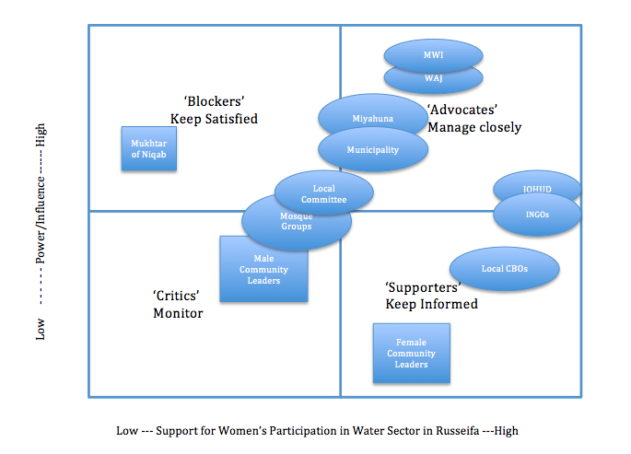

Figure 5. A map of stakeholders support for Women’s Participation in Community Water Management. Created by author based off key interviews with stakeholders and modeled on Zeitoun et al (2012).

INGOs like GIZ, MCA, USAID have been active in gender mainstreaming in Jordan through partnership with organizations like JOHUD and CBOs and so they were most enthusiastic over efforts to increase women’s participation at a community level. All of these actors had initiated their own gender and water projects elsewhere in the country and sought to support Oxfam’s proposed programs.

Most of the CBO’s in the Russeifa area expressed support for the water ambassador and water committee programs, though the CBO’s with more religious affiliations were hesitant at the idea of women participating in mixed committees. However, for the most part they believed that the programs would be feasible and effective. A Director of the Paradise of Safety Organisation said, “ The community and culture would be receptive to the idea of Women’s Water Ambassadors and Water Committees. We are open-minded people, men hear the voice of women and would accept this as all the stress and pressure of water problems is on women. Right now there are a lot of women in the Russeifa government and lots of the CBOs are run by women, so we could host the committees here.” Unofficial female community leaders operating outside of the CBOs that were unfamiliar with donor funded projects and women initiatives were more hesitant at the community acceptance of women’s participation in the water sector. Though they were supportive of the programs they emphasised women’s time commitments in the home as well as cultural barriers to women’s participation.

Consultations with the water service providers suggested that were committed to increasing women’s participation in the sector and amenable to Oxfam’s committees. Staff from instrumental governmental institutions, such as MWI and WAJ intimated that they would endeavor to train and support water committee participants where necessary. A Senior WAJ Official said, “We are very supportive of the idea. The first step (should be) water committees and from this, water ambassadors. Water committees would get commitment and buy in from different stakeholders. I felt in love with the water ambassador name. The keeper of water are women, to preserve water is really the responsibility of women in the house.” She added that it would be necessary to select open-minded men and women for these roles, with at least half of the committee participants being women. “It would be okay if she has no knowledge about water, WAJ could provide this but she needs to have some sort of leadership skills, independence, ability and willingness. With all this it’s easy to train her or to give her skills.”  She added that in 2014 the ratio of female to male staff at WAJ was rising to almost 20%, and that around 10 percent of its Managers and Department Heads were women. While she said that this was low comparatively to men, she said that women’s presence in the water sector was on the rise and that these programs would be a good way to increase women’s knowledge and participation in the sector potentially to prepare them for jobs with the government or service providers. A senior official at the Ministry of Water added:

“We promote women’s participation as much as possible. Though the majority of women just prefer not to do physical work because it's not feminine. It is also hard to promote women to go out of their city to live in Amman and work at MWI HQ because they want to be close to their family. We need to focus on education; it won't come from up top management. If you look at our government and parliament you see how much women are involved.”

One of Miyahuna’s Directors in Amman stated that she had sought to establish neighbourhood water committees earlier but this had not been possible due to funding but that if they were created Miyahuna would be able to support and cooperate with them. She added that working with citizens was a priority for Miyahuna and that it had been working with the Greater Amman Municipality (GAM) to arrange public consultations and awareness sessions with hopes to expand this into the Zarqa Governorate. She explained that as Miyahuna only took over service provision in this area at the beginning of year, it is prioritizing operations and engineering with a communications plan to follow.

A Senior Executive in the Municipality of Amman was similarly supportive, suggesting that the committee should be predominantly women and that the Municipality would help recruit participants. He was enthusiastic about cooperation with the municipality adding that “We have an open door policy – anyone can come and meet me. This is our stakeholder engagement”.

The only resistance to the water committee and water ambassador programs came from influential male figures. One Mukhtar or community headman said that;

“I’m the voice of this community and it’s my responsibility to tell people about its problems but no one is listening. So what is the point of people’s involvement? If you create a committee you will be making a window for more troubles. Just fix the broken pipes. One person to speak is better than many, where there would be protests and people complaining.  I’m everything for these people – I am here to fix all problems. We can create this committee but everyone will speak and nothing will happen. Women will just drink coffee and chai. They will just recite the problems with no solution.”

Those holding long-held patriarchal attitudes in the community are resistant to opening participatory spaces to women. When asked if women in his community currently had any spaces to meet, the Mukhtar expressed embarrassment at the idea of inviting women to come to the madafa to give their opinions.

While no male members of the mosque and local committees could be reached for interview, several women interviewed said that the groups that met in the mosque were ineffective and were not able or willing to integrate women’s voices into the decisions. The women suggested that the only means that women had to impact mosque group’s actions was to call the wives of the men on the committee and ask them to encourage their husband to take certain actions. Without direct representation let alone communication, women said they had little involvement or impact in these groups. As these groups meet in mosques, the women would have to meet separately which would not lead to inclusive participation.

In general, the national and regional organisations based in Amman were far more receptive than local groups to increasing women’s participation at a community level. This is probably related to their greater interaction with international donor discourse and a less conservative culture in Amman than in Russeifa. Institutional support for the committees would hence have to be implemented top down. The Mukhtar, mosque groups and CBO’s would want to know that Miyahuna and WAJ were invested in the committees before they would see value in them.

# Analysis: Constraining and Motivating Factors for Participation

To surmise the research findings, constraints for women and Syrian refugees to participate in community water governance outweigh motivating factors. Jordanian and especially Syrian women expressed interest in ‘consultative participation’ by giving advice out of the public sphere but there exists a hesitancy to participate more deeply and risk challenging existing social norms and power relations through ‘active or interactive participation’. Following the conceptual framework outlined by Das (2014) constraining factors will now be reiterated with recommendations on how to enhance motivating factors to pave the way for more substantive participation.

**Social norms** **and perspectives** that constrain women’s participation in water governance include: gender roles that relegate their responsibilities to the domestic sphere with time burdens for household maintenance and childcare, cultural and religious norms that discourage their interactions with men, a lack of confidence among themselves and particularly among men of their ability to effect change.

Among the participants, younger women were more constrained by social norms than older women, Syrian women more than Jordanian women, unmarried women more than married women who in turn were more constrained than widows. Jordanian Bedouin women in Abu Saya were in turn more restricted by social norms than women in downtown Jabal Ganouby in Russeifa. The impacts of these social norms were closely linked to spatial mobility restrictions.

While Das (2014) lists the **spatial context** for participation as a motivating factor, in Russeifa it is currently a constraint. Severe mobility restrictions discourage movement in public spaces to avoid interaction with men outside of their family.

The ‘binary gendered constructions of public-masculine and private-feminine’ (Sultana, 2009) are evident in Russeifa where women freely note that their gendered role in water management can only be in the household. While there are currently almost no spaces that women regularly meet outside of Mosque/Koran clubs, the CBOs in the area are well-equipped, safe spaces that would welcome the community water groups in the future. The non-religiously affiliated CBOs are the some of the only spaces in Russeifa where men and women could interact outside of family groups. Increasing spatial mobility can both increase confidence and committee effectiveness (Sultana, 2009) and hence future initiatives should focus on this by securing the support of the community for women to attend meetings in CBO spaces.

**Socioeconomic status** certainly proved to be a constraining factor for women’s and Syrian’s participation. Syrian refugees, unable to work legally due to national restrictions on refugees entering the labor force, had very limited budgets and often reported to be struggling to pay for rent and water. The costs related to transport to attend water committee meetings would prove too restrictive. Additionally, more than economic restrictions, Syrian’s identified their own non-citizen status as outsiders as preclusive to their participation in water governance in the host communities and expressed a lack of belonging, a lack of efficacy and a lack of incentive to work to participate. Additionally, as more recent residents, Syrian’s social networks were smaller than Jordanians and often they said they were isolated without family and community support networks that would allow for information sharing about the committees or water news in the community. Rules of engagement that necessitate Syrian representation would be needed to empower Syrian men and women to feel that they belonged on these committees. Jordanians were not resistant to the idea of including Syrians on community water groups as long as there were more Jordanians present.

Women interviewed were also generally not in the work force and only a few of the women interviewed in Russeifa were employed, mostly in CBOs. Jordan’s national employment rate for women is only at around 22% (World Economic Forum, 2014). Most participants suggested that women’s limited participation in the workforce stemmed from their cultural mobility restrictions and household responsibilities. Hence, women were often reliant on male relatives pay water bills and several said that they would not be able to pay the transport cost to participate in committees. A few men questioned that if women were not actually active in paying Miyahuna, why would they have the right to engage Miyahuna to manage community water decisions.

As such, **financial incentives** to participate in the water committees would be very effective in getting women to attend the committees at least for nominal or consultative participation; for more active and interactive participation, incentives will have to be joined by other motivating factors. An elderly widow said, “You would have to give them money, maybe 5JD a month. If they do a good job they should get a gift or a reward to keep them motivated and to encourage participation. You need to seduce them with something, as this generation is obsessed with comfort.”

**Institutional Support** seemed to offer the greatest promise to women’s participation, as Miyahuna, WAJ and the Municipality were all very supportive of women’s community engagement in the water sector. It was local community figures that were the most resistant – often justifying their resistance by saying that the service providers were hesitant to interact with women. Though, given that service providers and local government have expressed support for these groups, the next step is advocacy: expressing to resistant male community leaders the benefits of the programs and of gender inclusivity, given women’s existing role as household water managers, and demonstrating existing support from Miyahuna, MWI, WAJ and the Municipality.Top-down approval from institutions is a starting place and, once the committees are established, fostering more grassroots community support for their sustained implementation will be more effective. Furthermore, it will be necessary to work with traditional social institutions to promote women’s participation (Singh, 2008) such as in the mosques,by linking water conservation and management to religious motivations.

Greater **women’s solidarity** in water governance would be highly effective in increasing women’s participation. As the ability of individual women in Russeifa to participate is limited due to social norms and mobility restrictions, women’s solidarity is the fastest way to collectively overcome entrenched power structures and to normalize new patterns of behavior (Cleaver, 1998). For instance, the one proactive woman in Niqab was unable to rally the support of her female neighbours to meet with the official to complain about the polluted wadi, even though it was causing them a lot of problems, about which they were very vocal among themselves. One group of women in Abu Saya said that they intended to collectively go to Miyahuna in Russeifa to demand that it put a piped water network in their community, yet otherwise there were not many expressions of women’s solidarity and there was not much social interaction outside of familial or tribal communities. While the CBOs provided some space for women to attend programs and new people, there was little interaction beyond that. If there were rules of engagement in the water committee that required at least half of representation to women, these frequent interactions would slowly create solidarity that would allow women to overcome patriarchal power structures within the committees.

The **benefits of water** are indeed a motivating factor for women who spend considerably more time using, procuring and conserving water than men due to their domestic and reproductive responsibilities – yet women generally feel that they can benefit informally with male representation and there is a preference for ‘technical’ over ‘social and governance’ fixes to water problems. Male and female participants were very interested in material and infrastructural resources for their community, with a young Jordanian woman saying, “If we get pipes and water infrastructure, we will not want or need social or participation programs.” This preference for investment over social programs was widespread in the community, partially because there is indeed a big problem with NRW and partly because of a wariness of new participatory structures of governance.

# Conclusions

This dissertation has assessed how motivating factors for Syrian and Jordanian women to participate in community-level water governance in Russeifa would be outweighed by constraining factors leading to shallow spaces for ‘nominal’ or ‘consultative’ participation. It has argued that women’s participation is restricted by social norms and socioeconomic status and that in order to foster more substantive participation, programs should focus on developing institutional support, women’s solidarity and a spatial context for participation in the community.

Participatory committees for water governance will be most effective if they are seen as a holistic process advocating for a more inclusive society. If the water committees are indeed established in Russeifa then they will be as much a sociopolitical testament to women’s abilities to participate in society, as they would be a means of assuring accountability and good governance of water supply and services.

# 

# Appendix I: Ethics Screening

# Appendix II: Risk Assessment Form

# Appendix III: Information Sheet in English

# Appendix IV: Fieldwork Photos

# List of References

Adu-Ampong, A. (2012). The Continued Reign of Participation and Participatory Development: A rule of benevolence or tyranny? International Institute of Social Studies of the Erasmu, University of Rotterdam, The Netherlands. http://www.academia.edu/4943160/The_Continued_Reign_of_Participation_and_Participatory_Development_a_rule_of_benevolence_or_tyranny.

Agarawal, B .(2000). Conceptualizing environmental collective action: Why gender matters. Cambridge Journal of Economics, 24:8.

Agarawal, B .(2001). Participatory exclusions, community forestry, and gender: An analysis for South Asia and a conceptual framework. World Development, 29(10).

Agarawal, B. (2006). Gender inequality, cooperation, and environmental sustainability. In Baland, J. Bardhan, P. & Bowles, S. (Eds.), Inequality, cooperation, and environmental sustainability. New Jersey: Princeton University Press.

Ahlers, R., Cleaver, F., Rusca, M. & Schwartz, K. (2014). Informal space in the urban waterscape: Disaggregation and co-production of water services. Water Alternatives 7(1): 1-14

Alami, M. (April 20th, 2015) in Al-Monitor: The pulse of the Middle East. Online news media: http://www.al-monitor.com/pulse/originals/2015/04/jordan-amman-is-nusra-militants-salafi-jihadists.html

Albuquerque, C. (2014). Report of the Special Rapporteur on the human right to safe drinking water and sanitation, Human Rights Council, Mission to Jordan (1 16 March 2014)

Al Maaitah, R.,Al Maaitah, H., Hmoud, O. and Gharaeibeh, M. (2011) Arab Women and Political Development. Journal of International Women’s Studies, 12:3.

Altz-Stamm, A. (2012). Jordan’s Water Resource Challenges and the Prospects for Sustainability. http://www.caee.utexas.edu/prof/maidment/giswr2012/TermPaper/Altz-Stamm.pdf

Arafa, D, Fattal, L. and Laamrani, H. ( 2007). Gender & WDM in the Middle East & North Africa, Human Rights Council, 27: 3, Promotion and protection of all human rights, civil, political, economic, social and cultural rights, including the right to development

Arwal, B. (2010). Does women’s proportional strength affect their participation? Governing local forests in South Asia. World Development, 38 (1), 98-112.

Chambers, R. (1994). The Origins and Practice of Participatory Rural Appraisal. World Development, 22(7): 953-569

Cleaver, F. (1998). Choice, complexity, and change: Gendered livelihoods and the management of water. Agriculture and Human Values,15, 293-299.

Cleaver, F. (1999). Paradoxes of Participation: Questioning Participatory Approaches to Development. Journal of International Development 11: 597-612.

Cleaver, F. (2001). Institutions, Agency and the Limitations of Participatory Approaches to Development;

Cleaver, F., and Elson, D. (1995). Women and water resources: Continued marginalization and new policies. Gatekeeper Series, 49:15.

Cleaver, .F and Hamada, K. (2010). A water governance and gender equity: a troubled relationship, Gender & Development, 18:1, 27-41.

Cornwall, A. and Coelho, V. (2007). Spaces for Change? The Politics of Participation in New Democratic Arenas. New York. https://books.google.co.uk/books?id=LB-dw7DX0KMC&printsec=frontcover#v=onepage&q&f=false

Cornwall, A. and Brock, K. (2005). What do buzzwords do for development policy? A critical look at 'participation', empowerment' and 'poverty reduction'. Third World Quarterly, 26(7): 1043-1060.

Cornwall, A. (2002). Making spaces, changing places: situating participation in development. Institute of Development Studies. Brighton, England.

Cornwall, A. (2003). Whose Voices? Whose Choices? Reflections on Gender and Participatory Development. World Development 31:8.

Cornwall, A. and Gaventa, J. (2001). Bridging the gap: citizenship, participation and accountability. PLA Notes 40

Dababneh, A. (2012). Jordanian Women’s Political Participation: Legislative Status and Structural Challenges. European Journal of Social Sciences Vol.27 No.2

Das, P. (2014). Women’s Participation in Community-Level Water Governance in Urban India: The Gap Between Motivation and Ability. World Development 64:26.

Department of Statistics, (2014) Russeifa Statistics File (personal correspondence) June 2015. Government of Jordan.

Foucault, M. (1991). Governability in G. Burchell, C. Gordon and P. Miller (eds), The Foucault Effect: Studies in Governmentality, Chicago: University of Chicago Press.

Gaventa, J. (2005). Towards participatory governance: assessing the transformative possibilities. In: Hicky, S. & Mohan, G. (eds) (2005) Participation: From Tyranny to Transformation? Exploring new approach to participation in development. London: Zed Books.

Gaventa, J. (2006). Finding the Spaces for Change: A Power Analysis IDS Bulletin Volume 37:6 Institute of Development Studies. <http://www.powercube.net/wp-content/uploads/2009/12/finding_spaces_for_change.pdf>

GWP (2015) IWRM Principles. Accessed on 10 July 2015 at http://www.gwp.org/en/The-Challenge/What-is-IWRM/IWRM-Principles/.

Hausmann, R., Tyson, L. and Zahidi, S. (2011) The World Economic Forum Gender Gap Report. . Geneva, Switzerland

Hausmann, R., Tyson, L.D. and Zahidi, S. (2011) The Global Gender Gap Report. World Economic Forum, Unesco. http://www.uis.unesco.org/Library/Documents/global-gender-gap-report-education-2011-en.pdf

Henkell, H. and Stirrat, R. (2001) Participation as Spiritual Duty; Empowerment as Secular Subjection In: Cooke, B. & Kothari, U. (eds) (2001) Participation: The New Tyranny. London: Zed Press. 168-184.

HIcky, S. and Mohan, G. (2005). Relocating Participation within a Radical Politics of Development, Development and Change. 36(2): 237-262. http://onlinelibrary.wiley.com/doi/10.1111/j.0012-155X.2005.00410.x/pdf

Hicky, S. and Mohan, G. (2005) Participation: From Tyranny to Transformation? Exploring new approaches to participation in development, London: ZedBooks

JRPSC (2015) Jordan Response Platform for the Syria Crisis . Accessed online on 5 May 2015 at http://www.unrwa.org/where-we-work/jordan/camp-profiles?field=13.

Kapoor, I. (2005). Participatory development, complicity and desire. Third World Quarterly, 26(8): 1203-1220

Kelsall, T. and Mercer, C (2003). Empowering people? World Vision and ‘transformatory development’ in Tanzania. Review of African Political Economy, 96: 293-304.

Kesby, M. (2005). Retheorizing empowerment-through-participation as a performance in space: Beyond the tyranny to transformation. Signs, 30(4).

Mayoux, L. (1995). Beyond naivety: Women, gender inequality and participatory development. Development and Change, 26:32.

Meinzen-Dick, R. and Zwarteveen, M. (1998). Gendered participation in water management: Issues and illustrations from water users associations in South Asia. Agriculture and Human Values, 15:335.

Meinzen-Dick, R., Pandolfelli, L., Dohrn, S. and Athens, J. (2005). Gender and collective action: A conceptual framework for analysis. In International research workshop on gender and collective action.

Mercy Corps. (2014). Tapped Out: Water Scarcity and Refugee Pressures in Jordan. http://www.mercycorps.org.uk/sites/default/files/MercyCorps_TappedOut_JordanWaterReport_March204.pdf

Millernium Challenge Corporation (MCA). (2012). Social and Gender Integration Plan Millennium Challenge Account, Jordan http://www.mca-jordan.gov.jo/SystemFiles/Pages/file_635053206690573935.pdf

Miraftab, F. (2004). Invited and Invented Spaces of Participation: Neoliberal Citizenship and Feminists Expanded Notion of Politics. Invited and Invented Spaces of Participation. Wagadu Volume 1: Spring 2004

Mohan, G. (2001). Beyond Participation: Strategies for Deeper Empowerment, In Cooke and Kothari, U (eds) Participation: The New Tyranny. London: Zed Press.

Mohan, G. (2007). Participatory Development: From Epistemological Reversals to Active Citizenship. Geography Compass 1(4). 779-796.

Mohan, G. and Hicky, S. (2005). Relocating participation within a radical politics of development: critical modernism and citizenship in Cooke and Kothari, U (eds) Participation: The New Tyranny. London: Zed Press.

Mustafa, D., Altz-Stamm, A., Mapstone Scott, L. (2014) Unpublished Paper: The Political Ecology of Water User Associations in the Jordan Valley. London, United Kingdom.

MWI (2013) Structural Benchmark Action Plan to Reduce Water Sector Losses. Amman, Jordan. Accessed online on 4 June 2015 at http://www.mwi.gov.jo/sites/en-us/Hot%20Issues/MWI%20Action%20Plan%20To%20Reduce%20Losses%20in%20Water%20Sector%20(Financial%20Effeciency%20Enhancement).pdf

Oxfam (2015) Active Citizenship. Accessed on 6 June 2015 at http://policy-practice.oxfam.org.uk/our-work/citizen-states/active-citizenship-case-studies.

Pettygrove, M.W. (2006) Obstacles to Women’s Political Empowerment in Jordan: Family, Islam, and Patriarchal Gender Roles. SIT Jordan

Reed, M.S. (2008). Stakeholder participation for environmental management: A literature review. Volume 141, Issue 10, Pages 2417-2431.

Smirat, S.. Role of Women in Water Management and conservation in Jordan. Plan Net, Amman.

Sultana, F. (2009). Community and participation in water resources management: gendering and naturing development debates from Bangladesh. http://onlinelibrary.wiley.com/doi/10.1111/j.1475-5661.2009.00345.x/abstract

Sultana, F. (2009). Fluid lives: subjectivities, gender and water in rural Bangladesh, Gender, Place & Culture: A Journal of Feminist Geography, 16:4, 427-444.

Water Governance Facility. (2015) Water Governance. UNDP. Accessed at <http://watergovernance.org/> on 6 Jun 2015.

WAJ (2010) Private Sector Participation (PSP). Accessed 10 Aug 2015 at

<http://www.waj.gov.jo/sites/en-us/SitePages/About%20WAJ/Privatization.aspx>

World Bank (2013) Renewable Freshwater Resources Per Capita. Accessed 14 July 2015 at http://data.worldbank.org/indicator/ER.H2O.INTR.PC.

Westermann, O., Ashby, J., and Pretty, J. (2005). Gender and social capital: The importance of gender differences for the maturity and effectiveness of natural resource management groups. Volume 33, Issue 11, Pages 1783-1799

Wildman, T. (2013). Water Market System in Balqa, Zarqa, & Informal Settlements of Amman & the Jordan Valley. Oxfam. Jordan.

Worldofmaps.net. (2015). http://www.worldofmaps.net/en/middle-east/map-jordan/map-jordan-governorates.htm

Zeitoun, M. et al (2012) Water demand management in Yemen and Jordan: addressing power and interests. The Geographical Journal, Vol. 178, No. 1, March 2012,