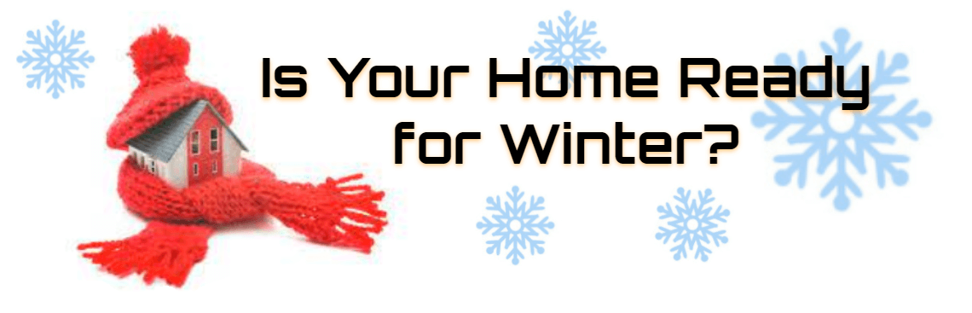
Locate your main Water Shutoff
Make sure everyone in your home knows where the water main shutoff valve is located and keep it clear of debris and obstacles at all time for easy access.
Exposed pipes and water heaters
Insulate pipes in unheated and drafty areas, such as an attic or garage.
Outside faucets
Turn off outside faucets. Remove all connected hoses and wrap faucets with towels or a Styrofoam insulator. Ensure vents are closed going under homes.
Protect indoor faucets
Allow faucets to slightly drip/flow throughout the DAY and night to reduce the risk of frozen pipes.
Open cabinets beneath kitchen and bathroom sinks to allow warmer air to circulate around pipes.
If your Pipes Freeze
- Try to determine which pipe(s) are frozen. If some faucets work and others do not, it means pipes inside your home are frozen.
- If a pipe is frozen, assume it may be broken and will leak when thawed. Be ready to shut off your water in a hurry when the line thaws.
- If there is no water to your home or your pipes appear to be frozen, call us at 502-347-9500 or 502-548-9500, so we can ensure water is flowing to your meter correctly.

