**CAR SALES AND INVENTORY STORE**

**Indian Institute of Information Technology, Guwahati.**

By:

Aman kumar shah(1301005)

Anupam Rai(1301011)

1. **Introduction**

The objective of this project is to develop a car sales and inventory store where cars and their parts can be bought from the comfort of home through the Internet. A car sales and inventory store is a virtual store on the Internet where customers can browse the catalog and select cars and their parts of interest. The selected items may be collected in a shopping cart. At checkout time, the items in the shopping cart will be presented as an order. At that time, more information will be needed to complete the transaction. Usually, the customer will be asked to fill or select a billing address, a shipping address, a shipping option, and payment information such as credit card number. An e- mail notification is sent to the customer as soon as the order is placed.

Here also a feature of regression is provided in which when user select any item then all items of the same type as of selected item comes at the screen as a suggestion to user.

1. **Features**

* User management
* Log in using Facebook or google account
* Administrator login
* Administrator manages the stocks can add or delete the entries.
* Verify email_id format
* Product Management
* Car search according to the type of the car and according to the company
* Car sort according to the price.
* Car parts search
* Add to cart
* Cart Management
* Payment gateway
* Test Drive
* Notify Customer of their orders via email
* Registration/login for suppliers
* Administrator can view suppliers list
* Administrator can notify the supplier about stock unavailability.
* Customers can post and view feedback.
* Recommendation System
* New Arrivals

**PROCESS MODEL**

1. Use case diagram

A use case diagram at its simplest is a representation of a user's interaction with the system that shows the relationship between the user and the different [use cases](https://en.wikipedia.org/wiki/Use_case) in which the user is involved. A use case diagram can identify the different types of users of a system and the different use cases and will often be accompanied by other types of diagrams as well.

So in brief, the purposes of use case diagrams can be as follows:

* Used to gather requirements of a system.
* Used to get an outside view of a system.
* Identify external and internal factors influencing the system.
* Show the interacting among the requirements are actors.

So in a brief when we are planning to draw a use case diagram we should have the following items identified.

* Functionalities to be represented as an use case
* Actors
* Relationships among the use cases and actors.

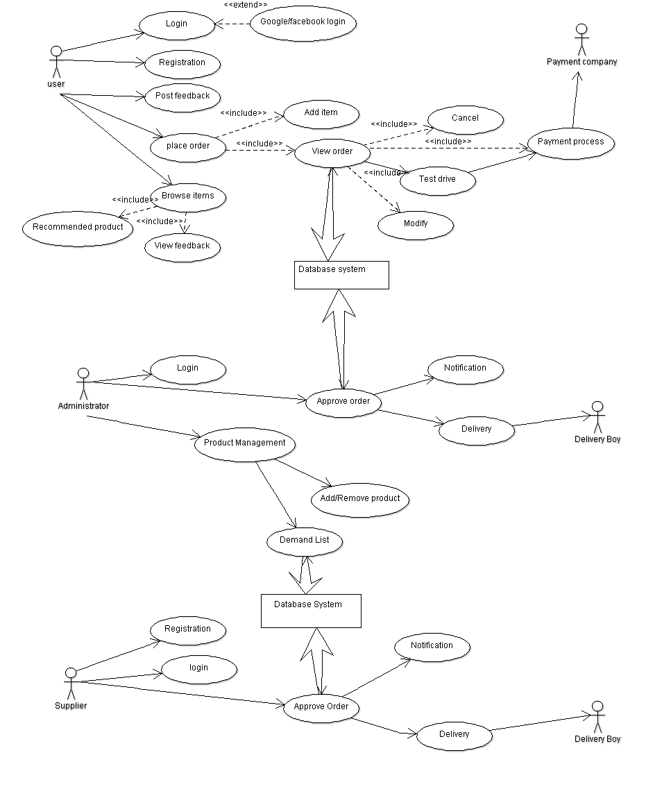

1. ER Diagram

A data model is a conceptual representation of the data structures that are required by a database. The first step in designing a database is to develop an Entity-Relation Diagram (ERD). The ERD serves as a blue print from which a relational database maybe deduced. Below fig shows the ERD for the project and later we will show the transformation from ERD to the Relational model.



