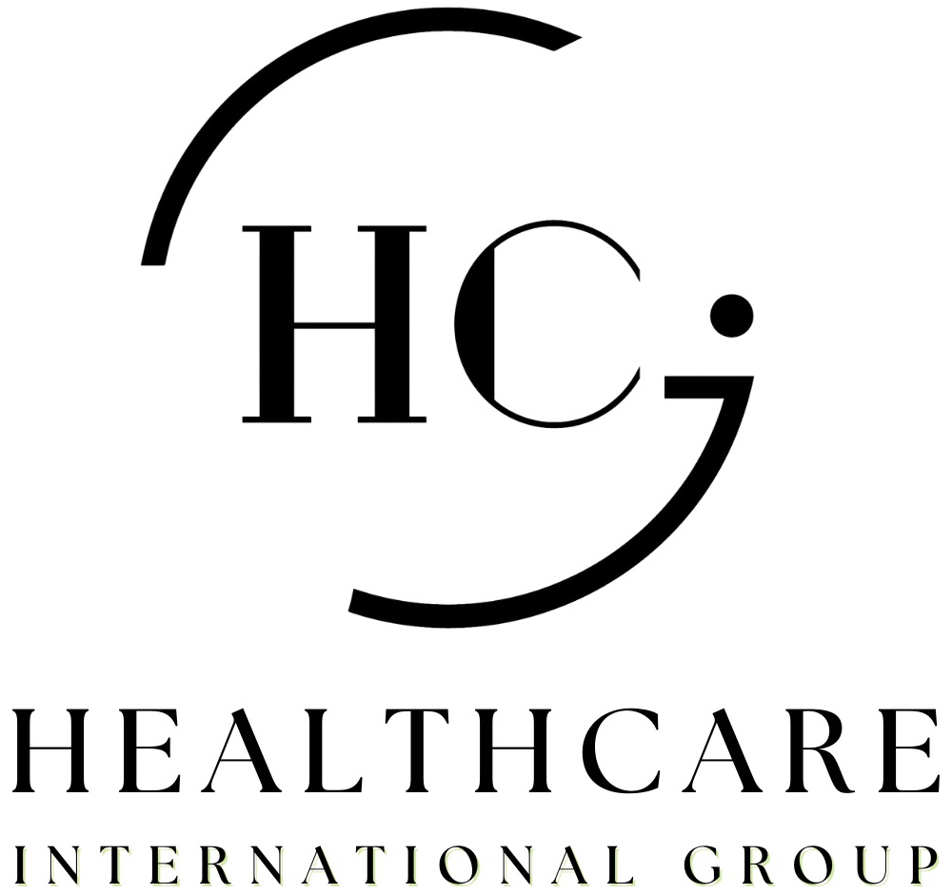
Subject: Strategic Healthcare Cooperation for Sukari Gold Mine
Dear [Name],
I am writing to propose a strategic healthcare cooperation between Healthcare International Group (HCIG) and [Company Name] for Sukari Gold Mine. I would welcome the chance to present it to you in person.
A remote site with a large workforce needs more than a clinic. It needs one medical group that answers at any hour, moves the patient to the right hospital, and stays with the case until recovery.
That is what HCIG is built to do.
Who we are
For more than 40 years, our group has delivered healthcare in Egypt.
- 600,000+ patients served
- 350+ medical professionals
- 135+ on-site clinics
We are an Official Partner of Global Healthcare Accreditation (GHA) and of the German Medical Wellness Association (DMWV).
Why HCIG
We do not only deliver care. We manage it. Our group runs every link in the chain, under one agreement:
- MedPark Hospital, El Quseir. A full hospital with a 24/7 emergency room, ICU, operating theatres and CT.
- MedPark Health Hub, Hurghada. Urgent care, diagnostics and dental.
- 24/7 Clinic. On-site clinics across Marsa Alam, El Quseir, Hurghada and the Red Sea coast.
- TMASI Global. International medical assistance and case coordination.
Our hospital and clinics already operate in the region around Sukari. One group covers each patient from the first call to discharge.
What we propose
1 Medical Referral Network
Referral of cases to our network of hospitals and specialised medical centres.
2 Emergency & Critical Care Support
Fast, coordinated admission of emergency and critical cases.
3 Medical Assistance & Case Management
Follow-up of every case from referral through treatment and discharge.
4 Healthcare Services for Employees & Contractors
Medical services for employees, contractors and their families when needed.
5 Accommodation Healthcare Services
Where hotels or residential camps serve the site, we can study setting up or operating medical services and clinics for the people living there.
What [Company Name] gains
- One point of contact for every medical case, day and night.
- Emergency cases coordinated with the receiving hospital before arrival.
- Care close to the site, with less transfer time and less time away from work.
- A clear report on each case until the employee is back at work.
- An on-site clinic model already running at 135+ locations.
- Strong support for your duty of care to employees and contractors.
Next step
I would welcome a meeting with you and your team in the week of [date]. We would like to understand Sukari's needs and agree the scope of a first phase.
I look forward to hearing from you.
Kind regards,
[CEO full name]
Chief Executive Officer
Healthcare International Group
partner@healthcareig.com · +2 01001828828
www.healthcareig.com

