Paradise Nursery
Online Plant & Seed Store

Student | Maqbool Hussain
Course | Database Lab
Submission Type | Final Project Report
GitHub Repository | https://github.com/maqboolhussain914-ops/Paradise-Nursery-Online-Plant-Seed-Store

1. Entity Relationship Diagram (ERD)

The following ERD illustrates the complete relational database schema for the Paradise Nursery application. It shows all seven tables, their attributes, primary keys (PK), foreign keys (FK), and the relationships between them.

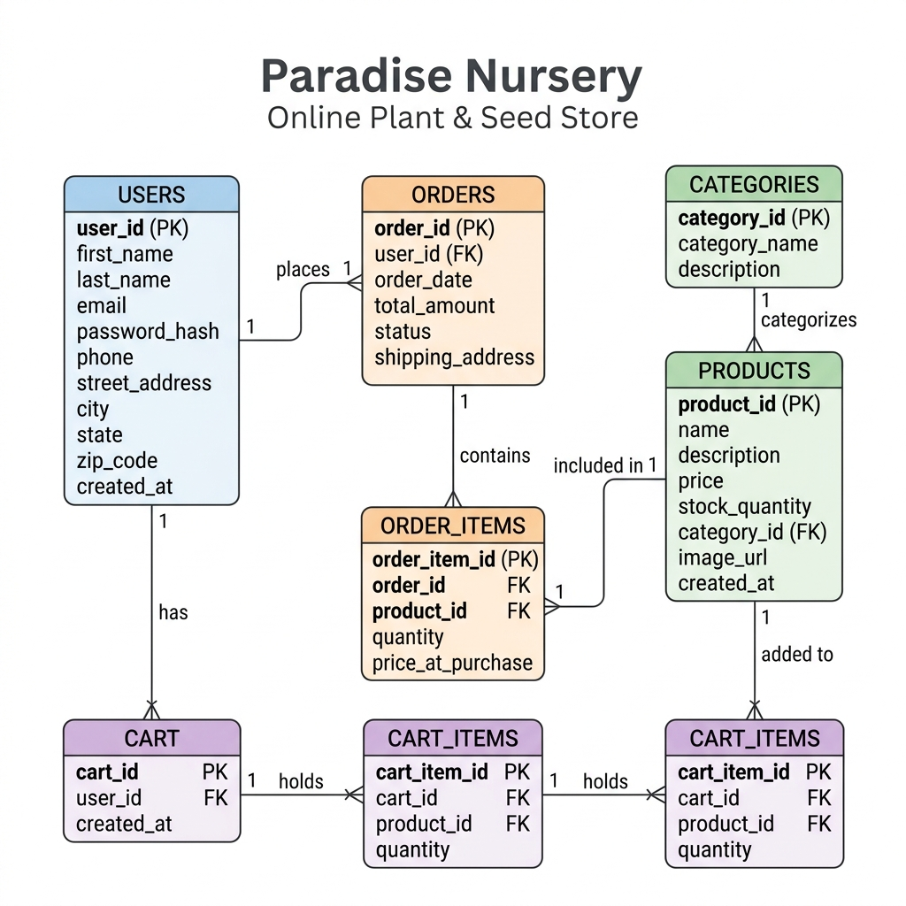
Figure 1: Paradise Nursery — Database ERD (Crow's Foot Notation)

2. Normalization Walkthrough (1NF → 3NF)

The following section describes how the database was designed according to the principles of normalization, walking through the first three normal forms (1NF, 2NF, and 3NF) to eliminate redundancy and ensure data integrity.

Initial Schema Considerations
Based on the initial conceptual model, the unnormalized data had the following issues:
- The Users table contained composite fields like full name and combined address blocks.
- The Products table had category information stored directly alongside product details (creating a transitive dependency).
- Order-product relationships required a bridging table with its own distinct attributes.

First Normal Form (1NF)
Attribute | Detail
Issue | The Users table had non-atomic fields: combined Name (e.g., 'Maqbool Hussain') and combined Address.
Resolution | Split Name into first_name and last_name. Split Address into street_address, city, state, and zip_code. This ensures each cell holds exactly one value, satisfying 1NF atomicity.

Second Normal Form (2NF)
Issue: In a composite-key approach to Order_Items using (order_id, product_id), including product_name in Order_Items would create a partial dependency (product_name depends only on product_id, not the full key).
Resolution: A surrogate primary key order_item_id was added to Order_Items. Product details like name and description remain exclusively in the Products table. Only price_at_purchase is stored in Order_Items because the historical price must be preserved at the time of the order.

Third Normal Form (3NF)
Issue: Storing category_name and category_description directly in the Products table creates a transitive dependency (category_name depends on category_id, which is not the primary key).
Resolution: A dedicated Categories table (category_id PK, category_name, description) was created. The Products table now holds only a foreign key (category_id), eliminating the transitive dependency. A category name can be updated in a single row without touching any product records.

3. Dataflow Description

The following describes how data flows through the Paradise Nursery application, from initial entry through processing and finally to reporting outputs.

Phase 1: Data Entry (Inputs)
Data enters the system through two primary actors:
- Customers: When a new user registers, their profile and contact data flow into the users table.
- Administrators: When they add product categories, data is inserted into the categories table. New inventory items flow into the products table, each referencing a category_id foreign key.

Phase 2: Active Shopping (Temporary State)
When a logged-in customer browses and adds items:
- A record is created in the cart table (one-to-one with users).
- Each selected product flows into the cart_items table, referencing both cart_id and product_id.
- Data in cart_items is highly mutable; quantities are updated frequently.

Phase 3: Order Processing (Transactional Flow)
Upon checkout, temporary data becomes a permanent, immutable record:
- An order record is generated in the orders table, capturing the user_id, shipping address, and total_amount.
- Data migrates from cart_items into order_items. The system captures price_at_purchase from the products table at this exact moment, preserving the historical transaction price.
- The cart and cart_items records are then cleared.

Phase 4: Output & Reporting (Outputs)
Data exits the system in several forms:
- Customer View: Customers query orders and order_items to see their purchase history and current shipping status.
- Admin Analytics: The admin dashboard aggregates data to show total revenue, a Sales-by-Category bar chart, and low-stock alerts from the products table.

4. GitHub Repository & Milestone Commits

Repository URL: https://github.com/maqboolhussain914-ops/Paradise-Nursery-Online-Plant-Seed-Store

The following milestones were completed and committed to the main branch:
Milestone | Description
Milestone 1 | Initial project setup, Flask application scaffolding, and MySQL database schema creation.
Milestone 2 | Core customer-facing pages: Homepage, Catalog with category filtering, Product Detail page, and Session-based Shopping Cart.
Milestone 3 | Admin authentication system, Admin Dashboard with KPI stat cards, product management (full CRUD), and order management.
Milestone 4 | Advanced Admin Dashboard: Chart.js sales-by-category bar chart, low-stock alert widget, and real-time order status updates.
Milestone 5 | 3-dot kebab toggle menu for seamless switching between Store and Admin mode.
Milestone 6 | UI/UX Enhancement: Lush greenhouse hero background, warm page background, high-quality plant images, and Clear Cart functionality.
Milestone 7 | Catalog page presentable banner and improved Admin top-strip with user avatar.

Paradise Nursery — Database Lab Project | Maqbool Hussain

