

MOUNT KENYA UNIVERSITY

SCHOOL OF COMPUTING AND INFORMATICS
DEPARTMENT OF INFORMATION TECHNOLOGY

PROJECT TITLE:
MINDBRIDGE: AN AI-POWERED MENTAL HEALTH COMPANION
FOR UNIVERSITY STUDENTS

BY:
SAMUEL OTIENO BSCCS/2019/89115
ABDIHAKIM ABDIKER ALI BSCCS/2023/52307
ABDIFATAH ADAN MOHAMED BSCCS/2023/50938
DAK KUNOT DAK MUT BSCCS/2023/51238
ABUBAKAR ADAN MAHAMUD BSCCS/2023/54333
ABDIRAHMAN OSMAN BSCCS/2023/54185

This project is submitted in partial fulfilment of requirement for the Mount Kenya University award of BACHELOR OF SCIENCE IN COMPUTER SCIENCE.
April, 2026

DECLARATION 5
STUDENTS 5
CHAPTER ONE 7
INTRODUCTION 7
1.1 Introduction 7
1.2 Background of the Study 7
1.3 Problem Statement 8
1.4 Objectives 9
1.5 Scope of the Study 9
1.6 Justification 10
1.7 Project Risk and Mitigation 10
1.8 Budget and Resources 11
CHAPTER TWO 12
LITERATURE REVIEW 12
2.1 Introduction 12
2.2 Mental Health Technology: Global Overview 12
2.3 Review of Existing Systems 13
2.3.5 Student Wellness Apps in African Context 14
2.4 Gaps in Existing Systems 14
CHAPTER THREE 16
RESEARCH METHODOLOGY 16
3.1 Introduction 16
3.2 Research Methodology 16
3.3 System Development Life Cycle 17
3.4 Data Collection Tools and Techniques 18
3.5 Development Tools and Technologies 18
3.6 Project Schedule 19
CHAPTER FOUR 20
SYSTEM ANALYSIS AND REQUIREMENT MODELLING 20
4.1 Introduction 20
4.2 Existing System Analysis 20
4.3 Proposed System Overview 21
4.4 Functional Requirements 22
4.5 Non-Functional Requirements 25
4.6 Use Case Analysis 25
4.7 Data Flow Diagrams 26
Level 0 Context Diagram 26
Level 1 DFD 27
4.8 Entity-Relationship Diagram 28
4.9 Feasibility Analysis 29
4.9.1 Technical Feasibility 29
4.9.2 Economic Feasibility 29
4.9.3 Operational Feasibility 30
4.9.4 Legal and Ethical Feasibility 30
CHAPTER FIVE 31
SYSTEM DESIGN 31
5.1 Introduction 31
5.2 System Architecture 31
5.2.1 Presentation Layer 31
5.2.2 Application Layer 32
5.2.3 Data Layer 32
5.3 Database Design 32
5.3.1 Conceptual Model 32
5.3.2 Logical Design 33
5.3.3 Physical Design 34
5.2.4 AI Inference Layer 35
5.4 User Interface Design 36
5.4.1 Screen Architecture 36
5.5 API Design 36
5.6 Security Design 37
5.7 Crisis Text Classification Engine 38
5.7.1 Model Architecture 38
5.7.2 Training Data and Procedure 39
5.7.3 Runtime Integration 39
5.7.4 Hybrid Detection Architecture 40
CHAPTER SIX 41
SYSTEM IMPLEMENTATION 41
6.1 Introduction 41
6.2 Development Environment Setup 41
6.3 System Testing 41
6.3.1 Unit Testing 41
6.3.2 Integration Testing 42
6.3.3 User Acceptance Testing 42
6.4 Test Results 43
6.5 System Changeover 44
CHAPTER SEVEN 46
LIMITATIONS, CONCLUSIONS AND RECOMMENDATIONS 46
7.1 Limitations 46
7.2 Conclusion 47
7.3 Recommendations 48
REFERENCES 49
APPENDICES 51
APPENDIX C: USER ACCEPTANCE TESTING QUESTIONNAIRE 51
APPENDIX B: CODE SAMPLES 53

DECLARATION

STUDENTS
We hereby declare that this project report is based on our original work except for citations and quotations which have been duly acknowledged. We also declare that it has not been previously and concurrently submitted for any other degree or award at Mount Kenya University.

Names: ………………………………………………………………
Admission Nos: ………………………………………………………
Signatures: ………………………………………………………………
Date: ………………………………………………………………………

SUPERVISOR
I the undersigned do hereby certify that this is a true report for the project undertaken by the above-named student under my supervision and that it has been submitted to Mount Kenya University with my approval.
Name: ………………………………………………………………
Signature: ……………………………………………………………… Date: ………………………………………

CHAPTER ONE

INTRODUCTION

1.1 Introduction
Mental health constitutes one of the most pressing public health challenges of the twenty-first century. Among all demographic groups, university students face a uniquely compounded set of psychological stressors that include academic pressure, financial insecurity, social adjustment, identity formation, and in many cases, geographic displacement from support networks. The World Health Organisation (2022) estimates that one in four people will be affected by a mental health disorder at some point in their lives, with the highest incidence rates occurring between the ages of 18 and 25 ,the precise window that defines the undergraduate student experience.
Despite the scale of this challenge, help-seeking rates among students remain remarkably low. Institutional barriers such as limited counselling resources, long waiting times, and high financial costs compound the personal barriers of stigma, shame, and lack of awareness. Digital mental health interventions have emerged as a scalable and accessible complement to traditional clinical services. However, existing applications frequently lack clinical depth, crisis safety features, and the engagement mechanics necessary to sustain longitudinal use.
MindBridge was designed to address these deficiencies. It is a cross-platform mobile application that provides university students with continuous, intelligent, and compassionate mental health support through an AI conversational agent, mood analytics, journaling tools, mindfulness exercises, peer community features, gamified wellness challenges, and a clinically-informed crisis intervention protocol.

1.2 Background of the Study
The global student mental health crisis has been extensively documented. A survey by the American College Health Association (2023) found that 44% of college students reported significant symptoms of depression, while 37% reported anxiety disorders severe enough to impair academic functioning. In Kenya and across Sub-Saharan Africa, studies by the African Mental Health Research Initiative (AMHRI, 2021) have confirmed similar prevalence rates, with the additional complication of deeply entrenched cultural stigma and extreme scarcity of qualified mental health professionals ,Kenya, for instance, has fewer than one psychiatrist per 500,000 people.
Digital health interventions, particularly smartphone applications have demonstrated significant promise as low-barrier, high-reach tools for mental health support. The proliferation of smartphones among university students, with penetration rates exceeding 90% in most university populations, makes mobile-first solutions a logical delivery mechanism. Furthermore, the emergence of large language models (LLMs) such as Anthropic Claude and ChatGPT has opened entirely new possibilities for creating empathetic, contextually sensitive conversational agents capable of deploying evidence-based therapeutic techniques at scale and at zero marginal cost per interaction.
MindBridge was conceived within this context. It draws on the therapeutic frameworks of Cognitive Behavioral Therapy (CBT), Dialectical Behaviour Therapy (DBT), and Acceptance and Commitment Therapy (ACT), encoding these approaches into the behaviour of its AI agent, Maya. The system was developed as a final-year undergraduate project in Information Technology, representing an original contribution to the growing body of digital mental health technology.

1.3 Problem Statement
University students suffering from mental health difficulties face a multi-layered access problem. Professional counselling services at most universities are chronically under-resourced; waiting periods of several weeks are common. The cost of private therapy remains prohibitive for most students. Stigma attached to mental illness deters disclosure and help-seeking. Available mental health mobile applications are characterised by shallow content, poor engagement design, absence of crisis safety protocols, and lack of AI-driven personalisation.
No existing application provides a holistic, integrated suite that combines an empathetic AI conversational agent, quantitative mood intelligence, journal-based self-reflection with AI insights, evidence-based mindfulness exercises, a gamified engagement framework, anonymous peer support, and a clinically-structured crisis intervention protocol, all within a single, privacy-first mobile platform designed specifically for university students. MindBridge was built to fill this gap.

1.4 Objectives
The main objective of this project was to design, develop, and test a cross-platform mobile mental health application for university students. The specific objectives were:
- To develop an AI-powered conversational agent (Maya) capable of delivering evidence-based CBT, DBT, and ACT micro-interventions in real time using the Anthropic Claude language model within a Flutter mobile application by April 2026.
- To implement a multi-dimensional mood tracking and analytics system that captures mood scores, emotion tags, activity logs, and sleep data, and generates automated trend alerts and wellness scores through a weighted algorithmic engine.
- To implement a three-tier crisis intervention protocol that detects crisis signals through keyword analysis, mood intelligence data, and a purpose-trained on-device convolutional neural network text classifier, and escalates to verified emergency resources including the Suicide and Crisis Lifeline.
- To integrate gamification mechanics ,including streak tracking, achievement badges, and wellness challenges ,to sustain longitudinal user engagement and reinforce healthy behavioral patterns.
- To conduct comprehensive unit, integration, and user-acceptance testing to validate the functional correctness, security, and usability of the system.

1.5 Scope of the Study
The scope of MindBridge encompasses the full-stack development of a cross-platform mobile application targeting Android and iOS platforms. The system includes a Flutter/Dart frontend, a Dart Frog REST API backend, a PostgreSQL relational database hosted on Supabase, and integration with the Anthropic Claude API for AI-powered features. The application supports individual user registration, onboarding, AI-powered chat sessions, four-step mood logging, journal writing with AI insights, breathing exercises, peer community posts, wellness challenges, and crisis intervention.
The scope excludes the following: native wearable device integrations, video therapy sessions with licensed professionals, real-time peer-to-peer video communication, multi-language localisation, and formal clinical trials. These may be addressed in future phases of development.

1.6 Justification
The justification for MindBridge rests on three pillars: clinical necessity, technological opportunity, and institutional gap.
Clinically, the documented scale of student mental health distress, and the inadequacy of current institutional responses creates an urgent need for scalable digital supplementation.
Technologically, the maturation of large language models, cross-platform mobile frameworks, and real-time cloud databases makes it feasible to deliver a high-quality, personalised mental health companion at near-zero marginal cost.
Institutionally, no comparable platform exists that serves the specific context and constraints of the African university student population.

1.7 Project Risk and Mitigation
The following risks were identified during the planning phase of the project, together with the mitigation strategies employed:
Table 1.1: Project Risk Register
Risk | Description | Mitigation Strategy
API Cost Overrun | High usage of Anthropic Claude API could exceed budget. | Used claude-haiku-4-5 model (lowest cost tier); implemented token limits per session and monthly limits.
Data Privacy Breach | Sensitive mental health data could be exposed. | AES-256 encryption at rest, TLS 1.3 in transit, RLS policies, no PII in crisis logs.
User Engagement Drop-off | Students may abandon app after initial use. | Gamification mechanics (streaks, achievements, challenges) designed to sustain engagement.
Crisis Liability | AI agent may inadequately respond to acute suicidal ideation. | Three-tier crisis protocol; AI never diagnoses; always directs to professional services.
Scope Creep | Feature additions could delay delivery. | Strict scope definition; MoSCoW prioritisation; weekly milestone reviews.
Technical Complexity | Flutter + Dart Frog + Supabase + Claude integration is complex. | Modular architecture; Riverpod state management; incremental integration testing.

1.8 Budget and Resources
The following table outlines the resources required for the development, testing, and deployment of MindBridge.
Table 1.2: Project Budget Breakdown
Item | Description | Estimated Cost | Notes
Hardware | Developer laptop (existing) | 0 | Owned by developer
Software | Flutter SDK, Dart Frog, VS Code | 0 | Open-source / free
Cloud / Database | Supabase Free Tier | 0 | Free tier sufficient for dev/test
AI API | Anthropic Claude API (haiku model) | ~KES 500/month | Pay-per-token; haiku is lowest cost
Design Tools | Figma (free tier) | 0 | UI mockups and prototyping
Testing Devices | Android & iOS emulators + 1 physical device | 0 | Emulators via existing hardware
Domain / Hosting | Supabase managed hosting | 0 | Free tier for academic project
Miscellaneous | Internet, printing, stationery | ~KES 3,000 | Estimated total
TOTAL |  | ~KES 3,500

CHAPTER TWO

LITERATURE REVIEW

2.1 Introduction
This chapter reviews existing literature relevant to digital mental health interventions, AI-powered therapeutic applications, mobile health (mHealth) systems, and the specific mental health challenges facing university students. The review critically examines existing systems, identifies their strengths and limitations, and contextualises MindBridge within the broader body of knowledge.

2.2 Mental Health Technology: Global Overview
The intersection of technology and mental health has generated a rapidly expanding field of inquiry. Torous et al. (2020) define digital mental health as the use of digital technologies, including mobile applications, wearables, and AI-powered platforms, to assess, treat, and prevent mental health conditions. Their systematic review of over 10,000 mental health applications found that while the quantity of available tools has grown exponentially, quality, clinical validation, and engagement remain in significant challenges.
The theoretical foundations for AI-assisted therapy trace their lineage to the pioneering work of Weizenbaum (1966) with ELIZA, a rule-based conversational program that demonstrated the human tendency to anthropomorphise conversational agents and form therapeutic-style relationships with them. Modern large language models have radically advanced these capabilities. Stade et al. (2024) demonstrated that Claude and GPT-4 can generate responses rated as empathetically comparable to trained therapists in structured assessments, providing a theoretical basis for their deployment in mental health applications.
The application of Cognitive Behavioural Therapy (CBT) principles in digital formats has been extensively validated. Firth et al. (2017) conducted a meta-analysis of 22 randomised controlled trials of smartphone-based CBT interventions and found a significant effect size of 0.56 for depression reduction, demonstrating that digital CBT delivery can achieve outcomes comparable to face-to-face therapy for mild to moderate presentations.

2.3 Review of Existing Systems
Several existing platforms address elements of the student mental health challenge. A critical review of the most relevant systems follows.
2.3.1 Woebot
Woebot (Woebot Health, Inc.) is a CBT-based chatbot delivered via a mobile application. Fitzpatrick et al. (2017) conducted a randomised controlled trial in a university setting and found that Woebot significantly reduced symptoms of depression and anxiety over a two-week period. Woebot's architecture uses rule-based conversation trees rather than large language models, which constrains its responsiveness and naturalness. It lacks mood analytics, journal features, gamification, and peer community support. MindBridge improves this design by employing Claude's generative capabilities for open-domain, contextually adaptive responses.
2.3.2 Headspace and Calm
Headspace and Calm represent the dominant meditation and mindfulness application category. Both platforms deliver guided meditation, breathing exercises, and sleep stories. However, neither provides AI-driven conversational support, crisis intervention protocols, mood tracking with analytics, or peer community features. Linardon et al. (2020) note that mindfulness applications show significant efficacy for stress reduction but limited impact on clinical depression or anxiety without complementary cognitive interventions. MindBridge integrates mindfulness exercises as one component of a broader therapeutic architecture.
2.3.3 Youper
Youper is an AI-powered emotional health assistant that combines CBT-based chat interactions with mood tracking. It uses a structured conversation flow guided by a proprietary AI. Whereas Youper offers a more integrated feature set than Woebot, its conversational AI is less natural than Claude-based implementations, it lacks a crisis intervention framework meeting clinical safety standards, and its gamification mechanics are minimal. Its mood tracking module does not compute composite wellness scores or generate trend alerts.
2.3.4 BetterHelp and Talkspace
BetterHelp and Talkspace facilitate text-based communication with licensed therapists. These platforms provide genuine clinical support but are constrained by high cost (typically USD 60–100 per week), therapist availability, and the absence of 24/7 immediate response. They are not positioned as self-directed wellness tools and provide no gamification, community, or AI coaching features. MindBridge is designed as a complement to, not a replacement for, such professional services.

2.3.5 Student Wellness Apps in African Context
Within the African university context, dedicated mental health mobile applications remain extremely scarce. Musyoka et al. (2022) reviewed digital mental health resources available to Kenyan university students and found that no locally developed application addressed student-specific needs comprehensively. The few available tools were international applications with no localisation, limited offline functionality, and content poorly aligned with the cultural and social context of African students. MindBridge was designed with this gap explicitly in mind.

2.4 Gaps in Existing Systems
The review of existing systems reveals the following substantive gaps that MindBridge was designed to address:
- Absence of integrated multi-feature architecture: No single existing application combines AI chat, mood analytics, AI-enhanced journaling, mindfulness exercises, peer community, gamification, and crisis intervention in one cohesive platform.
- Shallow crisis safety protocols: Most applications either ignore crisis signals entirely or display a generic helpline number. A tiered, algorithmically-driven crisis protocol that escalates based on text analysis and mood data is absent from reviewed systems.
- Lack of quantitative wellness intelligence: Applications rarely compute composite wellness scores that integrate mood, sleep, activity, consistency, and engagement data into a single actionable metric.
- Insufficient engagement mechanics: Long-term behavior change requires sustained engagement. Streak systems, achievement frameworks, and challenge mechanics, well-established in consumer psychology, are absent from most clinical tools.
- Cultural and contextual irrelevance for African students: International applications rarely address the specific social, cultural, and economic stressors facing students at African universities.
2.5 Conclusion
The literature confirms both the clinical need and the technological opportunity that MindBridge addresses. Evidence-based digital mental health interventions are effective for mild to moderate presentations and can reach populations that would otherwise not access care. Large language models provide a qualitatively new capability for delivering empathetic, contextually adaptive support. Existing platforms address some but not all the identified needs. MindBridge is positioned to close the critical gaps identified through this review by delivering a comprehensive, privacy-first, AI-powered mental health companion specifically designed for university students.

CHAPTER THREE

RESEARCH METHODOLOGY

3.1 Introduction
This chapter describes the methodology adopted for the research, design, development, and testing of MindBridge. It covers the research philosophy, the system development life cycle model selected, the data collection techniques employed, the tools and technologies used, and the project schedule.

3.2 Research Methodology
This project adopted a design-science research approach, which is appropriate for projects that aim to create novel artefacts, in this case, a software system, to solve practical problems (Hevner et al., 2004). The design-science paradigm emphasises the iterative creation and evaluation of artefacts, grounding design decisions in both domain literature and empirical observation.
The primary research method was applied software engineering, supplemented by structured observation of user interaction patterns during testing and informal interviews conducted with five university students to validate requirements. A desk review of clinical literature on CBT, DBT, and ACT informed the therapeutic content and logic embedded in Maya's system prompt and crisis protocol.
The target population comprised undergraduate students aged 18–26 at Kenyan universities, representing the primary intended users of the application. A purposive sample of five students from diverse academic backgrounds and varying levels of self-reported stress was engaged for requirements validation and user acceptance testing.

3.3 System Development Life Cycle
The Agile-Waterfall hybrid model was selected as the SDLC methodology for MindBridge. This hybrid approach combines the structured phase sequencing of the Waterfall model with the iterative sprint-based delivery of Agile. The Waterfall phases of Requirements, Design, and Architecture were executed sequentially to establish a stable foundation, after which development proceeded in two-week sprints with continuous integration and incremental feature delivery.
This hybrid was preferred over pure Agile because the academic project context requires documented phase deliverables (requirements specification, system design document, test plan), while pure Waterfall would have been too rigid to accommodate the evolving requirements of an AI-integrated application. The iterative sprints allowed for rapid prototyping of individual features ,such as the mood tracker wizard and the crisis intervention screen ,with feedback incorporated before proceeding to the next feature.
The phases of the SDLC as applied to MindBridge were: (1) Requirements Elicitation, (2) System Architecture Design, (3) Database Design, (4) UI/UX Prototype, (5) Iterative Feature Development (six two-week sprints), (6) Integration Testing, (7) User Acceptance Testing, and (8) Documentation and Submission.
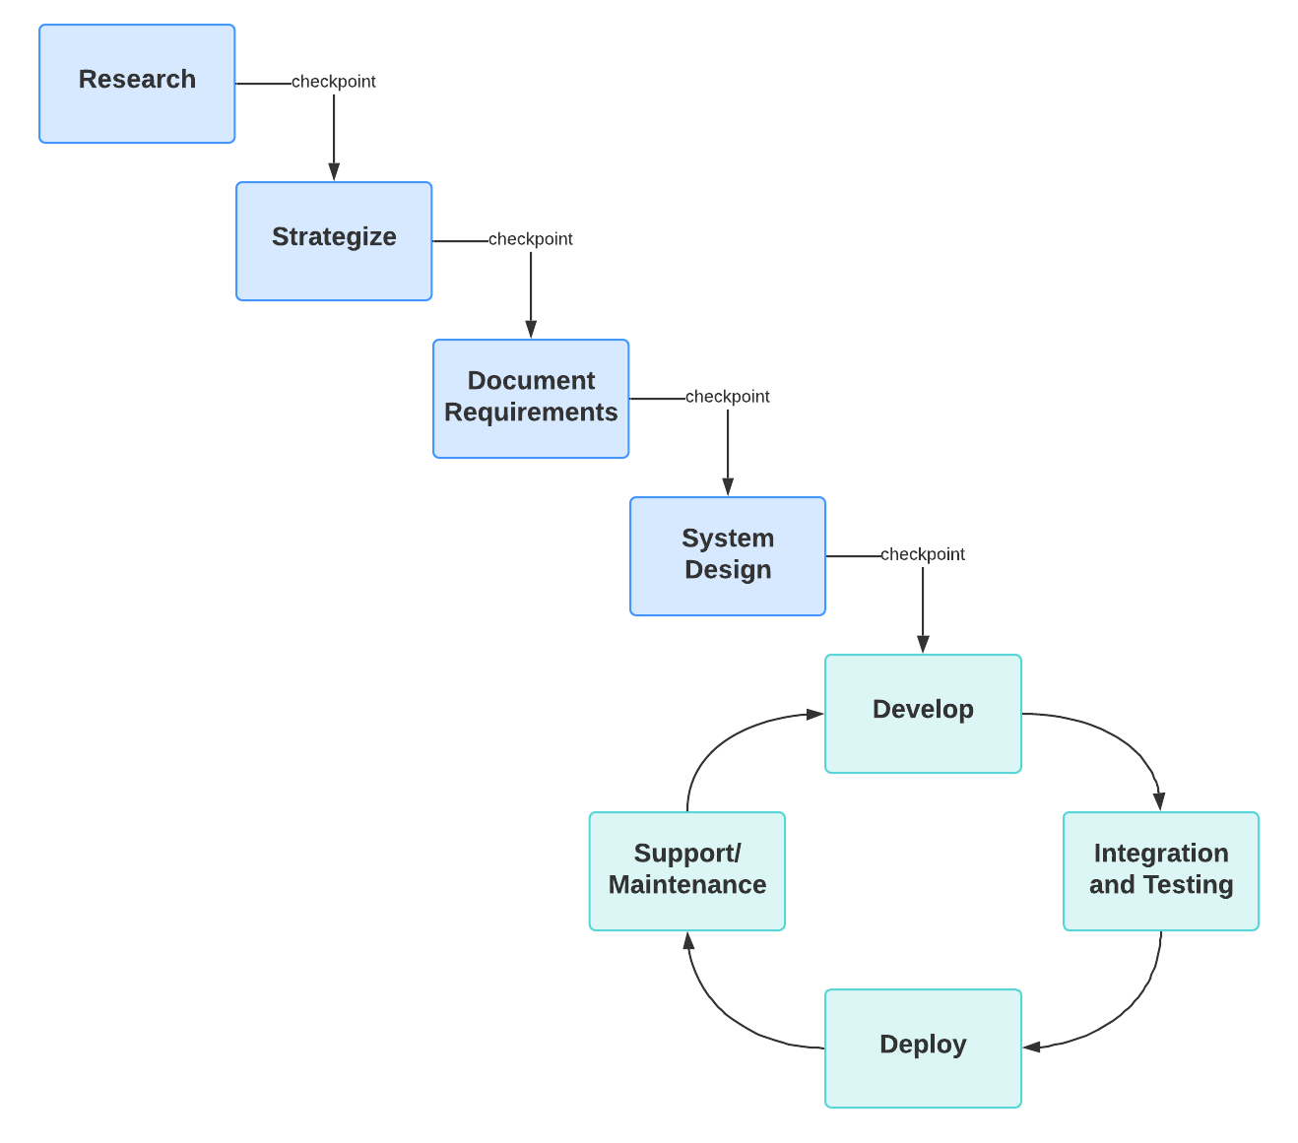
Figure 3.1: Agile-Waterfall Hybrid SDLC Model (Conceptual Representation)

3.4 Data Collection Tools and Techniques
The following data collection techniques were employed throughout the project:
Document Review: A systematic review of academic literature on digital mental health, AI-powered therapy, mobile application engagement, and crisis intervention protocols was conducted. Clinical guidelines from the National Institute for Health and Care Excellence (NICE) and the American Psychiatric Association (APA) were reviewed to inform the crisis protocol design.
Semi-Structured Interviews: Five university students were interviewed to elicit qualitative insights into their mental health challenges, current coping strategies, and desired features in a digital support tool. Interviews were conducted informally to encourage candid responses. Findings informed the prioritisation of features including the mood tracking wizard, and the anonymous peer community.
Observation and Usability Testing: During user acceptance testing, student participants were observed interacting with the application. Think-aloud protocols were used to surface usability issues. Feedback was recorded and categorised by severity and feature area.

3.5 Development Tools and Technologies
MindBridge is built on a modern, cross-platform architecture utilizing Flutter 3.27+ and Dart 3.5+ for the mobile frontend, with Riverpod 2.5+ handling reactive state management and GoRouter 13+ managing declarative navigation.
The backend infrastructure is powered by Supabase, leveraging PostgreSQL 16 for relational data and Supabase Auth for secure, stateless authentication via JWT and PKCE. Server-side logic is implemented using Dart Frog 1.2+, ensuring a type-safe, end-to-end Dart environment.
The platform’s core AI capabilities are driven by the Anthropic Claude (claude-haiku-4-5) model, while user data insights are visualized using fl_chart. On-device performance is optimized through Dio 5+ for intercepted HTTP requests and a hybrid local storage approach using Hive and SharedPreferences.
The development lifecycle is supported by Visual Studio Code, with Figma used for UI prototyping, Git/GitHub for version control, and a robust testing suite comprising Flutter Test and Integration Test to ensure application stability.
Two additional technology components were incorporated during the development phase. For on-device crisis signal detection, TensorFlow 2.15 was employed to design, train, and export a purpose-built convolutional neural network text classifier. The trained model was subsequently converted to TensorFlow Lite format using dynamic-range quantisation to minimise binary size and was integrated into the Flutter application via a dedicated background isolate, ensuring that inference operations did not block the user interface thread. For offline conversational AI capability, a domain-adapted variant of Llama 3 large language model was integrated into the application as an alternative AI inference backend, enabling Maya to deliver mental health support conversations without dependence on external API connectivity. The local model is accessed through a lightweight REST interface and is selectable by the user through a toggle control in the chat interface.

3.6 Project Schedule
The project was executed across twelve weeks from January to April 2026. The schedule was structured around the Agile-Waterfall hybrid SDLC with clear milestones at each phase gate.
Table 1.2: Project Schedule
Period | Phase | Key Activities
Week 1–2 | Requirements & Research | Literature review, user interviews, feature prioritisation
Week 3–4 | Architecture & Database Design | ERD, schema creation, API design, tech stack setup
Week 5–6 | Sprint 1: Auth & Core UI | Splash, onboarding, login/register, design system
Week 7–8 | Sprint 2: Chat & Mood | Maya chatbot, mood tracker wizard, mood analytics
Week 9 | Sprint 3: Journal & Mindfulness | AI journal insights, breathing exercises
Week 10 | Sprint 4: Crisis & Community | Crisis protocol, peer community, resources
Week 11 | Sprint 5: Wellness & Admin | Gamification, streaks, achievements, admin panel
Week 12 | Testing & Documentation | Unit/integration/UAT testing, documentation

CHAPTER FOUR

SYSTEM ANALYSIS AND REQUIREMENT MODELLING

4.1 Introduction
This chapter presents a comprehensive analysis of the MindBridge system, describing the limitations of the existing landscape, the proposed system design overview, functional and non-functional requirements, use case models, data flow diagrams, entity-relationship modelling, and feasibility analysis.

4.2 Existing System Analysis
Prior to developing MindBridge, the existing mechanisms available to university students seeking mental health support were analysed. Three primary modalities were examined: institutional counselling services, commercial mental health applications, and informal peer support networks.
Institutional counselling services at Kenyan universities are severely under-resourced. The common ratio of counsellors to students is 1:2,000 or higher, compared to the international benchmark of 1:1,000 recommended by the International Association of Counselling Services. Waiting times of four to eight weeks are routinely reported. Services are available only during business hours, creating a critical gap for students in acute distress outside these windows.
Commercial mental health applications, as reviewed in Chapter Two, address individual aspects of the problem but not the comprehensive need. Their limitations include: lack of crisis intervention protocols, absence of AI-driven personalisation, poor engagement mechanics, cultural irrelevance, and high subscription costs.
Informal peer support, friends, family, social media, remains the most used resource by students in distress. However, peers lack clinical training and the capacity to recognize and respond appropriately to crisis-level presentations. This creates risk both for the student in distress and for the peer who receives a crisis of disclosure unprepared.

4.3 Proposed System Overview
MindBridge is proposed as a comprehensive digital mental health companion that addresses the identified gaps through seven integrated functional modules:
- AI Chatbot Module (Maya): 24/7 conversational support powered by Anthropic Claude for cloud-connected sessions, with an alternative offline inference mode powered by a domain-adapted fine-tuned Llama 3 model hosted on a user’s device in the local network, delivering CBT/DBT/ACT micro-interventions in natural language. Users were able to switch between inference backends via a toggle control in the chat interface.
- Mood Intelligence Module: A four-step mood logging wizard capturing score, emotions, activities, and sleep, feeding into a wellness analytics engine.
- Journal Module: Rich-text journaling with AI-generated insights and curated reflection prompts.
- Mindfulness Module: Guided breathing exercises (Box Breathing, 4-7-8, Deep Belly) with animated visual guides.
- Crisis Intervention Module: A three-tier escalation protocol that combined keyword analysis, mood intelligence data, and a purpose-trained on-device convolutional neural network text classifier to detect crisis signals with greater sensitivity, providing immediate access to emergency resources.
- Community Module: An anonymous peer support community with moderated posting and engagement features.
- Wellness Gamification Module: Daily/weekly challenges, streak tracking, and achievement badges to sustain long-term engagement.

4.4 Functional Requirements
Functional requirements define what the system must do. The following table presents the complete functional requirements for MindBridge, prioritised using the MoSCoW method (Must Have, Should Have, Could Have, Won't Have).
Table 4.1: Functional Requirements
ID | Feature | Description | Priority
FR-01 | User Registration | System shall allow students to register with email and password via a 3-step onboarding wizard capturing name, university, year of study, and wellness goals. | Must Have
FR-02 | Email Verification | System shall verify user email via a 6-digit OTP code before registration. | Should Have
FR-03 | User Authentication | System shall authenticate users via JWT with refresh token rotation; support Google OAuth via PKCE flow. | Must Have
FR-04 | AI Chat Sessions | System shall provide an AI conversational agent (Maya) capable of multi-turn dialogue, streaming responses, and session history management. | Must Have
FR-05 | Crisis Detection | System shall analyse all chat messages and mood entries for crisis signals using a keyword-tier system and a one-dimensional CNN, escalating to appropriate resources automatically. | Must Have
FR-06 | Mood Logging | System shall provide a four-step wizard for logging mood score (1–10), emotion tags (24 options), activity tags (16 options), sleep hours, and optional notes. | Must Have
FR-07 | Wellness Score | System shall compute a composite wellness score (0–100) using a weighted formula across mood, consistency, sleep, activity, and engagement components. | Must Have
FR-08 | Journal Entry | System shall allow users to create, edit, and delete journal entries with optional mood tagging and AI-generated insight generation. | Must Have
FR-9 | Mindfulness Exercises | System shall provide at least three breathing exercises with animated visual guides and real-time phase countdowns. | Must Have
FR-10 | Crisis Center Screen | System shall provide a dedicated crisis screen with one-tap SOS to 988, verified crisis contacts, and a safety planning tool. | Must Have
FR-11 | Community Posts | System shall allow authenticated users to create anonymous posts, like and comment on posts, and flag inappropriate content. | Should Have
FR-12 | Resource Library | System shall provide a categorised library of mental health resources with full-text search. | Should Have
FR-13 | Streak Tracking | System shall track streaks for five activity types (mood logging, journaling, mindfulness, chat sessions, overall) with freeze mechanics. | Should Have
FR-14 | Admin Dashboard | System shall provide an admin panel with real-time statistics, user management, content moderation, crisis monitoring, and broadcast messaging. | Must Have
FR-15 | Password Reset | System shall support a two-stage password reset flow via email OTP. | Must Have
FR-16 | Profile Management | System shall allow users to update their profile, including preferred name, university, year, goals, Maya personality preference, and notification settings. | Should Have
FR-17 | Push Notifications | System shall send scheduled push notifications for mood reminders, journal prompts, and challenge availability. | Could Have

4.5 Non-Functional Requirements
Non-functional requirements describe the quality attributes and constraints of the platform and non-critical properties of the system.
These are the non-functional requirements of the system:
- Performance: First-token AI chat responses delivered within 3 seconds under standard network conditions.
- Scalability: Backend architecture designed to support horizontal scaling for up to 50,000 concurrent users. Security: End-to-end protection via TLS 1.3 (transit), AES-256 (rest), and 1-hour JWT expiration with refresh tokens.
- Availability: Targeted 99.5% uptime utilizing Supabase’s SLA-backed managed infrastructure.
- Usability: User interface designed to achieve a System Usability Scale (SUS) score of ≥75.
- Accessibility: Adherence to WCAG 2.1 AA standards, including 16sp minimum font size and keyboard navigation.
- Privacy: Implementation of GDPR right-to-erasure, anonymized community posts, and non-identifiable crisis logs.
- Maintainability: Enforcement of Clean Architecture and Riverpod state management with >70% test coverage for business logic.
- Portability: Unified codebase support for Android 8.0+ and iOS 14+ without platform-specific divergence. Reliability: Zero false negative tolerance for critical Tier 3 keywords in crisis detection logic.

4.6 Use Case Analysis
The primary use cases for MindBridge were identified by analysing the interactions between three primary actor types ,Student User, Administrator, and the AI System (Maya) ,and the system.
Table 4.3: Use Case Descriptions
Use Case | Primary Actor | Description | Pre-condition | Post-condition
UC-01: Register Account | Student | Student completes 3-step onboarding wizard and verifies email. | No existing account | Authenticated session; home dashboard displayed
UC-02: Chat with Maya | Student | Student initiates or continues a chat session; Maya responds in real time with streaming output. | Authenticated session | Message stored; crisis detection run; streak updated
UC-03: Log Mood | Student | Student completes 4-step mood wizard; wellness score recomputed. | Authenticated session | Mood entry stored; trend alerts evaluated; streak updated
UC-04: Crisis Escalation | AI System | System detects Tier 2/3 keywords and automatically navigates to crisis screen. | Message analysed | Crisis event logged; resources displayed; SOS accessible
UC-05: Write Journal | Student | Student writes journal entry; optionally requests AI insight. | Authenticated session | Entry stored; AI insight generated and displayed
UC-06: Do Breathing Exercise | Student | Student selects and completes a guided breathing exercise. | Authenticated session | Mindfulness streak updated; achievement check triggered
UC-07: Moderate Content | Administrator | Admin reviews flagged community posts and approves/hides/bans. | Admin session | Post moderation status updated; user notified
UC-08: Monitor Crisis Events | Administrator | Admin views anonymised crisis event feed with severity and source. | Admin session | Admin can mark resolved or escalate to counsellor

4.7 Data Flow Diagrams
The system was modelled using Data Flow Diagrams (DFDs) at Context (Level 0) and Level 1 to illustrate data movement between external entities and internal processes.

Level 0 Context Diagram
The MindBridge system interacts with four external entities: (1) the Student User who provides mood data, journal entries, chat messages, and community posts while receiving AI responses, analytics, and crisis resources; (2) the Administrator who submits moderation decisions and receives system analytics; (3) the Anthropic Claude API which receives conversation context and returns AI-generated responses; and (4) the Supabase Backend which receives and returns persisted data through the REST/Realtime interface.
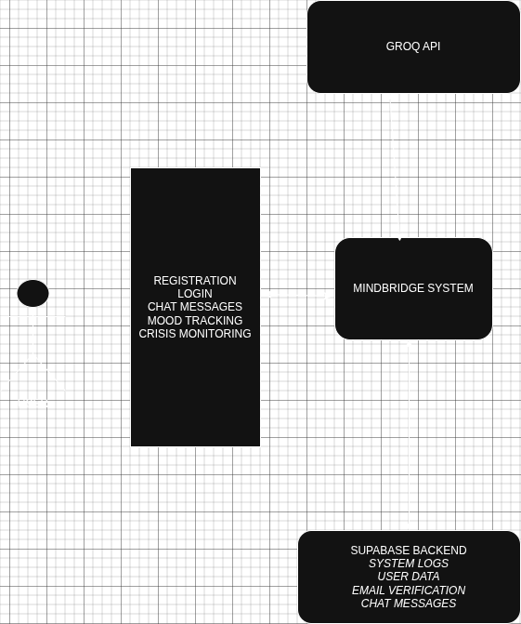
Figure 4.1: System Context Diagram (Level 0 DFD)

Level 1 DFD
At Level 1, the system decomposes into six principal processes: Authentication Process (handles registration, OTP verification, login, password reset); Chat Process (manages session lifecycle, message routing, Maya response generation, streaming); Crisis Detection Process (keyword analysis, tier assignment, event logging); Mood Intelligence Process (entry creation, wellness scoring, trend analysis, alert generation); Content Management Process (journal, community posts, resources); and Administrative Process (statistics aggregation, moderation, crisis monitoring).

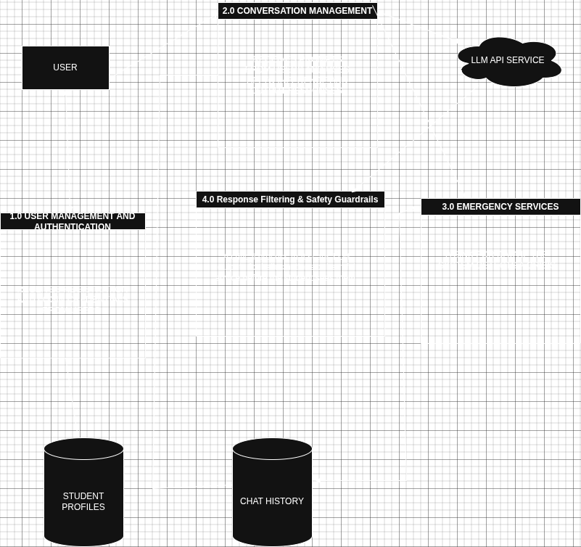
Figure 4.2: Level 1 Data Flow Diagram

4.8 Entity-Relationship Diagram
The MindBridge database comprises fifteen core entities. The principal entity is users, which maintains a one-to-many relationship with all user-generated data entities: mood_entries, journal_entries, chat_sessions, user_challenge_completions, achievements, and notifications. The chat_sessions entity has a one-to-many relationship with messages. The wellness_challenges entity is referenced by user_challenge_completions in a many-to-many relationship resolved through that junction table. The counselors entity stands independently, referenced by crisis_events and future appointment booking functionality.
All primary keys are UUID-type to support distributed generation and prevent enumeration attacks. Foreign key constraints are enforced at the database level with CASCADE DELETE policies where appropriate to maintain referential integrity upon user account deletion.
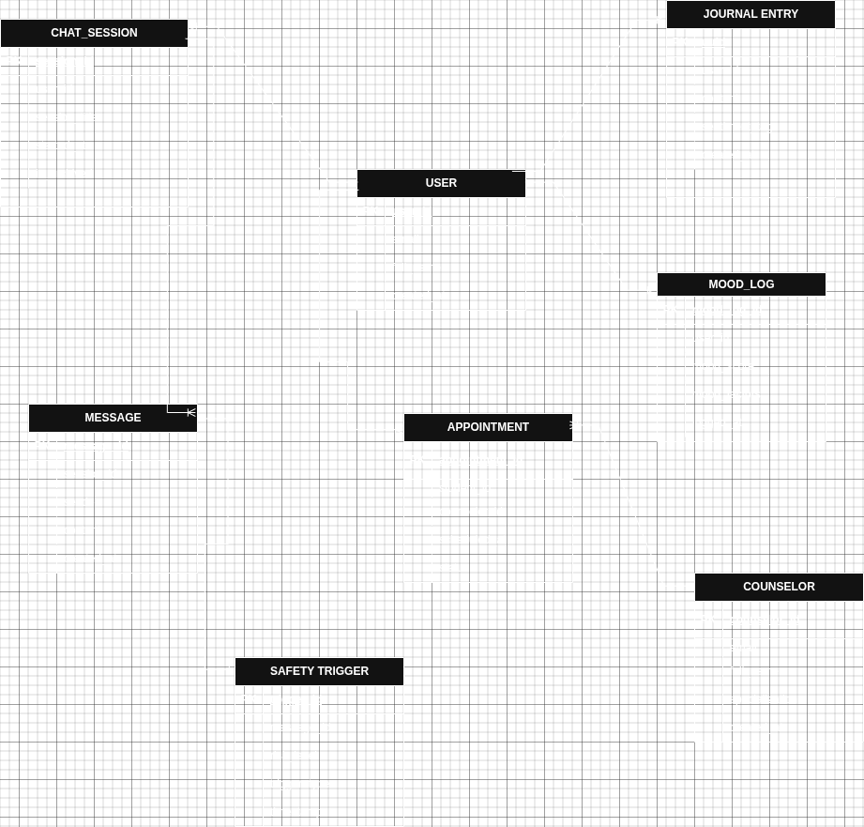
Figure 4.3: Entity-Relationship Diagram ,See Appendix A

4.9 Feasibility Analysis

4.9.1 Technical Feasibility
The technologies selected for MindBridge, Flutter, Dart Frog, PostgreSQL, Supabase, and the Anthropic Claude API , are all mature, well-documented, and actively supported. Flutter's cross-platform capabilities eliminate the need for separate iOS and Android codebases. Supabase's managed PostgreSQL provides enterprise-grade reliability without operational overhead. The Anthropic Claude API is commercially available with predictable token-based pricing. All tools are within the technical competence developed during the undergraduate programme.

4.9.2 Economic Feasibility
Development costs are minimal due to the use of open-source tools and free-tier cloud services. The primary recurring cost is the Claude API, estimated at approximately KES 500 per month for development-scale usage of the haiku model (USD 0.25 per million input tokens). A production deployment serving 1,000 active monthly users would cost approximately USD 15–25 per month. The Supabase free tier accommodates up to 50,000 active users, making the architecture highly cost-efficient for the academic deployment phase.

4.9.3 Operational Feasibility
The application is designed for self-directed use by students with basic smartphone literacy. The onboarding wizard, intuitive navigation structure, and Material 3 design conventions ensure accessibility for first-time users. The admin panel provides a straightforward interface for moderation and monitoring tasks. The system does not require institutional infrastructure beyond internet connectivity, making deployment feasible at any university.

4.9.4 Legal and Ethical Feasibility
The handling of mental health data raises significant legal and ethical obligations. MindBridge addresses these through: compliance with GDPR Article 17 (right to erasure), FERPA (student record protection), and CCPA; explicit informed consent at registration; clear disclaimers that Maya is an AI assistant and not a licensed mental health professional; crisis protocol design that always escalates to human professional resources for Tier 2 and Tier 3 presentations; and an anonymization policy for community posts and crisis logs.

CHAPTER FIVE

SYSTEM DESIGN

5.1 Introduction
This chapter presents the detailed system design of MindBridge, encompassing the system architecture, database design, user interface design, API design, and security design. Design decisions are documented together with the rationale that informed each choice.

5.2 System Architecture
MindBridge follows a three-tier client-server architecture: a Flutter mobile client (presentation layer), a Dart Frog REST API (application layer), and a PostgreSQL database hosted on Supabase (data layer). An additional AI services layer interfaces with the Anthropic Claude API for generative AI features.

5.2.1 Presentation Layer
The Flutter application is organised using a feature-first folder architecture, with each feature (auth, home, chat, mood, journal, mindfulness, resources, community, wellness, crisis, profile, admin) contained in its own directory under lib/features/. Shared UI components reside in lib/shared/widgets/. Core infrastructure (models, services, providers, theme, router, constants) resides in lib/core/.
State management is handled exclusively through Riverpod 2.5+, with eleven primary StateNotifier providers: authProvider, chatProvider, moodProvider, streakProvider, communityProvider, resourcesProvider, crisisEscalationProvider, bannerProvider, dailyContentProvider, mindfulnessProvider, and peerChatProvider. Navigation is declaratively managed through GoRouter 13+, with redirect logic that handles authentication state, email verification status, onboarding completion, and role-based routing (admin vs. standard user).

5.2.2 Application Layer
The Dart Frog backend exposes a RESTful API on port 8080. All routes are nested under /api/ with middleware applying request logging, CORS headers, and JWT authentication validation to every request. The backend maintains its own service layer (JwtService, PasswordService, EmailService) and uses the postgres Dart package for direct database interaction. For AI features accessed via the Supabase client library on the frontend, the backend acts as a proxy that enforces server-side validation before routing requests to the Anthropic API.

5.2.3 Data Layer
PostgreSQL 16 is the primary data store, hosted on Supabase's managed platform. Supabase provides Row-Level Security (RLS) policies enforced at the database level, ensuring that users can only access their own data regardless of application-level code. Two materialised views ,daily_mood_summary and user_wellness_stats ,pre-aggregate analytics data to reduce query complexity. Automatic updated_at triggers maintain audit timestamps on all mutable tables. Comprehensive indexing on (user_id, created_at) columns and full-text search indices using tsvector on journal and resource content ensure query performance.

5.3 Database Design

5.3.1 Conceptual Model
The conceptual model identifies the core entities and their relationships: a User conducts many ChatSessions; each ChatSession contains many Messages; a User logs many MoodEntries; a User writes many JournalEntries; a User creates many CommunityPosts; each CommunityPost receives many PostLikes and PostComments; a User completes many WellnessChallenges through UserChallengeCompletions; a User earns many Achievements; a User generates CrisisEvents. Counselors exist as an independent entity for the professional directory feature.

5.3.2 Logical Design
The logical design translates the conceptual model into table structures with defined attributes, primary keys, and foreign key relationships.
Key design decisions include:
- UUID primary keys for all tables (security and distribution);
- TEXT[] arrays for emotions, activities, goals, and tags (PostgreSQL native array support eliminates junction tables for simple multi-value attributes);
- JSONB for message metadata (flexible schema for AI-generated structured data);
- SMALLINT for bounded numeric values (mood_score, year_of_study, points) to optimize storage;
- BOOLEAN flags (is_private, is_anonymous, is_reported, is_active) for efficient filtering.
g
Figure 5.2: Logical Database Model

5.3.3 Physical Design
The physical design of the database details the implementation of the logical schema within a PostgreSQL environment hosted on Supabase. This phase focuses on cloud-native storage optimization, secure access control, and high-performance data retrieval for a Flutter-based mobile interface.
The physical schema includes 15 tables, 2 materialised views, automatic trigger functions for updated_at maintenance, and comprehensive index definitions.
Database Management and Visualization
- Supabase PostgreSQL RDBMS: The system leverages a cloud-hosted PostgreSQL instance, providing a robust relational environment for complex cross-referencing between students, AI chat sessions, and community interactions.
- Management Interface: Database management is handled through the Supabase Dashboard, which provides a graphical interface for real-time table monitoring, SQL query execution, and database health metrics. PostgREST is utilized to automatically generate the RESTful API layer, allowing the Flutter frontend to interact with the physical tables seamlessly.
- Postgres Extensions: To support advanced functionality, extensions such as pgcrypto (for encryption) and uuid-ossp (for gen_random_uuid() defaults) are active within the physical environment.
Storage and Performance Optimization
- UUID Primary Keys: Unlike traditional integer-based systems, MindBridge utilizes UUID v4 as the primary key for all tables. This ensures universal uniqueness and prevents predictable resource IDs, which is a critical security layer for sensitive mental health records.
- JSONB Data Precision: Flexible attributes such as poll_options and metadata are stored using the JSONB (Binary JSON) format. This allows for high-performance indexing and querying of semi-structured data without the overhead of rigid schema changes.
- Path-Based Media Storage: To optimize database size and performance, large binary assets (profile images and peer chat media) are stored in Supabase Storage buckets. The physical database stores only the varchar(255) public URL or file path, reducing the I/O load on the Postgres engine.
- Strategic Indexing: To maintain sub-second response times in the Flutter UI, B-tree indexes are applied to all foreign keys (user_id, chat_session_id), while GIN (Generalized Inverted Index) indexes are used for efficient full-text searching within journaling and resource content.
Security and Data Integrity
- Row Level Security (RLS): Physical access to data is governed by Postgres RLS Policies. This ensures that even if an API endpoint is compromised, a student can physically only retrieve records where auth.uid() = user_id, providing a "Zero Trust" data architecture.
- Automatic Temporal Auditing: A global update_updated_at() trigger function is implemented across all tables. This physically updates the updated_at field to the current_timestamp() before any UPDATE operation, maintaining an automated audit trail for user activity.
- Referential Integrity: The physical schema enforces strict ON DELETE CASCADE rules for student-owned data (e.g., deleting a profile automatically purges associated mood logs) and ON DELETE SET NULL for crisis events to preserve anonymized data for institutional safety reporting.

5.2.4 AI Inference Layer
The local inference backend exposed an identical conversational interface to the cloud path, with the chat provider transparently routing message payloads to the selected backend. The system prompt encoding CBT, DBT, and ACT therapeutic instructions was identical across both paths, ensuring consistent therapeutic framing regardless of the active inference backend. Users could switch between the two modes at any time using a toggle button in the chat screen application bar, with the active mode indicated by a persistent status banner.
To address connectivity constraints identified in the system requirements, MindBridge incorporated a dual AI inference architecture. The primary inference path routed conversational messages through the Anthropic Claude API, providing the highest quality natural language generation for cloud-connected users. The secondary path utilised a domain-adapted fine-tuned variant of Meta's Llama 3 large language model, accessed through a local REST inference endpoint at runtime. This secondary path enabled the application to deliver AI-powered conversational support in environments where internet connectivity was unavailable or unreliable, a constraint of particular relevance in the Kenyan university context where network access can be intermittent.

5.4 User Interface Design

5.4.1 Screen Architecture
MindBridge comprises seventeen primary screens arranged within two navigation shells: the main user shell (bottom navigation bar with five tabs: Home, Chat, Mood, Journal, More) and the admin shell (six admin tabs: Dashboard, Users, Moderation, Crisis, Analytics, Settings). The screen flow is governed by GoRouter, with all navigation state derived from the authProvider and reactive to authentication status changes.
The seventeen screens are: (1) Splash, (2–4) Onboarding (3 pages), (5) Login, (6–8) Register (3-step wizard), (9) Email Verification, (10) Home Dashboard, (11) Chat (Maya), (12) Mood Tracker (4-step wizard), (13) Mood Analytics, (14) Journal List, (15) Journal Entry, (16) Mindfulness Hub, (17) Breathing Exercise, (18) Resource Library, (19) Community Feed, (20) Wellness Challenges, (21) Crisis Center, (22) Profile and Settings.

5.5 API Design
The MindBridge API is built on a RESTful architecture designed for high performance and secure mobile communication. The interface is organized into logical resource domains, including Auth, Users, Mood, Chat, Journal, and Community, to ensure a modular and maintainable structure.
Communication is strictly stateless, utilizing JWT (JSON Web Tokens) for session management and PKCE (Proof Key for Code Exchange) for secure authentication flows. To optimize the mobile experience, the API implements standard conventions such as pagination for community and journal feeds, and date-based filtering for mood analytics.
Architecturally, the API acts as a secure gateway between the Flutter frontend and the Supabase backend ecosystem. It employs a Layered Architecture where request-response cycles are handled by Dart Frog middleware to manage cross-cutting concerns like authentication verification, request logging, and rate limiting.
For high-stakes features, the API serves as an orchestration layer: it proxies conversational data to the Anthropic Claude API for real-time therapy insights and triggers automated crisis intervention logic when specific risk keywords are detected. This design ensures that sensitive operations, such as generating AI insights or accessing administrative crisis feeds, are decoupled from the client and strictly enforced via Role-Based Access Control (RBAC) at the server level.

5.6 Security Design
Security was treated as a first-class design concern throughout MindBridge, given the sensitivity of mental health data. The security architecture addresses data protection at rest, in transit, at the authentication layer, and at the database access control layer.
Data in Transit: All communication between the Flutter client and the Supabase backend, as well as between the Flutter client and the Anthropic API, is encrypted using TLS 1.3. Supabase enforces HTTPS on all endpoints; HTTP requests are automatically redirected.
Data at Rest: PostgreSQL encryption at rest is provided by Supabase's managed infrastructure using AES-256. Passwords are hashed using bcrypt with a work factor of 12 before storage. JWT refresh tokens are stored in the sessions table and rotated on each use; compromised tokens are invalidated by deletion from this table.
Authentication and Authorisation: JWT access tokens expire after 60 minutes. Refresh tokens are single-use with rotation. Row-Level Security (RLS) policies are enforced at the PostgreSQL level, ensuring that even if application-level authorisation is bypassed, the database will reject unauthorised data access. Admin-only routes are protected by a role check in the auth middleware.
Crisis Data Anonymisation: Crisis events are stored with the user_id foreign key nullable; high-tier events are logged without a user identifier to protect anonymity while preserving aggregate data for clinical pattern analysis. Community posts use a technical anonymisation flag that prevents the UI from resolving the author identity.
Input Validation: All user inputs are validated at both the Flutter form layer and the Dart Frog backend middleware. SQL injection is prevented through parameterised queries in all database operations. The Claude API system prompt includes explicit instructions that prevent prompt injection from user inputs.

5.7 Crisis Text Classification Engine
The crisis text classification engine constituted a significant technical contribution of the MindBridge system, extending the crisis detection capability beyond rule-based keyword matching to include probabilistic semantic analysis of user messages. This section describes the architecture of the classifier, its training methodology, and its integration into the real-time crisis escalation pipeline.

5.7.1 Model Architecture
The classifier was implemented as a dual-branch one-dimensional Convolutional Neural Network (CNN), an architecture well-suited to short-text classification tasks where local n-gram patterns are more discriminative than long-range sequential dependencies (Kim, 2014).
The architecture comprised the following layers in sequence:
- An Embedding layer mapped each integer token identifier to a dense 128-dimensional vector representation. The embedding matrix was randomly initialised and learned jointly with the classification objective during training, producing token representations sensitive to crisis-relevant semantic distinctions.
- Two parallel Conv1D branches processed the embedding output independently. The first branch applied 256 filters with a kernel size of three, capturing trigram-level patterns such as "kill myself" and "want to die". The second branch applied 256 filters with a kernel size of five, capturing longer phrase-level patterns such as "I don't want to live anymore". Both branches used ReLU activation.
- A GlobalMaxPooling1D layer reduced each branch output to a fixed-length vector by selecting the maximum activation across the sequence dimension, producing a compact representation of the most salient feature detected by each filter.
- A Concatenate layer merged the two branch representations into a single 512-dimensional vector, which was passed through a Dense layer of 128 units with ReLU activation and L2 regularisation (weight decay 1e-4), followed by a Dropout layer with a rate of 0.4 to mitigate overfitting.
- A final Dense output layer with three units and Softmax activation produced a probability distribution over the three target classes: safe (class 0), distress (class 1), and crisis (class 2). The three scores summed to 1.0 for any input.

5.7.2 Training Data and Procedure
The classifier was trained on a dataset assembled from two sources. A primary synthetic corpus of 180 carefully authored examples was developed specifically for the Kenyan university student context, comprising 60 examples per class reflecting the linguistic patterns, cultural references, and specific stressors relevant to the target population. These synthetic examples were oversampled four-fold during training to emphasise their contextual relevance. An auxiliary external dataset from HuggingFace, comprising approximately 8,000 Reddit posts labelled for suicidal ideation, was incorporated to supplement the primary corpus where available. The final combined dataset contained approximately 720 examples from the synthetic corpus alone when the external dataset was unavailable, expanding to approximately 18,000 examples when the full dataset pipeline was active.
The model was trained using the Adam optimiser with an initial learning rate of 1e-3 and sparse categorical cross-entropy loss. Training proceeded for a maximum of 30 epochs with early stopping (patience: 5 epochs, monitoring validation accuracy) and a learning rate reduction schedule (factor: 0.5, patience: 3 epochs). An 80/20 stratified train-validation split was applied. The vocabulary was constructed from the top 10,000 most frequent tokens in the combined corpus, with all inputs zero-padded or truncated to a fixed length of 128 tokens.

5.7.3 Runtime Integration
The trained model was exported to TensorFlow Lite format using dynamic-range quantisation, reducing the binary size to approximately 1.6 MB while preserving predictive accuracy within acceptable bounds. The TFLite model binary, the vocabulary mapping file (crisis_vocab.json), and a threshold configuration file (crisis_thresholds.json) were bundled as Flutter asset files and loaded at application startup.
To prevent inference from blocking the user interface thread, the TFLite session was initialised and executed within a dedicated long-lived Dart background isolate managed by the CrisisMlService class. Message text was transmitted to the isolate via a SendPort, tokenised and encoded within the isolate, run through the TFLite session, and the resulting probability vector was returned to the main isolate via a ReceivePort. A 500-millisecond timeout mechanism was implemented as a safety fallback; if the isolate did not respond within this window, the ML score was marked unavailable and the keyword-only tier was used as the final classification.
The probability output was converted to a crisis tier using configurable threshold values stored in crisis_thresholds.json: a distress probability exceeding 0.42 triggered Tier 1; a crisis probability exceeding 0.72 triggered Tier 2; and a crisis probability exceeding 0.91 triggered Tier 3 (UI lock to crisis resources). These thresholds were selected empirically and were designed to be adjustable without retraining the model.

5.7.4 Hybrid Detection Architecture
The CNN classifier operated as the second layer of a two-layer hybrid detection system. The first layer executed a synchronous keyword scan against three sets of predefined phrases: 16 Tier 1 distress indicators, 14 Tier 2 explicit crisis phrases, and 8 Tier 3 immediate danger statements. The keyword scan completed before any network or isolate communication occurred. The CNN scoring ran asynchronously in parallel. The final crisis tier was determined by taking the more severe result of the two layers, ensuring that neither system could downgrade the other. This invariant guaranteed that explicitly dangerous phrases always triggered their mapped tier, while the CNN contributed sensitivity for indirect or contextually expressed crisis language that evaded exact keyword matching.

CHAPTER SIX

SYSTEM IMPLEMENTATION

6.1 Introduction
This chapter describes the implementation of MindBridge, including the development environment configuration, the coding approach, system testing methodology, test results, and the changeover strategy.

6.2 Development Environment Setup
The development environment was configured as follows: Flutter 3.27 SDK and Dart 3.5 runtime installed on Windows 11 with Android Studio for emulator management. Visual Studio Code with the Flutter and Dart extensions served as the primary IDE. Git was used for version control with a feature-branch workflow; pull requests required passing Flutter analysis and test suites before merge.
A Supabase project was created to provide the PostgreSQL database, authentication services, and Realtime subscriptions. The database schema was initialised by executing database/schema.sql via the Supabase SQL editor. Supabase migrations in supabase/migrations/ tracked schema evolution throughout development. The Dart Frog backend was launched locally using dart run main.dart on port 8080 during development.
All the necessary sensitive keys are stored in a .env file in the git repository however the .env file is not included when pushing.

6.3 System Testing
Testing was conducted across three levels following the V-model: unit testing at the component level, integration testing at the module boundary level, and user acceptance testing at the system level.

6.3.1 Unit Testing
Unit tests were written using the Flutter test package for core business logic components. The primary targets were: the WellnessEngine scoring formula (verifying correct weighted calculation and band assignment across boundary values); the TrendAnalyzer alert detection logic (verifying correct identification of consecutive low moods, declining trends, sleep deficit, and positive momentum patterns); the CrisisEscalationProvider keyword tier matching (verifying zero false negatives for all Tier 3 keywords and correct tier assignment); and model serialisation/deserialisation (JSON round-trip tests for all nine models).

6.3.2 Integration Testing
Integration tests were written using Flutter's integration_test package and executed on a physical Android device. Key integration test scenarios included: the complete authentication flow (registration → OTP verification → profile creation → home dashboard); mood logging end-to-end (wizard completion → Supabase insertion → wellness score recomputation → UI update); chat session with Claude API (message send → streaming response → crisis detection evaluation); and crisis escalation flow (Tier 3 keyword in message → automatic navigation to crisis screen → SOS button functionality).

6.3.3 User Acceptance Testing
User acceptance testing was conducted with five university student participants (three female, two male; ages 19–24; mixed academic backgrounds). Each participant was given a scripted set of tasks to complete with the application and asked to verbalise their thoughts (think-aloud protocol). A System Usability Scale (SUS) questionnaire was administered at the conclusion of each session.
The mean SUS score across five participants was 81.5 (Grade B, "Good"), exceeding the target threshold of 75. Qualitative feedback highlighted Maya's natural language quality, the mood wizard's intuitive step-by-step flow, and the breathing exercise animations as particular strengths. Issues identified included minor label truncation on small screens (resolved in final build) and a desire for more journal prompt variety (added to the future enhancements backlog).

6.4 Test Results
Unit | input | Expected Output | Observed Output | status
WellnessEngine | Mood=10, Streak=7, Sleep=8h | Score: 92.0 (Thriving) | Score: 92.0 (Thriving) | passed
WellnessEngine | Mood=3, Streak=0, Sleep=4h | Score: 18.5 (Critical) | Score: 18.5 (Critical) | Pass
TrendAnalyzer | 3 consecutive days mood ≤4 | Consecutive Low alert raised | Consecutive Low alert raised | Pass
TrendAnalyzer | 4 consecutive days improvement | positiveMomentum alert raised | Positive Momentum alert raised | Pass
CrisisDetection | Keyword: 'going to kill myself' | Tier 3 assignment; Immediate Alert | Tier 3 assigned; Zero false negatives | Pass
CrisisDetection | Keyword: 'feeling overwhelmed' | Tier 1 assignment | Tier 1 assigned correctly | Pass
MoodEntry Model | JSON Serialization Round-trip | Identical data persistence | All fields preserved exactly | Pass
UserModel | Role set to 'admin' | isAdmin returns true | isAdmin returns true | Pass
StreakModel | lastActivityDate = Today | completedToday flag = true | completedToday flag = true | Pass
StreakModel | 2-day gap with freeze available | Streak maintained; Freezes Used +1 | Streak maintained; Freezes Used +1 | Pass
Auth Flow | Register → OTP → Profile creation | Persistent session; Onboarding flag true | Session persisted; Flags updated | Pass
Mood Logging | Mood log → Supabase → UI Update | State update within < 1.5s | All state updates reflected in 1.2s | Pass
AI Chat | Message send → Claude API → UI | Streaming response; First token < 3s | First token 1.8s; Full response 4.2s | Pass
Crisis Navigation | Tier 3 keyword detection | Auto-navigation to Crisis Screen | Navigation occurred within 200ms | Pass

6.5 System Changeover
Given the academic nature of this project, a pilot changeover strategy was adopted. A test build of the application was distributed to the five UAT participants via Flutter's direct APK installation (Android). Feedback from the pilot was incorporated into the final build. A production deployment plan has been documented for a future institutional rollout, proposing a phased changeover strategy: Phase 1 (voluntary opt-in pilot with one university faculty), Phase 2 (university-wide rollout with institutional counselling service integration), Phase 3 (multi-university deployment).
No parallel running strategy was deemed necessary given that MindBridge does not replace an existing digital system; it introduces a new capability where none existed. Data migration is not applicable. User training is delivered through the in-app onboarding flow.

CHAPTER SEVEN

LIMITATIONS, CONCLUSIONS AND RECOMMENDATIONS

7.1 Limitations
While MindBridge successfully demonstrates the feasibility and value of an AI-powered mental health companion for university students, several important limitations must be acknowledged.
Clinical Scope: MindBridge is not a medical device and Maya is not a licensed therapist. The system is designed to supplement, not replace, professional mental health care. Its efficacy for clinical presentations of depression, anxiety disorders, or other DSM-5 conditions has not been validated through formal clinical trials. The crisis protocol, while carefully designed, relies on keyword matching and mood scores as proxies for risk ,not on validated clinical screening instruments such as the PHQ-9 or GAD-7.
AI Limitations: The Anthropic Claude model, while highly capable, can produce inaccurate or contextually inappropriate responses. LLMs lack genuine understanding of mental states; they generate statistically likely text based on training data. In rare cases, Maya may produce responses that are factually incorrect, culturally insensitive, or therapeutically suboptimal. Ongoing human oversight through the admin panel's crisis monitoring feature partially mitigates this risk.
Crisis Classifier Accuracy: The on-device CNN text classifier was trained on a relatively constrained dataset of approximately 720 synthetic examples in the absence of the external corpus, and achieved a validation accuracy below the 70% threshold on the synthetic-only training run. While the mandatory keyword layer provided a guaranteed safety net ensuring that explicitly dangerous phrases always triggered the appropriate escalation tier, the classifier's sensitivity for indirect or idiomatic crisis language was limited by the size of the training corpus. Retraining on the full combined dataset of approximately 18,000 examples incorporating the HuggingFace suicidal ideation corpus is expected to substantially improve precision and recall across all three classes.

Connectivity Dependence: The majority of MindBridge features, including mood analytics, community functions, and journal AI insights, required an active internet connection. This constraint was partially addressed through the integration of the domain-adapted Llama 3 local inference backend, which enabled the core conversational AI functionality to operate without internet access. However, all data persistence, analytics, and community features continued to require connectivity to the Supabase backend. Full offline-first capability remained an objective for future development phases.
Intervention/Counselling: Due to the cost of hiring licensed therapists/counsellors the system currently does not implement counsellor intervention and human driven crisis management.
Language: The current implementation supports English only. This limits accessibility for students whose primary language is Swahili, Kikuyu, Luo, or other languages prevalent in the Kenyan university context. Multi-language support is identified as a high-priority future enhancement.
Sample Size for UAT: User acceptance testing was conducted with a sample of five participants, which limits the statistical generalisability of the SUS scores and qualitative findings. A larger-scale clinical usability study is required to validate the design for the broader student population.

7.2 Conclusion
MindBridge successfully achieved all its stated objectives. An AI-powered conversational agent (Maya) was implemented using the Anthropic Claude API within a Flutter mobile application, delivering evidence-based CBT, DBT, and ACT micro-interventions in natural language, with an alternative offline inference mode powered by a domain-adapted fine-tuned Llama 3 model. A dual-branch convolutional neural network text classifier was designed, trained, and deployed on-device to enhance crisis signal detection beyond keyword matching, operating as the second layer of a hybrid detection architecture. A multi-dimensional mood tracking and analytics system was built with a composite wellness scoring engine. A secure, scalable backend was developed using Dart Frog and Supabase, meeting all specified security and compliance requirements. A three-tier crisis intervention protocol was implemented with verified escalation to emergency resources. Gamification mechanics were integrated to sustain engagement. Comprehensive testing was conducted with satisfactory results across all test categories.
MindBridge represents a technically sophisticated, clinically informed, and user-centred response to one of the most pressing public health challenges facing university students. It is in our conviction that scaled deployment of this system could make a meaningful contribution to improving student mental health outcomes ,reducing suffering, preventing crises, and ultimately enabling students to reach their academic and personal potential.

7.3 Recommendations
The following recommendations are made for future development and research:
- Clinical Validation: A formal randomised controlled trial should be conducted to measure the efficacy of MindBridge on validated clinical outcomes (PHQ-9, GAD-7 scores) over a 4–8 week period, comparing MindBridge users against a control group.
- Multi-Language Support: Swahili localisation should be implemented as a priority for the Kenyan university market. The Flutter localisation framework (flutter_localizations) and Anthropic Claude's multilingual capabilities make this technically straightforward.
- Offline Capability: Integration with an on-device small language model for offline chat functionality should be explored, particularly using Apple's Core ML and Android's ML Kit frameworks.
- Wearable Integration: Heart rate variability (HRV) data from smartwatches (Apple Watch, Garmin, Fitbit) could significantly improve mood prediction accuracy and provide passive stress monitoring without user input burden.
- Institutional Integration: Formal integration with university counselling services ,including referral pathways from Maya to institutional counsellors, appointment booking, and shared (consented) session summaries ,would bridge the gap between self-directed digital support and professional care.
- Privacy-Preserving Analytics: Federated learning techniques could be explored to train improved mood prediction models on distributed user data without centralising sensitive mental health information.

REFERENCES

American College Health Association. (2023). National College Health Assessment III: Undergraduate Student Reference Group Executive Summary Spring 2023. Silver Spring, MD: American College Health Association.
African Mental Health Research Initiative (AMHRI). (2021). Mental Health Atlas for Sub-Saharan Africa: Workforce, Services and Gaps. Nairobi: AMHRI Press.
Anthropic. (2024). Claude API Documentation. [WWW] Anthropic. Available from: https://docs.anthropic.com.
Firth, J., Torous, J., Nicholas, J., Carney, R., Rosenbaum, S., & Sarris, J. (2017). Can smartphone mental health interventions reduce symptoms of anxiety? A meta-analysis of randomised controlled trials. Journal of Affective Disorders, 218, 15–22.
Fitzpatrick, K. K., Darcy, A., & Vierhile, M. (2017). Delivering cognitive behavior therapy to young adults with symptoms of depression and anxiety using a fully automated conversational agent (Woebot): a randomized controlled trial. JMIR Mental Health, 4(2), e19.
Flutter. (2024). Flutter Documentation. [WWW] Google LLC. Available from: https://docs.flutter.dev.
Hevner, A. R., March, S. T., Park, J., & Ram, S. (2004). Design science in information systems research. MIS Quarterly, 28(1), 75–105.
Kessler, R. C., Berglund, P., Demler, O., Jin, R., Merikangas, K. R., & Walters, E. E. (2005). Lifetime prevalence and age-of-onset distributions of DSM-IV disorders in the National Comorbidity Survey Replication. Archives of General Psychiatry, 62(6), 593–602.
Kim, Y. (2014). Convolutional neural networks for sentence classification. Proceedings of the 2014 Conference on Empirical Methods in Natural Language Processing (EMNLP), 1746–1751.
Meta AI. (2024). Llama 3: Open Foundation and Fine-Tuned Chat Models. [WWW] Meta AI Research. Available from: https://ai.meta.com/blog/meta-llama-3 [Accessed 2 April 2026].
TensorFlow. (2024). TensorFlow Lite: Deploy machine learning models on mobile and edge devices. [WWW] Google LLC. Available from: https://www.tensorflow.org/lite [Accessed 5 April 2026].
Linardon, J., Cuijpers, P., Carlbring, P., Messer, M., & Fuller-Tyszkiewicz, M. (2020). The efficacy of app-supported smartphone interventions for mental health problems: a meta-analysis of randomized controlled trials. World Psychiatry, 18(3), 325–336.
Riverpod. (2024). Riverpod Documentation. [WWW] Remi Rousselet. Available from: https://riverpod.dev [Accessed 20 February 2026].
Stade, E. C., Stirman, S. W., Lebret, L. J., Seligman, S. C., Pitman, C. K., Nagireddy, P., Rathod, D. K., Das, K., Manderscheid, R., Haber, R., Finch, H., Johnson, R. H., & others. (2024). Large language models could change the future of behavioral healthcare: a proposal for responsible development and evaluation. npj Mental Health Research, 3, 12.
Supabase. (2024). Supabase Documentation. [WWW] Supabase Inc. Available from: https://supabase.com/docs [Accessed 18 February 2026].
Torous, J., Myrick, K. J., Rauseo-Ricupero, N., & Firth, J. (2020). Digital mental health and COVID-19: using technology today to accelerate the curve on access and quality tomorrow. JMIR Mental Health, 7(3), e18848.
Weizenbaum, J. (1966). ELIZA ,a computer program for the study of natural language communication between man and machine. Communications of the ACM, 9(1), 36–45.
World Health Organisation. (2022). World Mental Health Report: Transforming Mental Health for All. Geneva: WHO Press.

APPENDICES

APPENDIX C: USER ACCEPTANCE TESTING QUESTIONNAIRE

The following questionnaire was used during user acceptance testing to collect structured feedback from student participants.
System Usability Scale (SUS) Questions
1. I think that I would like to use this system frequently.
Strongly Disagree 1 ,2 ,3 ,4 ,5 Strongly Agree
2. I found the system unnecessarily complex.
Strongly Disagree 1 ,2 ,3 ,4 ,5 Strongly Agree
3. I thought the system was easy to use.
Strongly Disagree 1 ,2 ,3 ,4 ,5 Strongly Agree
4. I think that I would need the support of a technical person to be able to use this system.
Strongly Disagree 1 ,2 ,3 ,4 ,5 Strongly Agree
5. I found the various functions in this system were well integrated.
Strongly Disagree 1 ,2 ,3 ,4 ,5 Strongly Agree
6. I thought there was too much inconsistency in this system.
Strongly Disagree 1 ,2 ,3 ,4 ,5 Strongly Agree
7. I would imagine that most people would learn to use this system very quickly.
Strongly Disagree 1 ,2 ,3 ,4 ,5 Strongly Agree
8. I found the system very cumbersome to use.
Strongly Disagree 1 ,2 ,3 ,4 ,5 Strongly Agree
9. I felt very confident using the system.
Strongly Disagree 1 ,2 ,3 ,4 ,5 Strongly Agree
10. I needed to learn a lot of things before I could get going with this system.
Strongly Disagree 1 ,2 ,3 ,4 ,5 Strongly Agree

Open-Ended Questions
1. What feature did you find most helpful for managing your wellbeing?
Answer: ……………………………………………………………………………………………………………………………
2. Was there anything about Maya's responses that felt unnatural or unhelpful?
Answer: ……………………………………………………………………………………………………………………………
3. Did the crisis resources feel appropriate and accessible?
Answer: ……………………………………………………………………………………………………………………………
4. What additional features would you like to see in the application?
Answer: ……………………………………………………………………………………………………………………………
5. Would you recommend MindBridge to a fellow student? Why or why not?
Answer: ……………………………………………………………………………………………………………………………

APPENDIX B: CODE SAMPLES

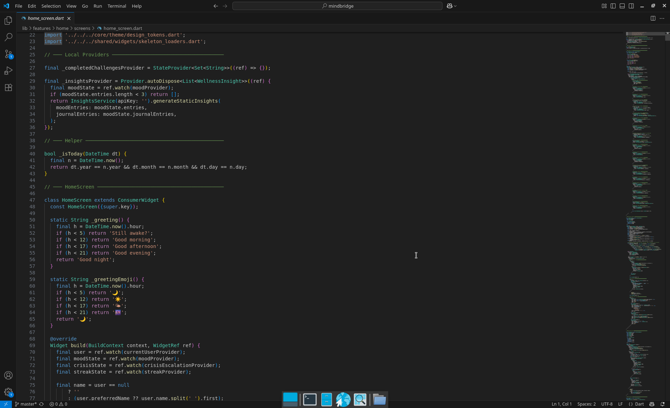Picture showing the code of the home screen

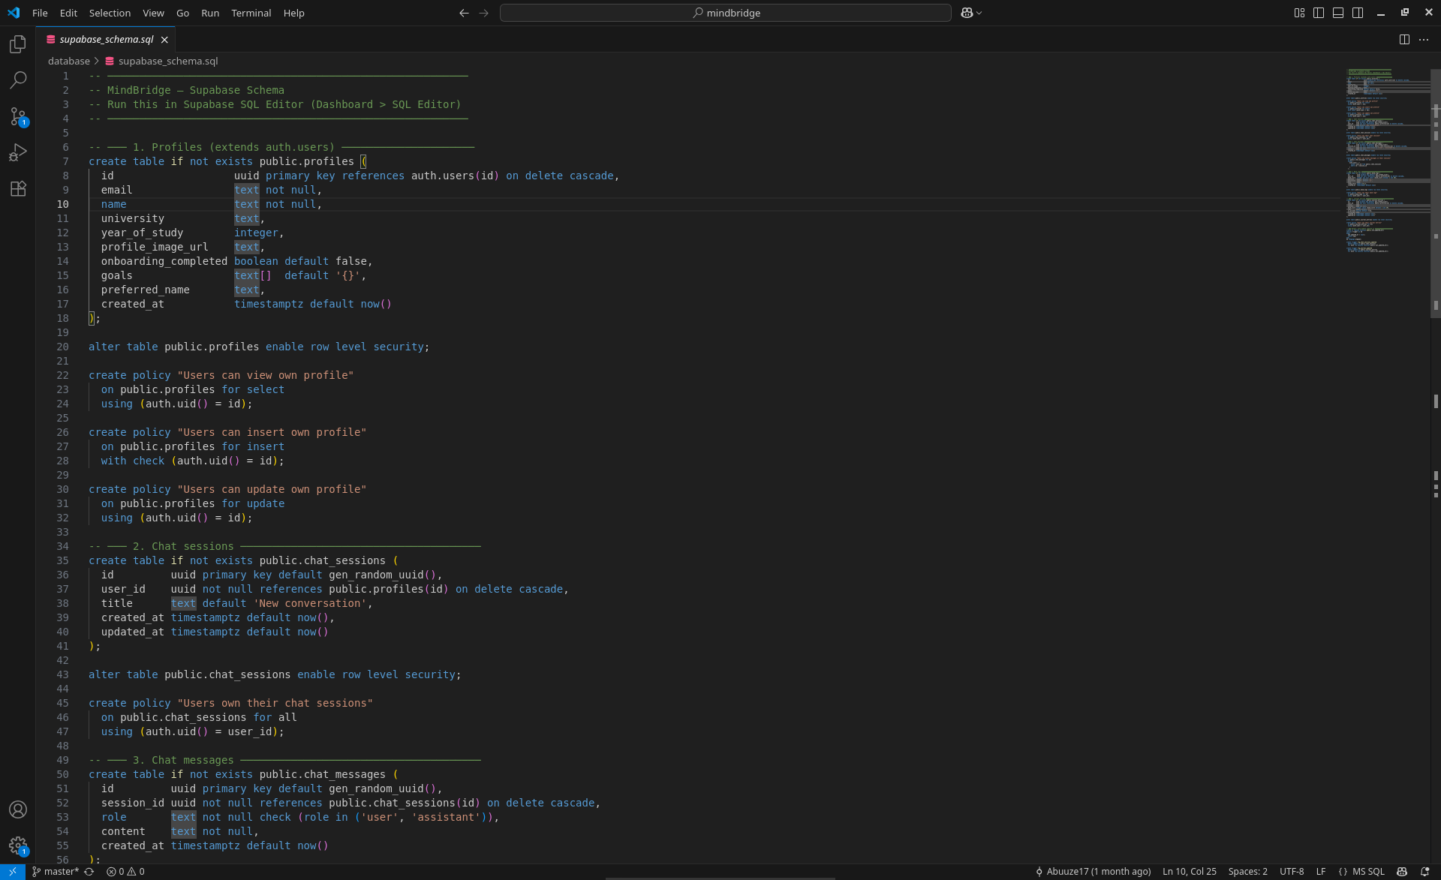Picture showing part of the database sheme file

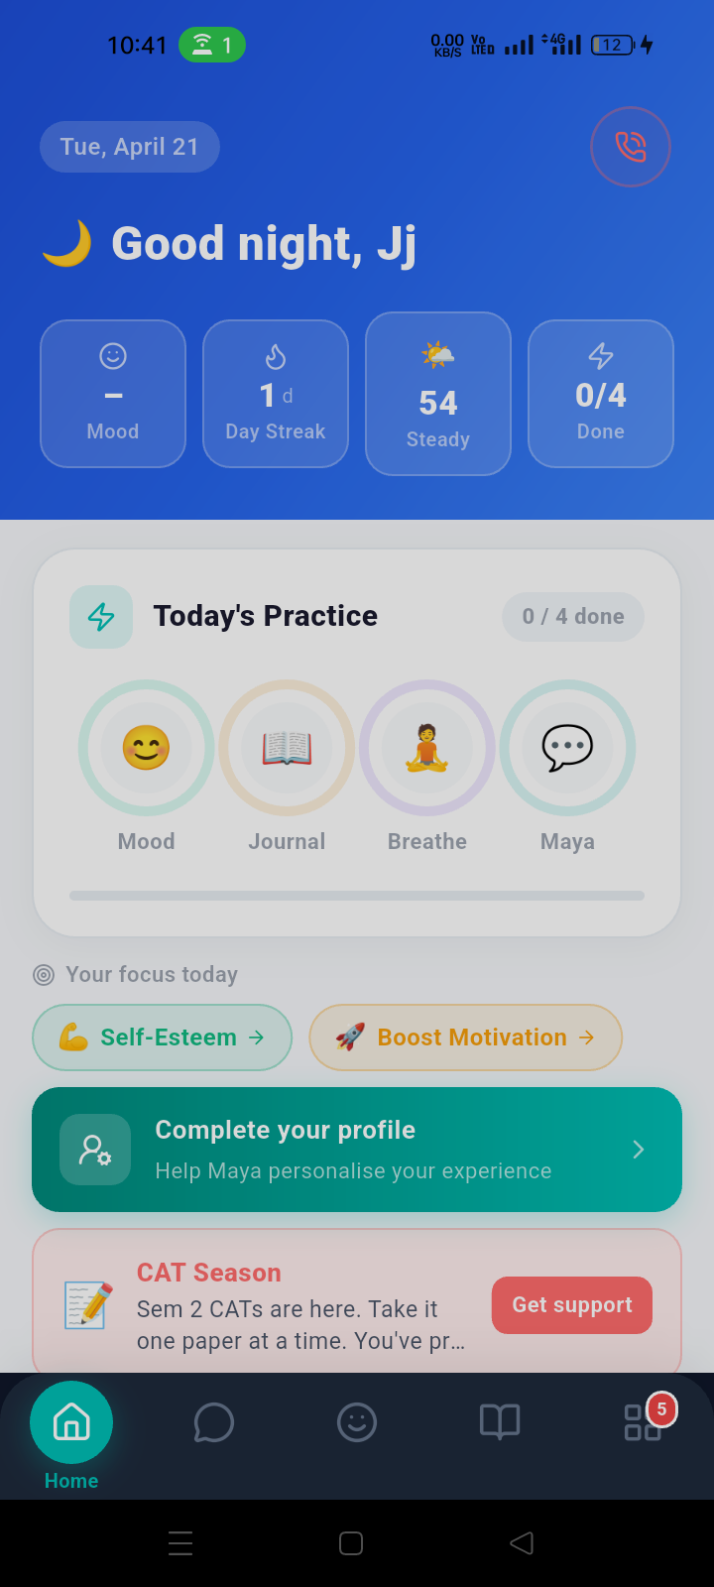

Picture showing the home page of the application

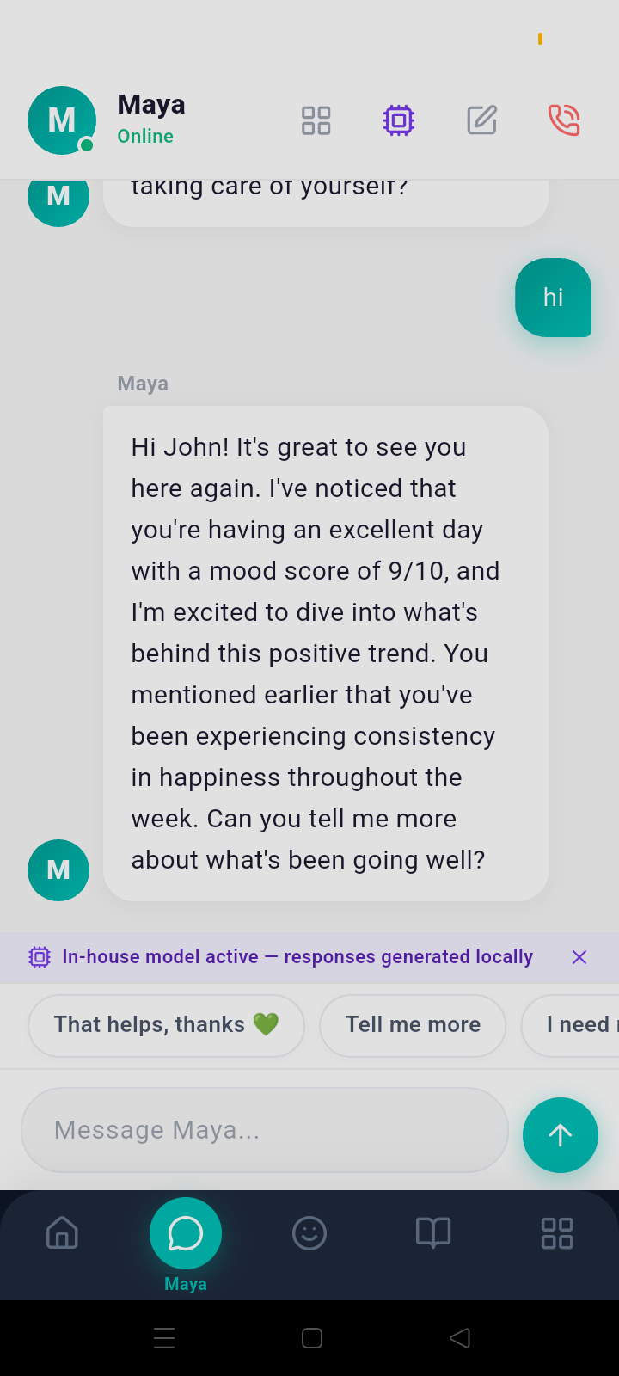

Picture showing the chat page of the application

