***Animated Movies Analysis***

***“Questions”***

1. ***What are the top 10 most popular animated movies?***

.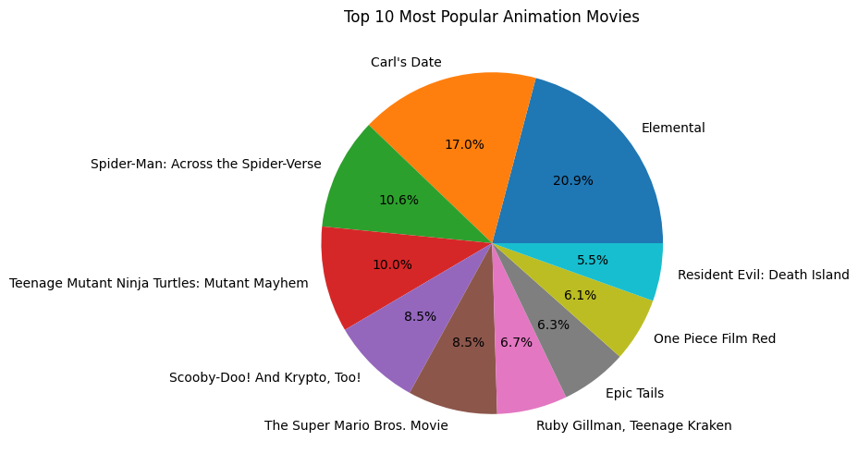

1. **In what language are the most movies produced?**

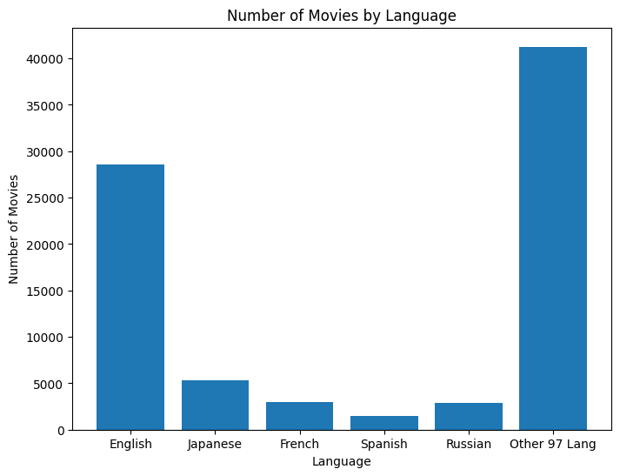

**Q. What are the top 10 movies with the lowest revenue to budget ratio?**

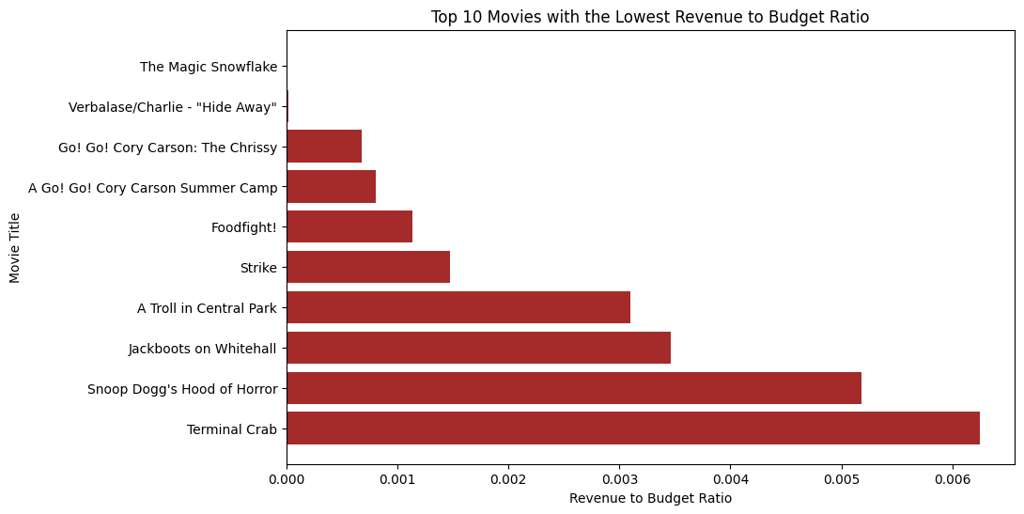

**Q. What are the top 10 countries with the most entries in production countries?**

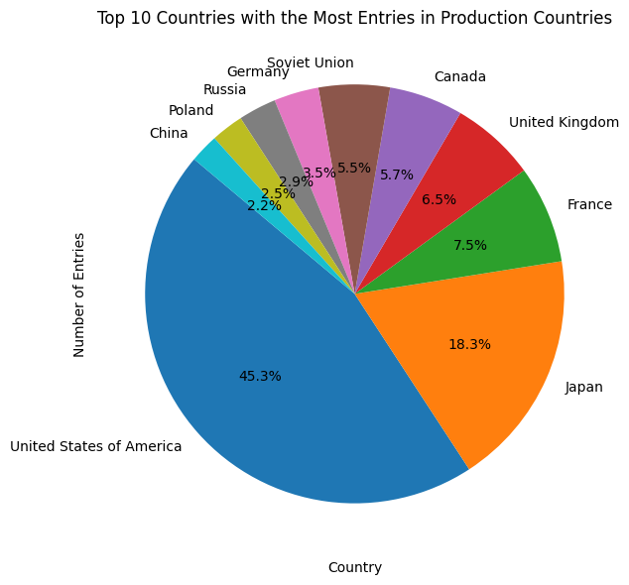

**Q. What are the top 10 countries with the most entries in production countries?**

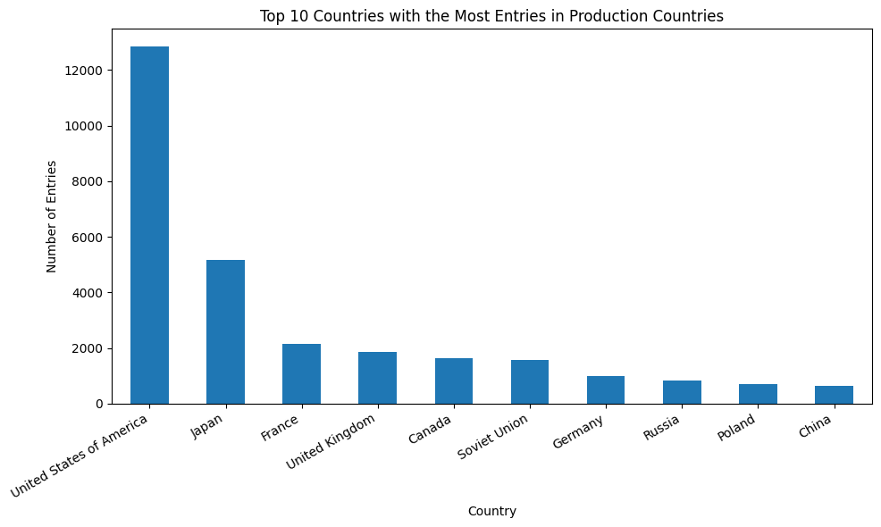

**Q. How has revenue changed over time?**

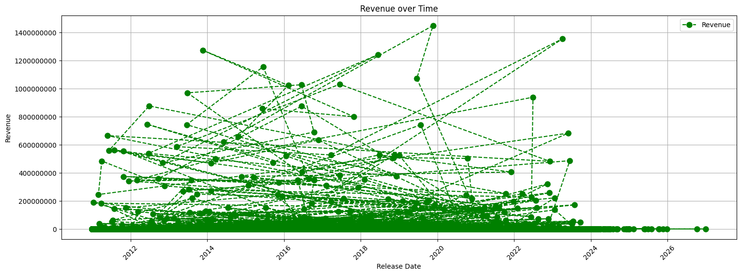

**Q. Which companies have produced the most high-grossing animatedFilms?**