Research Question

* More Cancellation occur when prices are higher.
* When there is a longer waiting list , customers tend to leave more frequently.
* The majority of clients are coming from offline travel agents to make their reservations.

Analysis and Findings

* 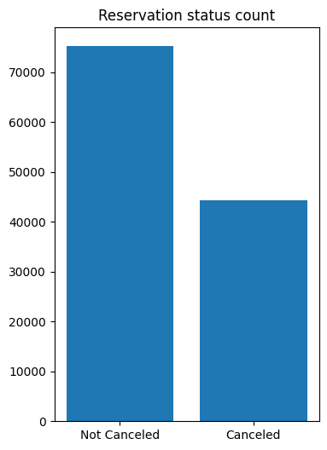
* The above image presents a simple bar chart titled "Reservation status count" which compares the number of reservations that are either "Not Canceled" or "Canceled". From the chart:
* The "Not Canceled" reservations are significantly higher than the "Canceled" ones.
* The "Not Canceled" reservations appear to be around 70,000 in count.
* The "Canceled" reservations are fewer, with the count being around 40,000.

This means that approximately 36.36% of the reservations were canceled, while the remaining 63.64% were not canceled.

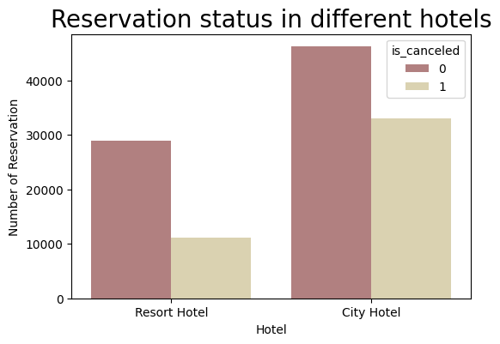

* The number of canceled reservations is higher than non-canceled reservations for both Resort and City hotels.
* The proportion of canceled reservations in the Resort Hotel is notably higher compared to the City Hotel. This suggests that the Resort Hotel experiences a higher rate of cancellations compared to the City Hotel.
* The City Hotel has a more balanced distribution between canceled and non-canceled reservations, indicating a more stable reservation pattern compared to the Resort Hotel.
* 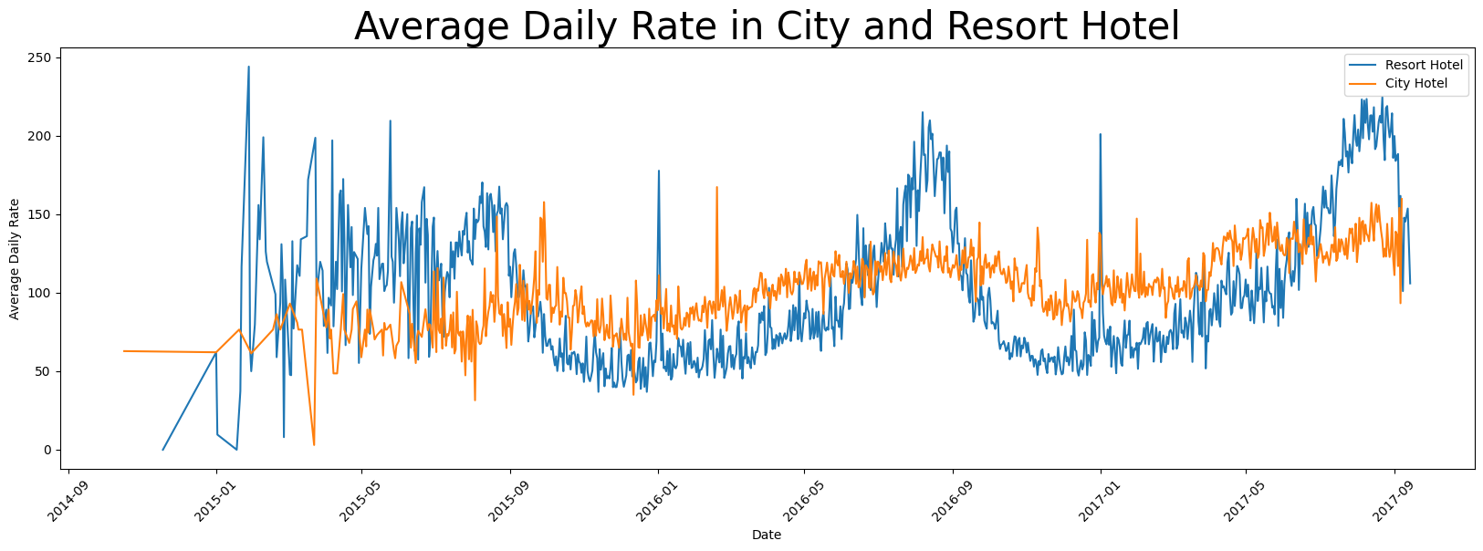
* The average daily rate for the city hotel generally appears to be higher than that of the resort hotel. This suggests that, on average, the city hotel may command higher pricing for its accommodations compared to the resort hotel.
* The average daily rate for the resort hotel shows more fluctuation over time compared to the city hotel. This could indicate that the pricing for the resort hotel is more sensitive to seasonal or market factors, leading to greater variability in the rates.
* The city hotel's average daily rate, while generally higher, shows relatively less variation over time, indicating a more stable pricing trend compared to the resort hotel.

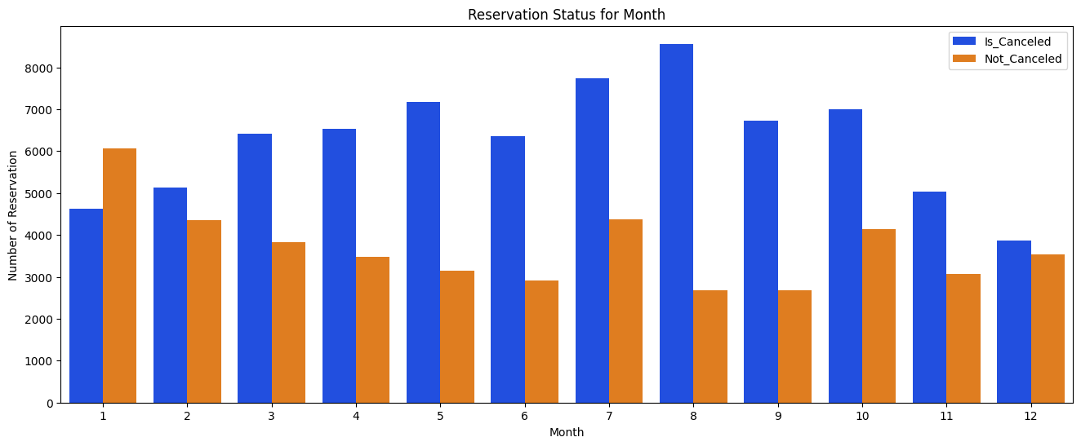

This image displays a bar chart titled "ADR per Month for Canceled Bookings," where ADR stands for Average Daily Rate. The chart depicts data for each month, represented on the horizontal axis (x-axis) labeled "month," with numbers from 1 to 12 indicating January to December respectively.

* The highest ADR for canceled bookings occurred in the first month (January), with a value just over 600,000.
* The second highest peak is in the seventh month (July), with the ADR value just over 500,000.
* Generally, there's a decline in ADR from January into February, a slight increase in March, and then fluctuations in the subsequent months with no clear increasing or decreasing trends.

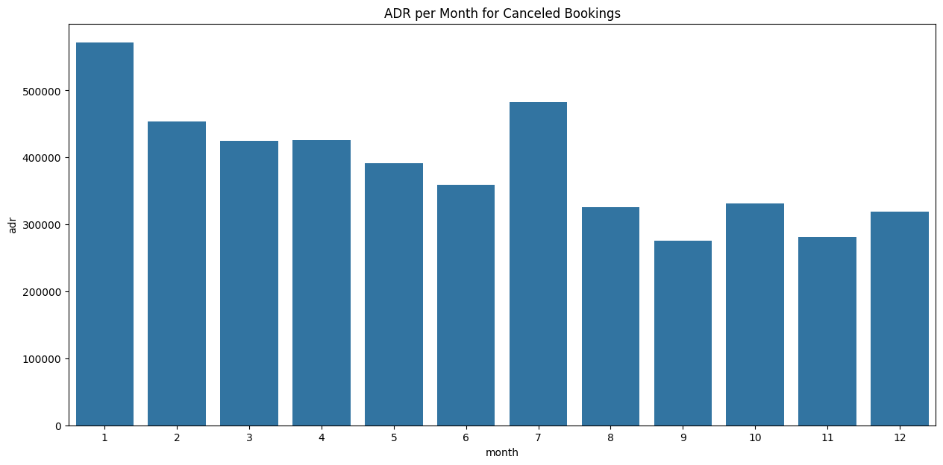

This is a bar chart titled "ADR per Month for Canceled Bookings," which illustrates the amount of Average Daily Rate (ADR) for canceled hotel bookings across 12 months of a year. The 'month' is labeled along the horizontal x-axis, ranging from 1 to 12, most likely representing January to December. The vertical y-axis represents the monetary values in what appears to be a currency, increasing in increments, possibly to show the ADR in each month.

* The highest ADR for canceled bookings occurred in the first month (January), with a value just over 600,000.
* The second highest peak is in the seventh month (July), with the ADR value just over 500,000.
* Generally, there's a decline in ADR from January into February, a slight increase in March, and then fluctuations in the subsequent months with no clear increasing or decreasing trends.

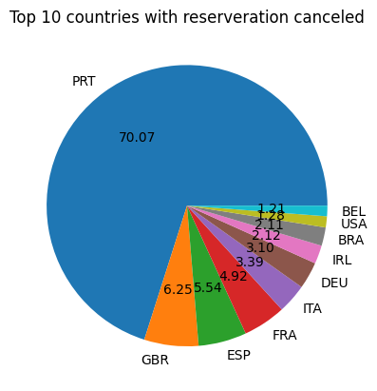

This image is a circular chart, often referred to as a pie chart, which is displaying data on the top 10 countries with reservations canceled.

* PRT (Portugal) with a very large proportion of 70.07%, dominating the chart.
* GBR (United Kingdom) with 6.25%.
* ESP (Spain) with 5.54%.
* FRA (France) with 4.92%.
* ITA (Italy) with 3.39%.
* DEU (Germany) with 3.10%.
* USA (United States of America) with 2.12%.
* BRA (Brazil) with 2.12% – interestingly shows the same percentage as the USA
* IRL (Ireland) with 1.28%.
* BEL (Belgium) with 1.21%.

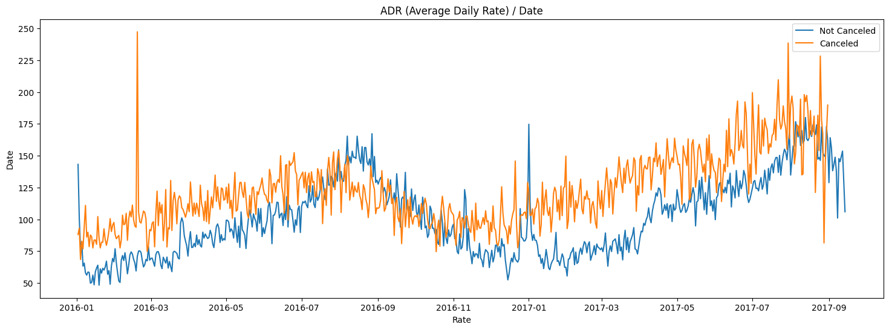

The image is line graph representing data over time, specifically it indicate the Average Daily Rate (ADR) trend over a range of dates.

****Time Series Data****: The graph represents time series data from early 2016 through late 2017.

****Two Categories of Data****: There are two lines on the graph, each representing a different category of data - one for "Not Canceled" and one for "Canceled". bookings or reservations, possibly for a hotel.

****ADR Trend****: Both categories show a trend of ADR increasing over time. The rates fluctuate, but there is a clear upward trend for both canceled and not canceled bookings.

****Comparison Between Canceled and Not Canceled****: The rate for "Canceled" is consistently higher than the rate for "Not Canceled". This could mean that bookings that are canceled tend to have a higher price.

****Seasonality****: There seems to be a pattern of peaks and troughs that may correspond to seasons or specific times of the year when rates increase or decrease, possibly due to demand fluctuations.

****Volatility****: The "Canceled" line appears to have more volatility with sharper increases and decreases compared to the "Not Canceled" line. This could indicate that cancellations are more sensitive to external factors or that there's a higher variance in the rates for bookings that end up being canceled.

****Events****: Some significant spikes and dips, especially in the "Canceled" data, might indicate special events.