Job Market Analysis Report
Insights into UK Job Opportunities from Reed.co.uk
Prepared by: M Aqeel
Date: August 7, 2025

1. Overview
This report analyzes job postings for various roles in the United Kingdom, sourced from the Reed.co.uk API. It uncovers trends in demand, salaries, locations, and application patterns. Based on the most recent 1000 job postings retrieved as of August 7, 2025, the analysis aims to assist both job seekers and recruiters in navigating the job market more effectively.
2. Objectives
Identify trends in job postings, salaries, locations, and applications.
Highlight high-paying roles with low competition.
Analyze the availability of remote and hybrid job types.
Provide actionable insights for both job seekers and recruiters.
3. Methodology
The analysis was conducted in three key phases: data collection, data cleaning, and exploratory analysis.
Data Collection
Job listings were retrieved via the Reed.co.uk API using the "keywords" parameter (e.g., "data analyst", "web developer") for roles based in the United Kingdom. The API was called in paginated form, fetching up to 1,000 of the most recent job postings as of August 7, 2025.
Data Cleaning & Preprocessing
Irrelevant columns with 100% missing values, such as employerProfileId and employerProfileName, were dropped.
Only postings from March 1, 2025 onward were retained for recency.
The date column was converted to datetime format and filtered accordingly.
Rows with both minimumSalary and maximumSalary equal to 0 were removed to exclude incomplete or non-disclosing listings.
The most frequent currency value (typically GBP) was imputed where currency information was missing.
Outliers were excluded:
- One posting with a salary greater than £150,000.
- Two postings with over 600 applications.
A new column salaryAvg was created to represent the average salary per job listing.
4. Key Insights
Market Freshness
24.5% of jobs were posted within the last 7 days.
15.8% are older than 30 days.
→ The market is active with frequent new listings.
Top Employers
Largest recruiters by job volume:
ITOL Recruit (183 jobs)
Harnham - Data & Analytics (87)
Reed(27), Robert Half(24), and Tenth Revolution Group(23)
Work Flexibility
Hybrid roles: 25.1%.
Remote roles: 5.3%.
→ Hybrid jobs are significantly more common than remote-only options.
Application Trends
Most applied job: IT Support Analyst at GroupNexus (563 applications).
Least applied job: Leasing Decision Tree Analyst at Santander Consumer Finance (0 applications).
Average applications per job: 49.45.
→ Competition varies widely by role and timing.

Top Locations for Job Listings
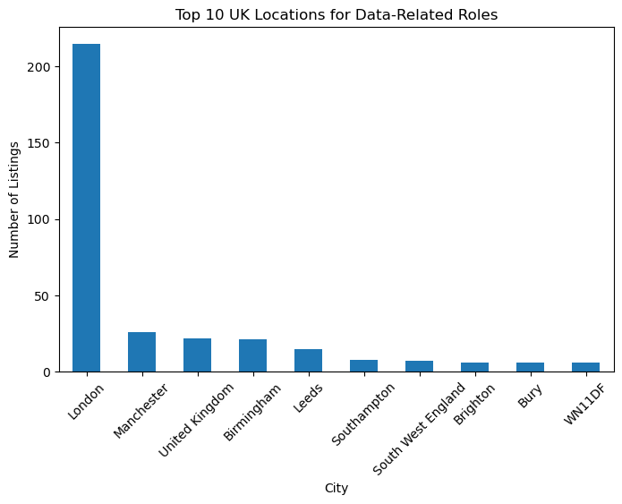
Top UK Locations by Average Salary
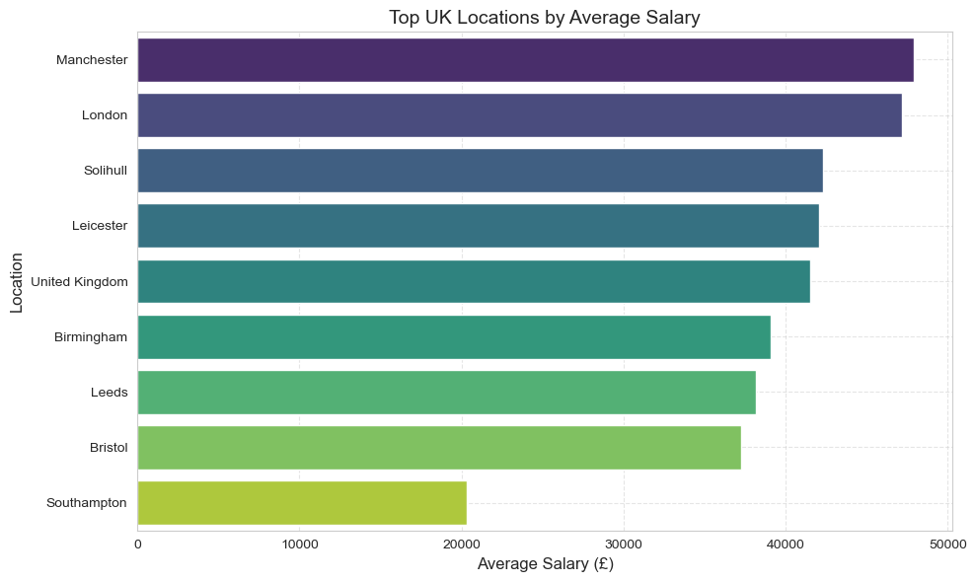

Top 15 Employers by Average Salary
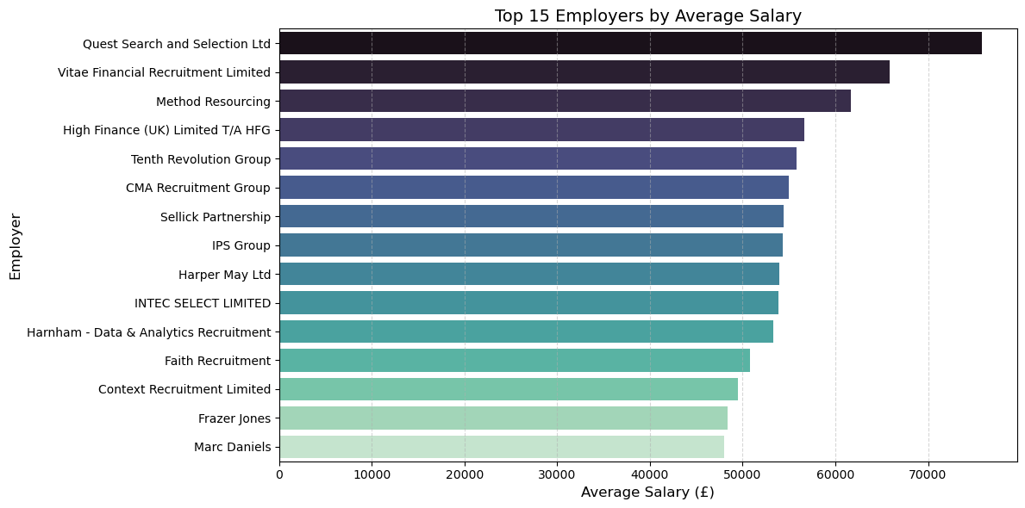
Job Age vs Applications
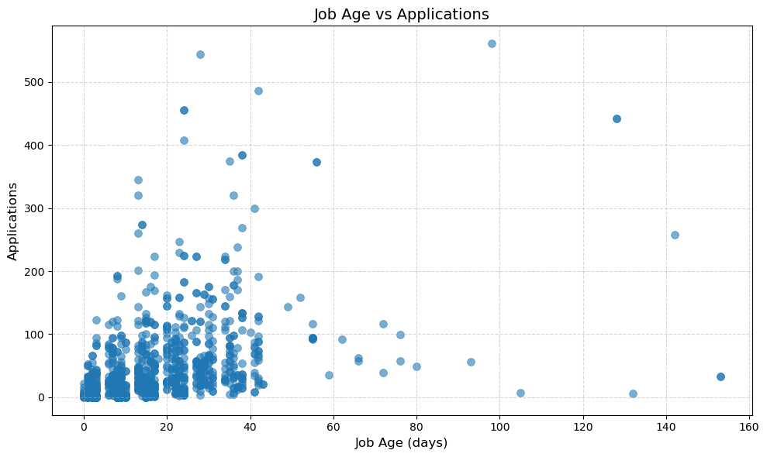
Job Posting Age
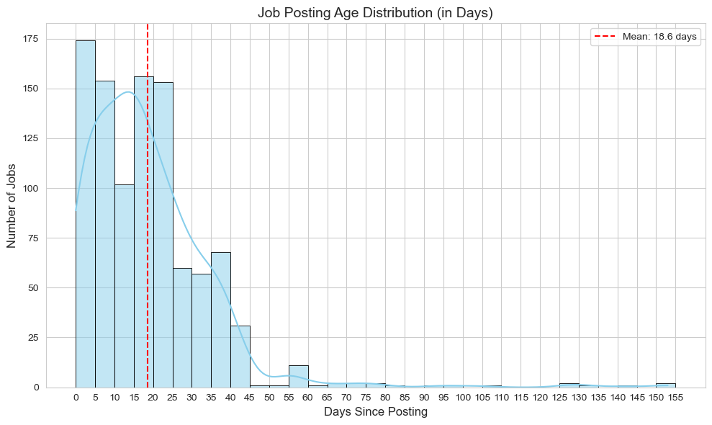
Hidden Opportunities
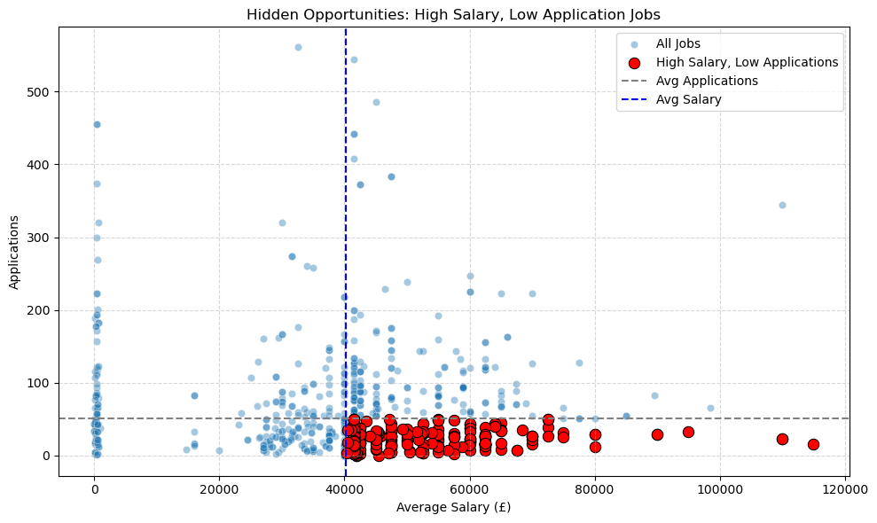

Correlation Insights
Salary vs Applications: A weak negative correlation (-0.058) suggests that higher-paying jobs don't necessarily attract more applications.
Job Age vs Applications: A moderate positive correlation (0.40) indicates that older job postings tend to receive more applications over time.
Salary vs Job Age: No significant correlation (0.03), meaning job age doesn’t influence the salary offered.

salaryAvg jobAgeDays applications
salaryAvg 1.000000 0.033179 -0.057870
jobAgeDays 0.033179 1.000000 0.400249
applications -0.057870 0.400249 1.000000
6. Recommendations
For Job Seekers:
Apply early: 23% of jobs were posted within the last 7 days — acting quickly gives you a competitive edge.
Target high-paying companies: Focus on employers like Robert Walters, Spectrum IT, and Harnham.
Explore top locations: Consider areas with high salary averages like Manchester, London, and Solihul.
Look for hidden gems: Seek roles with above-average salaries but fewer applications to reduce competition.
Be flexible: Hybrid roles are more prevalent (25%) than remote ones (7%) — take advantage of both.
For Recruiters and Hiring Managers:
Refresh older listings: Jobs older than 30 days often see more competition — reposting may boost visibility.
Benchmark salaries: Stay competitive by comparing offers with top-paying firms in your industry.
Promote flexibility: Hybrid options attract more applicants — consider emphasizing work style in job descriptions.
Re-evaluate low-response roles: If some listings get little attention, tweak the title, salary, or benefits.
Use data-backed insights: Correlation analysis can guide your posting strategies more effectively.
7. Limitations
Platform-Specific Data: Analysis is limited to Reed.co.uk and may not reflect trends across the broader UK job market or other platforms like LinkedIn or Indeed.
Keyword Bias: Jobs were filtered using specific keywords (e.g., "data analyst"), which may miss related roles under different titles (e.g., “Finance Analyst”, “ Corporate Credit Analyst” "insight analyst", "BI analyst").
No Skill-Level Classification: The data doesn’t distinguish between junior, mid-level, or senior roles, which could significantly impact salary and application patterns.
Location Ambiguity: Some locationName values are postal codes rather than clear city names, which may obscure regional trends.
Limited Job Type Categorization:The dataset doesn’t differentiate between full-time, part-time, contract, internship, etc., which could offer different insights for job seekers and recruiters.

