Laboratory Work 1
Student: Maqsat Syrtbay
Group: SE-2401
Course: Storage Systems
Professor: Tulebayev Yersultan

Goal of Lab: Initial Setup and Configuration for next works.

  - Configuration Setup
    - Login
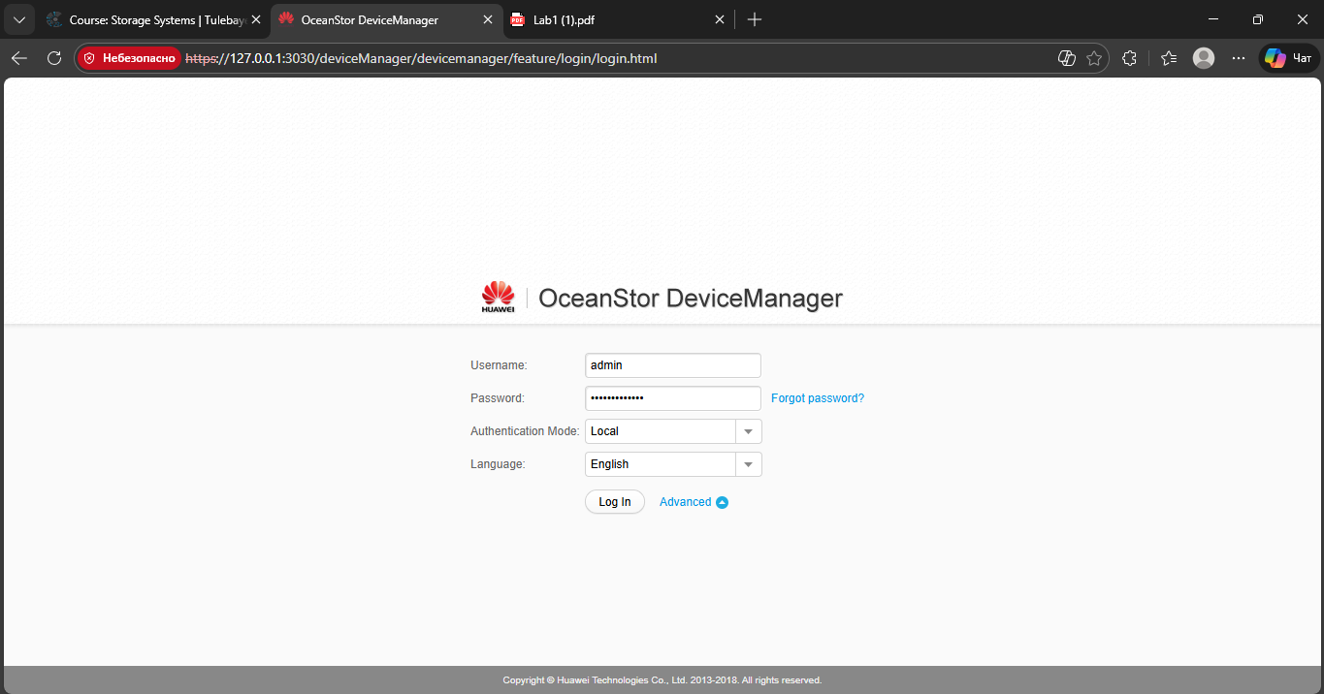
I entered the OSDM with standard account:
Username: Admin
Password: Admin@storage

1.1.2 Device configuration
After: Settings -> Basic Information -> Device Information
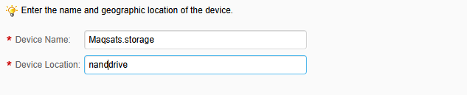
And save
1.1.3 Device Time Configuration
Next Step: Settings -> Basic Information -> Device Time
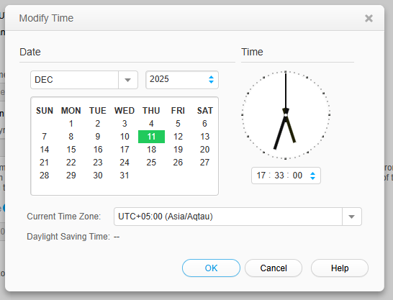
We are manually set time of our device.
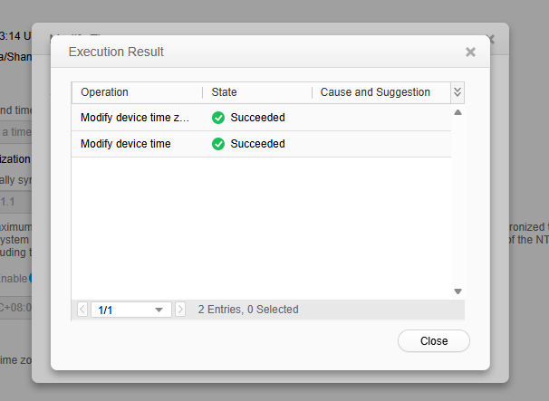

Time changed successfully :)

1.1.4 Monitoring the Controller enclosure
System -> Controller Enclosure
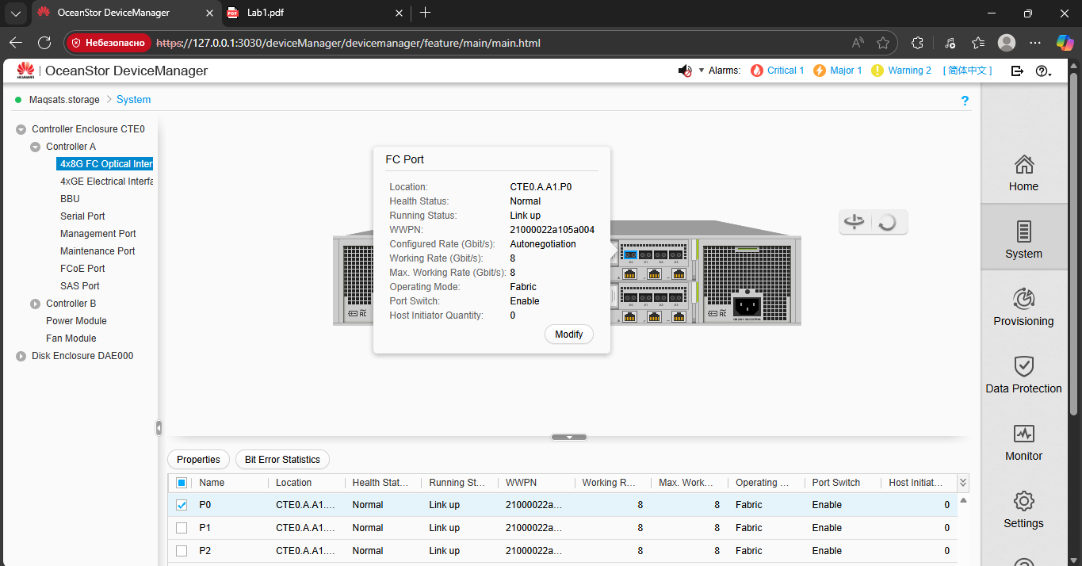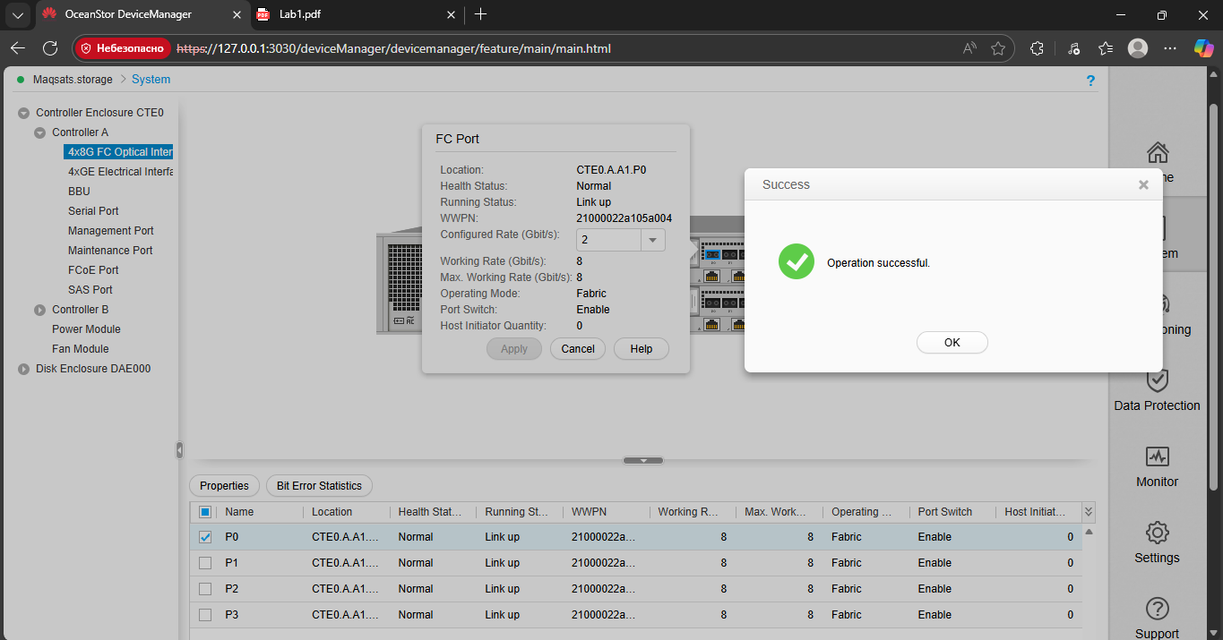
I changed configured rate speed to 2 GB/s
Successfully changed everything.
Next:
Ethernet I inputed my pc ipv4 and subnet mask in local network
ipv4: 192.168.56.1
mask: 255.255.255.0
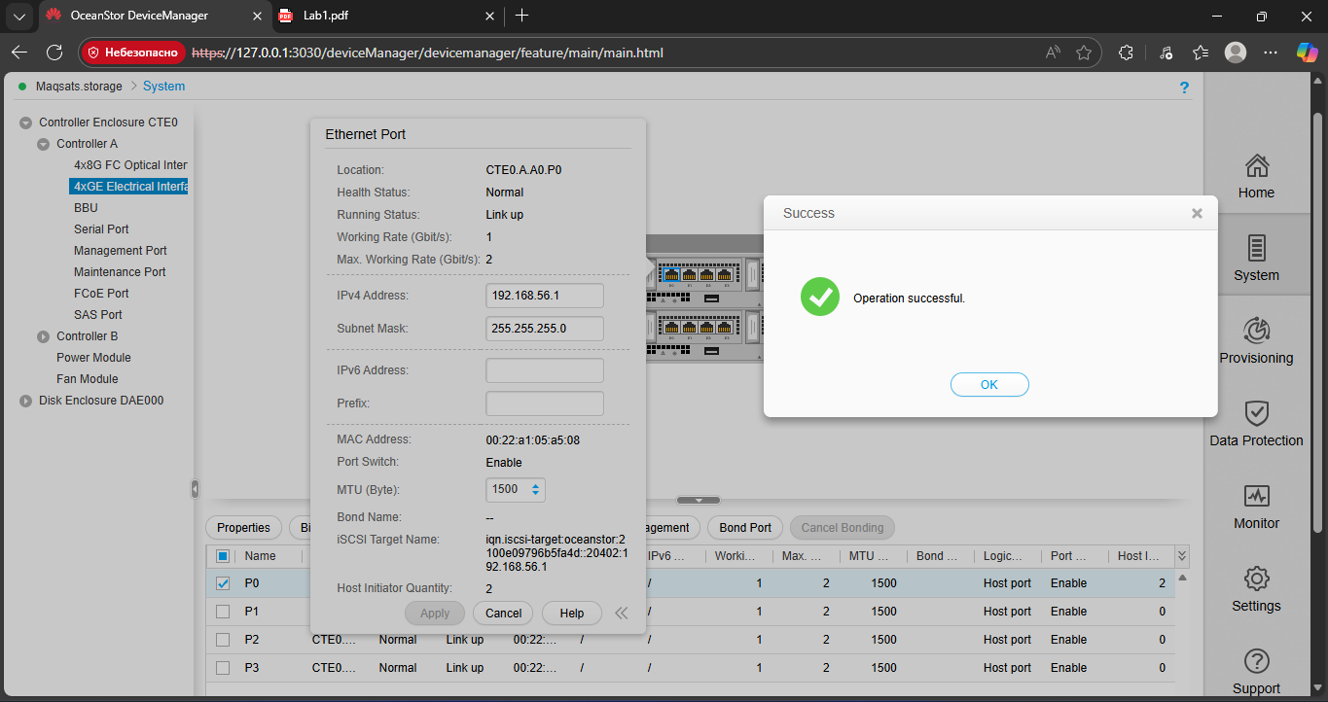
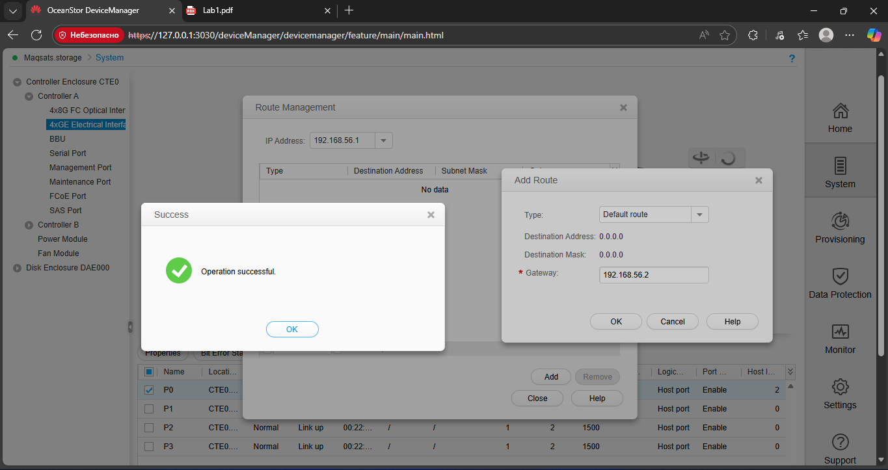
I configured routing because the service network segment of the servers and the Ethernet network segment of the storage array is not located within the same network segment.
1.1.5 Monitoring the Disk Enclosures
System -> Disk Enclosure -> Hard Disk
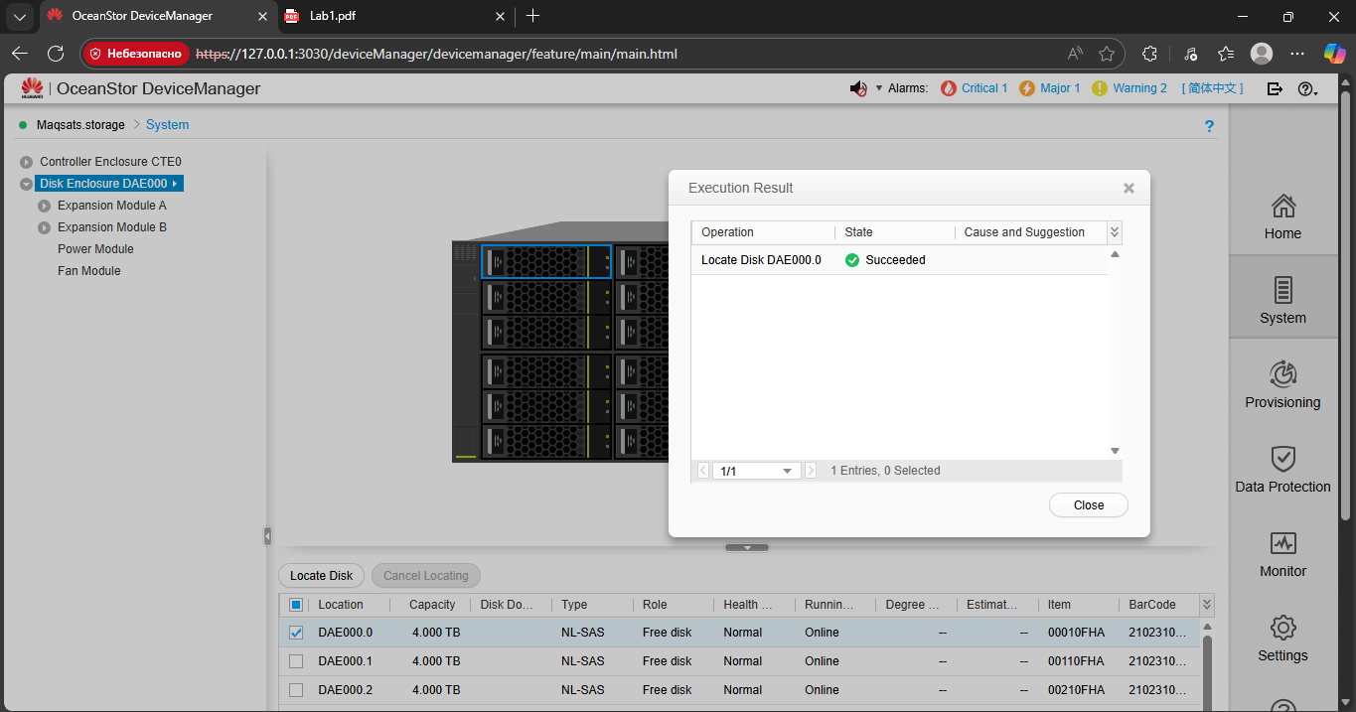
With this operation we located disk that we will use.
After changing the new hard disk, the HDD indicator light will be on. To turn of this we can cancel locating so the HDD indicator light will be off.
1.1.6 Powering On or Off Interface Modules
System -> Controller Enclosure ->  -> Interface Module -> Controller A
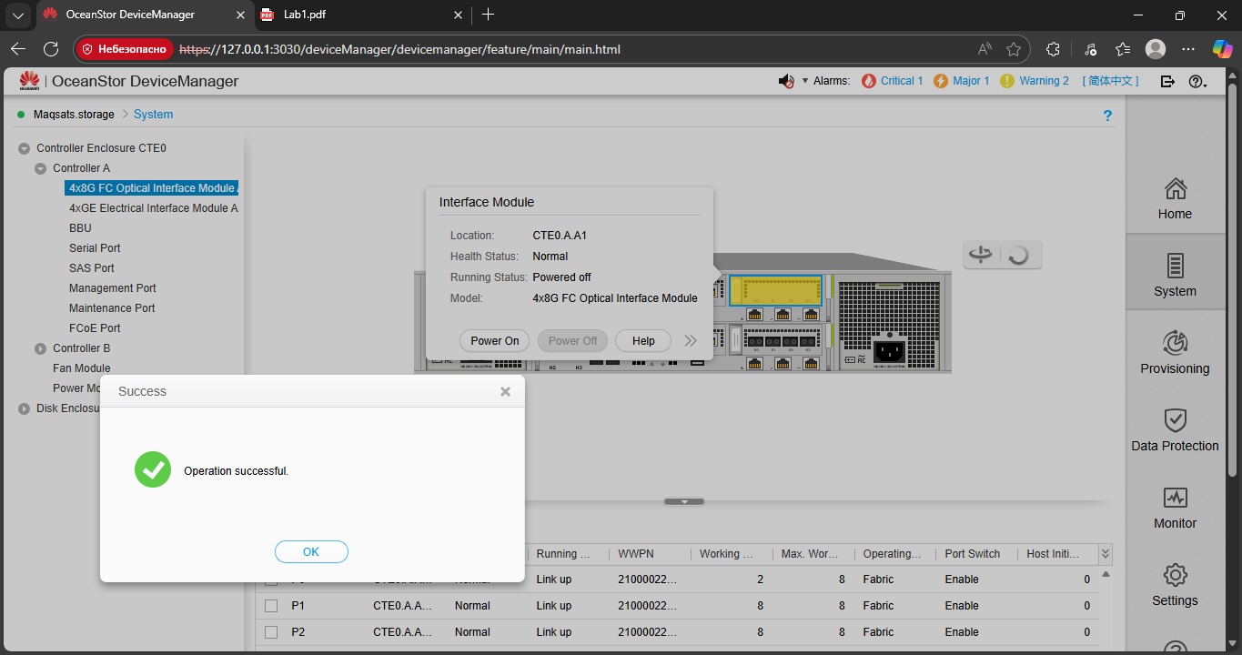
I just clicked Power On to switch power.
1.5 Questions
How to check the service IP of the storage and how to locate faulty HDD?

Service IP of the storage
Open the storage management interface and go to the Ethernet or network settings section under Settings or a similar menu.​
There you will see the IP address and subnet mask assigned to the storage array interface; that IP is the “service IP” you use for management and access.​

DISK
Go to System → Disk Enclosure → Hard Disk to see the list of drives and their status; a faulty HDD will usually be marked with an error/abnormal status.​
To physically locate the disk, use the “Locate” or similar function on that drive entry; this turns on the HDD indicator light on the corresponding slot, so you can find and replace it in the enclosure and then cancel locating to turn the light off.

