Laboratory Work 2
Student: Maqsat Syrtbay
Group: SE-2401
Course: Storage Systems
Professor: Tulebayev Yersultan

Goal of Lab: After completing this lab, you will understand the basic configuration and functions of SAN storage services. You will learn about resource pools such as disk domains, storage pools, LUNs, and LUN groups, using the OceanStor as an example.

  - Lab Configuration Tasks
    - Roadmap: Configuration of disk domain, storage pool, LUN and LUN group
    - Steps
    - Step 1
Login -> Maqsatto.Storage -> Provisioning -> Disk Domain -> “Create” button
Domain name: DiskDomain001
Domain desc: idk what to write here
Key: domain name.
We click on manual select of disks: 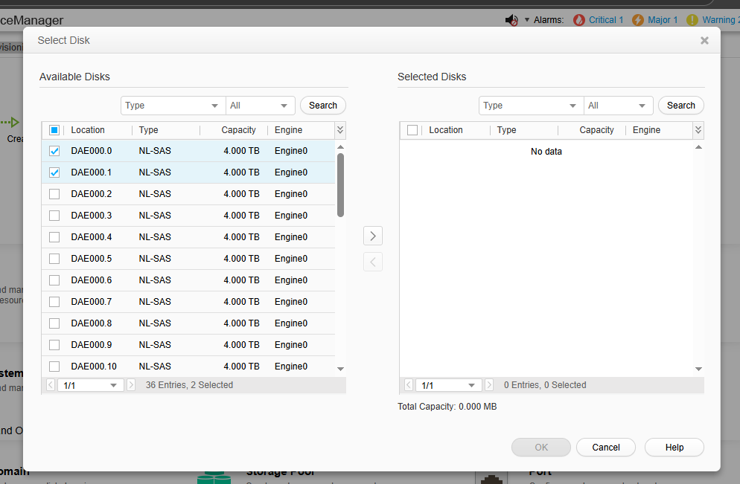

Next we Click ok:
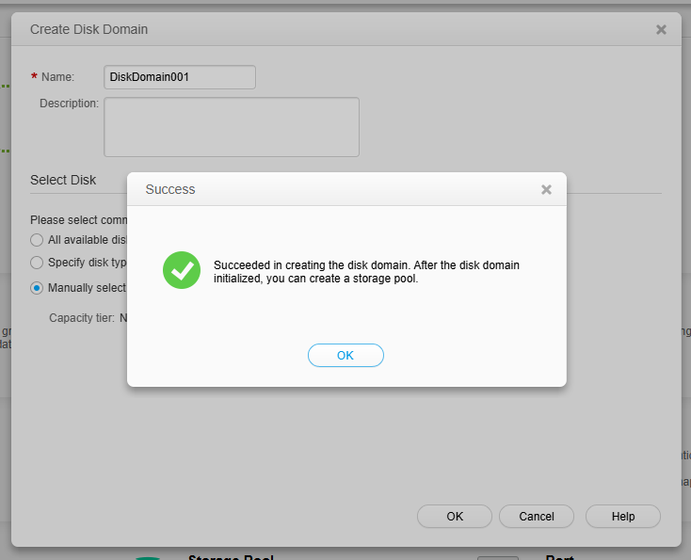

Step 2 Creating Storage pool
Maqsatto.Storage -> Provisioning -> Storage Pool -> “Create” button
Capacity Alarm Threshold” as 80, and “Data Migration
Granularity” as 4MB
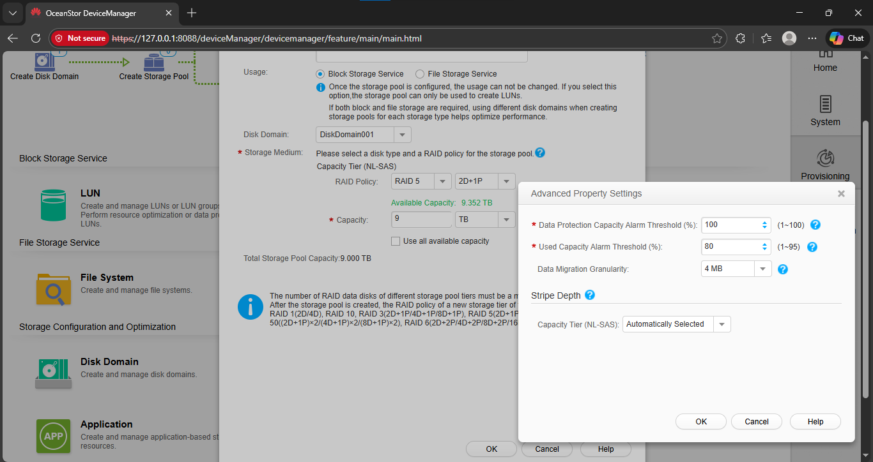
I successfully created storage pool.
Step 3 Createing LUN
Maqsatto.Storage -> Provisioning -> LUN -> “Create” button
Key in 20 within the “Capacity” field, which means that the size of the LUN would be 20GB.
Key in 2 at the “Quantity” field to create two LUNs.
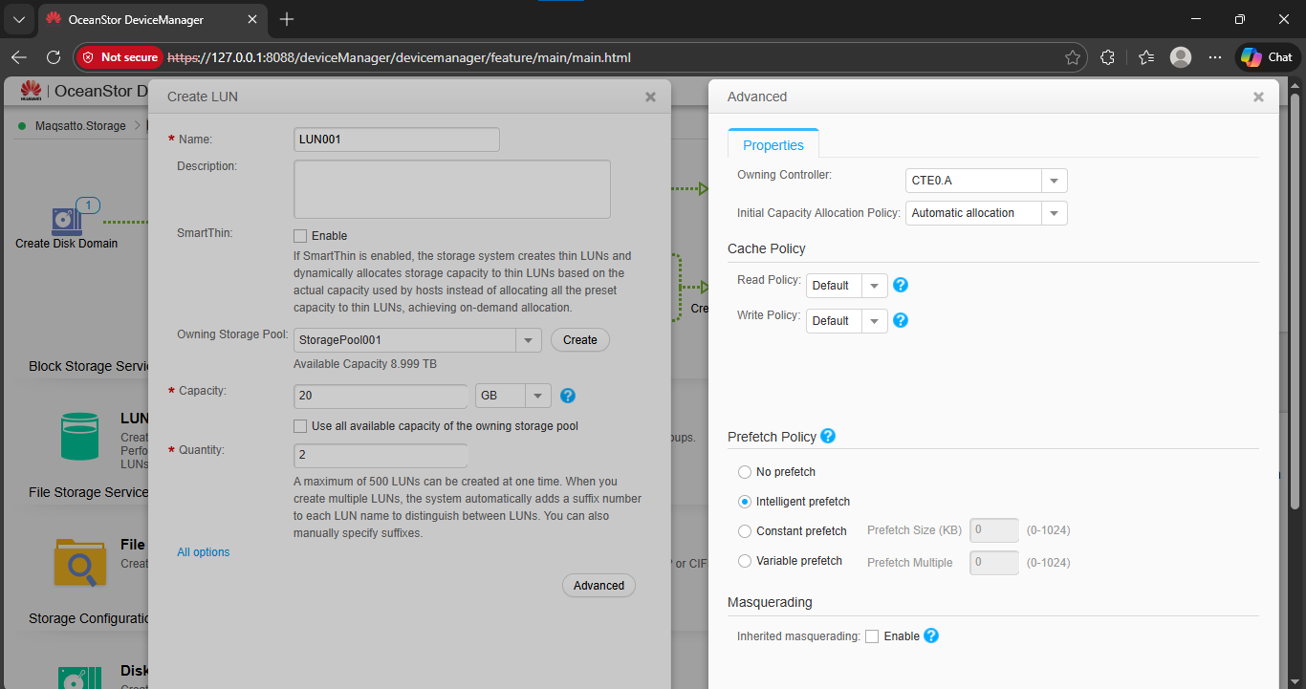
We Created LUN
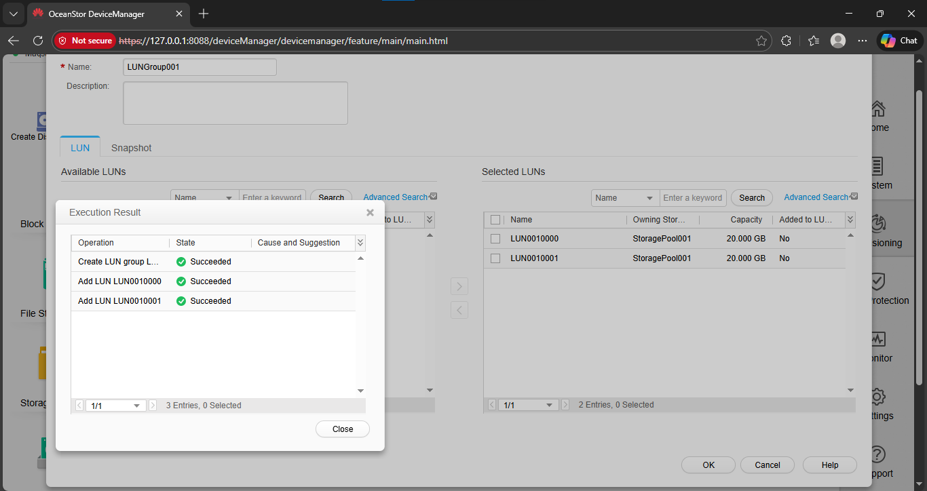
We Created LUN Group

1.2. Q/A
Q: Is creating a storage pool the prerequisite for creating a LUN?
A: Yes.

