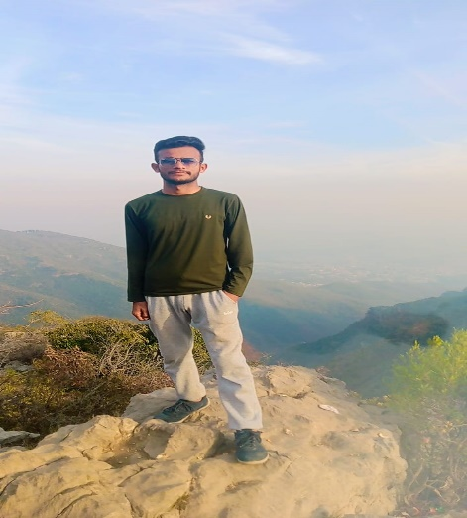**Maqsood Ahmed**

CS Student

Phone: 0325-2770421

Email: maqsoodnasirani421@gmail.com

Address: Islamabad I 11 / 4 near metro shopping mall.

**OBJECTIVE:** A motivated individual with in-depth knowledge of languages and development tools.

**EDUCATION:**

|  |  |  |
| --- | --- | --- |
| EDUCATION | INSTITUTE | YEAR |
| MATRICULATION | NEW HORIZON SCHOOOL DAHARKI | 2018-2020 |
| INTERMEDIATE | GOVT. DEGREE COLLEGE MPM | 2020-2022 |
| GRADUDATE | IQRA UNIVERSITY | 2023-Onwards.. |

**SKILLS:**

|  |
| --- |
| Expert in C programming language |
| Average knowledge of computers and OS |
| A little knowledge about Python, C++, HTML and CSS. |

**LANGUAGE:**

|  |
| --- |
| Sindhi |
| Urdu |
| English |