1

**DSA Lab: 10**



**Department of Computer Science**

**Iqra University Islamabad**

**DSA**

**Maqsood Ahmed**

**ID: 3818**

**Scenario:**

You are working in an automated warehouse where products are stored on shelves  
in increasing order of size. Due to a system upgrade, all the items on Shelf A  
need to be moved to Shelf C while preserving their order. A temporary Shelf B  
is available for intermediate storage. The robot moving the items has the  
following constraints:

* **Only one item can be moved at a time.**
* **A larger item cannot be placed on top of a smaller  
  item.**
* **The robot must follow an optimal sequence to  
  minimize the number of moves.**

**Task:**  
Write a recursive function to determine the sequence of moves required to  
transfer all items from Shelf A to Shelf C, using Shelf B as a temporary  
holding space.

**Source Code:**

#include <iostream>

using namespace std;

// Recursive function to solve the problem

void moveItems(int n, char fromShelf, char toShelf, char tempShelf) {

if (n == 1) {

cout << "Move item from " << fromShelf << " to " << toShelf << endl;

return;

}

// Step 1: Move n-1 items from 'fromShelf' to 'tempShelf' using 'toShelf' as temporary storage

moveItems(n - 1, fromShelf, tempShelf, toShelf);

// Step 2: Move the nth item directly from 'fromShelf' to 'toShelf'

cout << "Move item from " << fromShelf << " to " << toShelf << endl;

// Step 3: Move the n-1 items from 'tempShelf' to 'toShelf' using 'fromShelf' as temporary storage

moveItems(n - 1, tempShelf, toShelf, fromShelf);

}

int main() {

int n; // Number of items on Shelf A

cout << "Enter the number of items: ";

cin >> n;

// Call the recursive function

moveItems(n, 'A', 'C', 'B');

return 0;

}

**OUTPUT:**

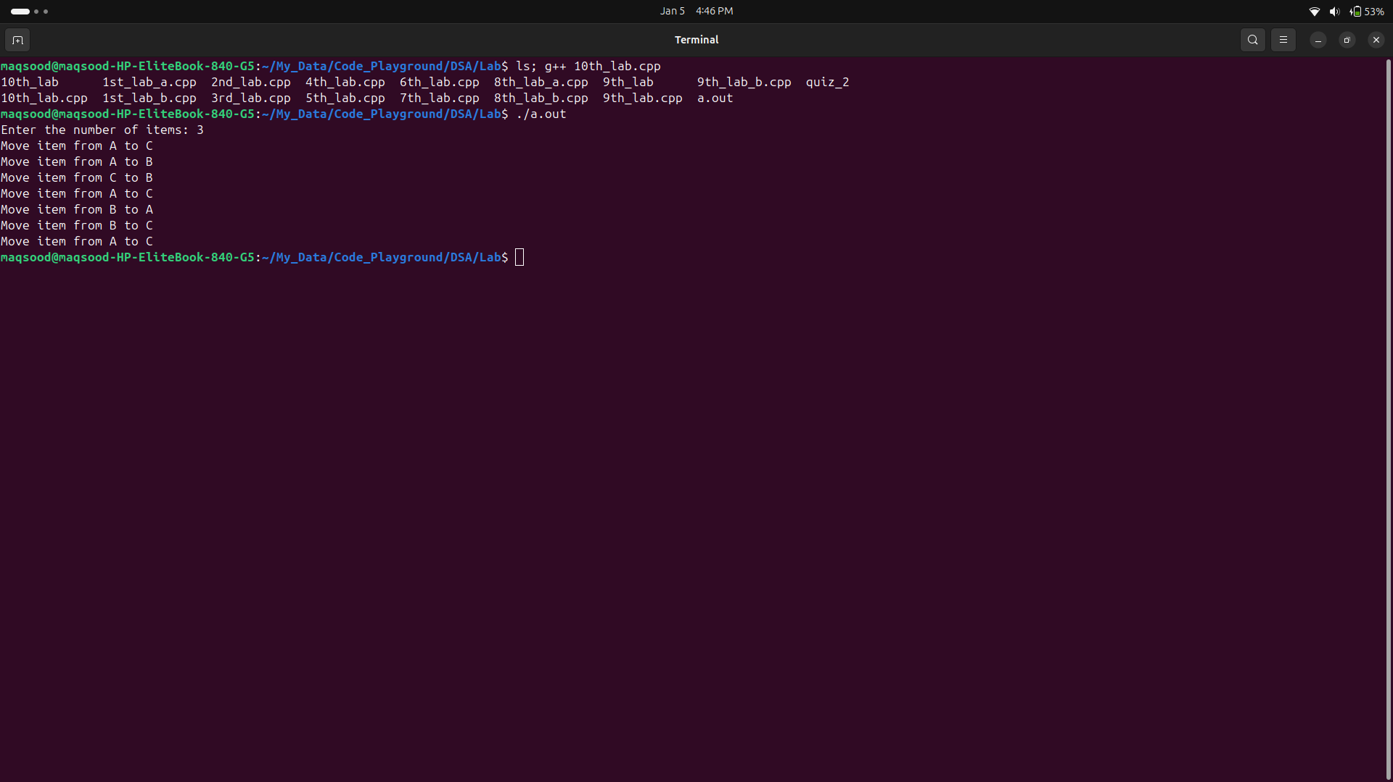

**The End**